Lab 3
Spark Setup & Batch Processing
Course theme: Big Data Platforms
Lab objective: Experience why Spark replaced MapReduce by re-running the Wikipedia word count from Lab 2 using PySpark RDDs.

This lab introduces Apache Spark as a replacement for MapReduce, focusing on RDDs, Transformations, Actions, the DAG, Shuffles, and Data Skew. We will use Wikipedia and the Yellow Taxi Trip Records datasets.

Learning Objectives
After completing this lab, you will be able to:
- Write a PySpark word count using flatMap, map, and reduceByKey
- Explain the difference between Transformations (lazy) and Actions (eager)
- Read the Spark UI DAG visualization and identify stages and shuffle boundaries
- Explain why reduceByKey is preferred over groupByKey
- Detect data skew in the Spark UI (and fix it using salting)
- (Use cache() to speed up iterative or interactive workloads)

Prerequisites Checklist
Verify the following before starting:
- Hadoop cluster (the master and executor nodes), Wikipedia text files on HDFS
- jps shows NameNode + ResourceManager on master, DataNode + NodeManager on workers
- Wikipedia data on HDFS (if not, re-upload from Lab 2 step 1)
- Python 3.10+ with pip installed on the master node (workers need Python 3.10+)

Step 0. Install PySpark 4 (on the master node)
We install PySpark via pip, which bundles the Spark engine and Hadoop client libraries.

0.1 Install Java 17 (all nodes)
Spark 4 requires Java 17+. Since YARN is already present as cluster manager, we can use it. However, Hadoop 3.3.6 cluster runs on Java 11, which we keep untouched.
We install Java 17 alongside it (see https://spark.apache.org/docs/latest/running-on-yarn.html for more details).
# enter the master node:
su - hadoop

# verify Hadoop version:
hadoop version

# Install Java 17 on the master node
sudo apt install -y openjdk-17-jdk

# Verify both are installed
ls /usr/lib/jvm/
# You should see both java-11-openjdk-amd64 and java-17-openjdk-amd64

Install Java 17 on all worker nodes:
for w in hadoop-worker1 hadoop-worker2 hadoop-worker3 hadoop-worker4; do
ssh -t hadoop@${w} 'sudo apt install -y openjdk-17-jdk'
done

# or without the loop:

ssh hadoop@hadoop-worker1
sudo apt install -y openjdk-17-jdk
exit

ssh hadoop@hadoop-worker2
sudo apt install -y openjdk-17-jdk
exit
# ... repeat for 3 and 4

Hadoop 3.3.6 supports Java 8/11 runtime only. Java 17 support was added in Hadoop 3.4.x. Spark 4 requires Java 17+.
By installing both, the Hadoop daemons keep using Java 11 (hardcoded in hadoop-env.sh) while Spark uses Java 17 via JAVA_HOME and YARN container environment variables.

Verify that hadoop-env.sh has Java 11 hardcoded (this protects Hadoop daemons):
grep JAVA_HOME $HADOOP_HOME/etc/hadoop/hadoop-env.sh
# Should show: export JAVA_HOME=/usr/lib/jvm/java-11-openjdk-amd64

0.2 Install PySpark
On the master node, install PySpark 4 into a virtual environment:
# Install venv support (if not already present)
sudo apt install -y python3-venv

# Create and activate a virtual environment
python3 -m venv ~/spark-env
source spark-env/bin/activate

# Install PySpark 4 (includes Spark engine + Hadoop 3 client)
pip install pyspark==4.1.1

0.3 Environment variables
Edit ~/.bashrc — change JAVA_HOME to point to Java 17. This is safe because Hadoop daemons read JAVA_HOME from hadoop-env.sh (which still points to Java 11), not from your shell:
# Activate the virtual environment on login
source spark-env/bin/activate

# Set JAVA_HOME to Java 17 for PySpark/Spark
# (Hadoop daemons use Java 11 from hadoop-env.sh, not this variable)
export JAVA_HOME=/usr/lib/jvm/java-17-openjdk-amd64

# Tell PySpark to use YARN as the cluster manager
export HADOOP_CONF_DIR=$HADOOP_HOME/etc/hadoop
export YARN_CONF_DIR=$HADOOP_HOME/etc/hadoop

# Ensure executors use the same Python version
export PYSPARK_PYTHON=python3

# Point Spark at a config directory for persistent settings
export SPARK_CONF_DIR=~/spark-conf

# finally, set the spark home directory to where pyspark is installed:
export SPARK_HOME=$(python3 -c "import pyspark; import os; \ print(os.path.dirname(pyspark.__file__))")

# verify that spark home is set:
echo $SPARK_HOME
/home/hadoop/spark-env/lib/python3.10/site-packages/pyspark

Then:
source ~/.bashrc

0.4 Configure Spark for YARN with Java 17
When YARN launches Spark containers (Application Master and executors) on worker nodes, those containers inherit YARN’s Java 11 by default. We must tell YARN to use Java 17 inside Spark containers. Create a spark-defaults.conf:
mkdir -p ~/spark-conf
cat > ~/spark-conf/spark-defaults.conf << 'EOF'
# Tell YARN to use Java 17 in Spark containers
spark.yarn.appMasterEnv.JAVA_HOME /usr/lib/jvm/java-17-openjdk-amd64
spark.executorEnv.JAVA_HOME /usr/lib/jvm/java-17-openjdk-amd64

# Event logging (for Spark History Server)
spark.eventLog.enabled true
spark.eventLog.dir hdfs:///spark-logs

# Spark UI: bind to all interfaces so remote browsers can reach :4040
spark.driver.host 10.92.0.92
spark.ui.host 0.0.0.0
spark.driver.bindAddress 0.0.0.0

# spark history
spark.history.fs.logDirectory hdfs:///spark-logs
spark.history.ui.port 18080
spark.history.ui.host 0.0.0.0
EOF

Create the Spark event log directory on HDFS:
hdfs dfs -mkdir -p /spark-logs

Last steps:

Open required ports from the VM dashboard (i.e. Strato):
- Port 4040: default for Spark UI (inspecting current Spark application)
- Port 18080: used by the Spark History Server (to inspect past jobs)

Resolve the cluster hostname from your local machine
When Spark runs on YARN, the driver UI on port 4040 does not serve content directly, and is redirected to the YARN Web Application Proxy:

http://hadoop-master:8088/proxy/<application-id>/

The redirect URL uses the ResourceManager hostname from yarn-site.xml (in our case, "hadoop-master").
To view the Spark web UI, we need to add the mapping to the /etc/hosts file in our machine:
Windows (PowerShell as Administrator):
Add-Content -Path "C:\Windows\System32\drivers\etc\hosts" -Value "10.92.0.92 hadoop-master"

Mac / Linux:
echo "10.92.0.92 hadoop-master" | sudo tee -a /etc/hosts

Verify:
ping hadoop-master
# Should resolve to 10.92.0.92

Finally, verify that you have the data ready in hdfs.
hdfs dfs -ls /user/$(whoami)/wikipedia/input/ | head -5

Checkpoint
Verify the installation:
python -c "import pyspark; print(pyspark.__version__)"
You should see 4.1.1.

Verify Java 17 is active:
java -version # should show openjdk 17.x

Verify YARN connectivity:
pyspark --master yarn --deploy-mode client
The PySpark shell should start and show the Spark 4.0 banner.
Type exit() to quit.

If the YARN Application Master fails, check that Java 17 is installed on
all workers and that spark-defaults.conf has the appMasterEnv/executorEnv
settings (see step 0.4 above).

Step 1. Word Count with PySpark RDDs

1.1 Create the script
Create a file wiki_wordcount.py on the master node (for now save it in a folder, e.g. ‘python_scripts’):
from pyspark.sql import SparkSession
import time

# Initialize Spark
spark = SparkSession.builder \
.appName("WikiWordCount-v1") \
.getOrCreate()
sc = spark.sparkContext

# Start timer
t0 = time.time()

# Read the Wikipedia text files from HDFS (same data as Lab 2)
text_rdd = sc.textFile("hdfs:///user/hadoop/wikipedia/input/")

# Word count pipeline:
# flatMap: split each line into words
# map: emit (word, 1) pairs
# reduceByKey: sum counts per word (local combine + shuffle)
word_counts = (
text_rdd
.flatMap(lambda line: line.lower().split())
.map(lambda word: (word, 1))
.reduceByKey(lambda a, b: a + b)
)

# Action: sort by count descending, take top 30
top_30 = word_counts.sortBy(lambda x: -x[1]).take(30)

elapsed = time.time() - t0

print(f"\n{'='*50}")
print(f" Top 30 words (completed in {elapsed:.1f}s)")
print(f"{'='*50}")
for word, count in top_30:
print(f" {word:<20} {count:>12,}")

spark.stop()

1.2 Submit the job
spark-submit \
--master yarn \
--deploy-mode client \
--num-executors 4 \
--executor-cores 2 \
--executor-memory 2g \
python_scripts/wiki_wordcount.py

While the application runs, open the Spark UI at http://hadoop-master:4040 and observe.
You can also inspect the Job history by running the Spark History Server and open http://hadoop-master:18080:
$SPARK_HOME/sbin/start-history-server.sh
Inspect the jobs:
- The Jobs tab: one job triggered by the take() action
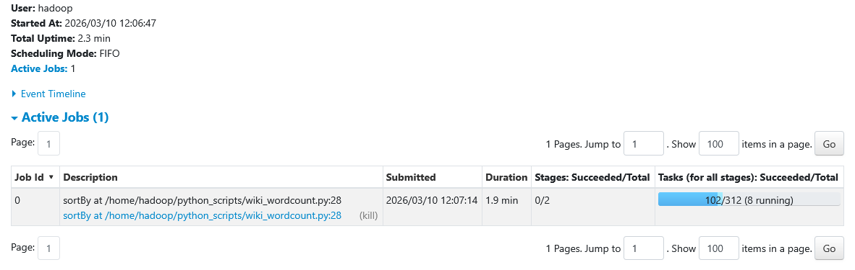
- The Stages tab: two stages (before and after the shuffle in reduceByKey)
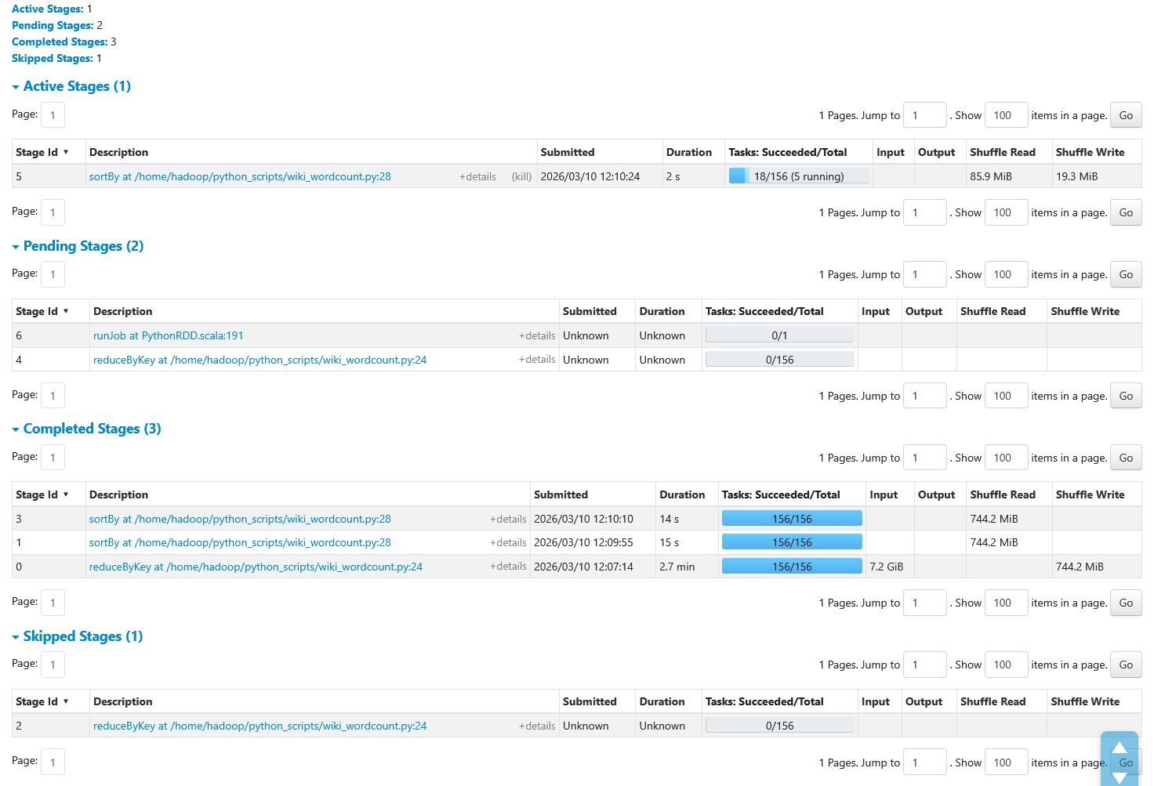

- The DAG Visualization: click the job to see the full execution graph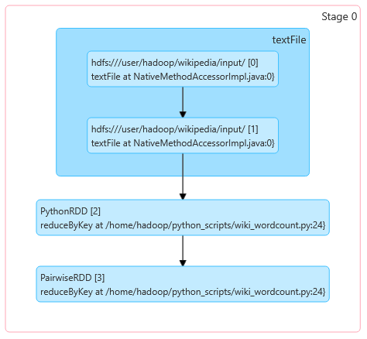
- The Tasks within each stage: how many ran in parallel?
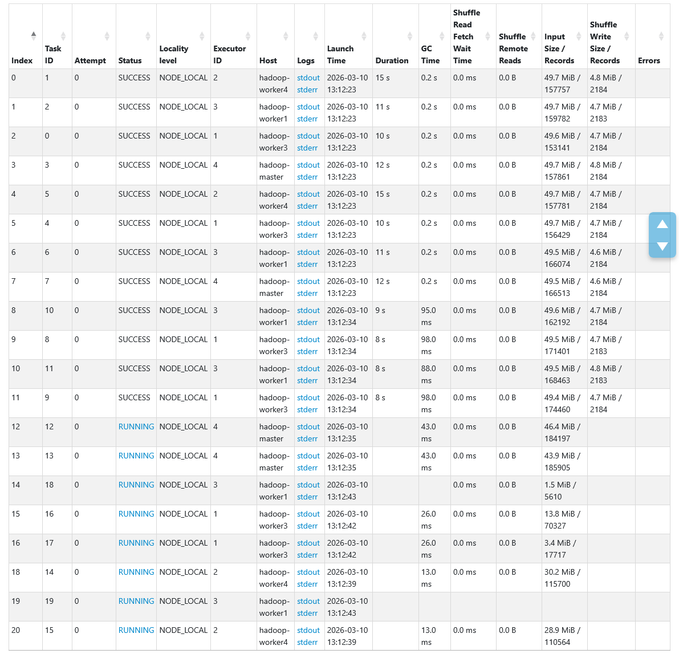

✅ Checkpoint
You should see output similar to Lab 2:
the 89,972,114
of 43,036,010
and 36,658,359
in 35,859,370
to 26,315,078

Step 2. Word Count v2 — Stop Word Removal

2.1 Create the improved script
Create wiki_wordcount_v2.py:
from pyspark.sql import SparkSession
import time
import re

spark = SparkSession.builder \
.appName("WikiWordCount-v2") \
.getOrCreate()
sc = spark.sparkContext

t0 = time.time()

# Load stop words from HDFS and broadcast to all executors
stop_words_rdd = sc.textFile("hdfs:///user/hadoop/wikipedia/stopwords.txt")
stop_words = set(stop_words_rdd.collect())

# Broadcast the set so every executor has a local copy (no re-transfer)
stop_words_bc = sc.broadcast(stop_words)

# Compile a regex for stripping punctuation
punct_pattern = re.compile(r'[^a-z0-9]')

def clean_and_split(line):
"""Lowercase, strip punctuation, remove empty/short tokens and stop words."""
words = line.lower().split()
sw = stop_words_bc.value
for w in words:
cleaned = punct_pattern.sub('', w)
if len(cleaned) > 1 and cleaned not in sw:
yield cleaned

# Pipeline
text_rdd = sc.textFile("hdfs:///user/hadoop/wikipedia/input/")

word_counts = (
text_rdd
.flatMap(clean_and_split)
.map(lambda w: (w, 1))
.reduceByKey(lambda a, b: a + b)
)

# Count unique tokens and get top 30
total_unique = word_counts.count()
top_30 = word_counts.sortBy(lambda x: -x[1]).take(30)

elapsed = time.time() - t0

print(f"\n{'='*50}")
print(f" Top 30 words — cleaned (completed in {elapsed:.1f}s)")
print(f" Unique tokens: {total_unique:,}")
print(f"{'='*50}")
for word, count in top_30:
print(f" {word:<20} {count:>12,}")

spark.stop()

2.2 Submit
spark-submit \
--master yarn \
--deploy-mode client \
--num-executors 4 \
--executor-cores 2 \
--executor-memory 2g \
wiki_wordcount_v2.py

✅ Checkpoint
Most common terms after filtering stop words:
during 1,753,670
between 1,295,594
later 1,280,974
such 1,268,335
city 1,222,189
school 1,183,061
while 1,163,530
under 1,118,795

3. Exercises

Exercise 1: Compare MapReduce vs Spark
Run both v1 and v2 and record the numbers. Find MapReduce times from your Lab 2 YARN UI history.

Metric | MapReduce (Lab 2) | Spark v1 | Spark v2
Total job time
Number of map/transform tasks
Shuffle bytes (YARN UI / Spark UI)
Lines of application code | ~50 (Java)

Questions:
- Why is Spark faster even though it reads the same data from HDFS?
- Why does Spark have fewer stages than MapReduce has phases? (Hint: pipelining of narrow transforms.)
- The stop words broadcast in v2 replaces Hadoop’s DistributedCache. What is the advantage of broadcast() over re-reading the file in every task?

Exercise 2: Data Skew Detection and Salting (NYC Taxi Data)

In this exercise you will work with NYC Yellow Taxi trip data to observe data skew during a join operation and apply two techniques to fix it: manual key salting and Adaptive Query Execution (AQE). The exercise uses DataFrames (a preview of Lab 4) because skew is most visible and practically relevant in join operations.

Step 1: Download the NYC Taxi data

The data is Yellow Taxi Trip Records for January–June 2022, published by the NYC Taxi and Limousine Commission (TLC). Each parquet file contains one month of trip records with pickup/dropoff locations, distances, fares, etc. The taxi zone lookup CSV maps location IDs to borough and zone names.

# Create a directory for the taxi data
mkdir -p ~/taxi_data && cd ~/taxi_data

# Download Yellow Taxi trip data (Jan-Jun 2022, ~200MB each)
for month in 01 02 03 04 05 06; do
wget -q "https://d37ci6vzurychx.cloudfront.net/trip-data/yellow_tripdata_2022-${month}.parquet" \
-O "yellow_tripdata_2022-${month}.parquet"
echo "Downloaded 2022-${month}"
done

# Download the taxi zone lookup CSV
wget -q "https://d37ci6vzurychx.cloudfront.net/misc/taxi_zone_lookup.csv" \
-O taxi_zone_lookup.csv

# Upload to HDFS
hdfs dfs -mkdir -p /user/hadoop/taxi/trips
hdfs dfs -mkdir -p /user/hadoop/taxi/zones
hdfs dfs -put yellow_tripdata_2022-*.parquet /user/hadoop/taxi/trips/
hdfs dfs -put taxi_zone_lookup.csv /user/hadoop/taxi/zones/

# Verify
hdfs dfs -ls /user/hadoop/taxi/trips/
hdfs dfs -ls /user/hadoop/taxi/zones/

Step 2: Analyze the data and introduce skew (Part A)

Create taxi_skew_partA.py. This script loads the taxi data, shows the natural pickup location distribution, then introduces artificial skew by replacing location IDs 1–200 with a single location (237, Upper East Side North). This simulates real-world scenarios where one key dominates: one warehouse receives 80% of orders, one user generates most log events, one product dominates sales. The skewed data is saved to HDFS for the subsequent parts.

Note: all four scripts disable AQE and broadcast joins so you can observe the skew. They also set shuffle partitions to 20 so the task table in the Spark UI is readable.

spark-submit --master yarn --deploy-mode client \
--num-executors 4 --executor-cores 2 --executor-memory 2g \
taxi_skew_partA.py

Step 3: Naive join (Part B)

Create taxi_skew_partB.py. This script joins the skewed trips with the zone lookup table using a standard sort-merge join (broadcast is disabled). The partition handling location 237 receives millions of rows while other partitions get thousands. This creates a straggler visible in the Spark UI.

spark-submit --master yarn --deploy-mode client \
--num-executors 4 --executor-cores 2 --executor-memory 2g \
taxi_skew_partB.py

Open the Spark UI at http://hadoop-master:18080 once the job terminates:
- Go to the Stages tab and find the SortMergeJoin stage
- Click on it and look at the Summary Metrics table
- Compare Min vs Max Duration. Usually, if there is a large deviation from the median, we can easily spot the straggler: let’s sort the task table by descending Duration.
- Note the Shuffle Read size for the slowest task vs the median

Step 4: Salted join — distribute the hot key (Part C)

Create taxi_skew_partC.py. This script adds a random salt (0–9) to the join key on the trips side, and replicates the zones table 10 times (once per salt value). Location 237 is now split into 237_0, 237_1, … 237_9, spreading its millions of rows across 10 tasks instead of one.

spark-submit --master yarn --deploy-mode client \
--num-executors 4 --executor-cores 2 --executor-memory 2g \
taxi_skew_partC.py

In the Spark UI, compare the task duration distribution with Part B. The Min/Max ratio should be more uniform.

Step 5: AQE automatic skew handling (Part D)

Create taxi_skew_partD.py. This script runs the exact same join as Part B — no salting, no code changes — but with Adaptive Query Execution (AQE) enabled. AQE, available since Spark 3.0 and on by default since 3.2, detects skewed partitions at runtime and automatically splits them into smaller sub-partitions, replicating the other side as needed.

spark-submit --master yarn --deploy-mode client \
--num-executors 4 --executor-cores 2 --executor-memory 2g \
taxi_skew_partD.py

In the Spark UI, go to the SQL/DataFrame tab and click the query. Look for “AQEShuffleRead” or “CustomShuffleReader” in the physical plan — this indicates AQE dynamically adjusted the partitioning.

Questions:

1. In Part B, what was the ratio between the slowest and fastest task? (Screenshot the Summary Metrics table from the Spark UI.)

2. Compare the Shuffle Read size of the slowest task in Part B vs Part C. How much did salting reduce the largest partition?

3. In Part C, we replicate the zones table 10 times (once per salt). Why is this necessary? What happens if we only salt the trips side without replicating zones?

4. AQE (Part D) handles skew automatically with zero code changes. When would you still prefer manual salting over AQE? (Hint: AQE only optimizes joins, requires Spark 3.0+, and only activates when the skew exceeds certain thresholds.)

5. In the real (unskewed) taxi data, pickup locations are spread across many zones. Why did we artificially introduce skew? Give an example of a real-world dataset where this level of skew occurs naturally.

6. The results (top zones by trip count) should be identical across Parts B, C, and D. Verify this. Why must they be the same even though the execution strategies differ?

Exercise 2: Explore the DAG and Lazy Evaluation
Step 1: Add redundant filters to the word count pipeline. Create wiki_dag_test.py:
from pyspark.sql import SparkSession

spark = SparkSession.builder \
.appName("DAG-Experiment") \
.getOrCreate()

sc = spark.sparkContext

text_rdd = sc.textFile("hdfs:///user/hadoop/wikipedia/input/")

# Chain of transformations
words = text_rdd.flatMap(lambda line: line.lower().split())
words = words.filter(lambda w: len(w) > 0) # Filter 1
words = words.filter(lambda w: w is not None) # Filter 2 (redundant)
words = words.filter(lambda w: len(w) > 0) # Filter 3 (duplicate of 1!)
pairs = words.map(lambda w: (w, 1))
counts = pairs.reduceByKey(lambda a, b: a + b)

# action
result = counts.take(10)
print(result)

# Keep the SparkContext alive so you can inspect the UI
input("Press Enter to stop (go look at the Spark UI first)...")
spark.stop()

Step 2: Submit it:
spark-submit --master yarn --deploy-mode client wiki_dag_test.py

Step 3: While it waits for your Enter key, open http://hadoop-master:4040:
- Go to Jobs -> click the job
- Examine the DAG Visualization
- How many stages are there?
- Check stage details: are the three filters visible as separate operations?

Questions:
- How many stages does the DAG show? Why that number?
- Did Spark remove the redundant filters? (With raw RDDs, it will not (all three filters run). This is different from DataFrames where the Catalyst optimizer could eliminate them.)
- What is the stage boundary? Which operation causes it?

Exercise 4 (Bonus) — Cache Effectiveness
Create wiki_cache.py:
from pyspark.sql import SparkSession
import time

spark = SparkSession.builder \
.appName("Cache-Experiment") \
.getOrCreate()
sc = spark.sparkContext

text_rdd = sc.textFile("hdfs:///user/hadoop/wikipedia/input/")

word_counts = (
text_rdd
.flatMap(lambda line: line.lower().split())
.map(lambda w: (w, 1))
.reduceByKey(lambda a, b: a + b)
)

# ============================================================
# WITHOUT cache: two actions = two full computations
# ============================================================
t0 = time.time()
count1 = word_counts.count()
t1 = time.time()
top1 = word_counts.sortBy(lambda x: -x[1]).take(10)
t2 = time.time()

print(f"Without cache:")
print(f" count(): {t1 - t0:.1f}s")
print(f" take(): {t2 - t1:.1f}s")
print(f" total: {t2 - t0:.1f}s")

# ============================================================
# WITH cache: second action reuses cached RDD
# ============================================================
word_counts_cached = word_counts.cache()

t0 = time.time()
count2 = word_counts_cached.count() # First action: computes AND caches
t1 = time.time()
top2 = word_counts_cached.sortBy(lambda x: -x[1]).take(10) # Reads from cache
t2 = time.time()

print(f"\nWith cache:")
print(f" count(): {t1 - t0:.1f}s (computes + caches)")
print(f" take(): {t2 - t1:.1f}s (reads from cache)")
print(f" total: {t2 - t0:.1f}s")

print(f"\nSpeedup on second action: {(t2 - t1):.1f}s vs previous run")

# Check the Storage tab in Spark UI to see the cached RDD
input("\nPress Enter to stop (check Storage tab in Spark UI)...")

word_counts_cached.unpersist()
spark.stop()

spark-submit --master yarn --deploy-mode client wiki_cache.py

Questions:
- How much faster was the second action (take) with caching vs without?
- Open the Storage tab in the Spark UI. How much memory does the cached RDD consume?
- When would caching not help? (Hint: if you only call one action, caching adds overhead without benefit.)

4. Spark UI Reference
Tab | What to look for
Jobs | One job per action. Click to see stages.
Stages | Stage boundaries = shuffle operations. Task count = partition count.
Storage | Cached RDDs, their size, and fraction cached.
Executors | Memory usage per executor, shuffle read/write.
SQL | Only relevant for DataFrames/Spark SQL (Lecture 6).

Access at: http://hadoop-master:4040 (while a job is running)
To start the History Server (if you installed the full Spark distribution):
# If using pip-installed PySpark, find the Spark home:
python -c "import pyspark; print(pyspark.__file__)"
# The sbin/ directory is inside the PySpark package
Then visit: http://hadoop-master:18080

5. Common Errors & Fixes
Error | Likely cause
ModuleNotFoundError: No module named 'pyspark' | Virtual environment not activated. Run: source ~/spark-env/bin/activate
UnsupportedClassVersionError (class file version 61.0) | JAVA_HOME still points to Java 11. Edit ~/.bashrc to set JAVA_HOME to java-17-openjdk-amd64, then source it. Make sure there is only one JAVA_HOME line.
AM Container exited with exitCode: 1 (empty stderr) | YARN containers using Java 11. Ensure spark-defaults.conf has spark.yarn.appMasterEnv.JAVA_HOME and spark.executorEnv.JAVA_HOME set to Java 17 path. Also verify Java 17 is installed on all worker nodes.
python3-venv not available | Run: sudo apt install -y python3-venv, then recreate the venv.
sudo: a terminal is required to read the password | Use ssh -t for interactive sudo over SSH: ssh -t hadoop@worker 'sudo apt install ...'
Initial job has not accepted any resources | Not enough YARN memory. Reduce --executor-memory or free containers.
Container killed by YARN for exceeding memory | Increase spark.executor.memory or reduce parallelism
Spark UI not accessible | Ensure port 4040 is open. Use --conf spark.ui.port=4041 if occupied.
FileNotFoundException: /user/hadoop/wikipedia/input | Re-upload Wikipedia data from Lab 2
Python version mismatch between driver and executor | Set PYSPARK_PYTHON=python3 and ensure all nodes have Python 3.10+

6. Cleanup
# Remove Spark event logs (optional)
hdfs dfs -rm -r /spark-logs/*

# Remove any cached data
# (happens automatically when SparkContext stops)

Keep the Wikipedia input data on HDFS — you will reuse it in Lab 4 (Spark SQL & DataFrames).

References
- Zaharia, M. et al. (2012). Resilient Distributed Datasets: A Fault-Tolerant Abstraction for In-Memory Cluster Computing. NSDI ’12.
- Damji, J. et al. (2020). Learning Spark, 2nd Edition. O’Reilly. Chapters 1–2.
- Apache Spark RDD Programming Guide: spark.apache.org/docs/latest/rdd-programming-guide.html
- Apache Spark Configuration Guide: spark.apache.org/docs/latest/configuration.html
- Databricks: Avoid GroupByKey: databricks.gitbooks.io
- Spark Cluster Overview: spark.apache.org/docs/latest/cluster-overview.html

https://hadoop.apache.org/docs/r3.4.3/hadoop-yarn/hadoop-yarn-site/WebApplicationProxy.html

