Transform Generator (TG) -- (Version 6.8)
- Introduction
- Operation Overview
- Changes in Release 6.8
- Operating Requirements
- Windows PC Installation Instructions
- Mac Installation Instructions
- Release History
- User's Guide
- Further Reading
- Acknowledgments
- Contact Information

Introduction
TG was developed to make the calculation of transform coefficients easier – avoiding the need for large Excel spreadsheets. When used in conjunction with VPHOT to identify standard stars it reduces the time to generate transforms to less than half an hour.
TG V6.8 supports the following standard fields:
- M67
- NGC 7790
- NGC 1252
- NGC 3532
- M11
- Melotte 111
- Landolt Fields
A table containing links to the chart and photometry table for each of these fields can be found here: https://www.aavso.org/apps/vsd/stdfields
It is assumed users are familiar with transformation concepts as explained in Chapter Six of the CCD Photometry Guide - https://www.aavso.org/ccd-camera-photometry-guide
TG runs on both Windows and Mac computers. There has been some use under Ubuntu and Linux but no recent testing.
While the program is written in Python, no knowledge of Python is required. Specific installation instructions are provided below.
Major Change in TG Release 6.8
- Eliminated software security check causing a “Could Not Access the AAVSO Website” error message
- Increased default size of plots

Operation Overview
Users first obtain images of a standard starfield using different filters and use software packages such as VPHOT, AIP4WIN, or MaxIm to process the images and create instrument magnitude output files of the standard stars within the field..
After starting TG, users enter the name of their telescope, select the standard star field used and load their instrument magnitude file(s). TG calculates all transform values. Users can analyze each transform by plotting the raw data alongside the linear fit from the computed transform value. Outlier data points can be removed by users interacting with the plot. After reviewing each transform, users save the entire transform set.
Subsequently, users can examine and compare saved transform sets. They can select the best sets and average them, producing a master set of transforms. This master set is saved to a file that can be printed or loaded directly into AAVSO’s Transform Applier (TA) tool.
A detailed users guide is available TransformGeneratorUsersGuide. All the information in the user’s guide applies to this release.

Operating Requirements
TG requires the use of Python along with several additional libraries. For both Mac and PC’s the simplest installation method uses an integrated set of Python software libraries known as Anaconda (https://store.continuum.io/cshop/anaconda/). Following the procedures below will ensure all necessary software is installed on your computer.
Execution of TG requires an active Internet connection.

Windows PC Installation Instructions
Download Required Files
Download this zip file (TG_V6.8_InstallationFiles.zip) containing two files:
- TG_V6.8.pyw – the program file
- M67_T17_20140330_Photometry_Demo_instrument_mags.txt - a demonstration instrument magnitude measurement file
Updating an existing TG installation: If you previously installed TG, installation only requires you copy the TG_V6.8.pyw file downloaded above into the Photometry directory. To create a new desktop icon to start the program, navigate to the TG_V6.8.pyw file using Windows Explorer. Right click on the file name, and select “Send to” > "Desktop (create shortcut)".
Installing into Existing Python Installations: There are many different Python installation alternatives – not fully compatible with each other. If you have one installed, try to run TG in that environment. If it does not run successfully, the best approach is probably to do a clean installation using the Anaconda environment below.
New Installations: TG runs with the standard Python suite known as Anaconda. Download the correct Anaconda installation package here - https://repo.anaconda.com/archive/Anaconda3-2021.11-Windows-x86.exe. Then run the install program, accepting defaults, EXCEPT for two items. First, be sure you install for “All Users” – not “Just Me”. Second, on the Advanced options menu, select BOTH options – unless you are an experienced Python user who runs multiple versions of Python on your computer. This will install Anaconda into the folder c:/ProgramData/Anaconda3.
The two windows you modify during installation are shown below:

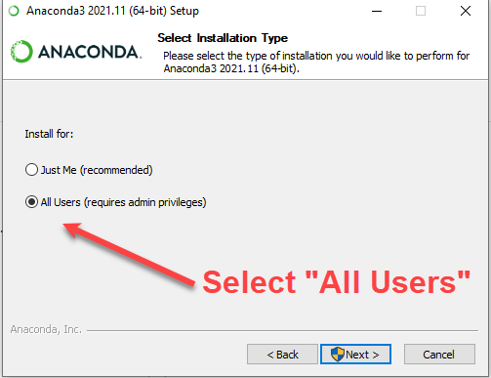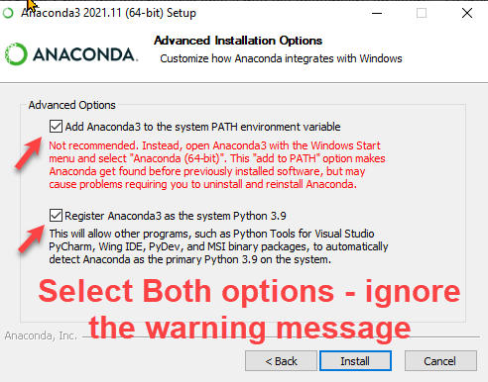

After successfully installing Anaconda –
- navigate to c:/ProgramData/Anaconda3 using Windows Explorer and create a new subfolder “Photometry” – e.g. c:/ProgramData/Anaconda3/Photometry.
- Copy the two files downloaded earlier - TG_V6.8.pyw and M67_T17_20140330_Photometry_Demo_instrument_mags.txt - into the Photometry folder.
- Create a desktop icon to start the program by navigating to the TG_V6.8.pyw file in c:/ProgramData/Anaconda3/Photometry; right-click on the file name, and select “Send to” > "Desktop (create shortcut)".
- Double click the icon to start the program.
If Windows requests you identify what program to use to execute TG_V6.8.pyw, navigate and select c:/ProgramData/Anaconda3/pythonw.exe. You will need to scroll down all the installed apps and at the bottom, select the option to open Explorer where you can navigate to the c:/ProgramData/Anaconda3 folder and select pythonw.exe. The program you select is automatically used in the future. FYI, when you start the program with the icon the first time, it may take 15-30 seconds to start – be patient.
If TG has not started, use this approach:
- open Anaconda Navigator
- launch Spyder
- Navigate to TG_V6.8.pyw in the photometry folder and open it.
- “Run” the program

For operational details see the TransformGenerator_V6.4_Users Guide. All information in the Users Guide also applies to this version 6.8.

Mac Installation Instructions
Download Required Files
Download this zip file (TG_V6.8_InstallationFiles.zip) containing two files:
- TG_V6.8.pyw – the program file
- M67_T17_20140330_Photometry_Demo_instrument_mags.txt - a demonstration instrument magnitude measurement file
Updating an existing TG installation: If you previously installed TG, updating to V6.8 only requires you copy the TG_V6.8.pyw file into the Photometry folder. Then create a new desktop icon for the Mac. Refer to the paper Create Mac Icon to Start TransformGenerator.pdf . Also, note it can take over 15 seconds to launch the program. Please be patient.
Installing into Existing Python Installations: There are many different Python installation alternatives – not fully compatible with each other. If you have one installed, try to run TG in that environment. If it does not run successfully, the best approach is probably to do a clean installation using the Anaconda environment below.
New Installations: TG runs with the standard Python suite known as Anaconda. Download this version of the Anaconda installer - https://repo.anaconda.com/archive/Anaconda3-2019.10-MacOSX-x86_64.pkg. (Note: This is not the current version of Anaconda because there is an incompatibility with the more recent Anaconda versions.). Run the install program by double clicking the downloaded .pkg file. Be patient, on my admittedly old machine, it took over a minute for the install window to appear. Accept all defaults
The Anaconda3 folder will be placed on the Macintosh HD in your user folder. This is what it looks like in Finder –

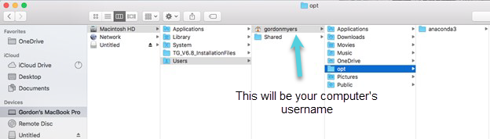

After successful installation of Anaconda, navigate to /Anaconda3 using Finder and create a new folder “Photometry” – e.g. /Anaconda3/Photometry. Copy the program TG_V6.8.pyw and the demonstration file M67_T17_20140330_Photometry_Demo_instrument_mags.txt into the Photometry folder.
Finder should now show this:
Here are the left and right half screen shots for readability –
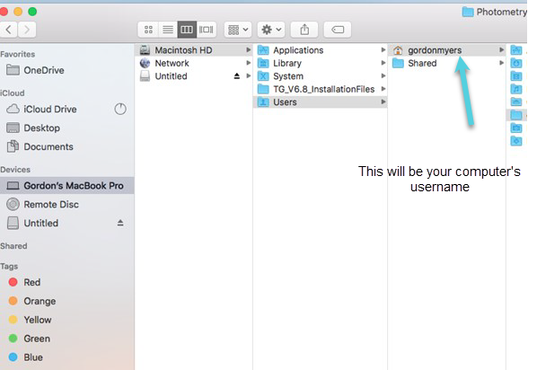

Creating a new desktop icon for the Mac takes a little extra work. Refer to the paper Create Mac Icon to Start TransformGenerator.pdf. On the detailed instructions, change TG_V6.4.pyw to TG_V6.8.pyw. The icon to start the program will be shown in the LaunchPad. Note it can take over 15 seconds to launch the program.
For operational details see the TransformGeneratorUsersGuide.

Release History

Version 6.8 – Maintenance and New Capabilities
- Eliminated software security check causing a “Could Not Access the AAVSO Website” error message
- Increased default size of plots

Version 6.6 – New Capabilities
- Create additional transform coefficient Tbr, Tbi, Tb_br, Tb_bi
- Support the changes coming in VPhot photometry reports, the additional Max column

Version 6.4 – New Capabilities
- Added support for Landolt Fields

Version 6.3 – Maintenance and New Capabilities
- Added support for Melotte 111
- Enabled both Python 2.7 and Python 3.x
- Tested with most recent versions of Anaconda (v. 5.0.1) using both Python 2.7 and 3.6 on both Windows and Mac
- Tested with latest Mac OSX release - High Sierra

Version 6.0 – Maintenance and New Capabilities
- Added support for NGC 1252 and NGC 3532
- Error fixes
  - Correction to properly handle multiple VPHOT files containing both “True” and “False” measurements of the same star (usually caused when stars are saturated in some images and not others).
  - Correction causing some bright standard stars (brighter than 10th magnitude) to be excluded from calculations

Version 5.10 – Maintenance and New Capabilities
- Added Support for M11 standards field
- Changed 3 sigma error lines on plots (which had been based on the Transform slope error) to 2 sigma error lines (based on the “y axis” variance between measurements and the linear transform fit.) This gives the lines more physical meaning – in theory 95% of all measurements will be within this 2 sigma error band.
- Error fixes
  - corrected calculation of the error associated with color transforms
  - “Original Fit 3 sigma” line on plots changed to “All Measurements 2 sigma” line. Users see the 2 sigma error line calculated using all measurements (e.g. both active and inactive). (In addition the error lines calculated using only the currently active measurements are displayed).

Version 5.8 – Maintenance Release (Required Update)
- TG internal software changed to support new VSP API. This is a mandatory update. Previous TG versions will not run when the new VSP is released (within a few weeks of mid-August, 2015).

Version 5.7 – Maintenance Release and Mac OS X (v.10.10) Yosemite Support
- Fix problem with deletion of saved transform
- Support Mac OS X (v.10.10) Yosemite release

Version 5.6 – Maintenance Release
- Star add/delete label on plots corrected
- Error randomly causing one observation not to be included in transform corrected
- Description in header of .ini export file enhanced

Version 5.5 – New Capabilities Release
- Addition of 3 sigma error lines on transform plot
- Addition of scrollbars to main menus

User's Guide
The User's Guide is available here: TransformGenerator V6.4 Users Guide

Further Reading
- Applying Transformation & Extinction to Magnitude Estimates - How Much Does it Improve Results (pptx 1.1MB)
- AAVSO CCD Photometry Guide
- AAVSO DSLR Observing Manual

Acknowledgements
Transform Generator (TG) was conceived and written by AAVSO member/observer Gordon Myers in response to a need for an easy-to-use program which aids observers computing their transformation coefficients. Ken Menzies, George Silvis, Richard Sabo and Matt Craig provided valuable advice and testing of the program.

Contact Information
Send questions and comments to Gordon Myers - gordonmyers @ hotmail.com

