Testing VStar

Introduction 1
Unit Testing 1
System Testing 1
Scenario: General Tour 2
Scenario: Saving and Printing 11
Scenario: Loading from the AAVSO International Database 11
Scenario: Polynomial Fit 11
Scenario: Response to Erroneous Input 11
Scenario: Installing and Using an Observation Source Plug-in 11

Introduction
There are two main types of testing necessary for an application such as VStar: unit testing and system testing.

Unit Testing
VStar contains a set of so-called unit tests that can be run via ant test (see build.xml at the top-level of the VStar distribution available from SourceForge: http://vstar.svn.sourceforge.net/viewvc/vstar/trunk/test/?pathrev=671) to determine whether key modules (Java classes) and functionality work and continue to work over time in the face of changes to the code base. The ability to perform such regression testing provides some confidence in the health of VStar’s code base and allows the code to be modified without fear. If a unit test fails after a change is made, the test itself can help to debug the cause of the problem.
There are many more unit tests that could be written to improve code coverage, and anyone interested in writing unit tests for VStar should put their hand up.

System Testing
As important as unit testing is, it is no substitute for GUI or system testing. In the case of VStar, this is something that has been done in a very ad hoc way, usually just before a release.
The strategy in future releases is to first make a WebStart release available to the Citizen Sky VStar Software Development Team. After a period of system testing by team members, the version will be deployed to the broader AAVSO community.
The focus of this document is to set out some system testing scenarios. For a new version of VStar, please choose one or more scenarios and test VStar against it, reporting any problems you find to the Citizen Sky VStar Team forum or to me (dbenn@computer.org). The forum is better, especially if more than one person finds the same bug.
Some scenarios make use of 5 star analysis tutorial data files (hereafter referred to as “5-star file”. You can obtain 5star-data-files.zip from SourceForge: https://sourceforge.net/projects/vstar/files/
The test scenarios are, to some extent, meant only as guides. I would recommend initially following them mechanically, later coming up with your own variations. There is value in simple repetition, from a regression viewpoint, i.e. to answer the question: has anything broken/changed/been fixed since the last time I did this?
If you would like to contribute scenarios to this document, please do so either via the Citizen Sky VStar Team forum or via email.
Of course, you should also carry out any other kind of testing you desire. Try to break VStar! The change log:
http://vstar.svn.sourceforge.net/viewvc/vstar/trunk/ChangeLog.txt?revision=671&view=markup&pathrev=671
is updated for each release, and provides a good indication of new features and bug fixes that need testing over and above the scenarios below.

Scenario: General Tour
This scenario takes a broad approach to testing key VStar features.
- Select New Star from File from the File menu or toolbar.
- Open the 5-star file lx_cyg_2439800_2447500.csv
- Select Information from the File menu or toolbar. The opened dialog should look like this:
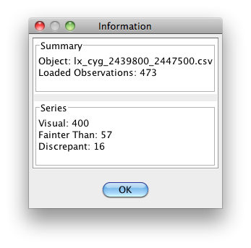
- Select the Mean Plot tab. Unselect Error bars? and Join means? check-boxes. The mean plot should look like this:
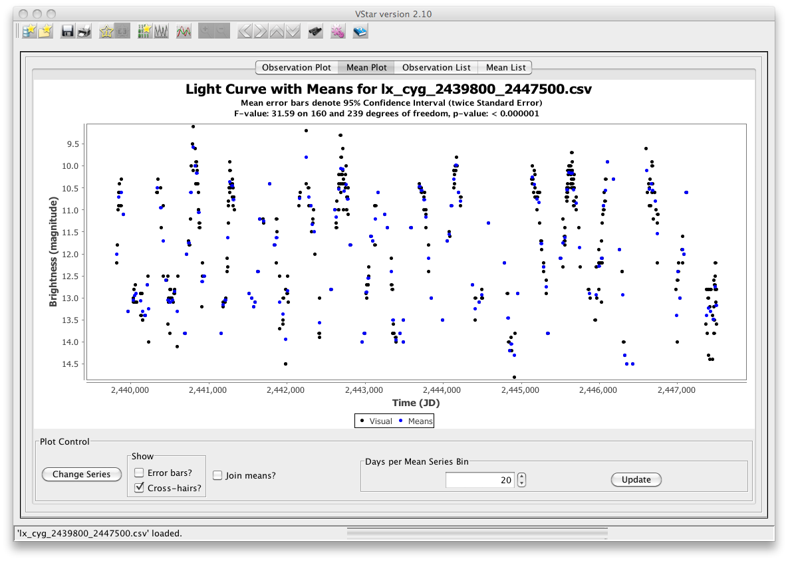
- Select the Observation List tab. Select the row whose Julian Day is 2440130.6. This is what you should see:
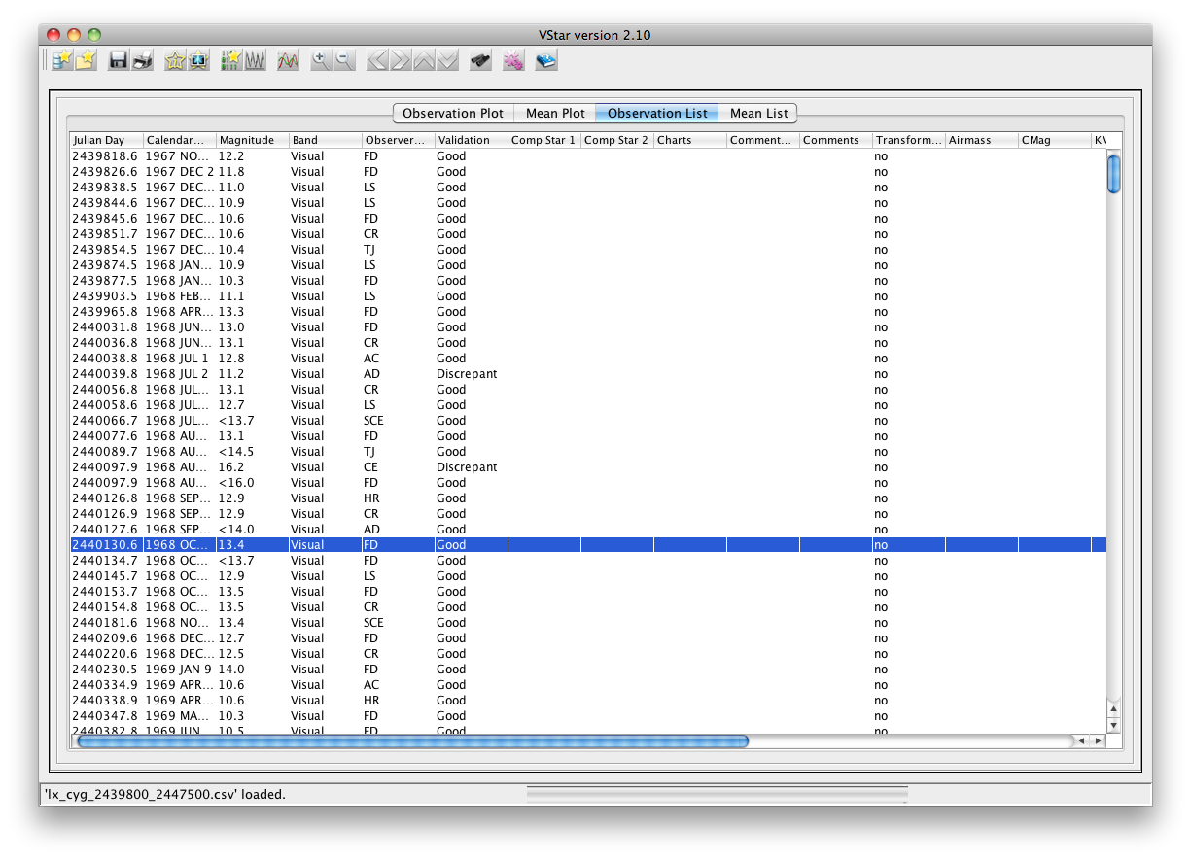
- Notice that the observation details and zoom toolbar buttons and View menu items are now active but were not before the selection.
- Select the Observation Plot tab. The cross-hair should be on the observation whose Julian Day is 2440130.6, as follows:
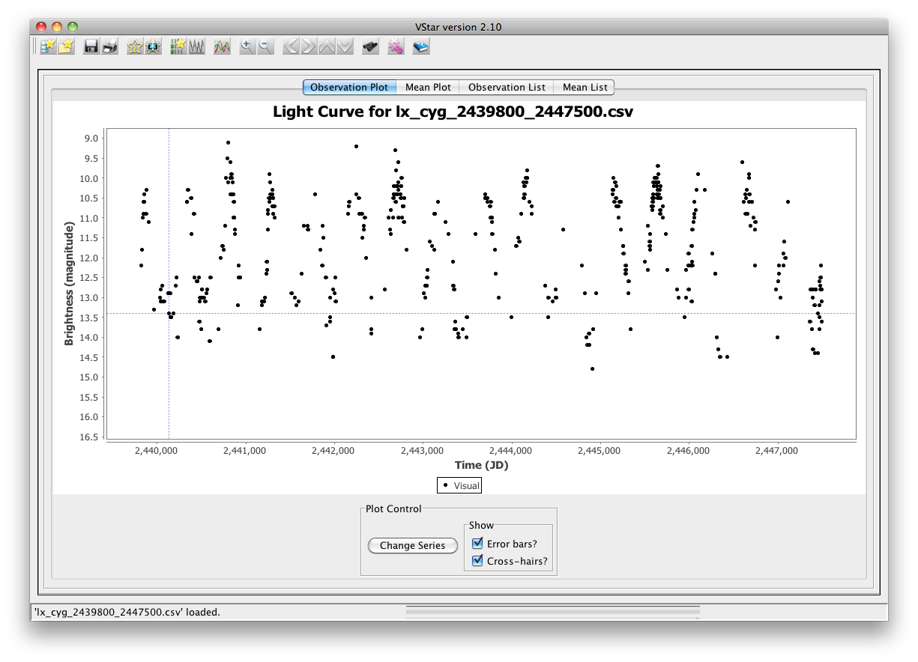
- Select the Observation Details View menu item or toolbar button. The dialog should look like this:
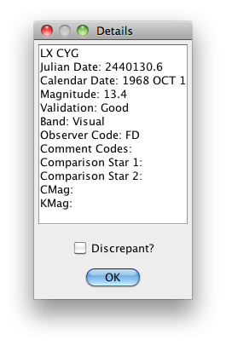
- Close this dialog, then:
  - Select another data point in the Observation Plot by clicking once with the mouse elsewhere on the plot.
  - Compare the result of opening the Observation Details dialog via this view and via the Observation List tab; they should be identical. Hint: you can have multiple Observation Details dialogs open at once.
  - Check that the selected row in the Observation List contains information that is consistent with the data point selected in the Observation Plot view.
- Carry out similar operations using the Mean Plot and Mean List views.
- Select the Observation Plot view and select a data point somewhere near the middle.
- Use the toolbar zoom buttons to zoom in a few steps, then back out again.
- Zoom in a few steps and use the left, right, up, and down pan arrow keys to ensure you can view parts of the plot “hidden” by the zoom operation.
- Open the filter dialog via the toolbar “binoculars” button or the View menu item. Select an observer code matcher and select the “Use selected observation?” checkbox. Depending upon which star the cross hairs are on, the filter dialog should look like this, possibly with a different observer code:
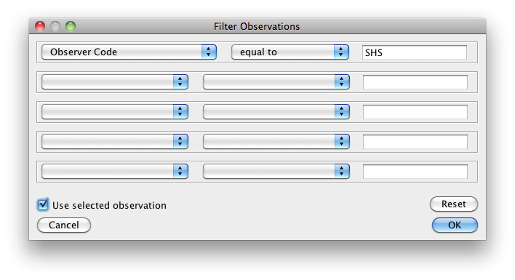
- Click the OK button. A new series should appear, showing all data points made by the observer corresponding to the data point under the cross hair.
- Click the Change Series button near the bottom of the Observation Plot view, deselecting all but the Filtered series, so that only the filtered observations appear, like this:
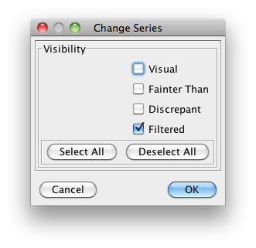
- Open the filter dialog again and add another matcher, such as magnitude, and an operator such as “less than”:
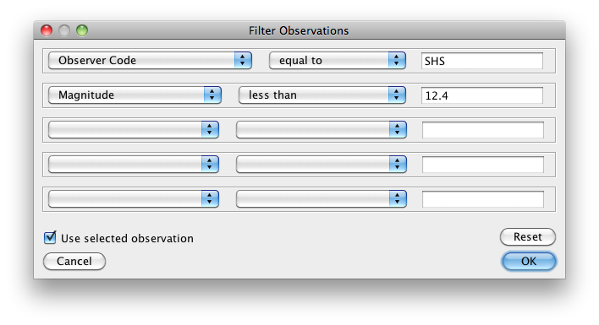
- Check that the Observation Plot and Observation List views match what you would expect, e.g. for the filtering operation above:
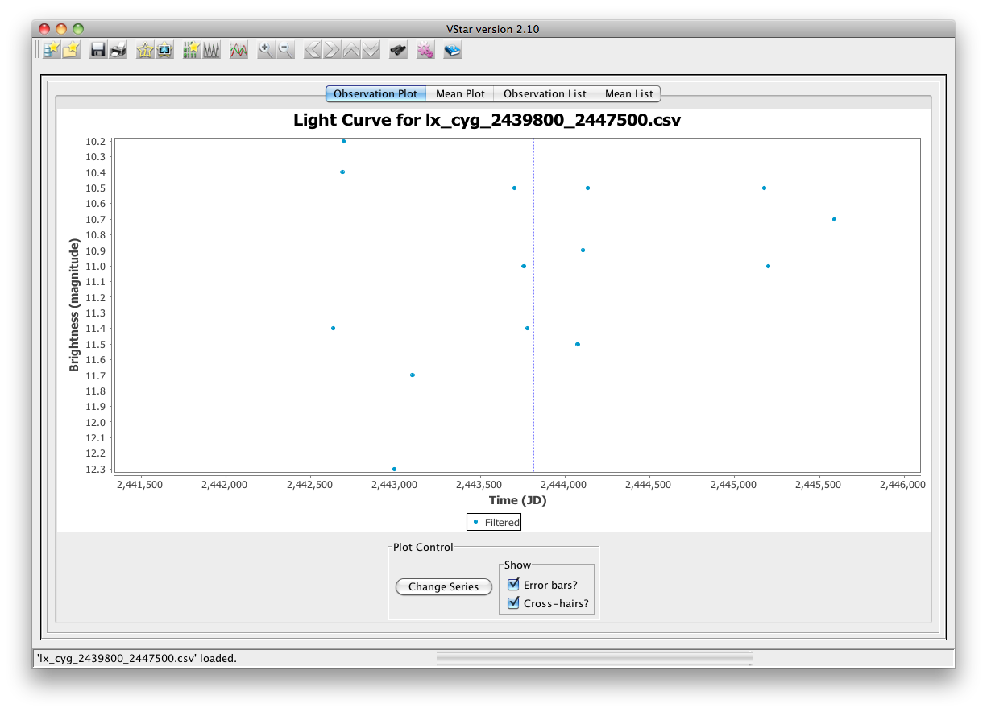
- Repeat similar operations with different 5-star files.
- Open the Preferences dialog and change the color of the Filtered series, ensuring that the Observation Plot view updates accordingly after clicking the Apply or OK buttons. The following shows an example Preferences setting change for the Filtered series.

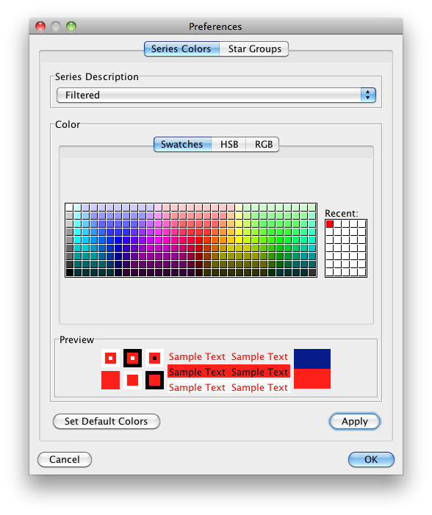
- Negate the filter by selecting No Filter from the View menu.
- Right-click (or ctrl-click on Mac OS X …) on the Observation Plot and select Auto Range ▶ Both Axes (or zoom out if you prefer) to see all the data points.
- Select Date Compensated DFT… from the Period Search sub-menu of the Anaysis menu.
- Accept the default parameters in the dialog box that opens by clicking OK.
- From the Top Hits tab of the resulting dialog box, select the row with the highest power value, like this:
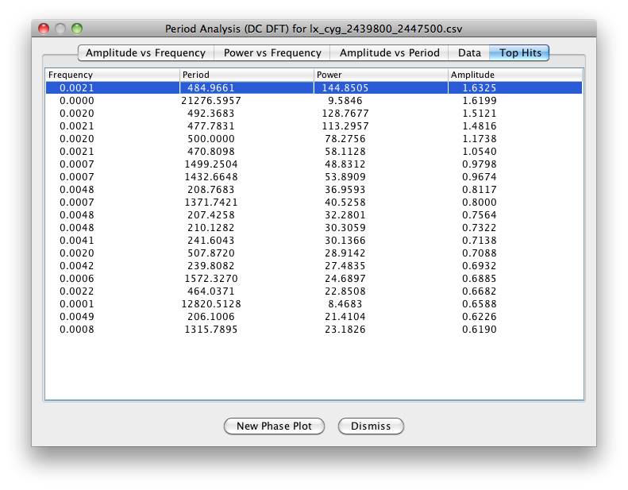
- Notice that before selecting this row, the New Phase Plot button was disabled. Now that it is enabled, click that button. Accept the period and epoch values in the Phase Plot dialog box that opens next by clicking OK.
- Dismissing the period analysis dialog box, you should see a phase plot like this:
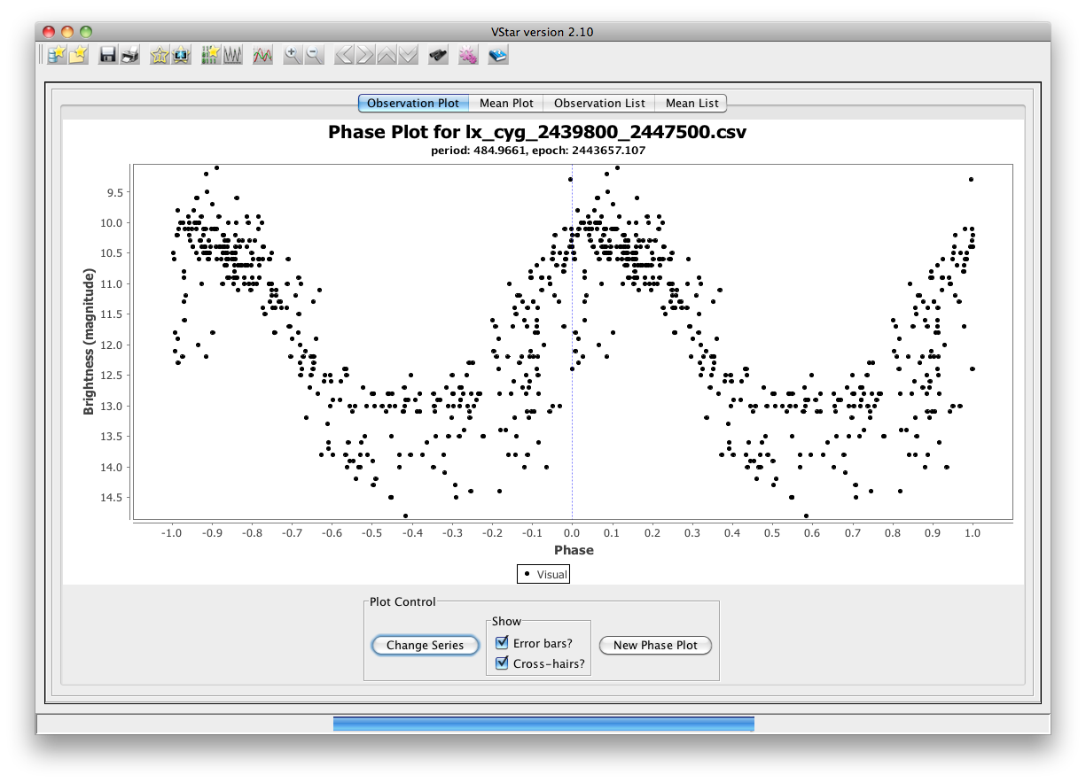
- The Mean Plot view should look like this:
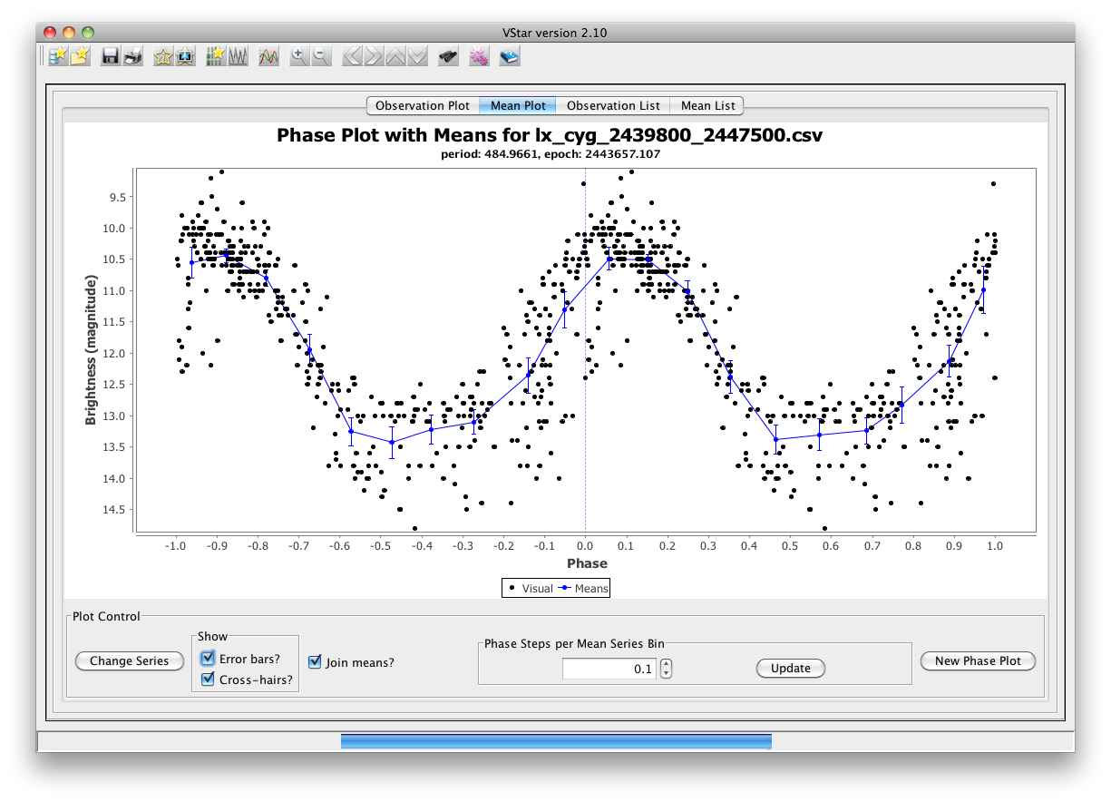
- Select the Raw View and Phase Plot buttons in the toolbar to switch between analysis modes.
- Try opening observation detail dialogs for selected phase plot view data points.
- Quit VStar either via the menu item or by closing the window itself.

Scenario: Saving and Printing

Scenario: Loading from the AAVSO International Database

Scenario: Polynomial Fit

Scenario: Response to Erroneous Input

Scenario: Installing and Using an Observation Source Plug-in

Scenario: Star Group Management

