Instruction for using the SuperWASP FITS file VStar plugin (v2)

SuperWASP data can be downloaded via the site https://wasp.cerit-sc.cz/form

To get a light curve, enter object coordinates, the search radius and click [Search].
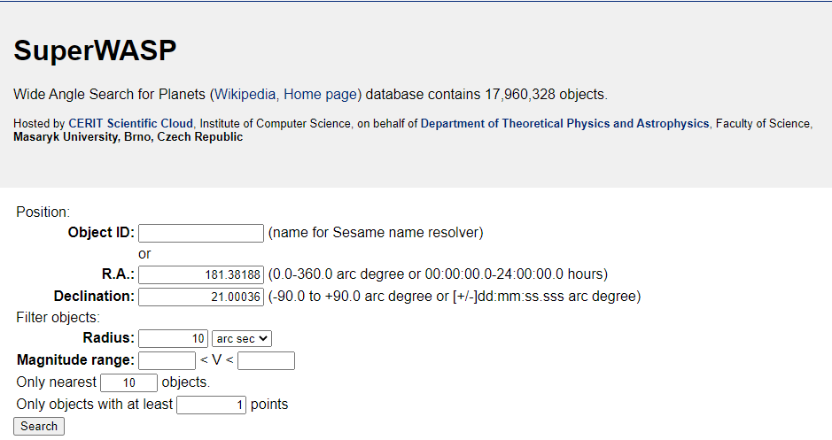

Data are available in two formats: FITS and CSV:
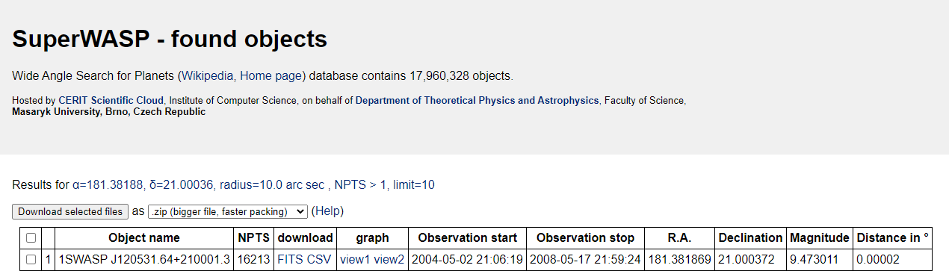

The plugin reads the FITS version of the data.
After downloading a FITS file, open it using VStar (select ‘SuperWASP FITS v2’ source):
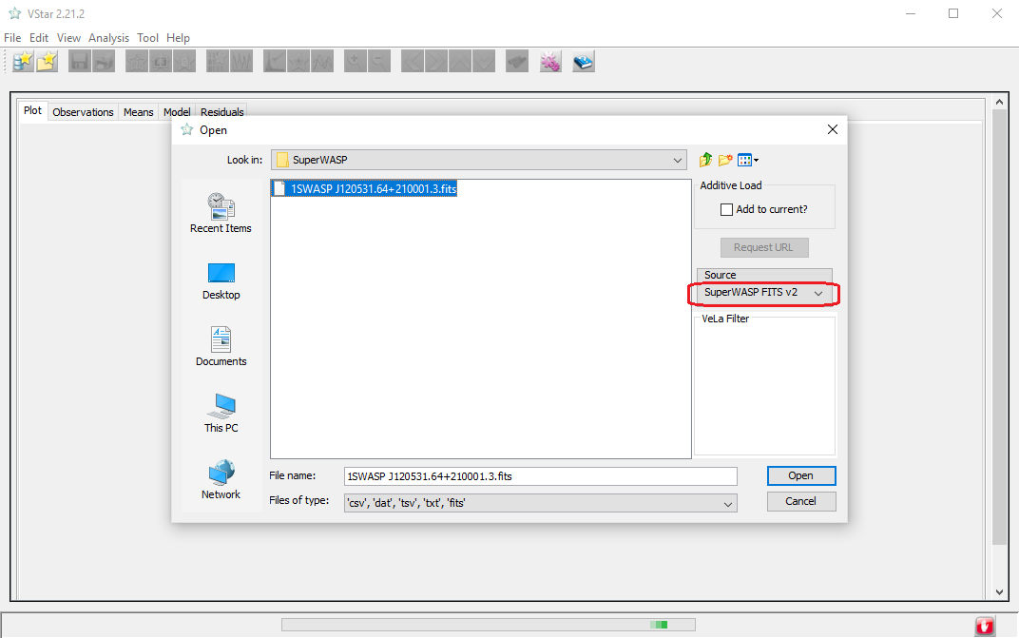

Before opening, the plugin asks for a maximum magnitude error allowed and for a version of the data:
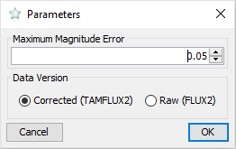

There are two versions of data in the SuperWASP FITS file: FLUX2 and TAMFLUX2 (https://exoplanetarchive.ipac.caltech.edu/docs/SuperWASPProcessing.html). The first data set is ‘raw’, the second one is ‘corrected’ (TAMFLUX2 = ‘SYSREM corrected fluxes’, see above link for details). Corrected data set is identical to the CSV version of SuperWASP data (see above).

After opening, VStar shows observations having an error that exceeds the specified limit as ‘excluded’:
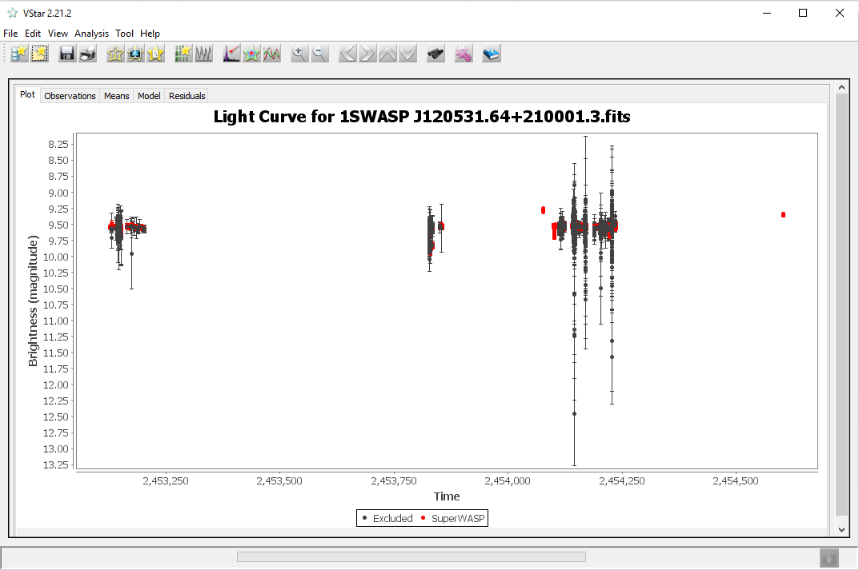

Use ‘Plot Control..’ menu (or toolbar) command to hide them:
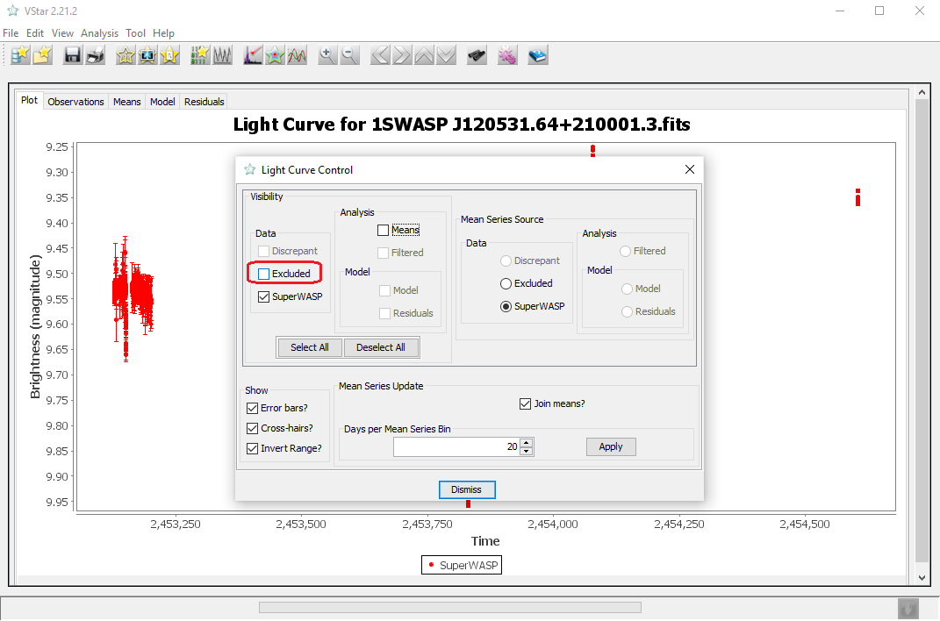

The star used in this example is an eclipsing variable with a period of 15.0821 days:
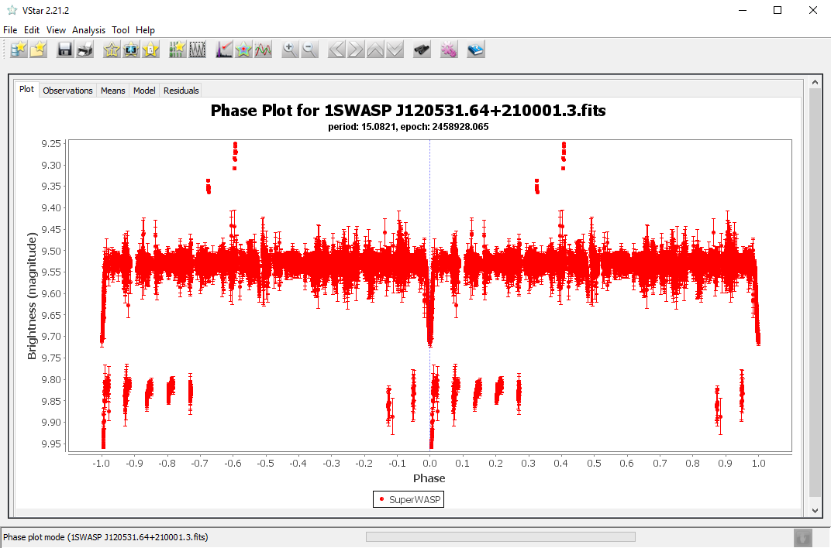

Maksym Pyatnytskyy, PMAK
Rev A
2020-10-23

Revision History

Rev | Date | Description
A | 2020-10-23 | Initial Release

