VStar Retrieval of Gaia Variable Star Light Curve Data

This plugin allows you to read light curve data for any of the Gaia DR2/DR3 stars that were identified by Gaia processing as variable and therefore have photometry available. Data are accessed directly from the Gaia web service. The passbands can either be the Gaia red (RP), green (G) and blue (BP) or they can be transformed to V, Rc, Ic.

Gaia Mission
Gaia is a spacecraft launched by the European Space Agency (ESA) to measure the positions and distances to stars. The Gaia coverage includes the entire sky from magnitude 5 to 20. In 2022 the project has made its third data release, known as Gaia Data Release 3 (DR3).
Gaia captures photometry in three passbands, shown graphically here, and described in detail in the paper Gaia Data Release 2 Photometric content and validation. As part of the processing pipeline, Gaia identifies sources that appear to be variable using a set of machine learning algorithms. Currently (on Apr 2th 2023) the “Gaia Data Release 3 (Gaia DR3) Part 4 Variability” catalog contains 11754237 sources (records).

Obtaining Gaia source_id
Each Gaia star is identified by a unique key, the source_id. The Gaia archive is available for interactive and programmatic access with a well-documented set of interfaces. The Help link provides access to a number of tutorials. Only the simple query interface will be discussed here.
Consider the classical Cepheid, XX Mon. From the Gaia archive page, click Search to go to the basic query screen and enter XX Mon in the name field.
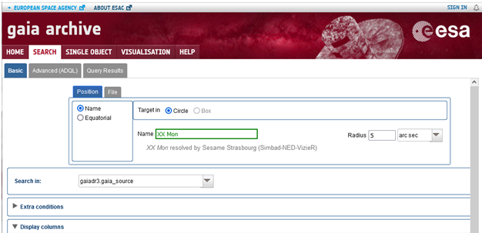
Then open the Display columns section and select the phot_variable_flag column. This will allow you to determine if Gaia has identified this star as variable and therefore has light curve data available.

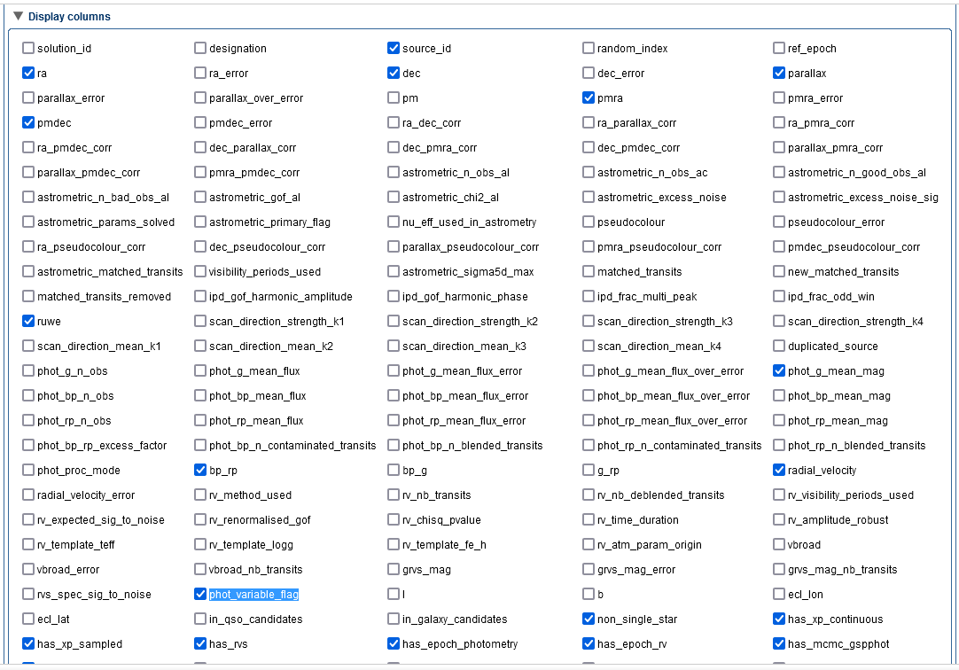
Submit the query and you will see the row of data from the main Gaia table. Make sure the phot_variable_flag says “VARIABLE”.
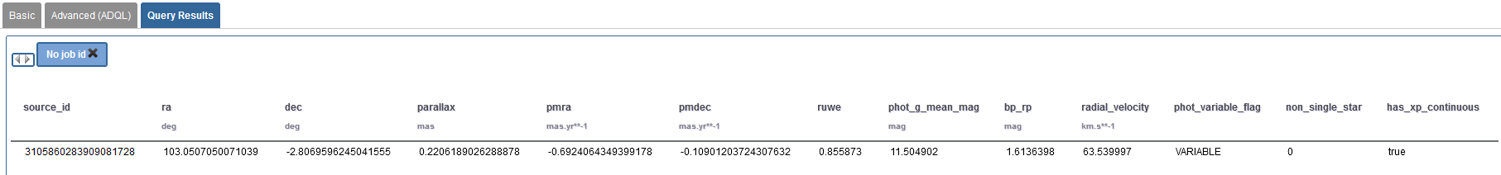

Make note the source_id or copy it to the clipboard.
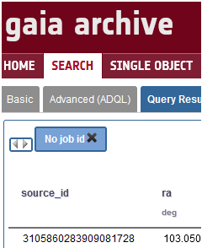
A more advanced approach might do a proximity search using equatorial coordinates and specifying the variable flag equal to “VARIABLE” in the Extra Conditions section.

Using the Gaia Plugin
The Gaia plugin is installed like any other as described here.
Select “New star from Gaia DR2/DR3 Photometry” on the VStar file menu to open the dialog box.
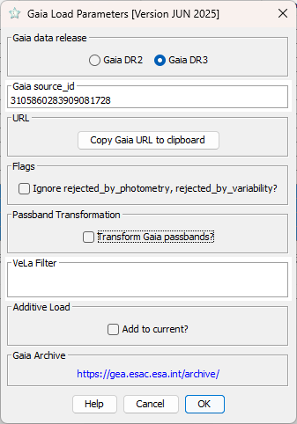
Enter the source_id you obtained from the Gaia Archive. By default, the Gaia passbands will be represented in VStar as Blue, Green and Red for Gaia’s BP, G and RP, respectively. If you would rather have the passbands transformed to V, Rc, Ic, and B check the Passband Transformation box.
For the Gaia DR2 data, the transformation equations from https://arxiv.org/pdf/1804.09368 (Appendix A) are used. For Gaia DR3, the relations from https://gea.esac.esa.int/archive/documentation/GDR3/Data_processing/chap_cu5pho/cu5pho_sec_photSystem/cu5pho_ssec_photRelations.html are applied.
You can also choose to add the light curve data to the existing VStar observations by checking the Additive Load box.
In order to transform the Gaia passbands, three observations in the Gaia passbands closely spaced in time must exist. Therefore, if transformation is selected, Gaia observations that do not occur in triples will be considered invalid and appear at the bottom of the VStar Observations tab. The Gaia variability processing may have marked some observations in the light curve as rejected for processing with the variability machine algorithms. These will be marked as Discrepant in VStar and appear with a gray color. If transformation is selected and any one of the three observations involved in the transformation are discrepant, then all three of the resulting V, R and I observations will be marked discrepant.
The observation time from Gaia is Barycentric Julian Date (BJD).
The phase diagram with Gaia DR3 data for the XX Mon is shown below:
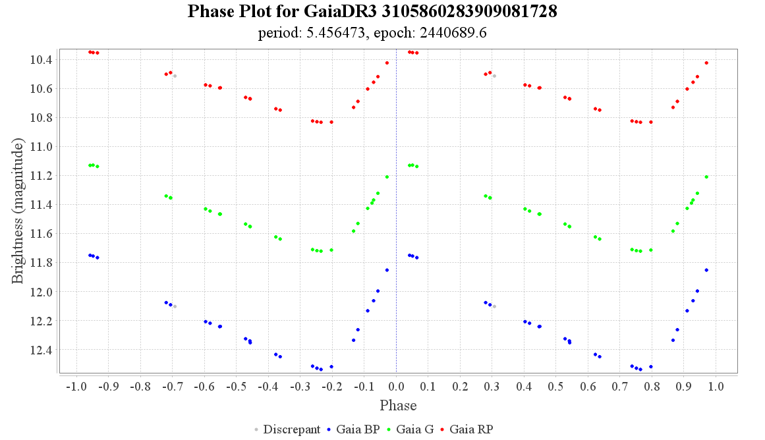

Advanced Gaia Queries
You will likely want to perform more advanced queries against the Gaia DR3. The Advanced (ADQL) tab of the Gaia Archive provides access not only to the main Gaia table, but the tables created by the variability processing as well.
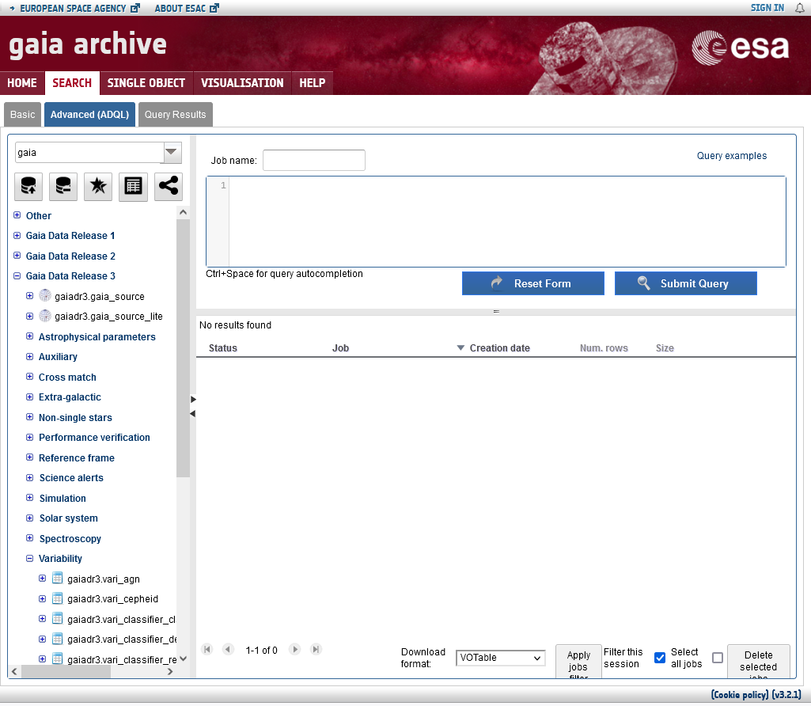
You can expand these tables to see the columns and data descriptions are easily accessed from here as well.

Rev | Date | Description
C | 2025-06-17 | Updated according to the last plugin’s release (PMAK)
B | 2023-04-02 | Updated according to the last plugin’s release (PMAK)
A | 2020-11-01 | Initial release (Cliff Kotnik)

Transformation to the B band is only possible for Gaia DR3.

