Introduction
VStar is a free, open source, multi-platform application for visualizing and analyzing time-series data. It is primarily intended for use with variable star data, but any data that can be represented in terms of a Julian Date and magnitude (or other numerical values) is suitable.

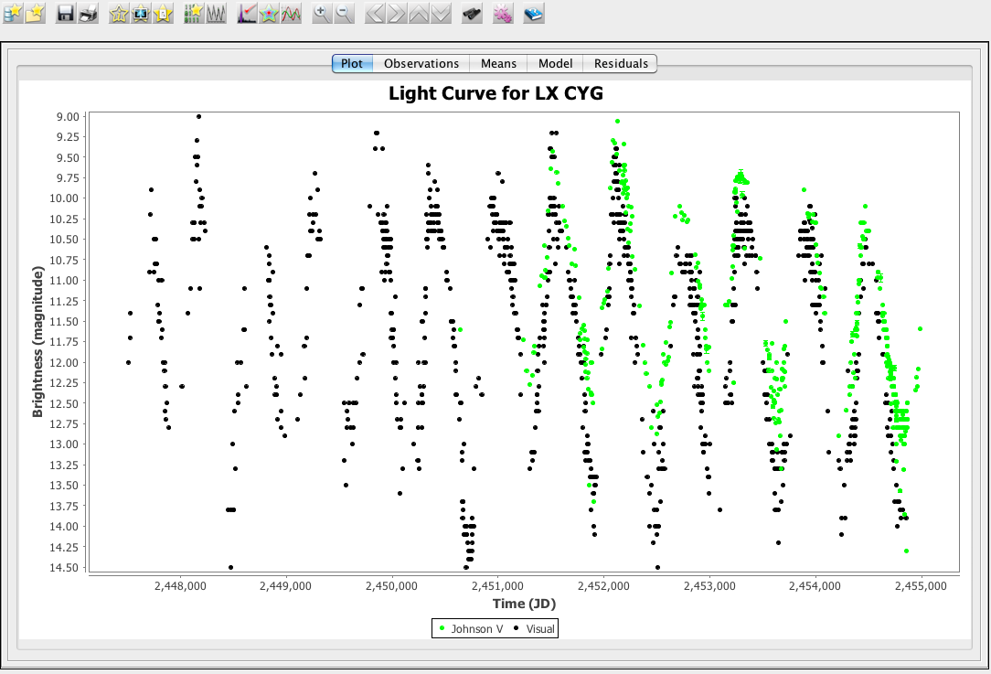

The following figure shows that VStar is able to load observations from a variety of sources, including the AAVSO International Database (AID), files, and other sources (such as http streams). The Observation Sources section describes what kinds of data can be loaded into VStar and from what sources.

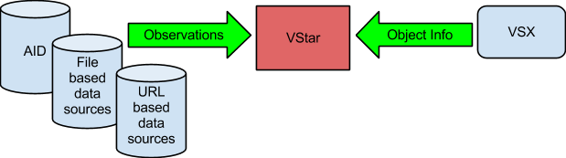

When in “online mode” (loading from AID), VStar also requests information from the Variable Star Index (VSX) about the requested object, such as period, variable type, spectral type and discoverer.

VStar allows data to be viewed and filtered via plots or tables. The details of each observation can be viewed individually or in tabular form. Data and plots can be saved or printed. A mean plot can counteract the effect of noise in data and provide an indication of the extent of signal present.

Phase plots can be created, assuming a certain period, revealing the shape of a star’s light curve in a way that a raw data plot may not.

Period analysis can be applied to reveal one or more periods in the data. Models can be created to represent the essence of a light curve and to subtract one or more periods from the data, the “residual data” being amenable to further analysis. Time-frequency analysis permits changes in period over time to be discovered.

VStar is written in the Java programming language, requiring at least version 1.6 to run on Windows, Mac OS X, Linux, and OpenSolaris. New functionality can be added via plug-ins (from a plug-in library) or can be written by anyone with knowledge of Java or other languages that target the Java Virtual Machine.

The following figure shows the main window’s toolbar and tabs.

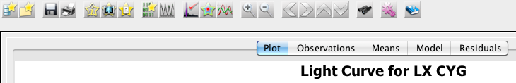

The two toolbar buttons below switch between “raw data mode” (or “raw mode” or “light curve mode”) and “phase plot mode” (or “phase mode”).

The tabs labeled Plot, Observations, Means, Model, and Residuals show the same data in different forms or reveal different facets of the underlying data.

In both raw and phase mode the Plot pane contains a multi-series plot of the loaded dataset along with any “synthetic” series, such as means, model, residuals, or filtered observations. Various attributes of the plot can be customized. See the Plot Pane section for more detail.

The Observations pane reflects the Plot pane in tabular form. It also provides the ability to search the data and create filtered subsets from search results or a manual selection of observations. See the Observation List section for more detail.

The remaining 3 panes – Means, Model, and Residuals – show “synthetic” data in simple tabular form.

The remainder of this document describes different aspects of VStar’s functionality. To learn more about the context in which VStar was developed, see Benn (2012).

Note that user interface screenshots of components such as file choosers, dialogs and windows were taken from VStar running on Mac OS X and will differ from other operating systems such as Windows and Linux.

