Preferences

VStar allows some aspects of its functionality to be customized, for example:

- The color and size of observations in a series as they appear on a plot.
- The precision of numbers, i.e. the number of decimal places.
- The objects that appear in the Load from AAVSO International Database (AID) dialog.
- Plug-in and Locale settings.

To open the Preferences dialog, select the File → Preferences... menu item or the corresponding toolbar button.

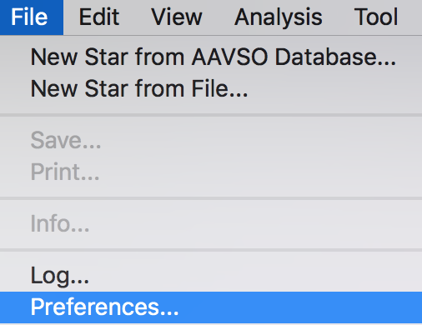
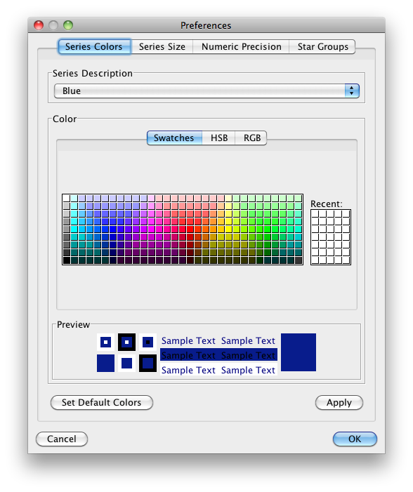
The first tabbed pane shown above controls the color of a series observation as it appears on a plot. The series is selected from a list and the color selected. Clicking the Apply or OK buttons confirms the color change. Like all preference settings, this change persists across VStar invocations. A change can be cancelled via the Cancel button. The Set Default Colors button resets all series colors back to their “factory settings.” This is particularly important for series colors since AAVSO defines a set of standard colors for many series. This does not include synthetic series such as Filtered, Model, Residuals, Means, Excluded.

The Series Size tab controls the size of a series observation as it appears on a plot. The series is selected from a list and the size selected from another list. Clicking the Apply or OK buttons confirms the size change. The Set Default Sizes button resets all series sizes back to their “factory settings.”
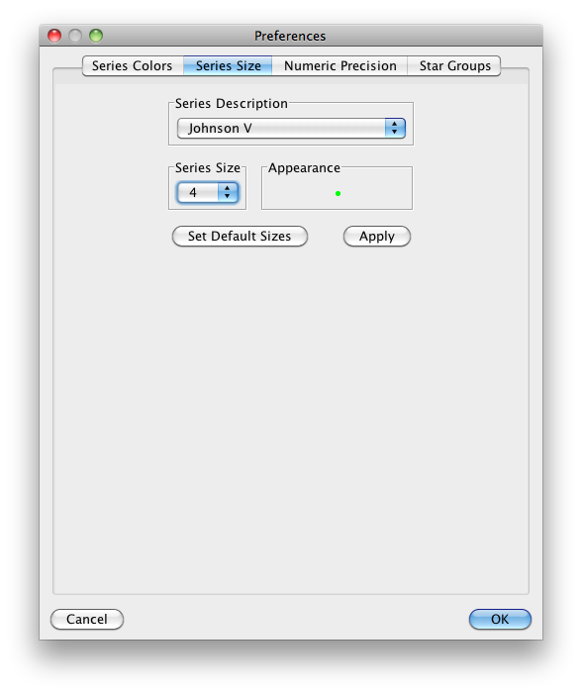
On a related note, while not part of VStar's Preferences, some other aspects of a plot can be configured (for the current VStar session only) by selecting Properties… from the context menu (e.g. by right-clicking on Windows, ctrl-click on Mac OS X):
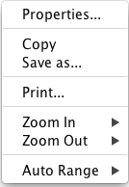 | 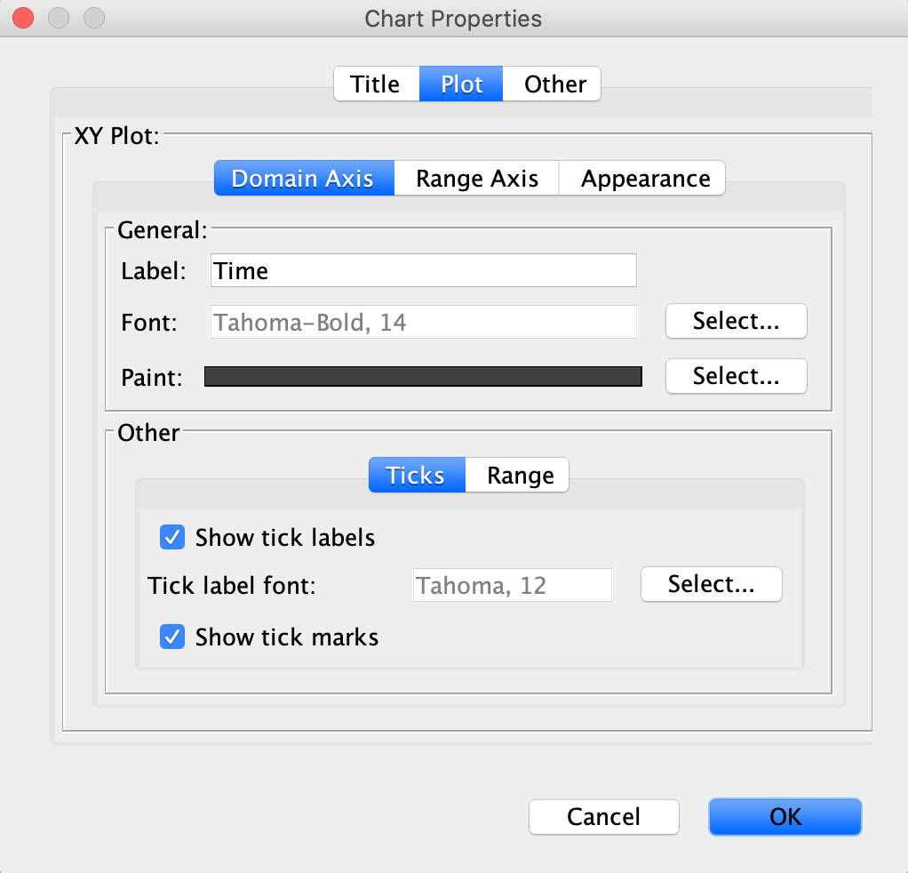

The Numeric Precision tab permits the number of decimal places to be customized for various categories of numeric values that appear as in VStar’s user interface, e.g. parameter dialog fields. The Set Default Precision Values button resets all precision values back to their “factory settings.”

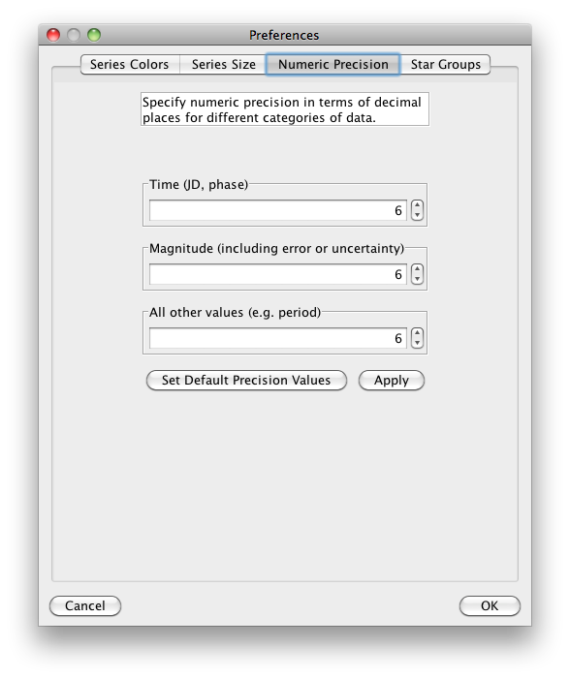
The Star Groups tab permits new groups of stars to be added to the dialog that opens when File → New Star from AAVSO Database… is selected.

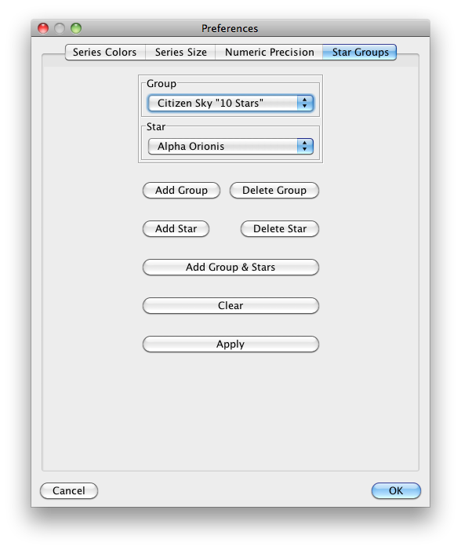
Suppose we want to add a new group for novae. To do so, click the Add Group button and enter the text “Novae” into the dialog, as shown.

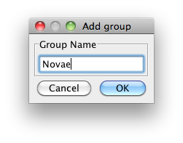
The Preferences dialog now shows an empty Novae group.

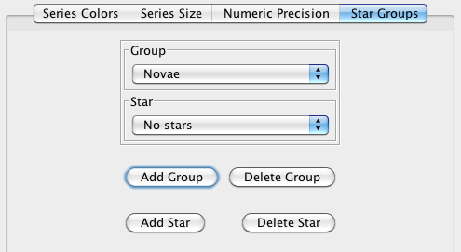
The next step is to click the Add Star button and enter the text “V0339 Del” into the dialog, as shown.
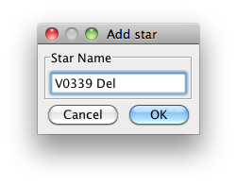
VStar will show the busy mouse cursor as it goes away to the Variable Star Index (VSX) to ask if this object exists. If so, it will be added to the group. The Group and Stars sections of the pane should now look like this:
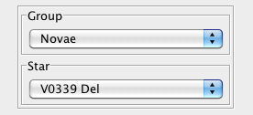

Click the Apply or OK button to save the change. Doing so will make the change available immediately and across VStar runs.

The Delete Star button deletes a star from the currently selected group.

The Delete Group button deletes the currently selected group.

Now suppose we want to add a new group with multiple stars all at once. To do so, click the Add Group & Stars button and populate the dialog that opens as shown:
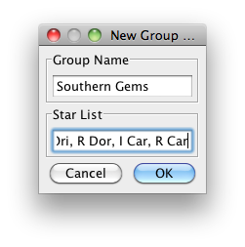
See the References and Further Reading section for details of “Southern Gems”. The Star List text to be entered is:

X Sgr, W Sgr, eta Aql, kap Pav, zet Phe, bet Dor, V Pup, alf Ori, R Dor, l Car, R Car

After each object has been checked (the busy mouse cursor will stop), click the Apply button to save the new group and its stars. Doing so will make the change available immediately and across VStar runs.

The New Star from AAVSO Database dialog will now have Novae and Southern Gems groups from which objects can be selected for loading.

The Clear button will set the groups back to “factory settings” (the Citizen Sky “10 Stars” group remains). As with all the other operations above, clicking the Apply or OK button will make the change available beyond the current run of VStar.

The Plug-in Settings preferences tab appears as follows:

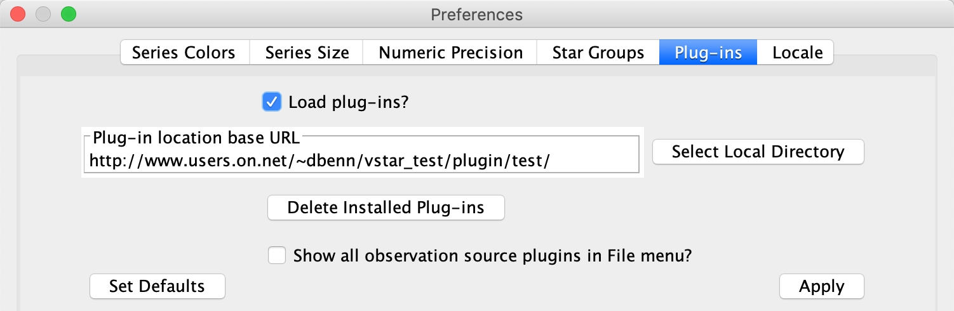
and it allows:

- plug-in loading to be controlled, i.e. whether or not to load plug-ins next time VStar is started;
- all locally installed plug-ins to be deleted;
- the plug-in location URL; changing this will cause plug-ins to be loaded from a different repository, even a local directory containing a .plugins.lst file, a vstar_plugins directory and a vstar_plugin_libs directory (see Select Local Directory button);
- all observation source plugins to be shown in the File menu instead of being selectable in the file load chooser; after the checkbox state has been changed, the new setting will only take effect after VStar is restarted.

The Locale settings tab allows the user to change the locale used by VStar, e.g. for menu and dialog item names and numeric format (comma vs period to denote a decimal point). Once selected, VStar must be restarted for the change to take effect.

