Fourier Model plug-in

The Fourier Model plug-in takes as input a series of observations and creates a model based upon one or more user-specified periods and one or more harmonics per period.

The Period Analysis section of the VStar user manual gives examples of Fourier model creation in conjunction with Date Compensated Discrete Fourier Transform (DCDFT). The plug-in allows models to be created independent of period analysis.

Suppose the following X Cyg data set (JD 2447000 to 2447960) is loaded into VStar:

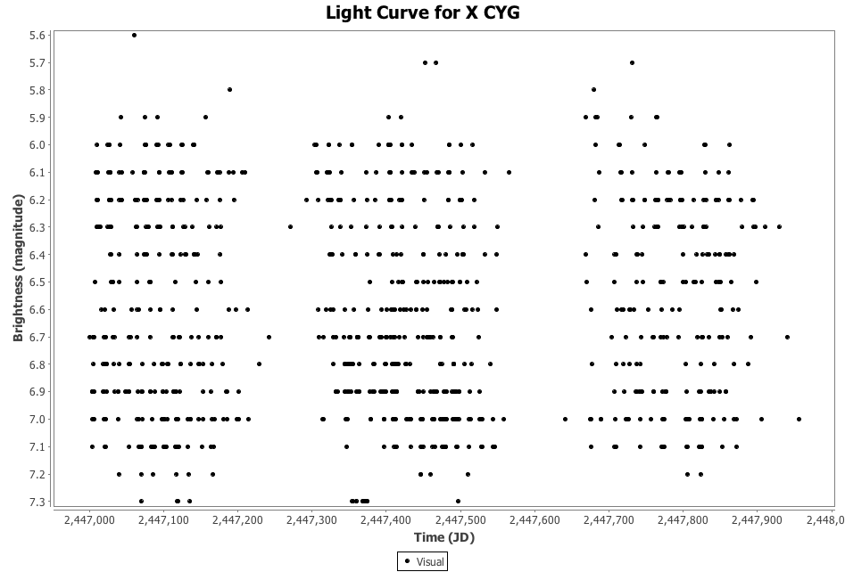
and suppose you know the period without having carried out a period search (e.g. by finding it in a publication or loading it from AID so the period is retrieved from VSX). A phase plot could be created with this known period via the Phase Plot item in the Analysis menu:

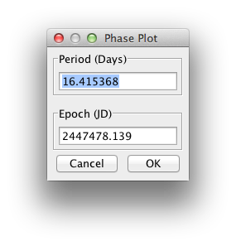
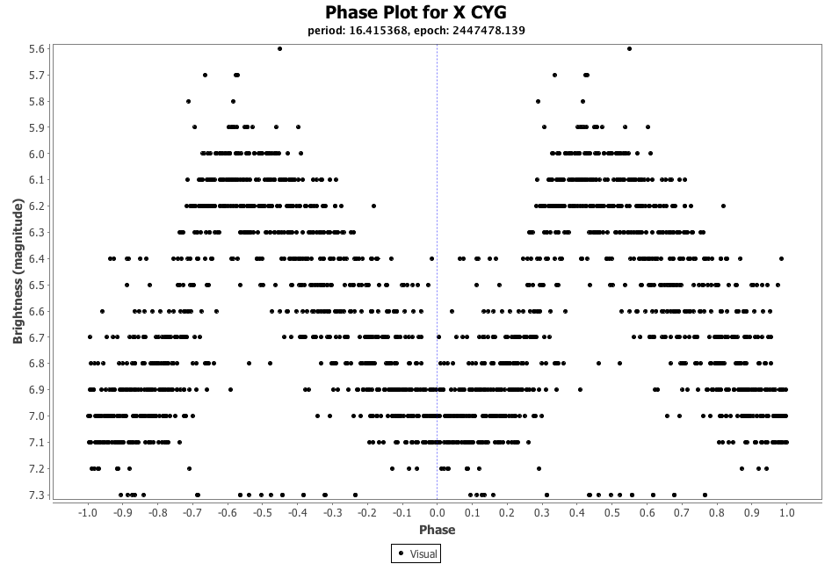
After installation of the plug-in via the Plug-in Manager item in the Tool menu, a model could be created via the Fourier Model item in the Analysis menu.

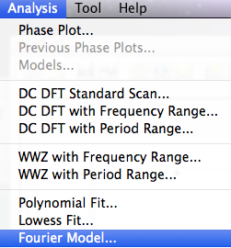
This yields a dialog requesting the series to be modelled, followed by another dialog requesting the number of periods to be used in the model:

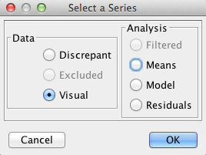

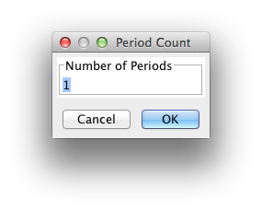
Accepting the default of 1 period and clicking OK results in the following dialog opening.

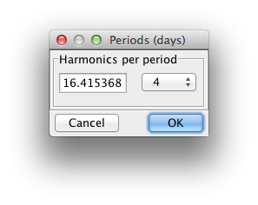
Note that this dialog can be resized to make the period text box larger if so desired.

The default period that appears in this dialog is 1 day. Replacing this value with 16.415368 as shown above, and selecting the desired number of harmonics (where the first harmonic is just the period itself), 4 in this case, creates a Fourier model and displays it on the plot.

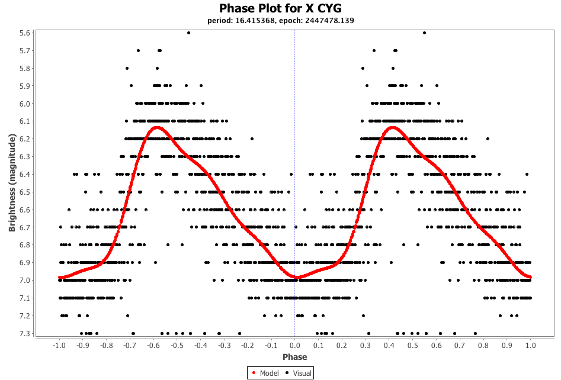
Note that it is not necessary to first create a phase plot. A Fourier model can be created while in raw or phase plot mode.

A model with more than one period can be created by specifying this in the Period Count dialog, e.g.
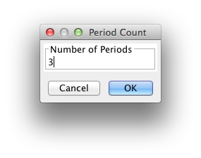
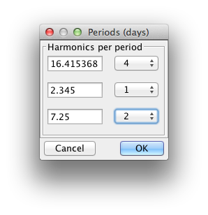
As with all models, the Model tab and Models dialog (see Analysis menu) can be consulted for additional details.

