Log

The File menu's Log... item opens a dialog that contains all log messages for the current session.
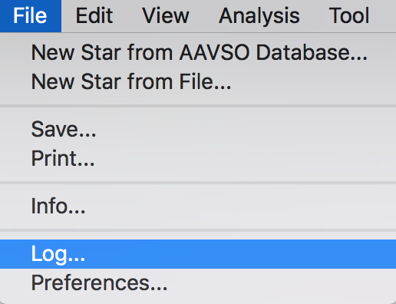
The dialog below shows a log entry that was generated when an attempt was made to load the target “eta Far” from the AID:

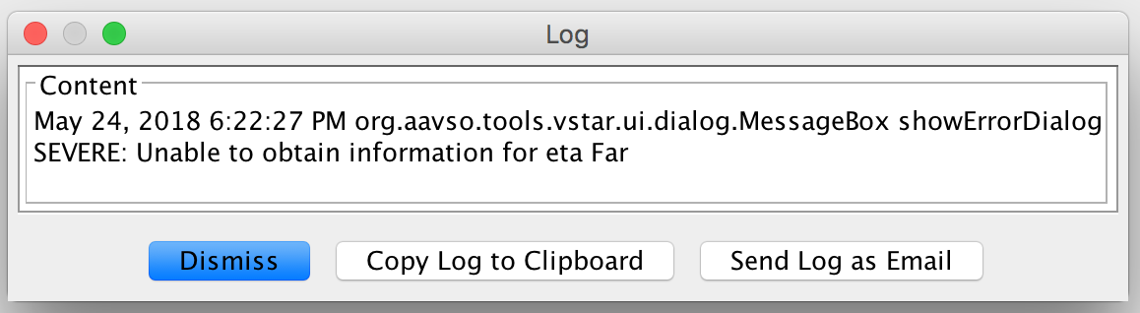
The log's content can be copied to the clipboard, allowing it to be pasted into a forum message or document. The log content can also be sent via email to AAVSO. The email message is prepared for sending by the default email application if possible, as shown below:

