VSX Query plug-in
The VSX Query plug-in shows variable star information taken from the VSX database. Additionally, it calculates ephemerides for periodic variables for any phase. This is convenient if someone wants to know ephemerides for the secondary eclipse of eclipsing binaries etc.
While loading data from AAVSO International Database (AID) via the “New Star from AAVSO Database” menu command, VStar gets the star’s information automatically, including a period and an epoch (for periodic variables) that can be directly used while building phase plots. Additional star’s parameters (such as variability type, spectral type, coordinates, etc.) are available via the “Info” dialog. In other cases, when data is loaded from a file or another data source, that information is not available directly from within VStar and should be searched using the VSX web portal (https://aavso.org/vsx/).
The VSQ query plugin allows the user to get the star’s information within VStar directly. When installed, the plugin is accessible through Tool->VSX Query command.
Let’s take as an example a star TIC 279236955. There is no data for it in AID (at the time of writing this document). There is ASAS-SN data from which we want to create a phase plot. Instead of opening an internet browser and searching via VSX portal we can launch the VSX Query plug-in and enter star’s identifier in the “VSX Name” field:
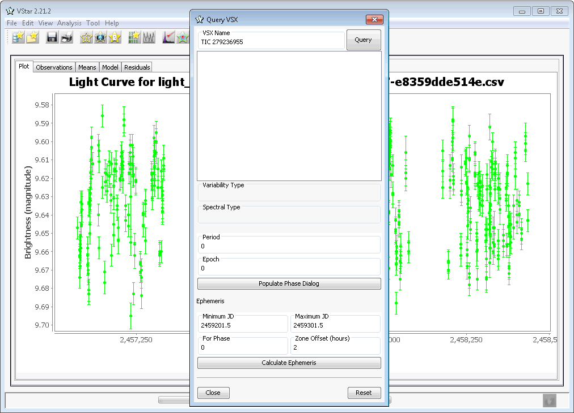

After clicking the [Query] button and waiting for several seconds (time depends on your internet connection and current load of VSX server) you should get the following information:
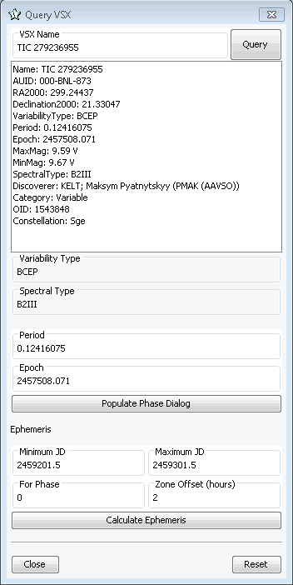

The star is periodic (the period and the epoch are in “Period” and “Epoch” fields respectively). There is no need to enter the period and the epoch manually in the “Phase Plot” dialog, just click the [Populate Phase Dialog] button. Then open Phase Dialog (via Analysis->Phase Plot… menu command). Period and Epoch fields should be already filled by respective values.
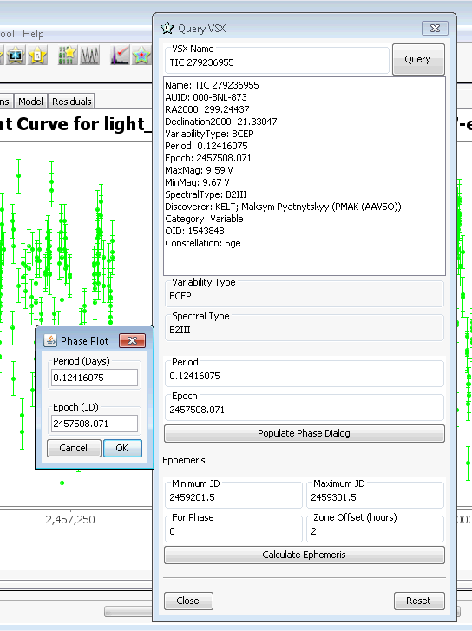
Press the [OK] button to build the phase plot:
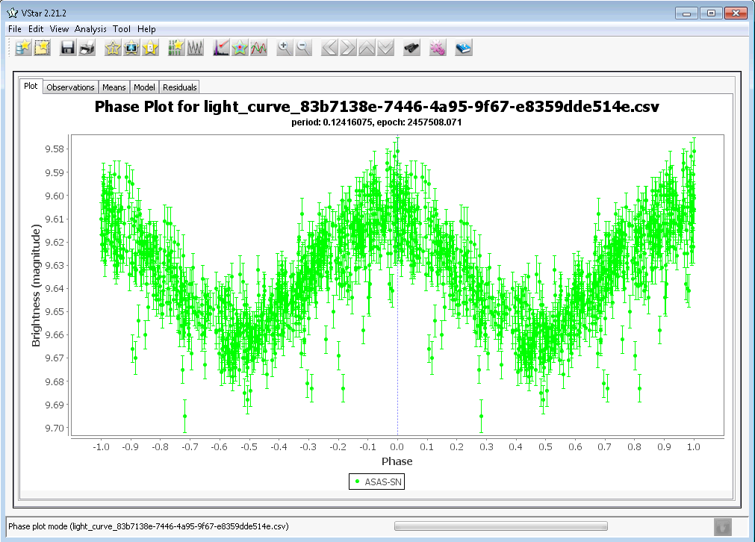

The calculator of ephemerides is located in the bottom part of the VSXquery dialog. Enter the time range for calculations (minimum and maximum JD) and a phase for which the ephemerides should be calculated. Ephemerides are calculated for UT and for UT+zone offset (that is specified in the respective field).
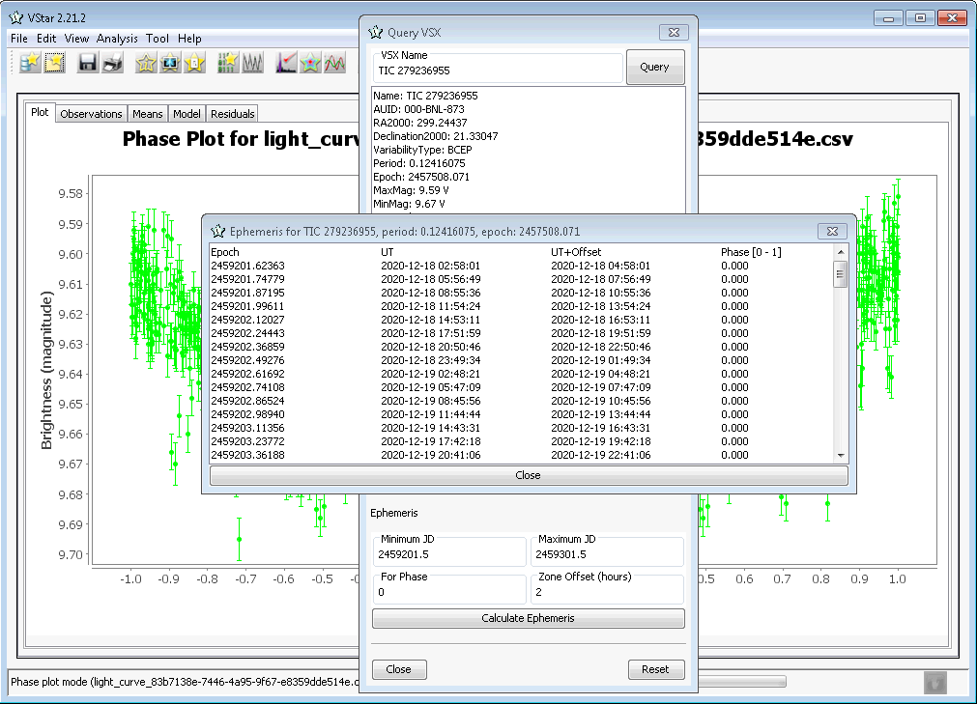
Rev. C
Revision History
Rev | Date | Description | Author
A | 2020-06-12 | Initial Release | Maksym Pyatnytskyy, PMAK
B | 2020-10-23 | Description of ephemerides calculator | Maksym Pyatnytskyy, PMAK
C | 2020-12-18 | Pictures updated | Maksym Pyatnytskyy, PMAK

