Plug-ins

VStar’s capabilities can be extended in various ways by installing plug-ins, e.g.

- Loading observations from sources such as Kepler and ASAS.
- Filtering the loaded dataset in a custom way.
- Creating models, e.g. Loess fit.
- Performing period analysis using an algorithm other than the in-built ones.
- Transforming observations in arbitrary ways.
- Saving observations in particular formats.

See http://www.aavso.org/vstar-plugin-library for details of how to install plug-ins manually.

Alternatively, use VStar's plug-in manager, which is accessible from the Tool menu. After selecting the Plugin-Manager... menu item, the plug-in manager dialog will open:

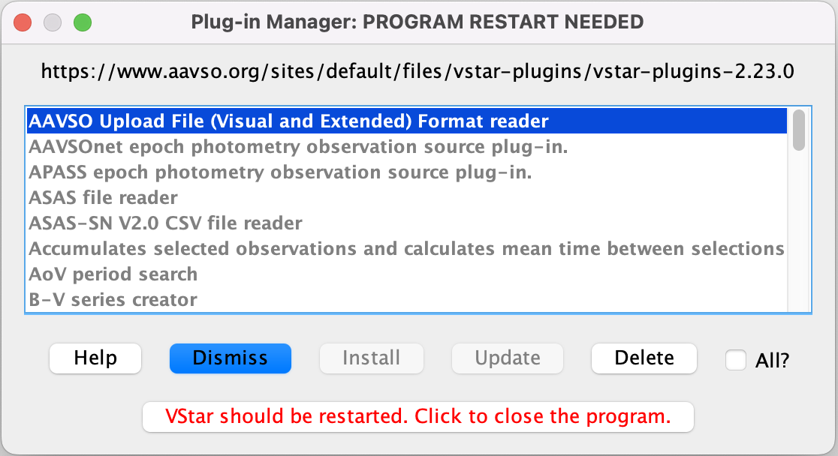
Scrolling through the list of plug-in descriptions and selecting each one will indicate whether a plug-in can be installed or updated. If neither the Install nor the Update button is enabled, then the plug-in is up-to-date on your local machine with respect to the AAVSO plug-in archive.

A plug-in can be deleted from your system via the Delete button.

If the All? checkbox is selected, all plug-ins will be installed or deleted when the Install or Delete button is selected. The Update button is disabled when the All? checkbox is selected.

Some plug-ins require AAVSO membership status to run (e.g. APASS, BSM), but VStar will allow these to be installed, updated or deleted.

As shown in the figure above, after installing, updating, or deleting a plug-in, you will be prompted to close and restart VStar.

The menu in which a plug-in will appear in VStar depends upon its type. Observation source plug-ins appear in the File menu or in the file open dialog (for file or URL load based plug-ins). Custom filter plug-ins appear in the View menu. Model creation and period analysis plug-ins appear in the Analysis menu. Observation and general tools appear in the Tool menu as do observation transformation plug-ins. File sink plug-ins appear in the file save chooser.

See the Preferences section for information about plug-in preferences.

See https://github.com/AAVSO/VStar/blob/master/plugin/doc/vstar_plugin_dev.pdf to learn about how to develop plug-ins for VStar.

