Plug-ins

VStar’s capabilities can be extended in various ways by installing plug-ins, e.g.

- Loading observations from sources such as Kepler and ASAS.
- Filtering the loaded dataset in a custom way.
- Creating models, e.g. Loess fit.
- Performing period analysis using an algorithm other than the in-built ones.

See http://www.aavso.org/vstar-plugin-library for details of how to install plug-ins manually.

Alternatively, use VStar's plug-in manager, which is accessible from the Tool menu. After selecting the Plugin-Manager... menu item, VStar will ask for an AAVSO web user name and password. The plug-in manager dialog will then open:
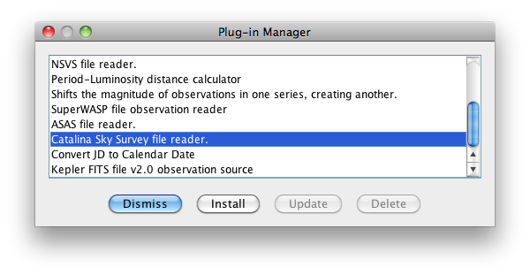
Scrolling through the list of plug-in descriptions and selecting each one will indicate whether a plug-in can be installed or updated. If neither the Install nor the Update button is enabled, then the plug-in is up-to-date on your local machine with respect to the AAVSO plug-in archive. A plug-in can be deleted from your system via the Delete button.

Some plug-ins require AAVSO membership status to run (e.g. APASS, BSM), so these will only be listed if the user is a member.

After installing, updating, or deleting a plug-in, dismiss the dialog, then close and restart VStar to see the changes.

The menu in which a plug-in will appear in VStar depends upon its type. Observation source plug-ins appear in the File menu. Custom filter plug-ins appear in the View menu's Custom Filters sub-menu. Model creation and period analysis plug-ins appear in the Analysis menu. Observation and general tools appear in the Tool menu.

Follow these links to learn about how to develop plug-ins for VStar:

- https://sourceforge.net/p/vstar/code/HEAD/tree/trunk/plugin/doc/vstar_plugin_dev.pdf

- https://sourceforge.net/p/vstar/code/HEAD/tree/trunk/doc/vstar_docs.zip

The first is a document titled “Developing VStar Plug-ins.” The second is a zip file containing the latest VStar Java API in standard “javadoc” form.

