ZTF Plug-in for VStar

This plugin allows you to retrieve light curve data from the online ZTF database. The details of the ZTF project can be found here: https://www.ztf.caltech.edu/ .
The plugin can retrieve data by star coordinates or by the unique ZTF object ID. Several ZTF object IDs can belong to one star; to get all available data, you usually have to combine data series from several different object IDs. Retrieving data by star coordinates lets us get all data points at once; however, you have to limit the search area by a small circle.

Retrieving data by the star’s coordinates or by the VSX name
Select “New star from ZTF Photometry” on the VStar file menu:
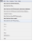

A dialog box will appear with the input fields for star coordinates. Enter the coordinates in degrees (epoch J2000):
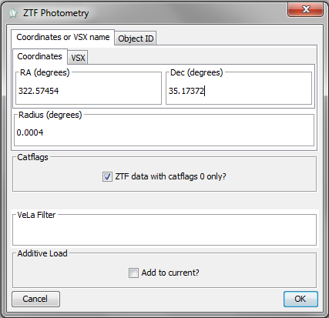
You can find the coordinates of the star of interest on the VSX website https://www.aavso.org/vsx. The “Radius” field defines the search radius; in most cases, the default value is ok.
Another option is to use the VSX name. Besides the primary name, the VSX usually recognizes several assigned names from existing catalogs. So, instead of the coordinates, you can switch to the “VSX” tab and enter the star’s name:
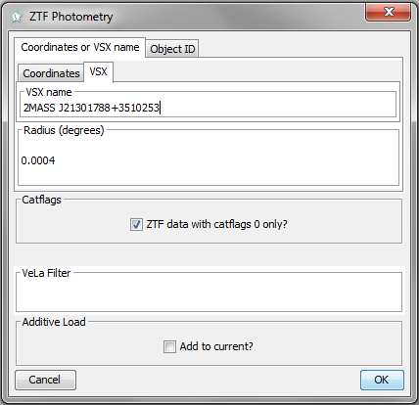
If the checkbox “ZTF data with catflags 0 only” is checked (this is by default), only the data with no “bad flags” will be retrieved. This is recommended by the VSX.
After entering the coordinates or the VSX name, press the [OK] button. When a VSX name is entered, the plug-in first refers to the VSX website, trying to obtain the coordinates. Then it calls the ZTF web service to get the data for the ZTF objects inside the circle with the specified radius centered on the coordinates you set (or obtained from the VSX by the object name). The process of retrieving the data sometimes may take dozens of seconds. As a result, the light curve(s) should appear in the plot pane:
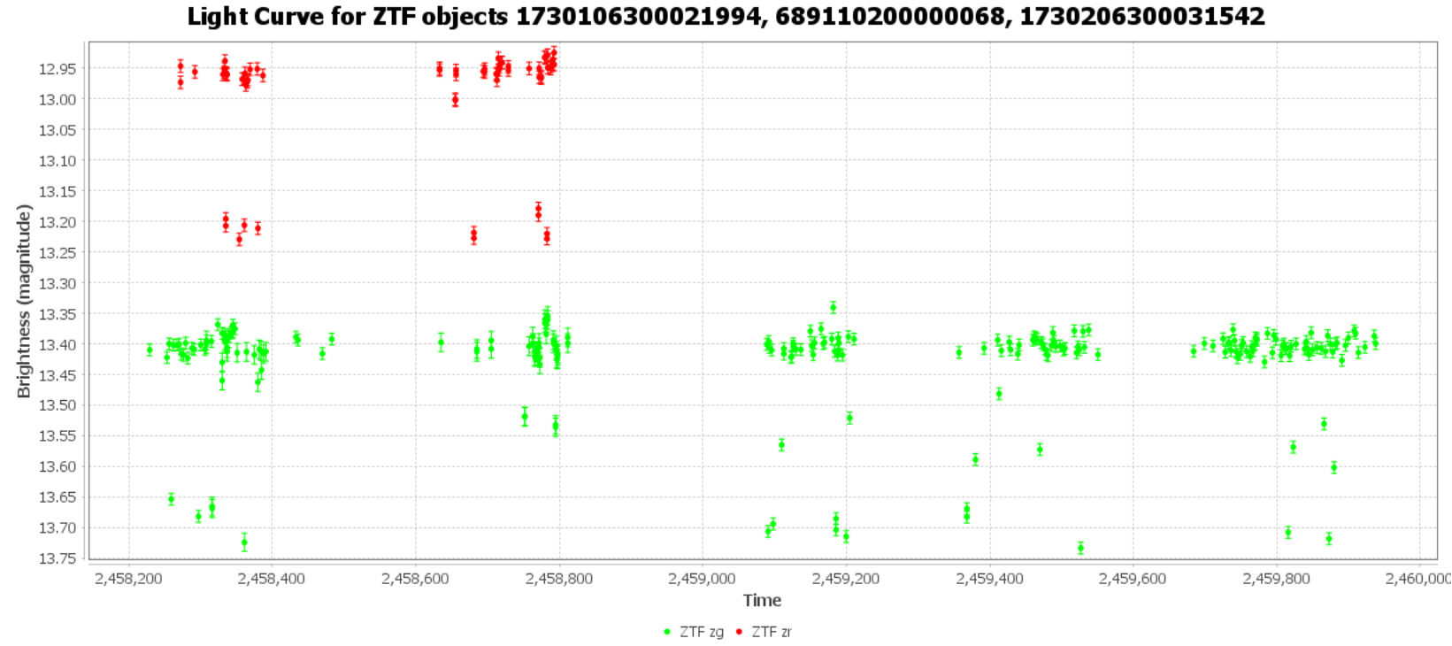
In our example, we used the EA star PMAK V5 (=2MASS J21301788+3510253) with a period of 4.7391 days. Here is the phase plot:
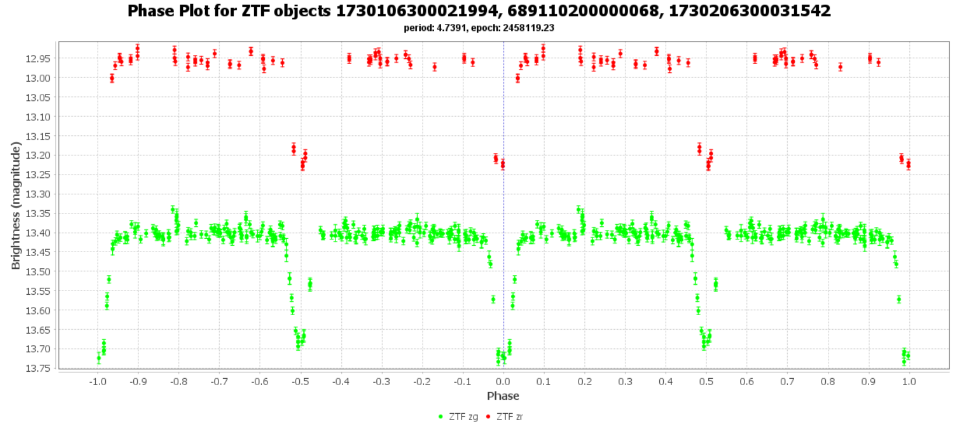

Retrieving data via ZTF object ID
Also, you can retrieve the data via ZTF object ID. To determine the ID of the star of interest, go to https://irsa.ipac.caltech.edu/cgi-bin/Gator/nph-scan?submit=Select&projshort=ZTF, select a catalog, and press the [SELECT] button:
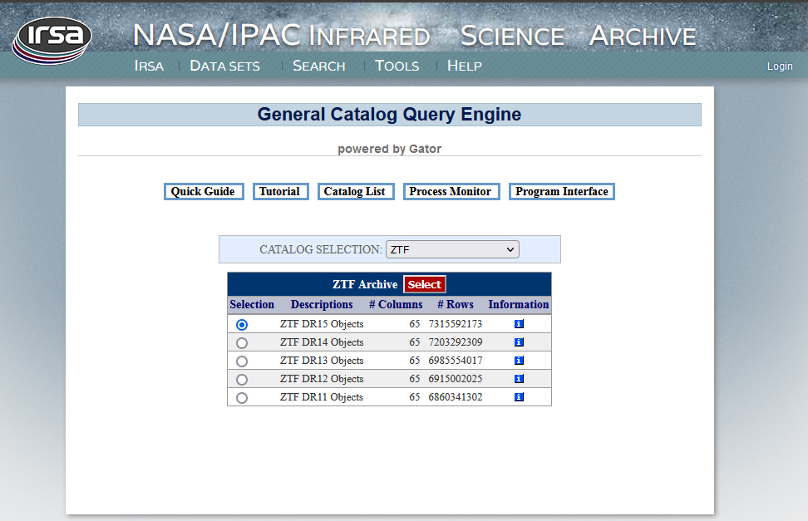

On the next page, enter the object’s coordinates (or object name), then click [Run Query]:
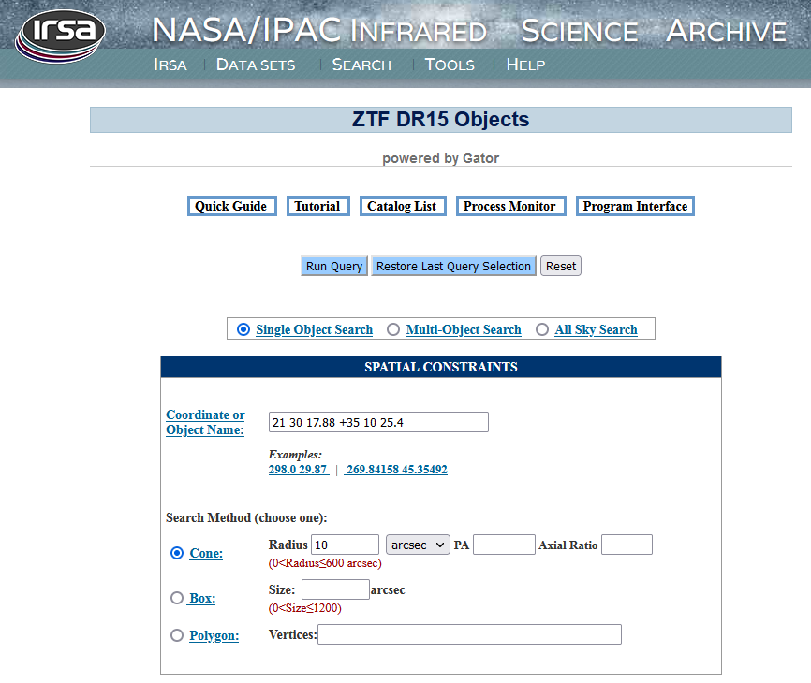

You will see a sky image of the vicinity of the object (it can be zoomed in with the mouse or by clicking on the appropriate toolbar icon).
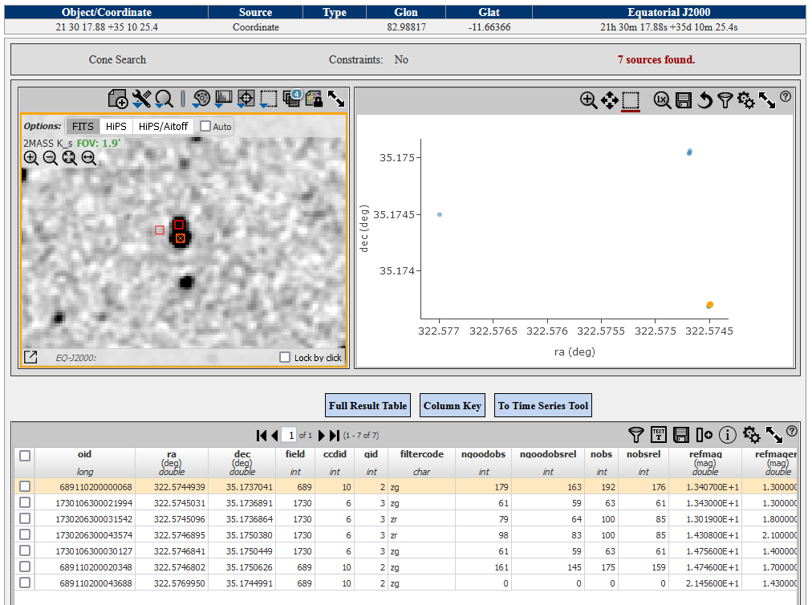
In the table below the image, you can see object identifiers (oid). Take one that corresponds to your object [There can be several IDs that belong to the object. Using “additive load” (see below) you can utilize them all]

Put a ZTF ID in the “ZTF object ID” on the “Object ID” tab:
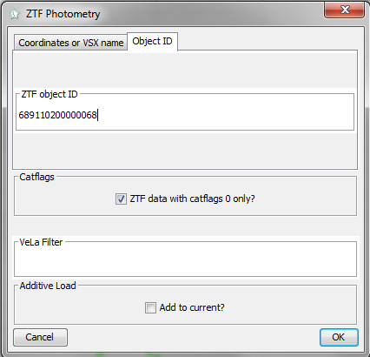
Then press the [OK] button. The light curve should appear in the plot pane:
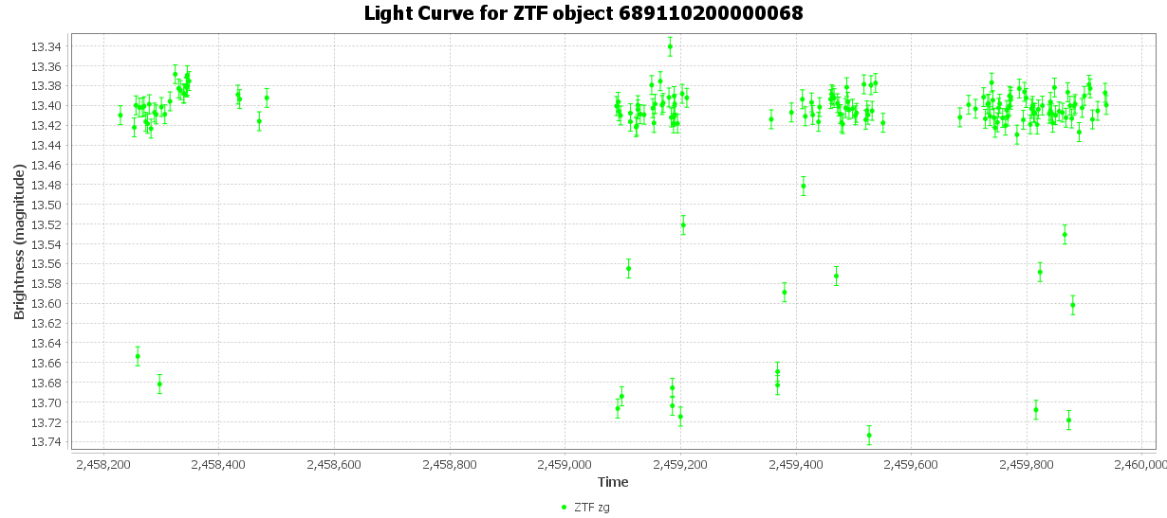

Revision History
Rev | Date | Description | Author
A | 12 Mar 2023 | Initial release | Maksym Pyatnytskyy (PMAK)

