Current Mode ANOVA plug-in

Introduction
The Current Mode ANOVA plug-in allows the ANOVA (One-way Analysis of Variance) algorithm to be applied to a loaded set of observations in raw or phase plot mode.

The plug-in can be installed via the Plug-in Manager item in the Tool menu. After VStar has been restarted, the Tool menu will contain a new item for the plug-in:

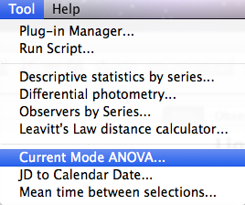
Suppose the following X Cyg data set (JD 2447000 to 2447960) is loaded into VStar:

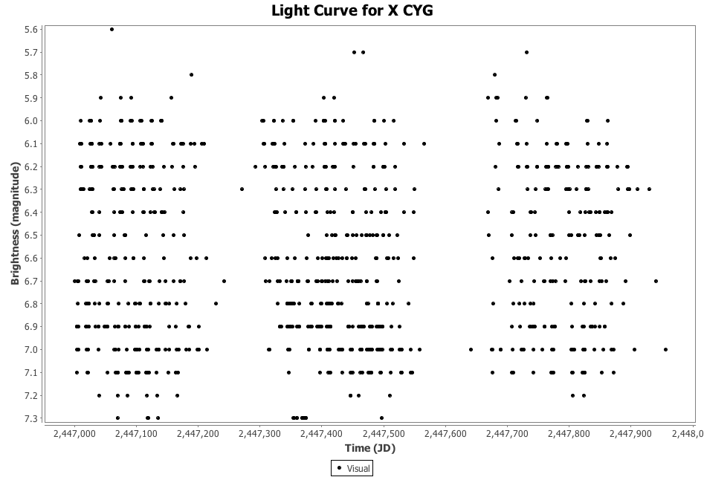
A phase plot could be created via the Phase Plot item in the Analysis menu:

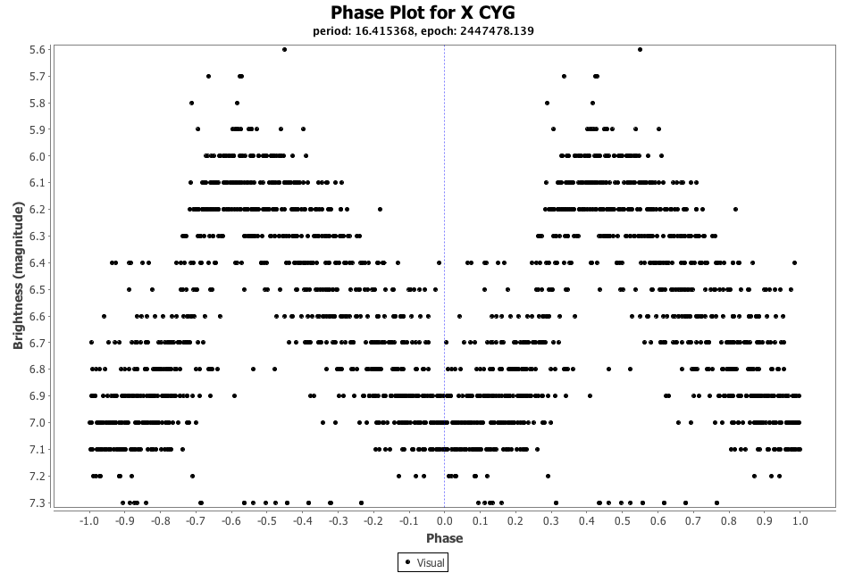
Selecting the Means series via the Plot Control dialog (from the View menu or toolbar) shows the mean curve upon which the ANOVA will be based.

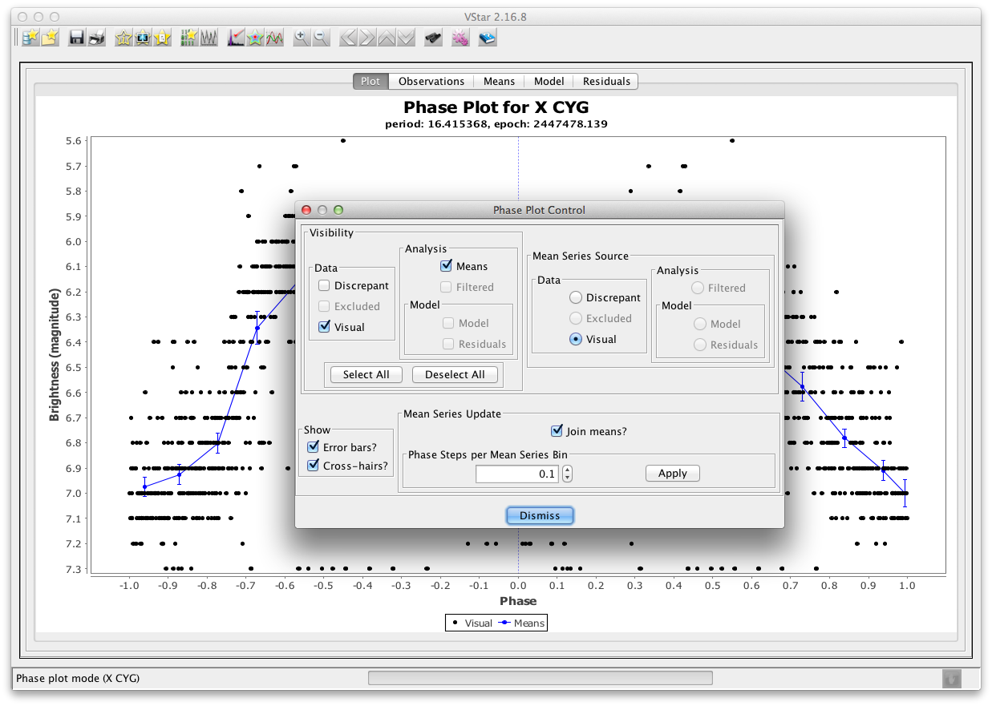

The following would be the result of invoking the Current Mode ANOVA item from the Tool menu for this phase plot:

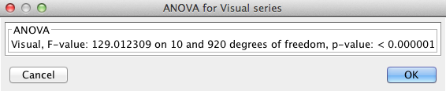
The plug-in can also be applied to the raw plot (see the View menu or toolbar to switch between raw and phase plot modes) and its current Means series.

The key point to understand is that the Current Mode ANOVA plug-in will be applied to the Means series of the current plot mode, whether that series is visible or not on the plot.

Understanding ANOVA
The ANOVA p-value indicates whether there is sufficient evidence to reject the null hypothesis that there is no non-trivial signal (of some kind). A low p-value indicates that the probability of there being no non-trivial signal is low. A high value indicates that the probability of there being no non-trivial signal is high. A low p-value does not mean that there is a high probability of a signal being present. Also, the question of what kind of signal there may be is a separate issue, e.g. it could be, for example, the result of actual variability in the star's brightness, observer bias, or an artifact observation frequency.
As Grant Foster (2010) says in Analyzing Light Curves: A Practical Guide:
It's also important never to forget that...a "statistically significant" result doesn't mean that our model is correct, only that the null hypothesis is false.

Useful Links for ANOVA
StatSoft, Introduction to ANOVA/MANOVA: An overview of ANOVA techniques from the publisher of a statistics textbook. The page links to a great deal of other information on statistical analysis. [http://www.statsoft.com/textbook/anova-manova/?button=1]
Wikipedia - One-way ANOVA (analysis of variance): Standard Wikipedia entry summarizing the basics of the ANOVA technique. [http://en.wikipedia.org/wiki/One-way_analysis_of_variance]
How to Calculate and Understand Analysis of Variance (ANOVA) F Test.
[https://explorable.com/anova] (video)

