HipparcosObservationSource

This plug-in will allow you to read Hipparcos Catalog Data. Install the Hipparcos plug-in by going to the Tool menu and selecting the Plug-In Manager. AAVSO login is required. Scroll down to and select Hipparcos file reader and click Install. After installation, restart VStar.

Starting with VSX, click on “Search” and enter HIP 76343 into the “Name” field and click on “Search”. This yields the VSX page for HIP 76343 (also known as RU CrB). Go to “External Links/Location/Select”, scroll down to the “Hipparcos Epoch Photometry Data” option and click on “Go”. This will give you:

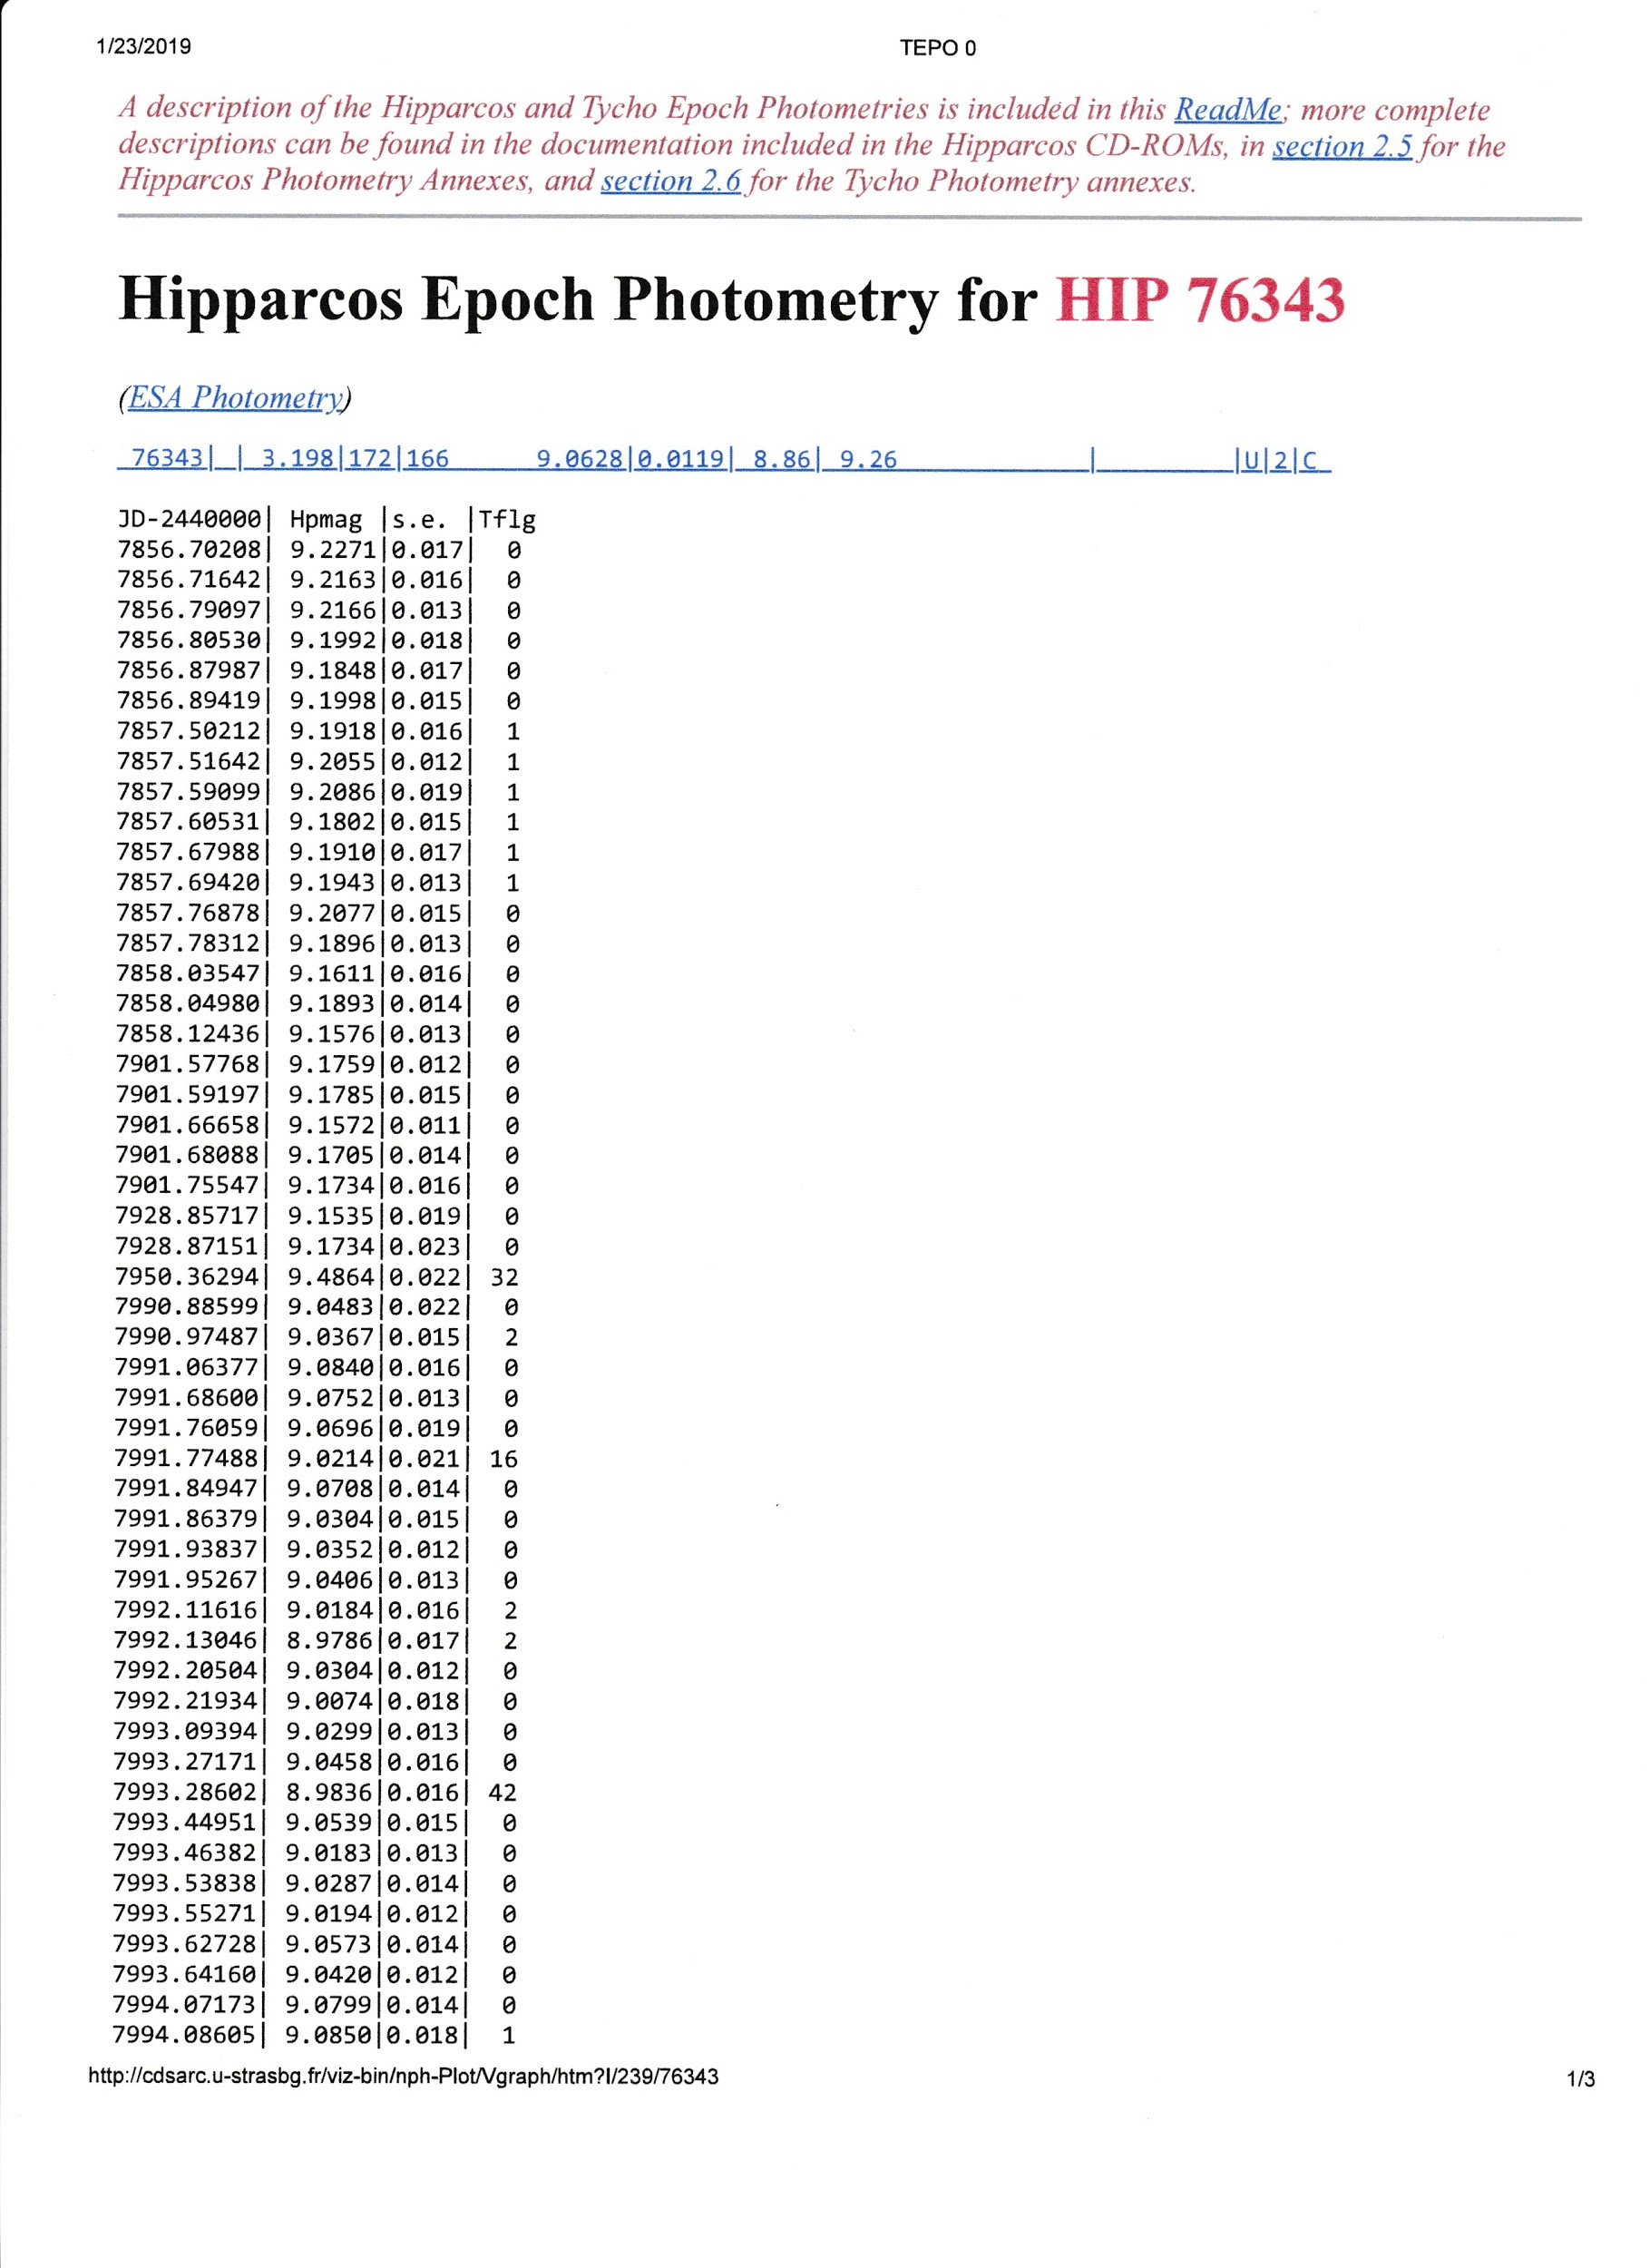
Copy and paste the photometry data into a text file, e.g. HIP76343.txt on your local computer.

Go to the VStar File drop down tab and select the “New Star from File” option. Load the above text file into VStar.

As an alternative to loading it from a file,the URL of the data page shown above can be pasted into the file chooser's Request URL button, e.g.

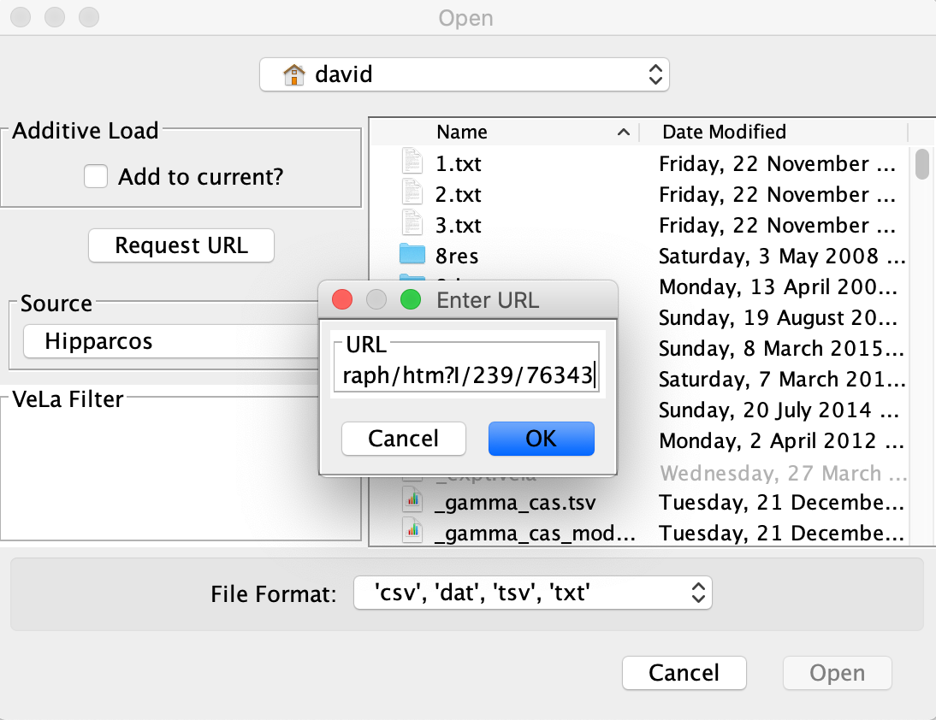
In both cases, the following light curve will be shown:
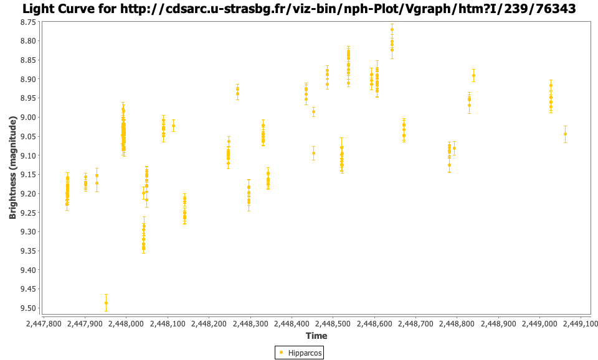
From here, there are multiple analysis options that can be performed with VStar.

