**HipparcosObservationSource**

This plug-in will allow you to read Hipparcos Catalog Data. Install the Hipparcos plug-in by going to the *Tool* menu and selecting the *Plug-In Manager*. AAVSO login is required. Scroll down to and select Hipparcos file reader and click *Install*. After installation, restart VStar.

Starting with VSX, click on “Search” and enter HIP 76343 into the “Name” field and click on “Search”. This yields the VSX page for HIP 76343 (also known as RU CrB). Go to “External Links/Location/Select”, scroll down to the “Hipparcos Epoch Photometry Data” option and click on “Go”. This will give you:

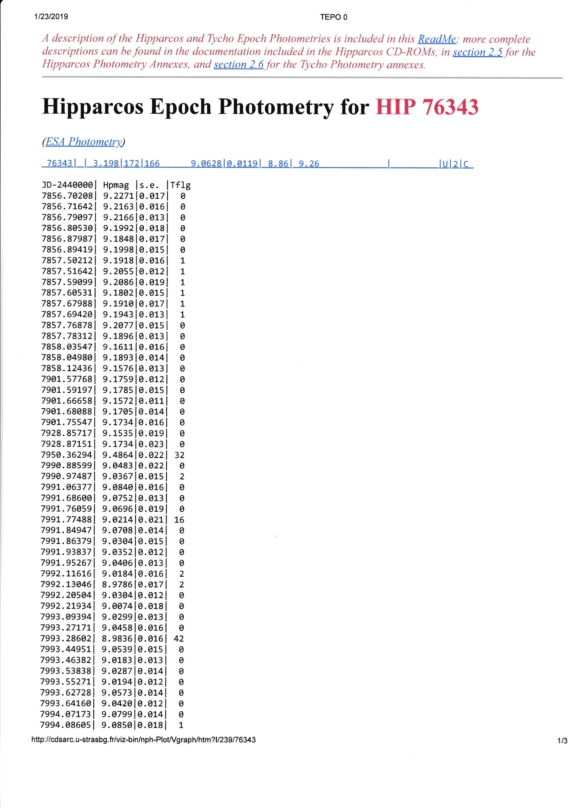

Copy and paste the photometry data into a text file, e.g., HIP76343.txt on your local computer.

Go to the VStar *File* drop down tab and select “New Star from Hipparcos File”. Load the above text file into VStar. This will produce the following light curve.



From here, there are multiple analysis options that can be performed with VStar.