Leavitt’s LawPlug-In for VStar

This VStar plug-in will determine the distance to a star. Right now the distance can only be calculated for Classical Cepheid variables (DCEP) but the ability to calculate the distance to other types of variables may be added in the future.

First, the plug in needs to be loaded from the tool menu. Select Plug-in Manager from the tool menu. Your AAVSO username and password are required. In the Plug-in Manager, select “Leavitt’s Law (Period-Luminosity Relationship) distance calculator” and click on install.

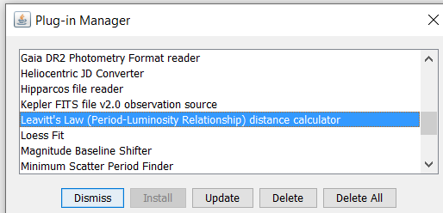

Restart VStar after installation of the Plug-in.

Select your star from “New star from AAVSO database”. Type in the name of the star. The default minimum and maximum JD will load data from the last 2 years of observations for that star or select the JD range you are interested in then click ok. The prototype star for the Classical Cepheid, Delta Cephei, is used in this example.

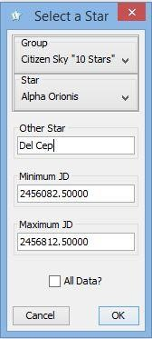

From the tool menu select “Leavitt’s Law distance calculator”. Select a series to use in the calculation. An input menu appears.

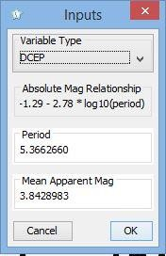

There is a drop down menu for variable type. At this time the only variable type supported for this particular Plug-in is DCEP. The next input is for the period. The default period is the period obtained from VSX. If you prefer, you can calculate the period for the current range of data that you have loaded by using DC DFT Standard Scan from the analysis menu.

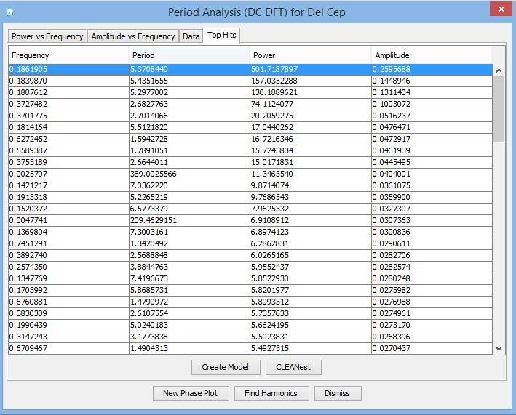

The next input is the mean apparent magnitude. The default value is the mean apparent magnitude for the range of observations that you have selected. Click ok. The computed absolute magnitude and distance in parsecs and light years is displayed.

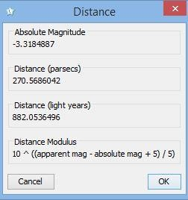

The distance will vary depending on the series used (visual, Johnson V, etc.), the range of data used to calculate mean magnitude and period. Also shown in the distance box is the distance modulus, the formula used to calculate the distance in parsecs.