QPL FITS Plug-in

The QLP FITS plugin reads data from FITS files prepared by the QLP team from TESS Full-Frame Images (<https://archive.stsci.edu/hlsp/qlp>). The archive of light curves in FITS format is accessible from the page <https://archive.stsci.edu/hlsp/qlp> (a separate bundle for each TESS sector). However, the archived bundles are very large. Individual light curves can be downloaded via MAST portal: <https://mast.stsci.edu/portal/Mashup/Clients/Mast/Portal.html>

Enter coordinates of the object of interest and click [Search]:

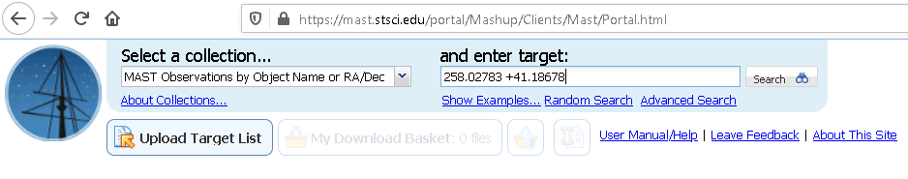

To reduce the number of results and focus on QLP data, click the “QLP” checkbox:

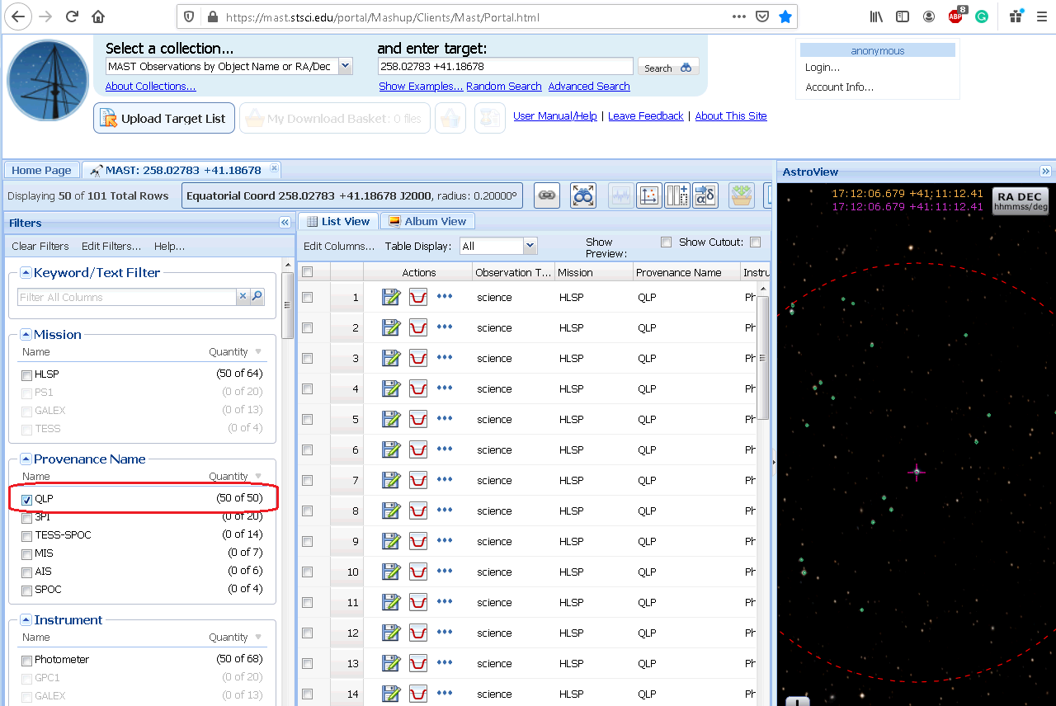

Rows with signs contain light curve data for stars near the object you searched. You may highlight the star that corresponds to the row by clicking the checkbox near the row. Click on diskette sign () to save an archived light curve (zip file with the light curve FITS plus some additional files). Find the FITS file inside the archive and unpack it. Then you can use VStar with the QLP FITS plugin installed to view the light curve:

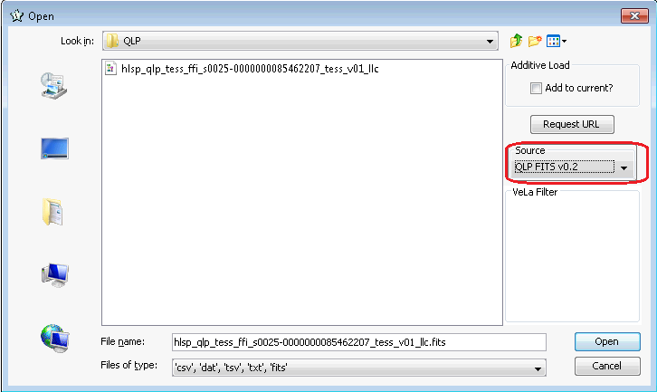

After opening the FITS you should see the following dialog:

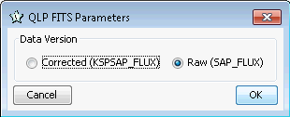

It seems that for QLP data it is better to use the “Raw” version (without correction). Looks like that the correction (see <https://archive.stsci.edu/hlsp/qlp> for details) removes not only bad trends but also some real features. Play with “Raw” and “Corrected” versions to see what better suits your needs.

Choose Data Version and press [OK]. You will see the light curve:

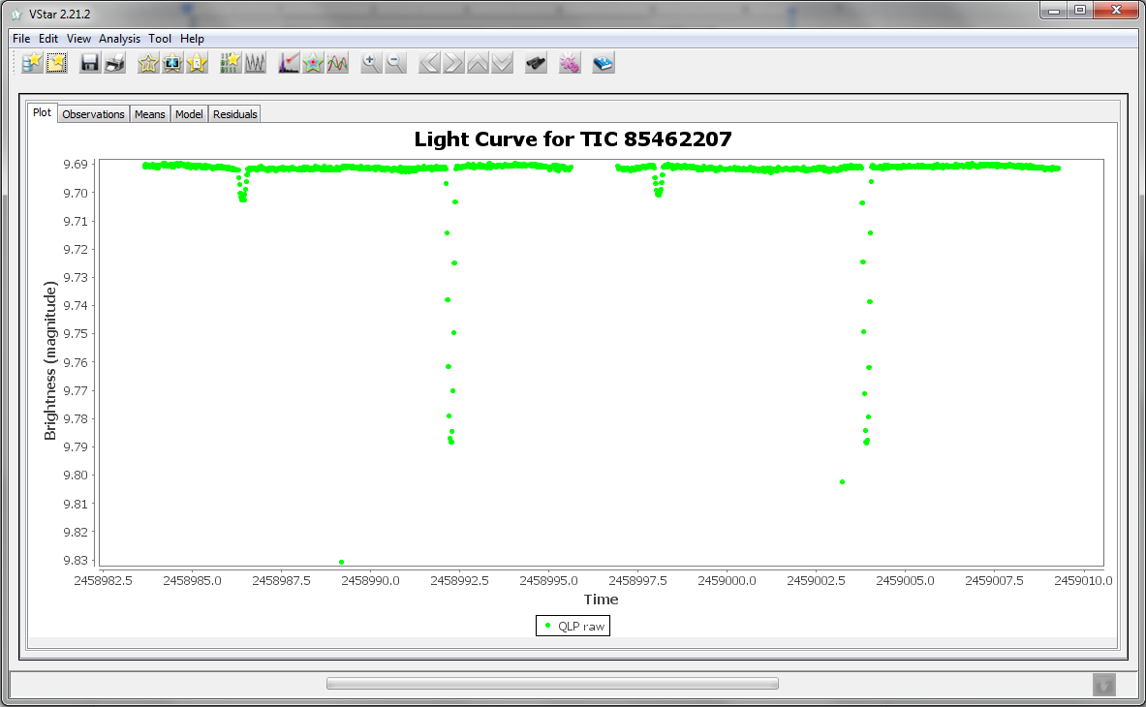

**Revision History**

|  |  |  |  |
| --- | --- | --- | --- |
| Rev | Date | Description | Author |
| A | 2020-12-23 | Initial Release | Maksym Pyatnytskyy, PMAK |