**VSX Query plug-in**

The VSX Query plug-in shows variable star information taken from the VSX database.

While loading data from AAVSO International Database (AID) via “New Star from AAVSO Database” menu command, VStar gets star’s information automatically, including a period and an epoch (for periodic variables) that can be directly used while building phase plots. Additional star’s parameters (such as variability type, spectral type, coordinates, etc.) are available via “Info” dialog. In other cases, when data is loaded from a file or another data source, that information is not available directly from within VStar and should be searched using the VSX web portal (<https://aavso.org/vsx/>).

The VSQ query plugin allows the user to get the star’s information within VStar directly. When installed, the plugin is accessible through Tool->VSX Query command.

Let’s take as an example a star TIC 279236955. There is no data for it in AID (at the time of writing this document). There is ASAS-SN data from which we want to create a phase plot. Instead of opening an internet browser and searching via VSX portal we can launch VSQ Query plug-in and enter star’s identifier in the “VSX Name” field:

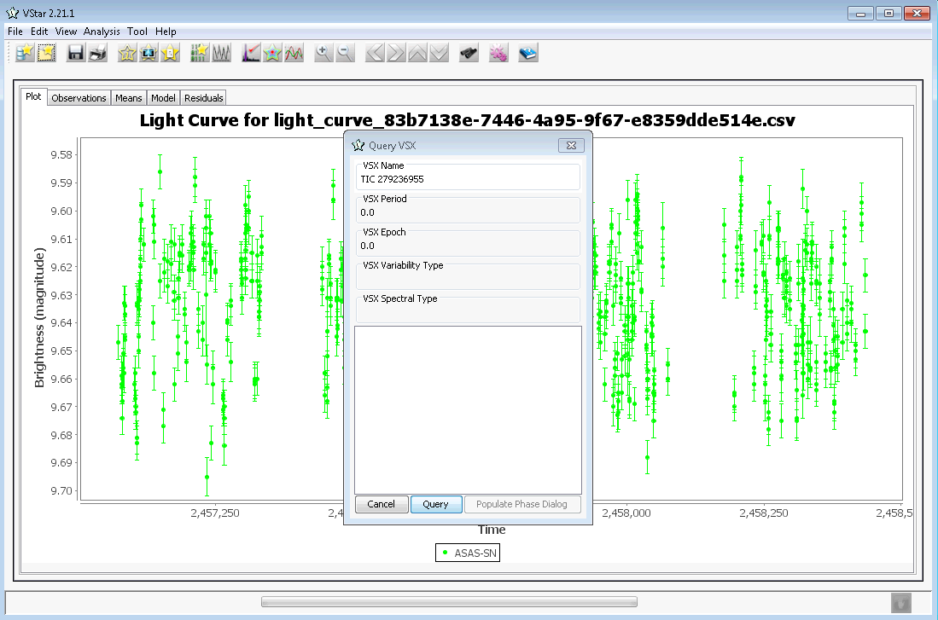

After clicking [Query] button and waiting for several seconds (time depends on your internet connection and current load of VSX server) you should get the following information:

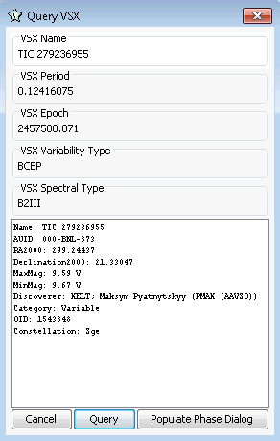

The star is periodic (the period and the epoch are in “VSX Period” and “VSX Epoch” fields respectively). There is no need to enter the period and the epoch manually in the “Phase Plot” dialog, just click the [Populate Phase Dialog] button. Then open Phase Dialog (via Analysis->Phase Plot… menu command). Period and Epoch fields should be already filled by respective values.

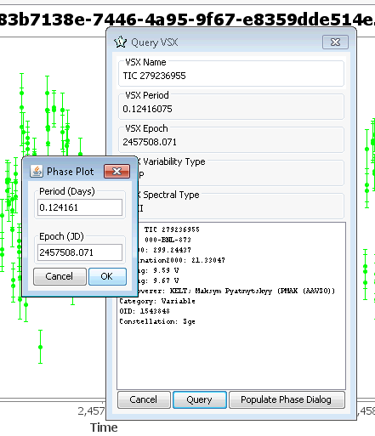

Press [OK] button to build the phase plot:

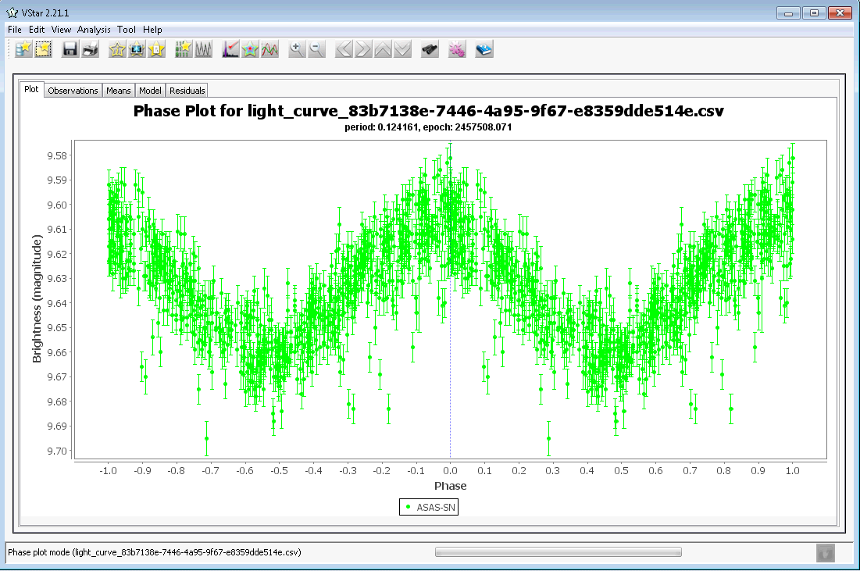

Rev. A

**Revision History**

|  |  |  |  |
| --- | --- | --- | --- |
| Rev | Date | Description | Author |
| A | 2020-06-12 | Initial Release | Maksym Pyatnytskyy, PMAK |