# Retrieving ZTF Light Curves

This plugin allows you to retrieve light curve data from the online ZTF database. The details of the ZTF project can be found here: <https://www.ztf.caltech.edu/>.

## Obtaining ZTF object ID

The plugin gets data for the unique ZTF object ID. To determine the ID of the object of interest, go to <https://irsa.ipac.caltech.edu/cgi-bin/Gator/nph-scan?submit=Select&projshort=ZTF>, select a catalog, and press the [SELECT] button:

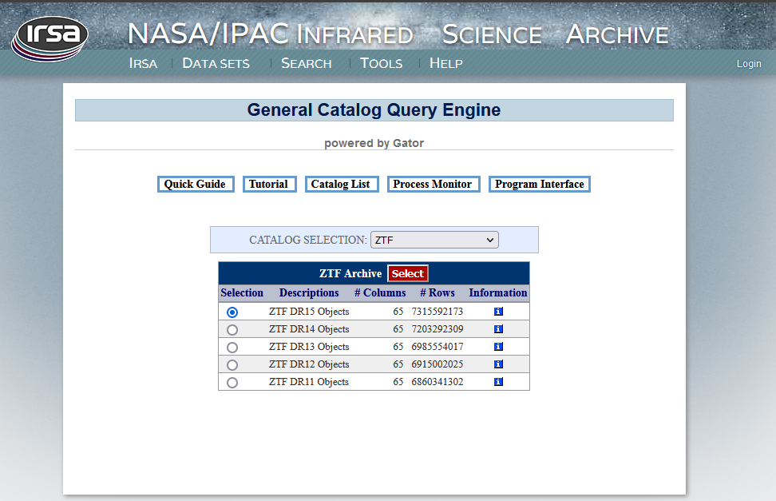

On the next page, enter the object’s coordinates (or object name), then click [Run Query]:

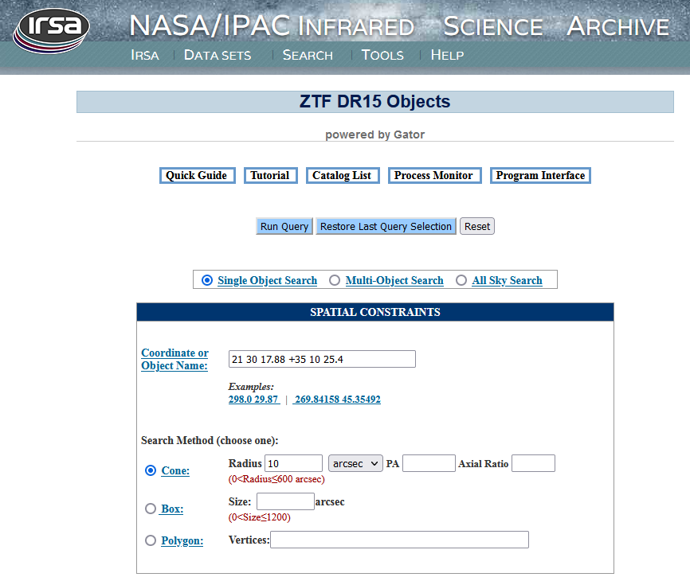

You will see a sky image of the vicinity of the object (it can be zoomed in with the mouse or by clicking on the appropriate toolbar icon).

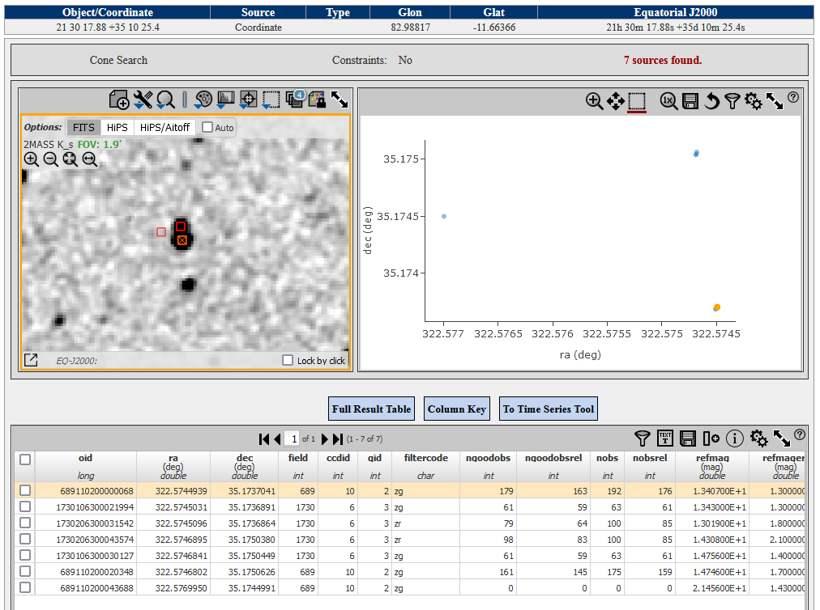

In the table below the image, you can see object identifiers (oid). Take one that corresponds to your object [There can be several IDs that belong to the object. Using “additive load” (see below) you can utilize them all]

Select “New star from ZTF Photometry” on the VStar file menu to open the dialog box. Put a ZTF ID in the upper field.

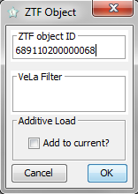

You can also choose to add the light curve data to the existing VStar observations by checking the “Add to current?” checkbox. Then press the [OK] button. The light curve should appear in the plot pane:

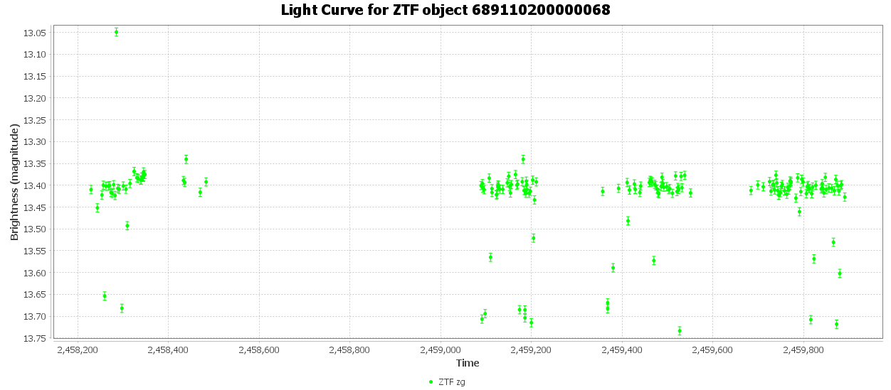Similarly, you can import additional ZTF observations for the star using ZTF IDs for it with the additive load (checking the “Add to current?” checkbox while loading). Here is the result of additive loading data 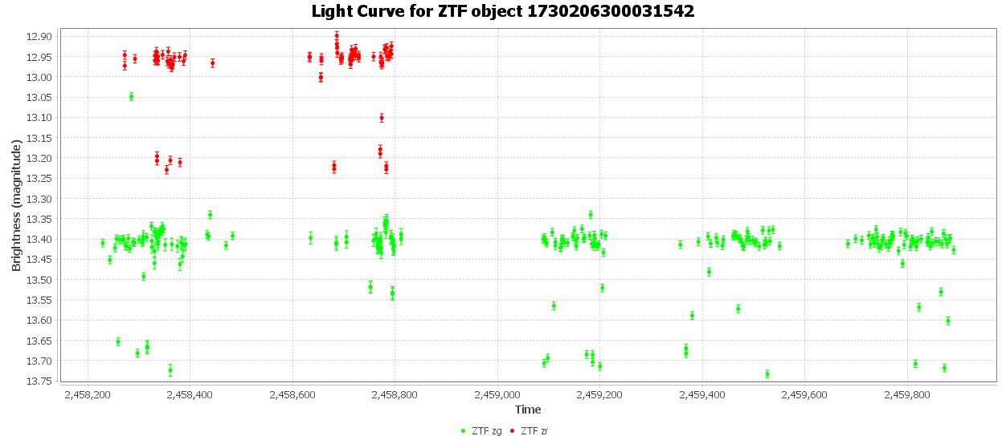for the IDs 1730106300021994 and 1730206300031542:

In our example, we used the EA star PMAK V5 with a period of 4.7391 days. Here is the phase plot:

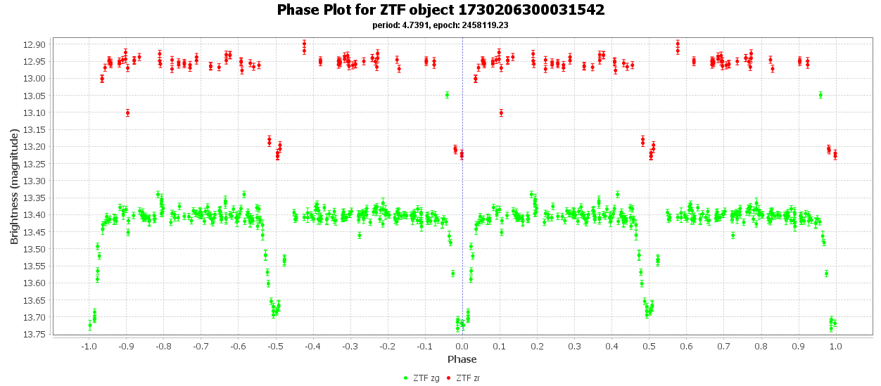

**Revision History**

|  |  |  |  |
| --- | --- | --- | --- |
| Rev | Date | Description | Author |
| A | 05 Mar 2023 | Initial release | Maksym Pyatnytskyy (PMAK) |