**AAVSO APASS and AAVSOnet Epoch Photometry**

These plug-ins will allow you to read data from the AAVSO APASS Epoch Photometry and the AAVSOnet Epoch Photometry databases. Access to these is restricted to AAVSO members and you will have to enter your username and password the first time you access them during a VStar session.

Install the plugins using the plugin manager or by downloading them from the [VStar members-only plugin library](https://www.aavso.org/vstar-members-only-plugins) and placing them in your vstar_plugins folder. Note that you will have to be logged into the AAVSO website to access this page.

The following is an example of using this plugin to obtain RR Lyrae observations from the AAVSOnet Epoch database. APASS is similar. Starting with VSX, click on “Search” and enter RR Lyr into the “Name” field and click on “Search”. This yields the VSX page for RR Lyrae.

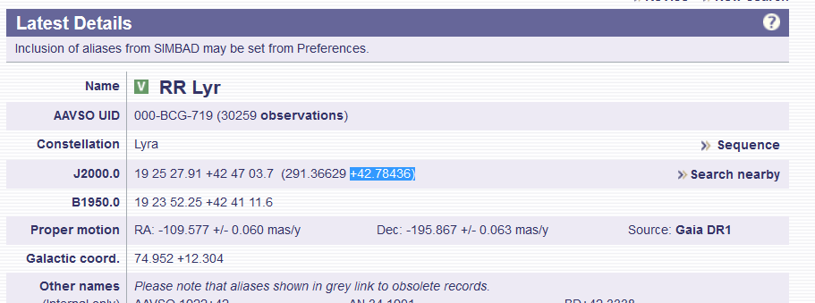

In VStar, pick the “File->New Star from AAVSOnet epoch photometry database…” menu item.

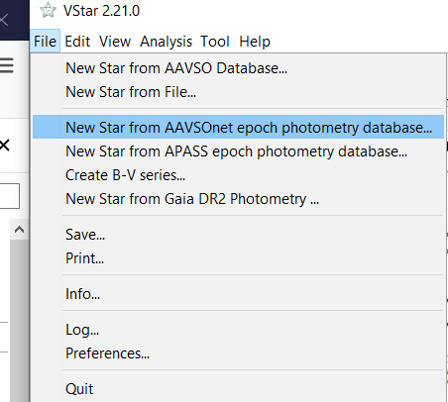

The first time you access this plugin during a VStar session you are prompted for your AAVSO username and password. Enter them and click “OK”.

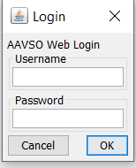

You will see this dialog box:

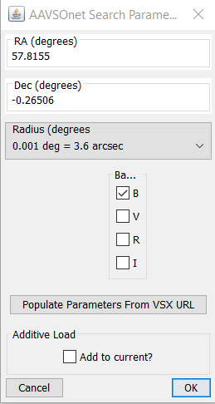

From the VSX screen get the RA and DEC in degrees (291.36629 +42.78436 in this example) and enter them into this dialog. The default radius is usually what works, but increase the size if you do not get any data. Select the filters you are interested in and optionally click the “Add to current” box if you want this data added to what is already in VStar. Click the “OK” button and the data are displayed.

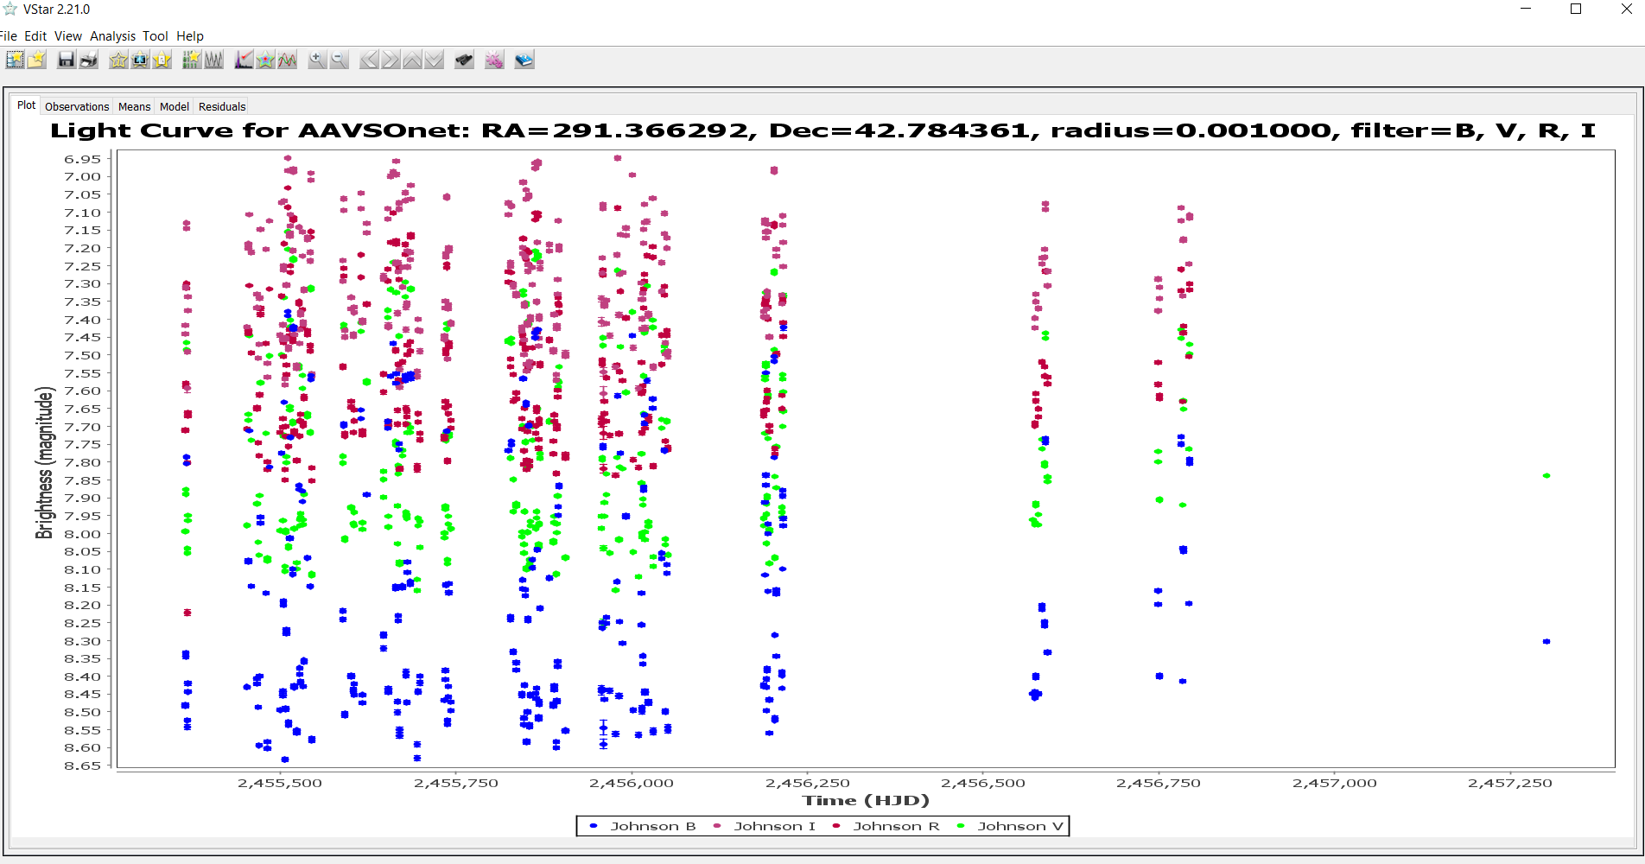

Another way to get the coordinates is by using VSX’s external links. In the RR Lyrae detail page in VSX, go to “External Links/Location/Select”, scroll down to the “APASS” option and click on “Go”.

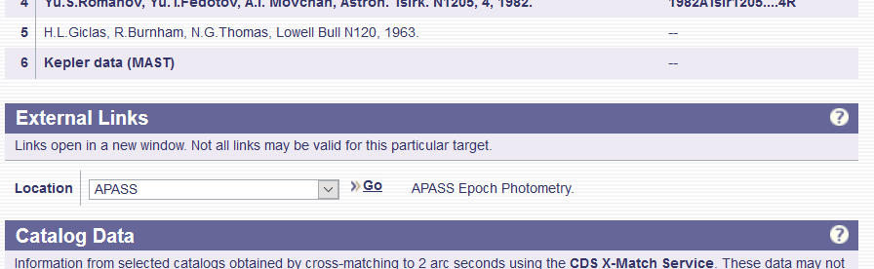

Note you should use the “APASS” external link for both APASS and AAVSOnet data. This will give a web page with the raw data. In this example APASS has no data, but the URL is still valid. Copy the URL from your browser. Return to the VStar dialog box shown above and click “Populate Parameters From VSX URL”. Paste the URL into the new dialog box that was just displayed and click “OK”.

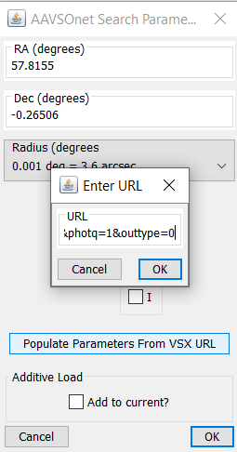

You should see the RA and DEC fields change. Select your filters and optionally the “Add to current” as with the manual entry of coordinates.

More information about the AAVSOnet Epoch Photometry database is available at [this page](https://www.aavso.org/aavsonet-epoch-photometry-database) on the AAVSO website. More information on APASS can be found [here](https://www.aavso.org/apass).