**ApacheCommonsLoessFilter**

This plugin creates a locally weighted scatterplot smoothing fit of the specified series. See

<http://en.wikipedia.org/wiki/Local_regression>

for more information about the algorithm. The Loess interpolator in the Apache Commons Math library (already used by VStar to implement ANOVA) is used.

Local regression or local polynomial regression, also known as moving regression, is a generalization of [moving average](https://en.wikipedia.org/wiki/Moving_average) and [polynomial regression](https://en.wikipedia.org/wiki/Polynomial_regression). Its most common methods, initially developed for [scatterplot smoothing](https://en.wikipedia.org/wiki/Scatterplot_smoothing), are LOESS (locally estimated scatterplot smoothing) and LOWESS (locally weighted scatterplot smoothing). They are two strongly related [nonparametric regression](https://en.wikipedia.org/wiki/Non-parametric_regression) methods that combine multiple regression models in a [*k*-nearest-neighbor](https://en.wikipedia.org/wiki/K-nearest_neighbor_algorithm)-based meta-model.

LOESS and LOWESS thus build on ["classical" methods](https://en.wikipedia.org/wiki/Classical_statistics), such as linear and nonlinear [least squares regression](https://en.wikipedia.org/wiki/Least_squares_regression). They address situations in which the classical procedures do not perform well or cannot be effectively applied without undue labor. LOESS combines much of the simplicity of linear least squares regression with the flexibility of [nonlinear regression](https://en.wikipedia.org/wiki/Non-linear_regression). It does this by fitting simple models to localized subsets of the data to build up a function that describes the deterministic part of the variation in the data, point by point. In fact, one of the chief attractions of this method is that the data analyst is not required to specify a global function of any form to fit a model to the data, only to fit segments of the data.

A smooth curve through a set of data points obtained with this statistical technique is called a Loess Curve, particularly when each smoothed value is given by a weighted quadratic least squares regression over the span of values of the y-axis [scattergram](https://en.wikipedia.org/wiki/Scattergram) criterion variable. When each smoothed value is given by a weighted linear least squares regression over the span, this is known as a Lowess curve.

Install the LOESS plug-in by going to the *Tool* menu and selecting the *Plug-In Manager*. AAVSO login is required. Scroll to the selected LOESS Fit file reader and click Install. After installation, restart VStar. As an example, go to the VStar *File* drop down tab and select “New Star from AAVSO Database” This yields the information for R Lyr (maximum/minimum JD). Click OK. This produces the following light curve in Johnson V and Visual for R Lyr.

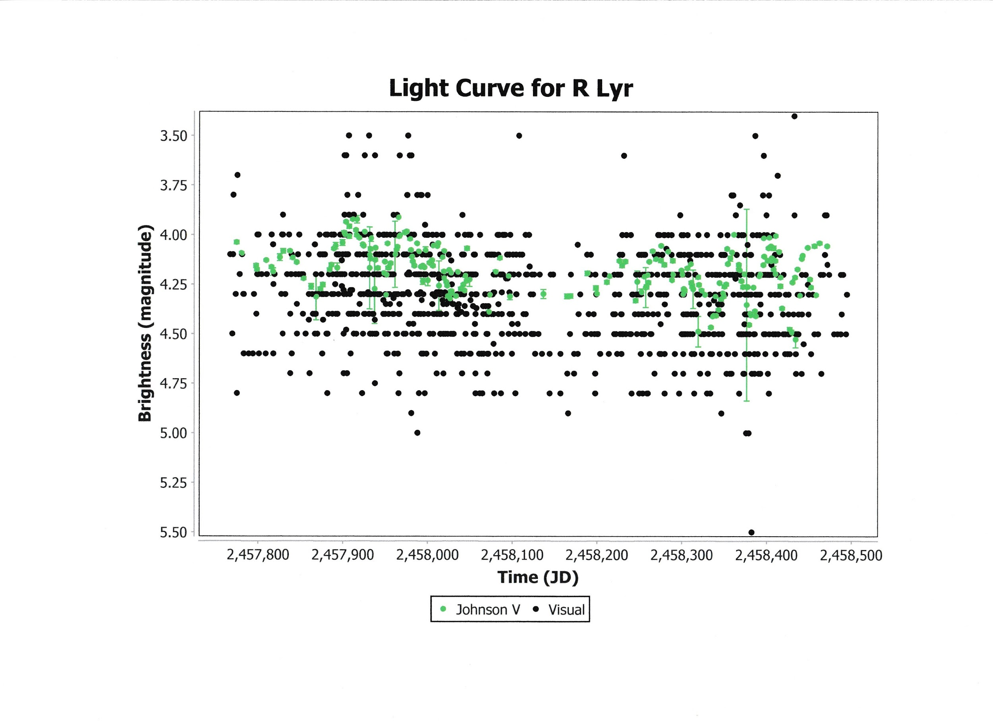

Go to the *Analysis* drop down menu and select “Loess fit”. Choose an option from the popup screen, e.g., Visual. Click OK. This yields the following result.

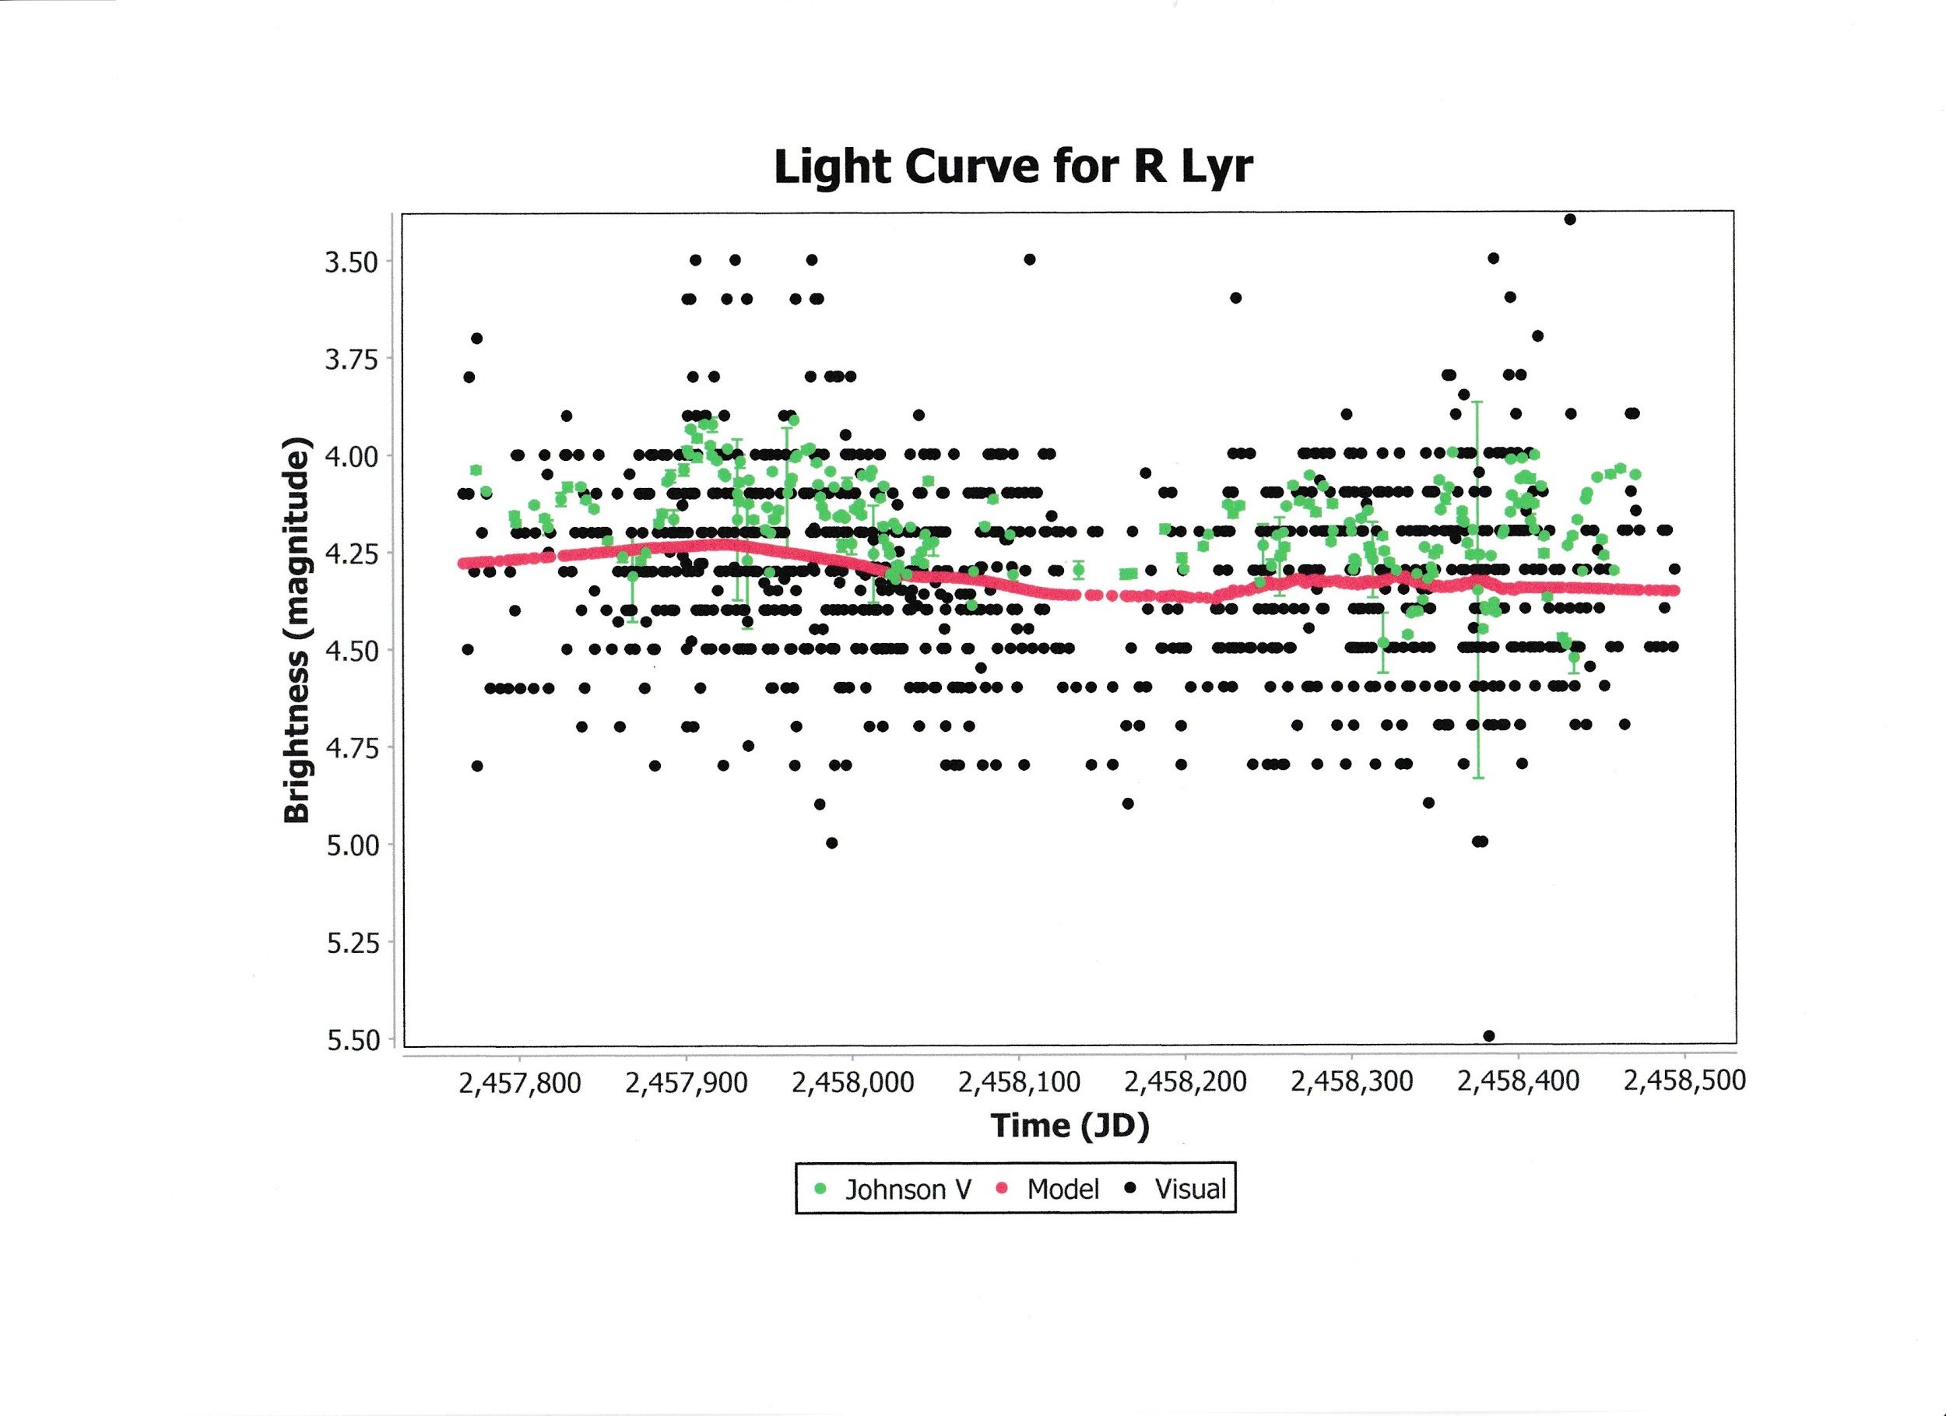

If Johnson V had been selected instead the result would be as shown.

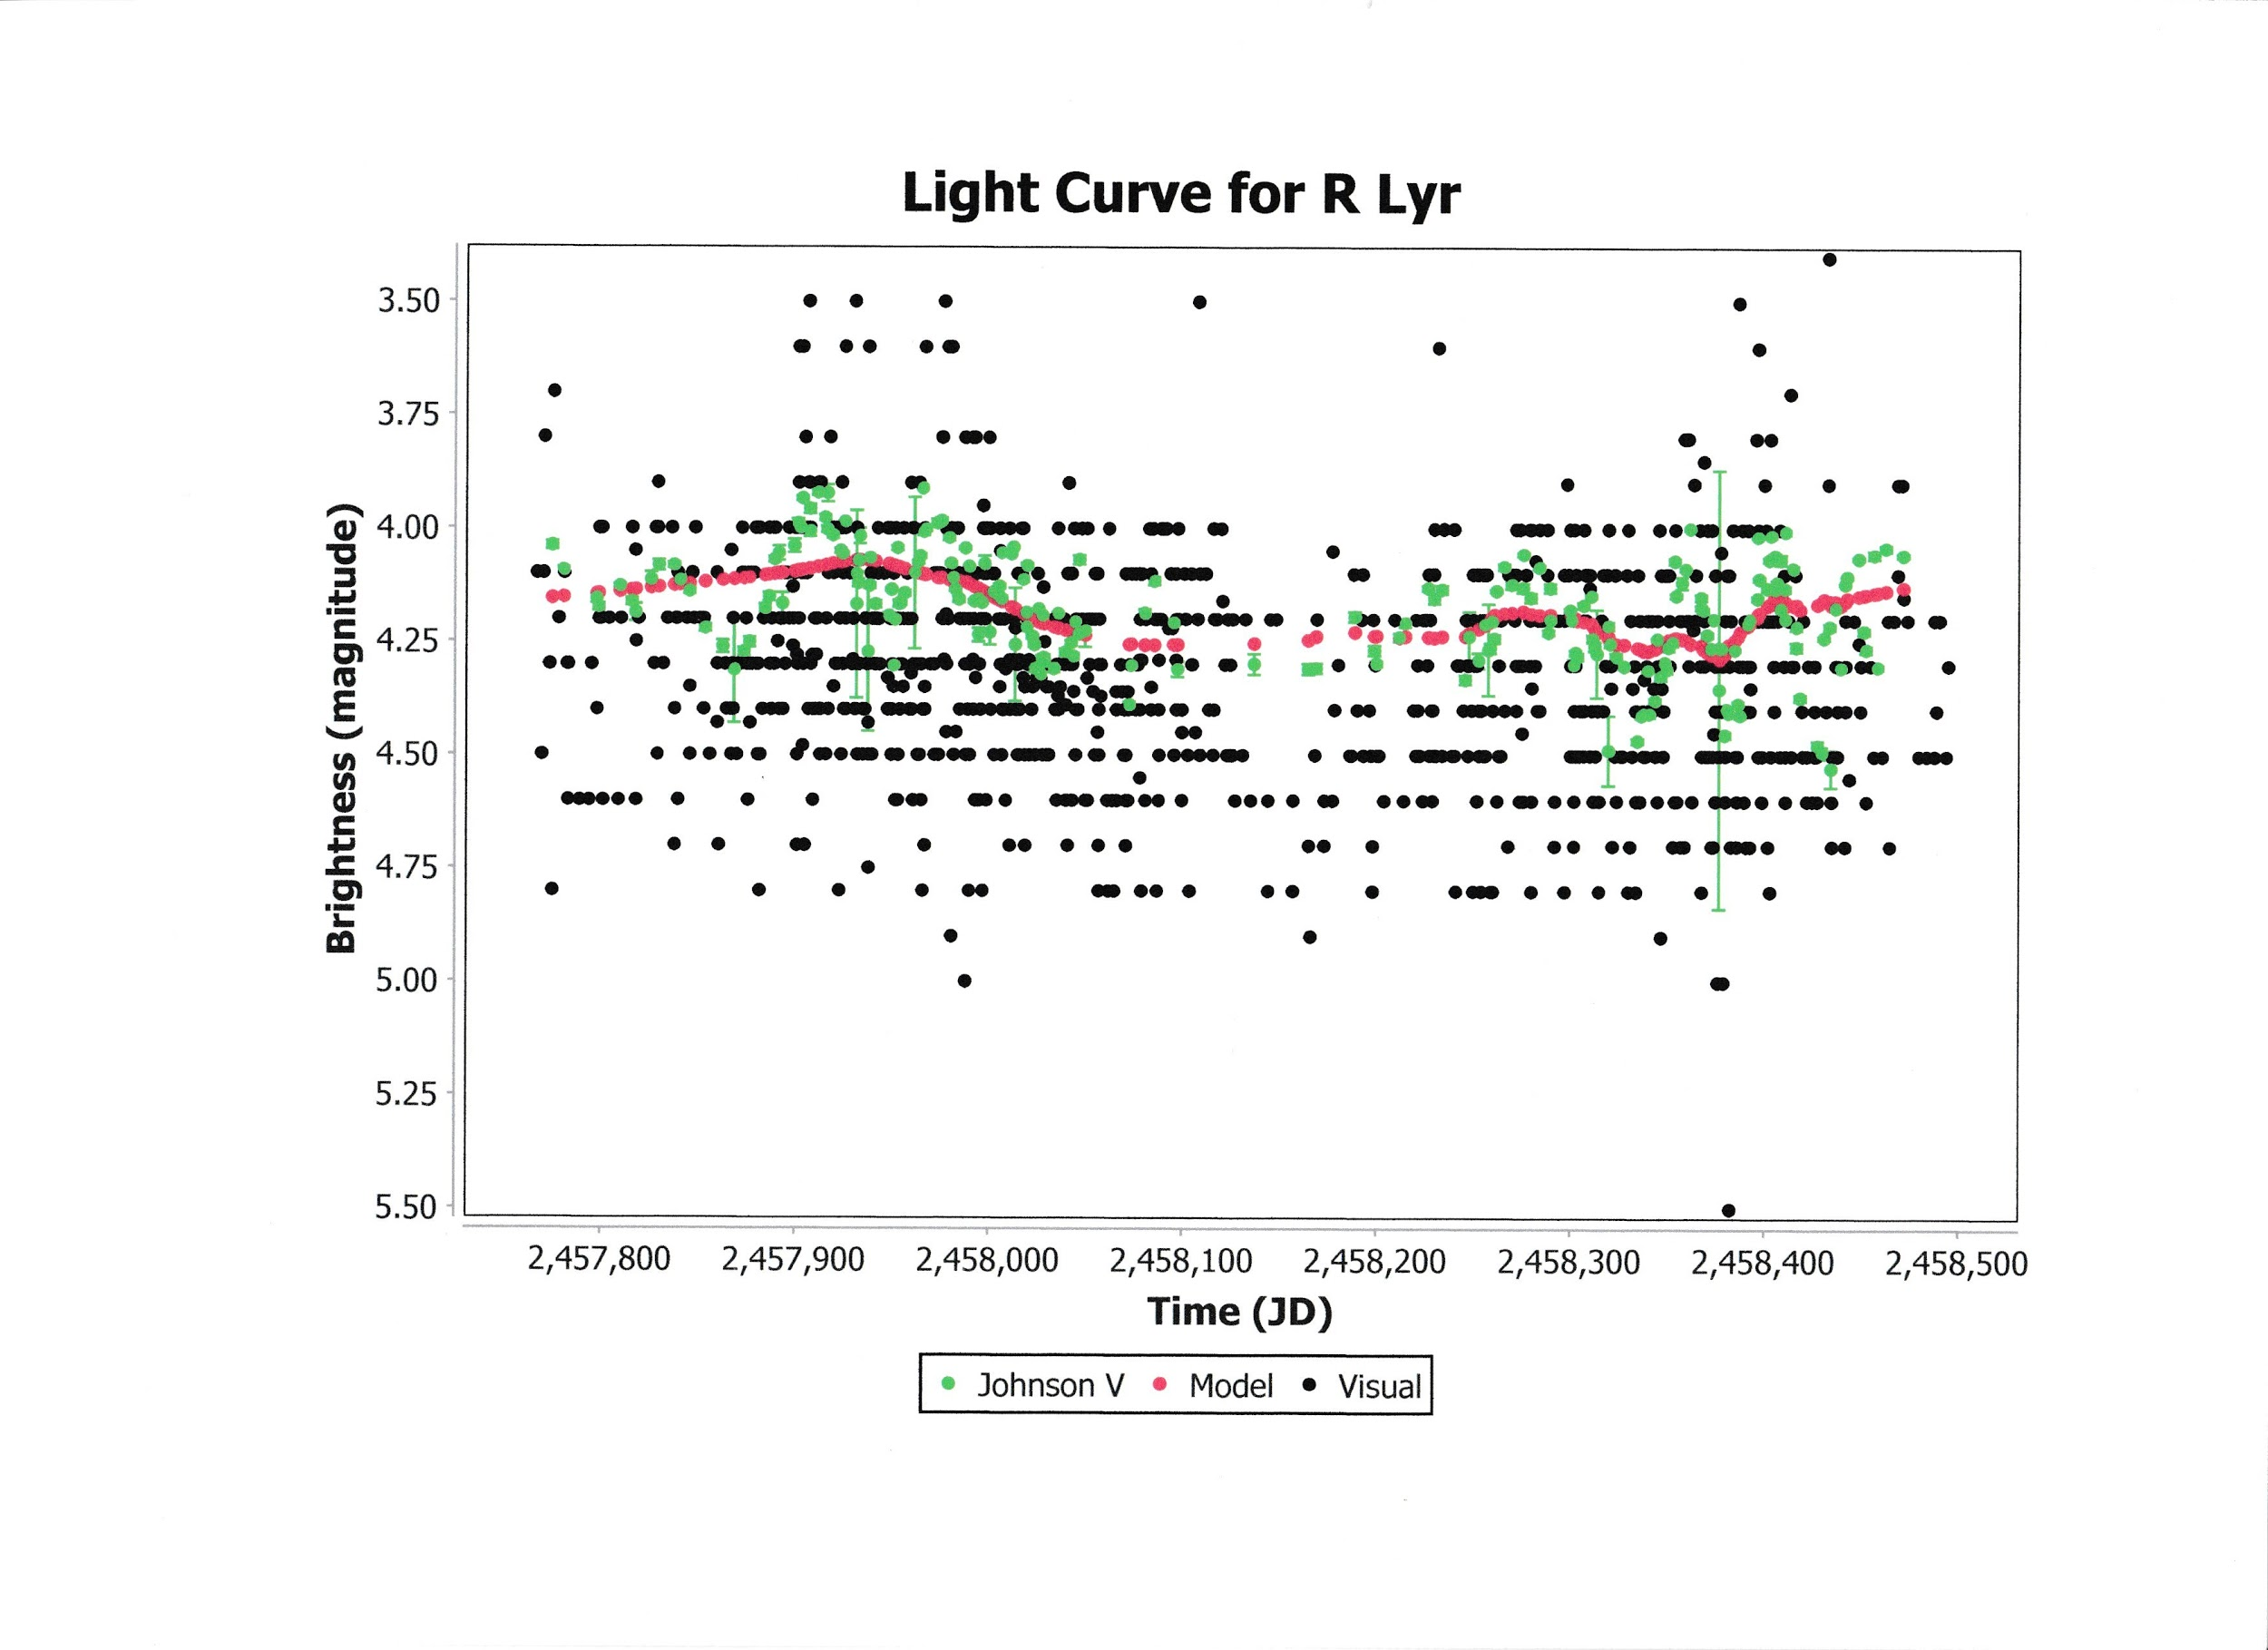Other options include plotting Means, Model and Residuals.