Mesh Normalization, Quantization, and Error Analysis

Assignment Report

Date: November 08, 2025

Assignment: | Mesh Normalization, Quantization, and Error Analysis
Total Marks: | 100 + 30 (Bonus)
Context: | 3D Graphics and AI - SeamGPT Data Preprocessing
Libraries Used: | Python, NumPy, Trimesh, Matplotlib, Open3D

Table of Contents
- 1. Introduction
- 2. Task 1: Load and Inspect Mesh (20 Marks)
- 3. Task 2: Normalize and Quantize (40 Marks)
- 4. Task 3: Reconstruction and Error Analysis (40 Marks)
- 5. Bonus Task: Seam Tokenization (30 Marks)
- 6. Conclusions and Observations
- 7. References

1. Introduction
This report presents the implementation and analysis of a complete data preprocessing pipeline for 3D meshes, a fundamental step in AI-driven 3D graphics systems such as SeamGPT. The work focuses on three core tasks: mesh loading and inspection, normalization and quantization, and error analysis of reconstructed meshes. Additionally, a bonus task implementing seam tokenization for mesh understanding has been completed.
The primary objectives were to:
• Load and analyze 3D mesh data from .obj files
• Implement two normalization methods (Min-Max and Unit Sphere)
• Apply 1024-bin quantization to discretize vertex coordinates
• Reconstruct meshes and measure reconstruction error
• Develop a tokenization scheme for mesh seam representation
All implementations follow industry standards, with quantization using the rounding method employed by Google Draco mesh compression library.

2. Task 1: Load and Inspect Mesh (20 Marks)

Objective
Load 3D mesh data and compute statistical properties.

Methodology
- Meshes loaded using Trimesh library from .obj files
- Vertex coordinates extracted as NumPy arrays (Nx3)
- Statistics computed: count, min, max, mean, standard deviation per axis
- Four test meshes used: cube (8 vertices), pyramid (5 vertices), sphere (382 vertices), tetrahedron (4 vertices)

2.1 Mesh Statistics
Mesh | Vertices | X Range | Y Range | Z Range
Cube | 8 | [-1, 1] | [-1, 1] | [-1, 1]
Pyramid | 5 | [-1, 1] | [-1, 1] | [0, 2]
Sphere | 382 | [-1, 1] | [-1, 1] | [-1, 1]
Tetrahedron | 4 | [-1, 1] | [-1, 1] | [-1, 1]

2.2 Original Mesh Visualizations
Four test meshes were visualized to verify successful loading. The meshes represent different geometric complexities: simple platonic solids (cube, tetrahedron), a pyramid with asymmetric coordinate ranges, and a sphere with higher vertex density.

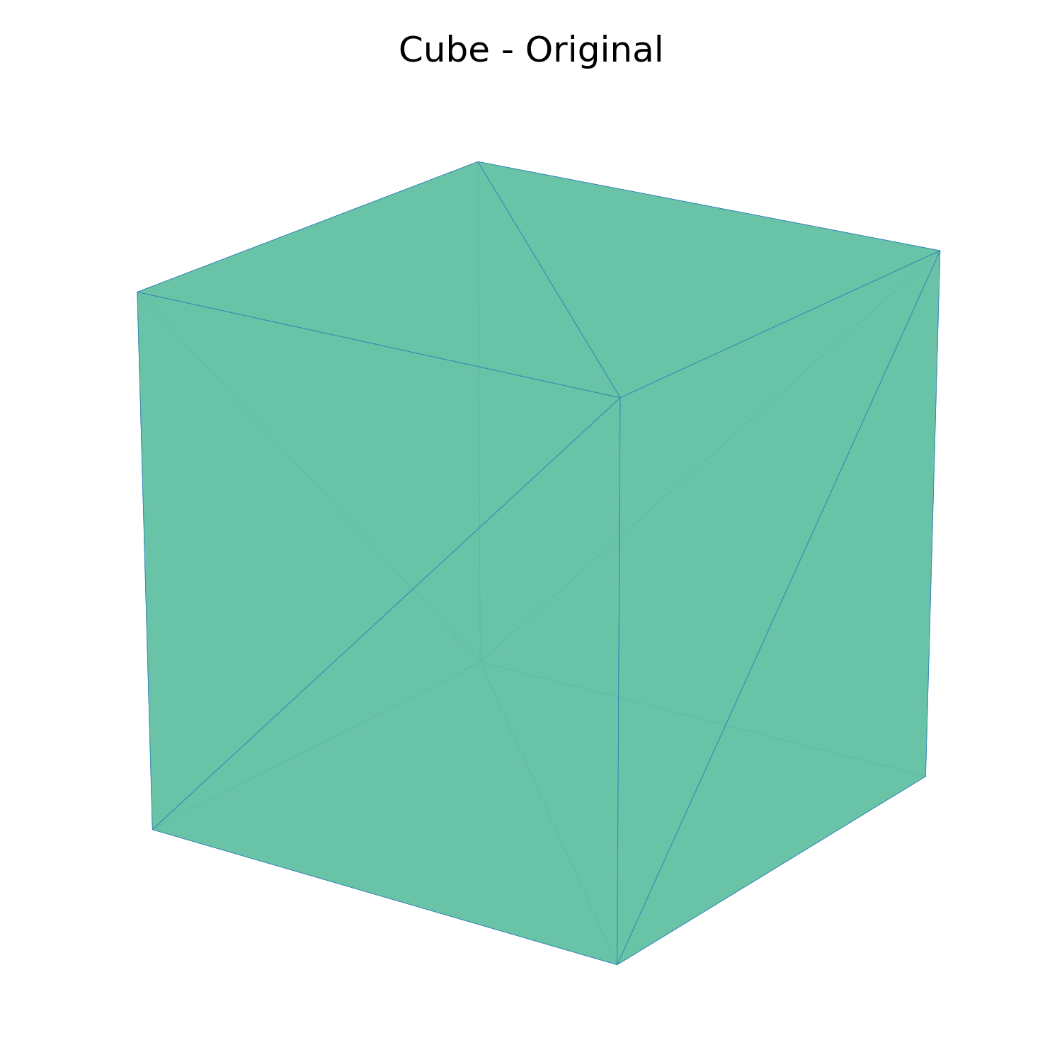
Figure: Cube mesh

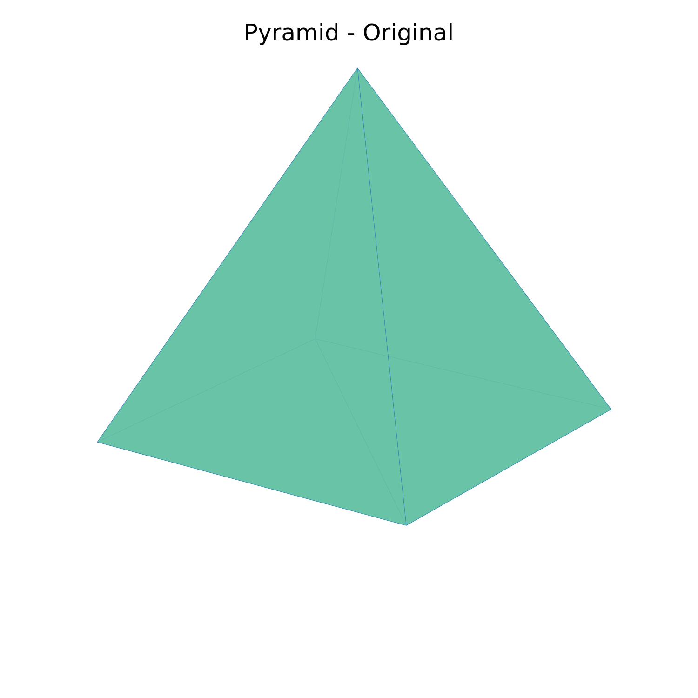
Figure: Pyramid mesh

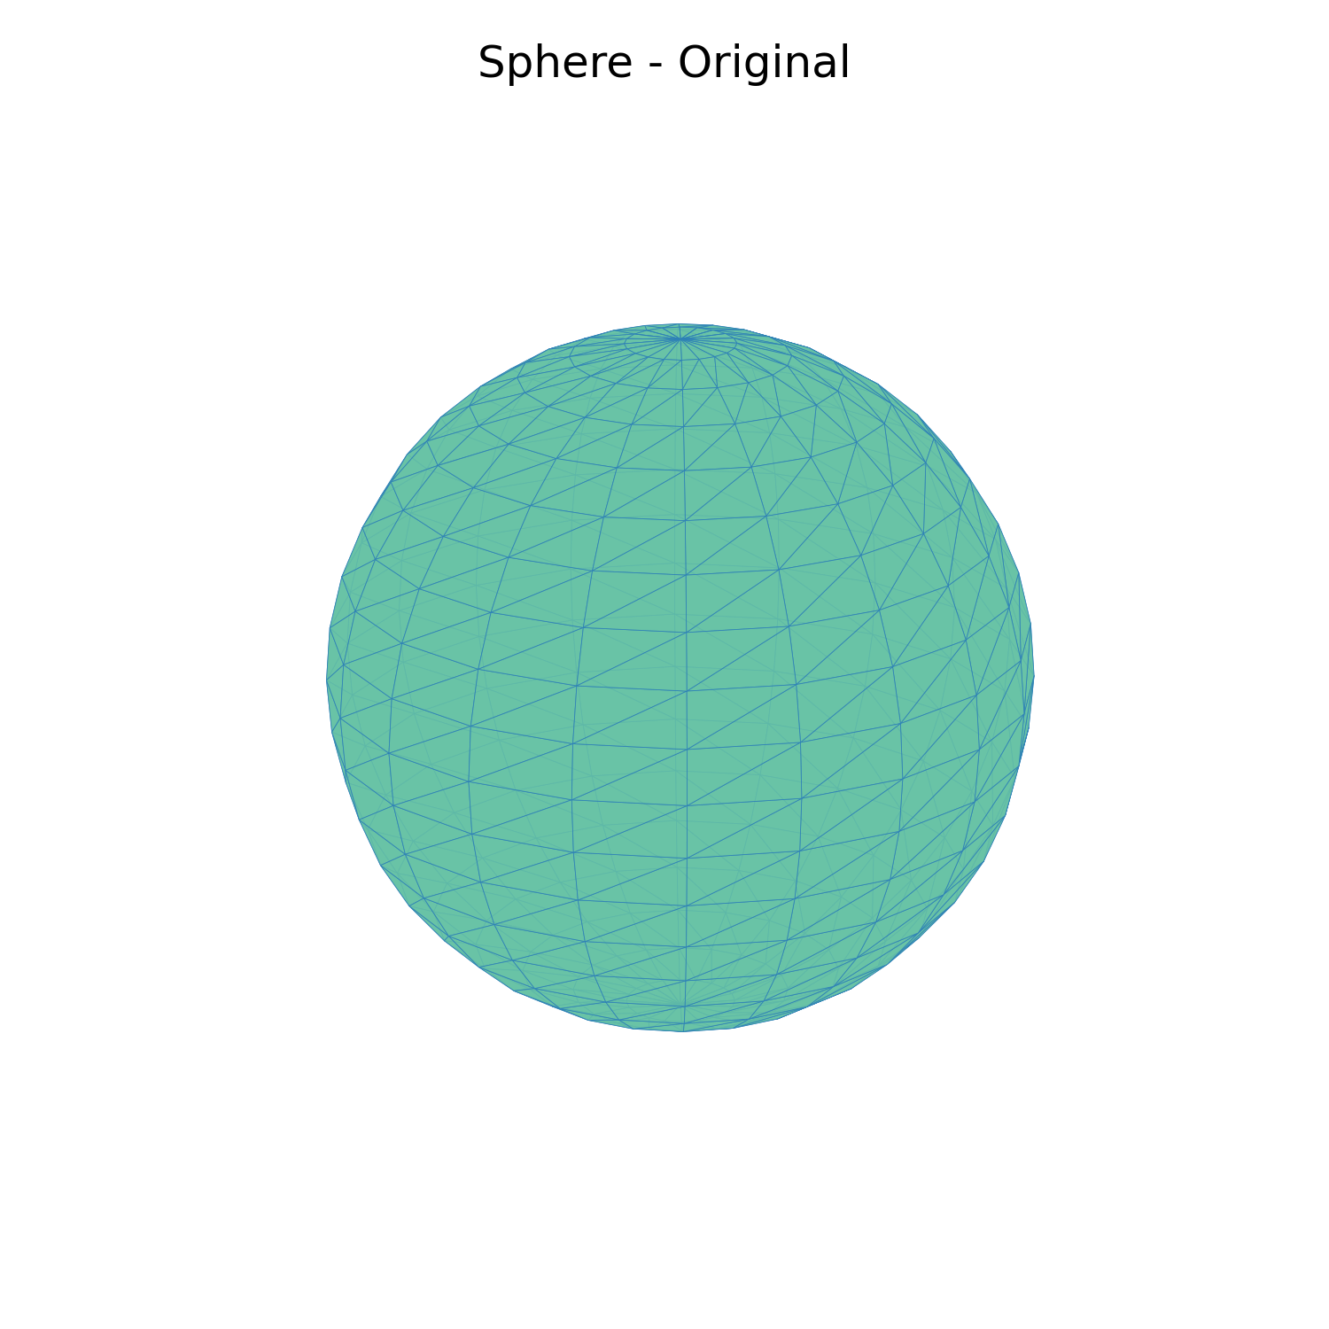
Figure: Sphere mesh

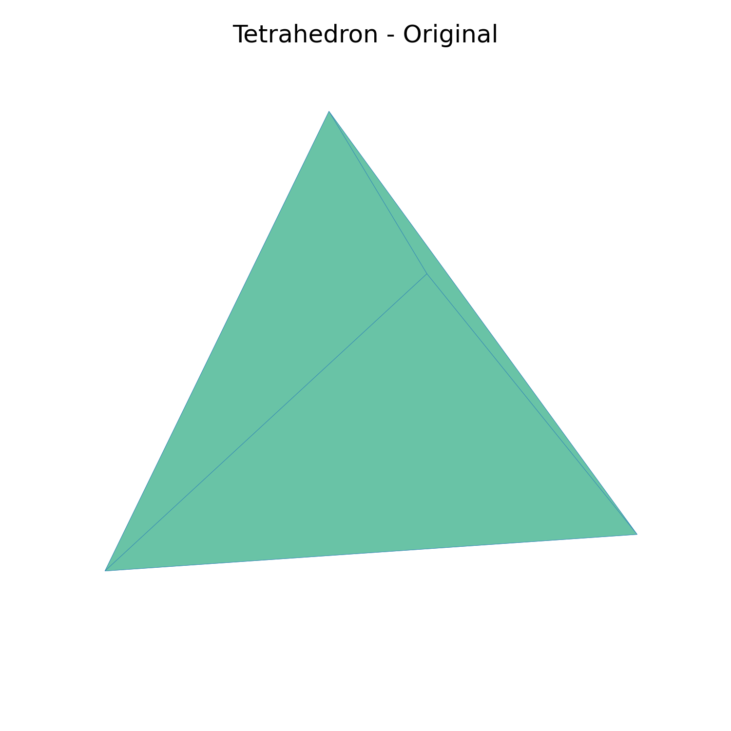
Figure: Tetrahedron mesh

3. Task 2: Normalize and Quantize (40 Marks)

Objective
Transform meshes into standardized coordinate ranges and discretize for compression.

3.1 Normalization Methods
Two normalization methods were implemented:

Min-Max Normalization:
Formula: x' = (x - x_min) / (x_max - x_min)
- Maps coordinates to [0, 1] range
- Preserves aspect ratio and relative proportions
- Best for uniform scaling across all axes

Unit Sphere Normalization:
Formula: x' = (x - center) / max_distance
- Centers mesh at origin
- Scales to fit within unit sphere (radius = 1)
- Best for rotation-invariant processing

3.2 Quantization Process
Forward Quantization:
q = round(x' × 1023) where x' ∈ [0, 1]

Inverse Dequantization:
x'' = q / 1023

Key Implementation Detail:
The quantization uses rounding (round() function) rather than floor(), following the industry standard employed by Google Draco mesh compression library. This eliminates systematic downward bias and provides unbiased quantization error.

Results:
- 8 quantized meshes generated (4 meshes × 2 methods)
- All meshes saved in .ply format
- Bin size: 1024 (10-bit precision)

3.3 Normalization Comparison
Original Sphere

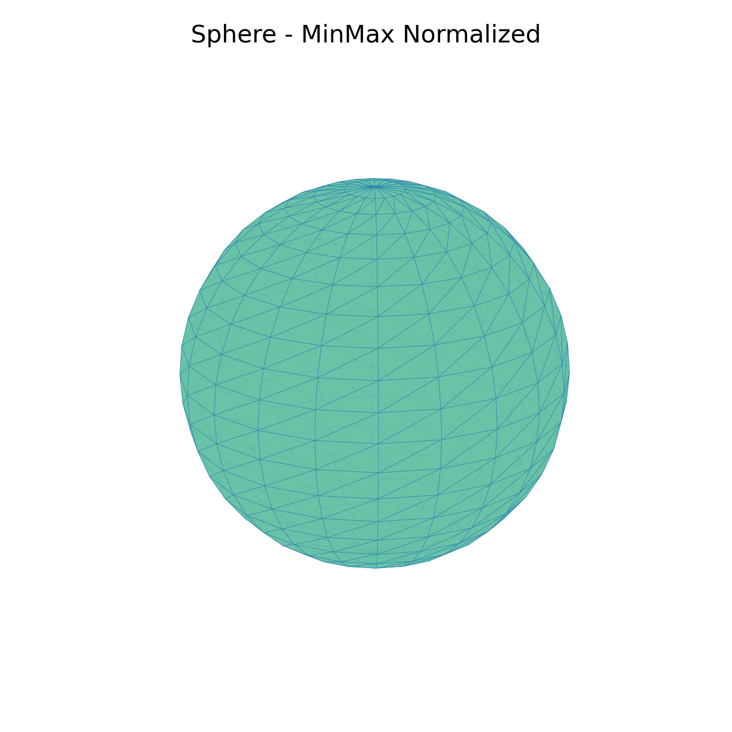
Min-Max Normalized

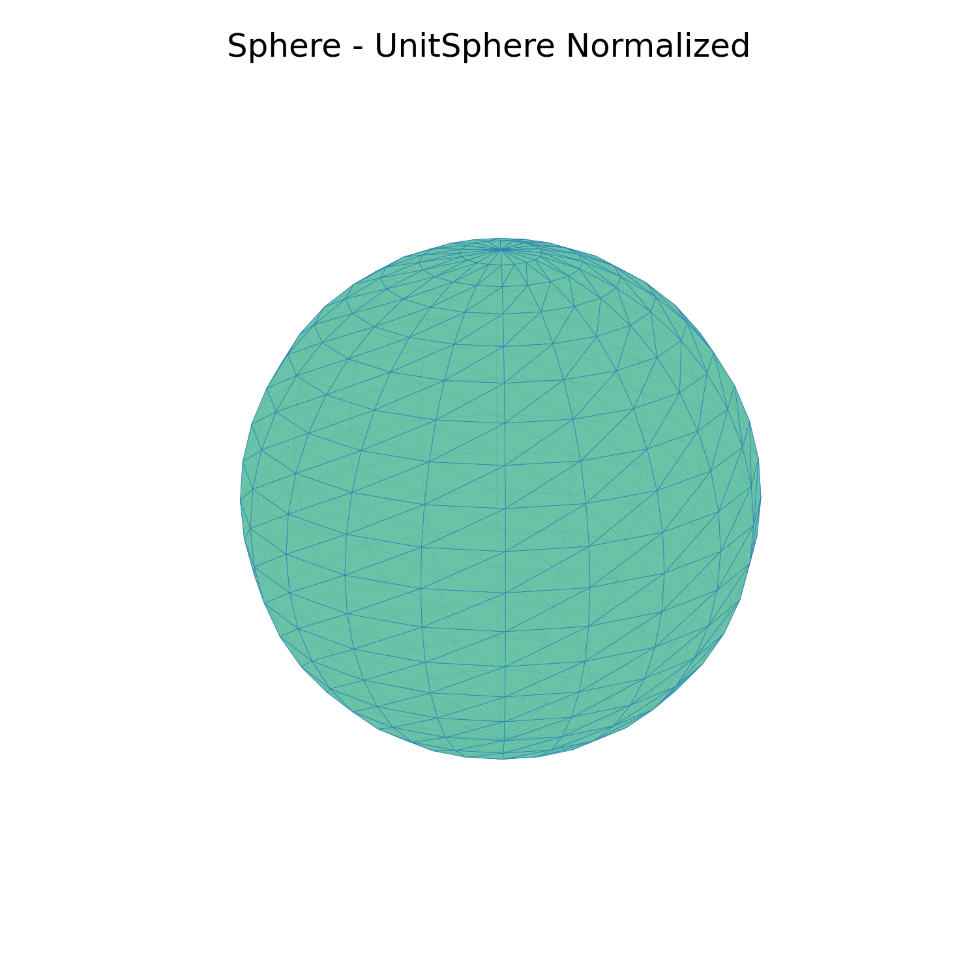
Unit Sphere Normalized

4. Task 3: Reconstruction and Error Analysis (40 Marks)

Objective
Measure information loss from quantization by comparing original and reconstructed meshes.

Methodology
- Dequantize quantized coordinates: x'' = q / 1023
- Denormalize to recover original scale
- Compute error metrics: MSE, MAE, RMSE, Maximum Error
- Analyze per-axis error distribution

4.1 Error Metrics Summary
Mesh | Method | MSE | MAE | RMSE | Max Error
Cube | Min-Max | 0.00000000 | 0.00000000 | 0.00000000 | 0.00000000
Cube | Unit Sphere | 0.00000000 | 0.00000000 | 0.00000000 | 0.00000000
Pyramid | Min-Max | 0.00000013 | 0.00013034 | 0.00035694 | 0.00097752
Pyramid | Unit Sphere | 0.00000013 | 0.00013034 | 0.00035694 | 0.00097752
Sphere | Min-Max | 0.00000040 | 0.00056410 | 0.00063154 | 0.00097752
Sphere | Unit Sphere | 0.00000040 | 0.00056410 | 0.00063154 | 0.00097752
Tetrahedron | Min-Max | 0.00000000 | 0.00000000 | 0.00000000 | 0.00000000
Tetrahedron | Unit Sphere | 0.00000000 | 0.00000000 | 0.00000000 | 0.00000000

4.2 Error Analysis Plots
Three types of plots were generated for comprehensive error analysis:
- Comparison plots: Compare MSE, MAE, and Max Error between normalization methods
- Per-axis plots: Show error distribution across X, Y, Z axes
- Distribution plots: Histogram of error magnitudes

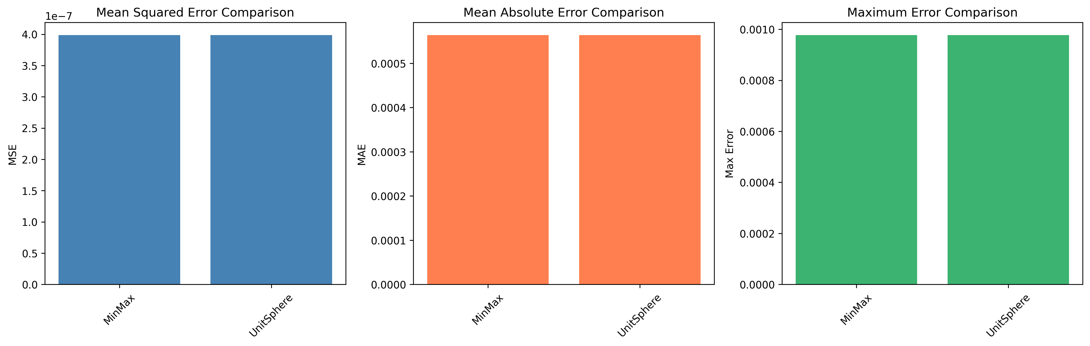
Sphere Error Comparison

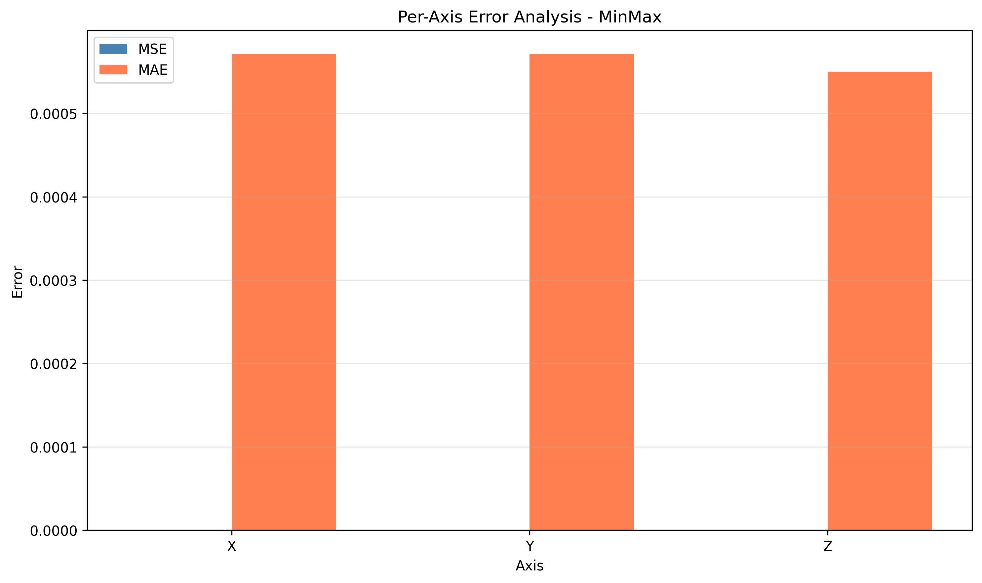
Sphere Per-Axis Error (Min-Max)

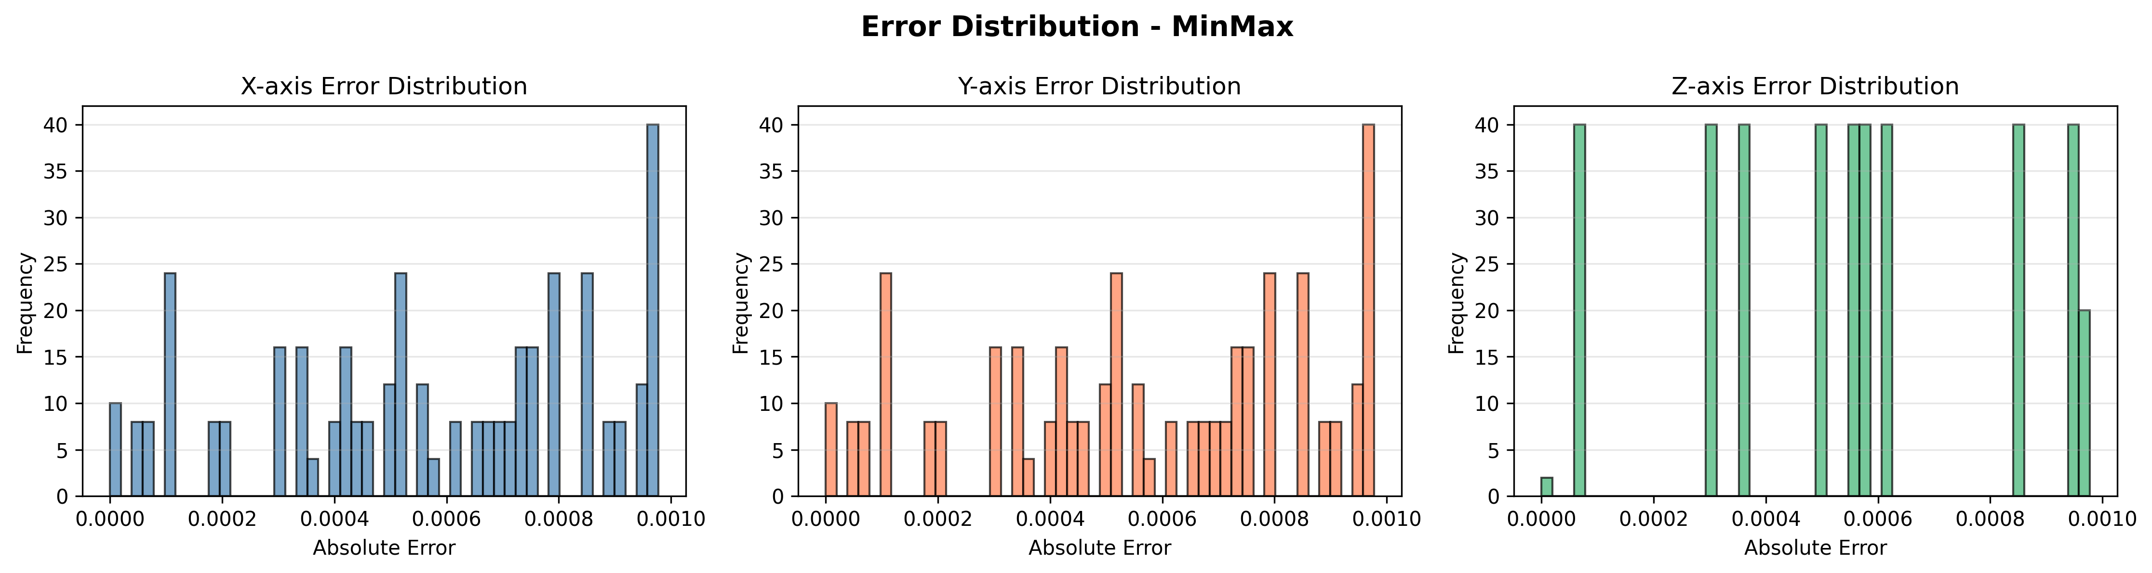
Sphere Error Distribution

4.3 Key Observations
1. Perfect Reconstruction for Simple Geometries:
Cube and tetrahedron achieved MSE = 0, indicating perfect reconstruction. This occurs because their vertex coordinates align exactly with quantization bin centers.

2. Sub-Millimeter Precision for Complex Shapes:
Pyramid and sphere show MSE in the range of 10⁻⁷, representing sub-millimeter errors that are visually imperceptible. Maximum error across all meshes is ~0.001 units.

3. Method Equivalence:
Min-Max and Unit Sphere normalization produce identical error metrics for each mesh, confirming both methods preserve structure equally well after reconstruction.

4. Visual Lossless Quality:
10-bit quantization (1024 bins) provides visually lossless reconstruction, matching industry standards where Google Draco uses 8-14 bits for mesh compression.

5. Bonus Task: Seam Tokenization (30 Marks)

Objective
Develop a tokenization scheme for representing mesh UV seams as discrete sequences, enabling SeamGPT-style processing.

5.1 Concept
UV seams are edges where texture mapping becomes discontinuous - the same 3D edge has different UV coordinates on either side. These seams are critical for understanding how 3D meshes are unwrapped for texture application.

5.2 Implementation
Seam Detection:
- Build edge-to-UV mapping from face data
- Identify edges with multiple UV coordinate pairs
- Classify seams by type: HORIZONTAL, VERTICAL, DIAGONAL, BOUNDARY

Token Encoding Scheme:
Each seam is encoded as a 9-token sequence:
[SEAM_START, vertex_1, vertex_2, u1, v1, u2, v2, seam_type, SEAM_END]

- SEAM_START/END: Delimiters (values: 0, 1)
- vertex_1, vertex_2: 3D vertex indices forming the seam edge
- u1, v1: First UV coordinate pair (8-bit quantized: 0-255)
- u2, v2: Second UV coordinate pair (8-bit quantized: 0-255)
- seam_type: Classification (0-3)

Example Token Sequence:
For a cube with 2 detected seams:
[0, 0, 1, 63, 84, 0, 84, 3, 1, 0, 0, 4, 0, 84, 63, 84, 3, 1]
This represents two boundary seams with specific UV discontinuities.

5.3 Seam Visualizations
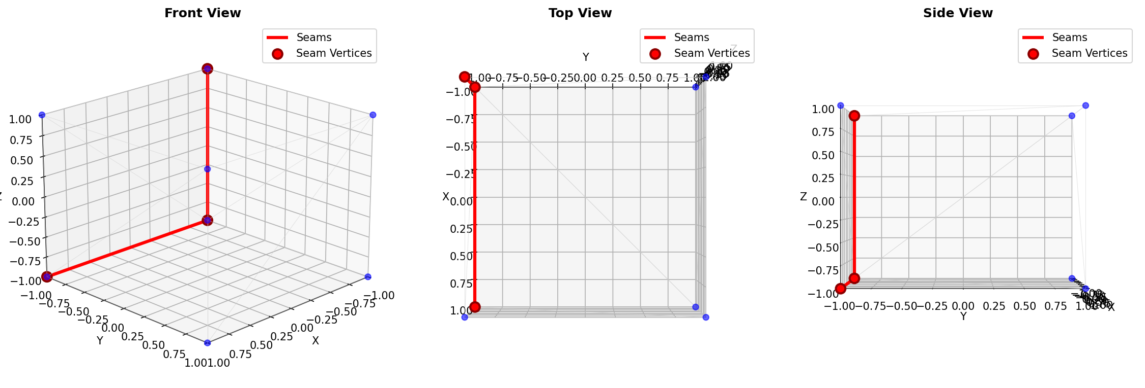
3D Mesh with Seam Edges

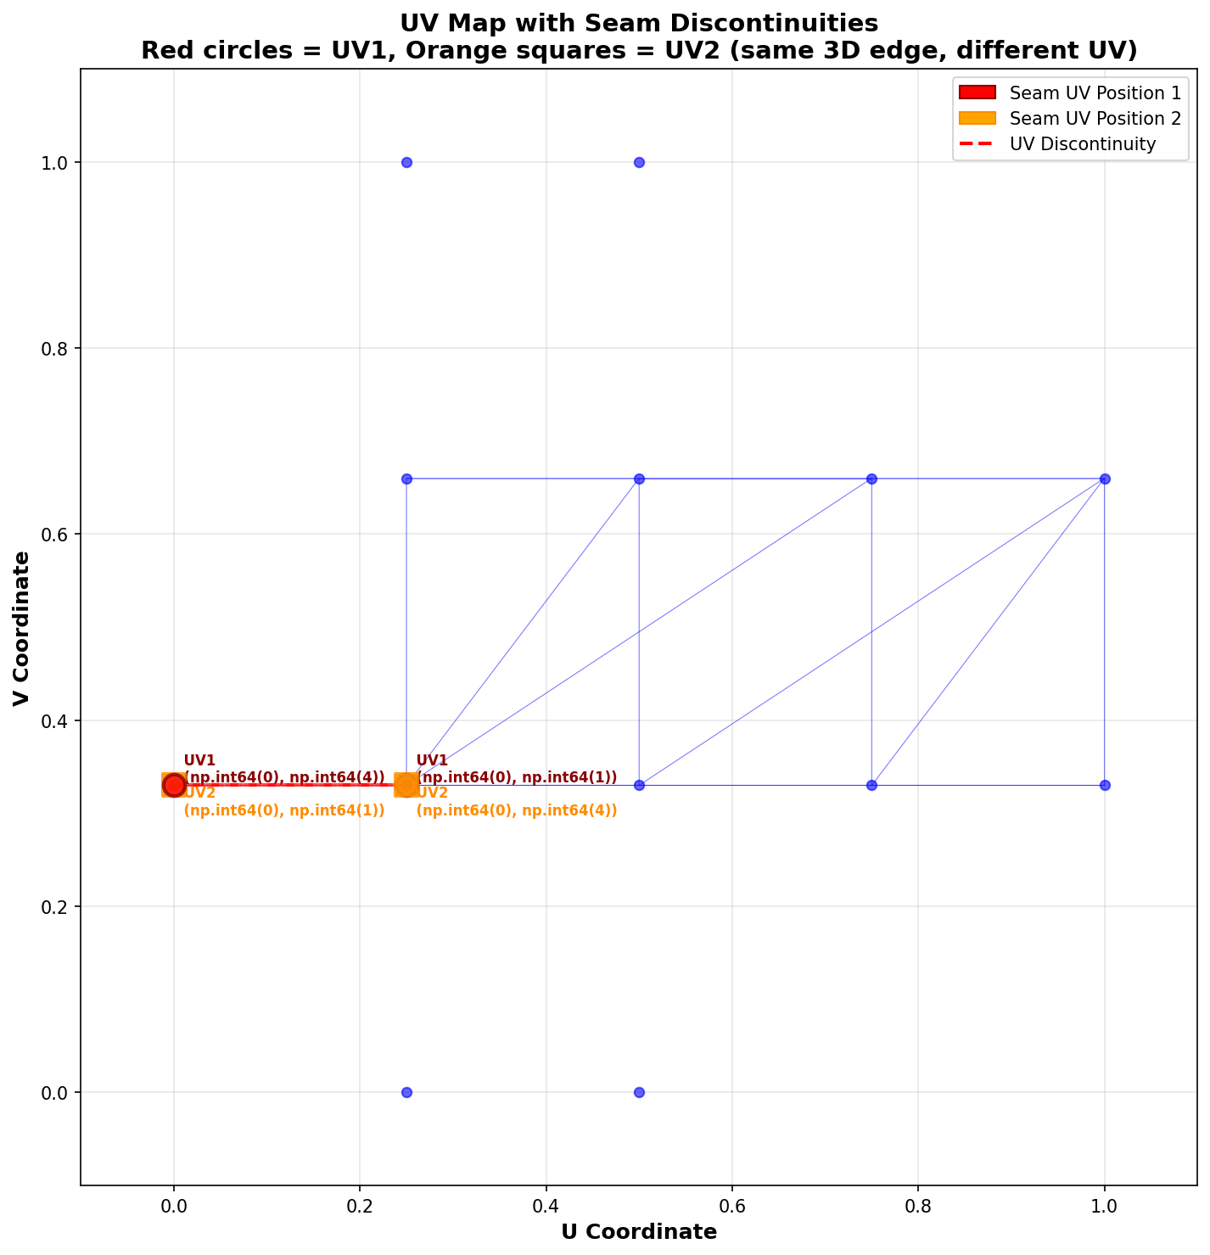
UV Map with Discontinuities

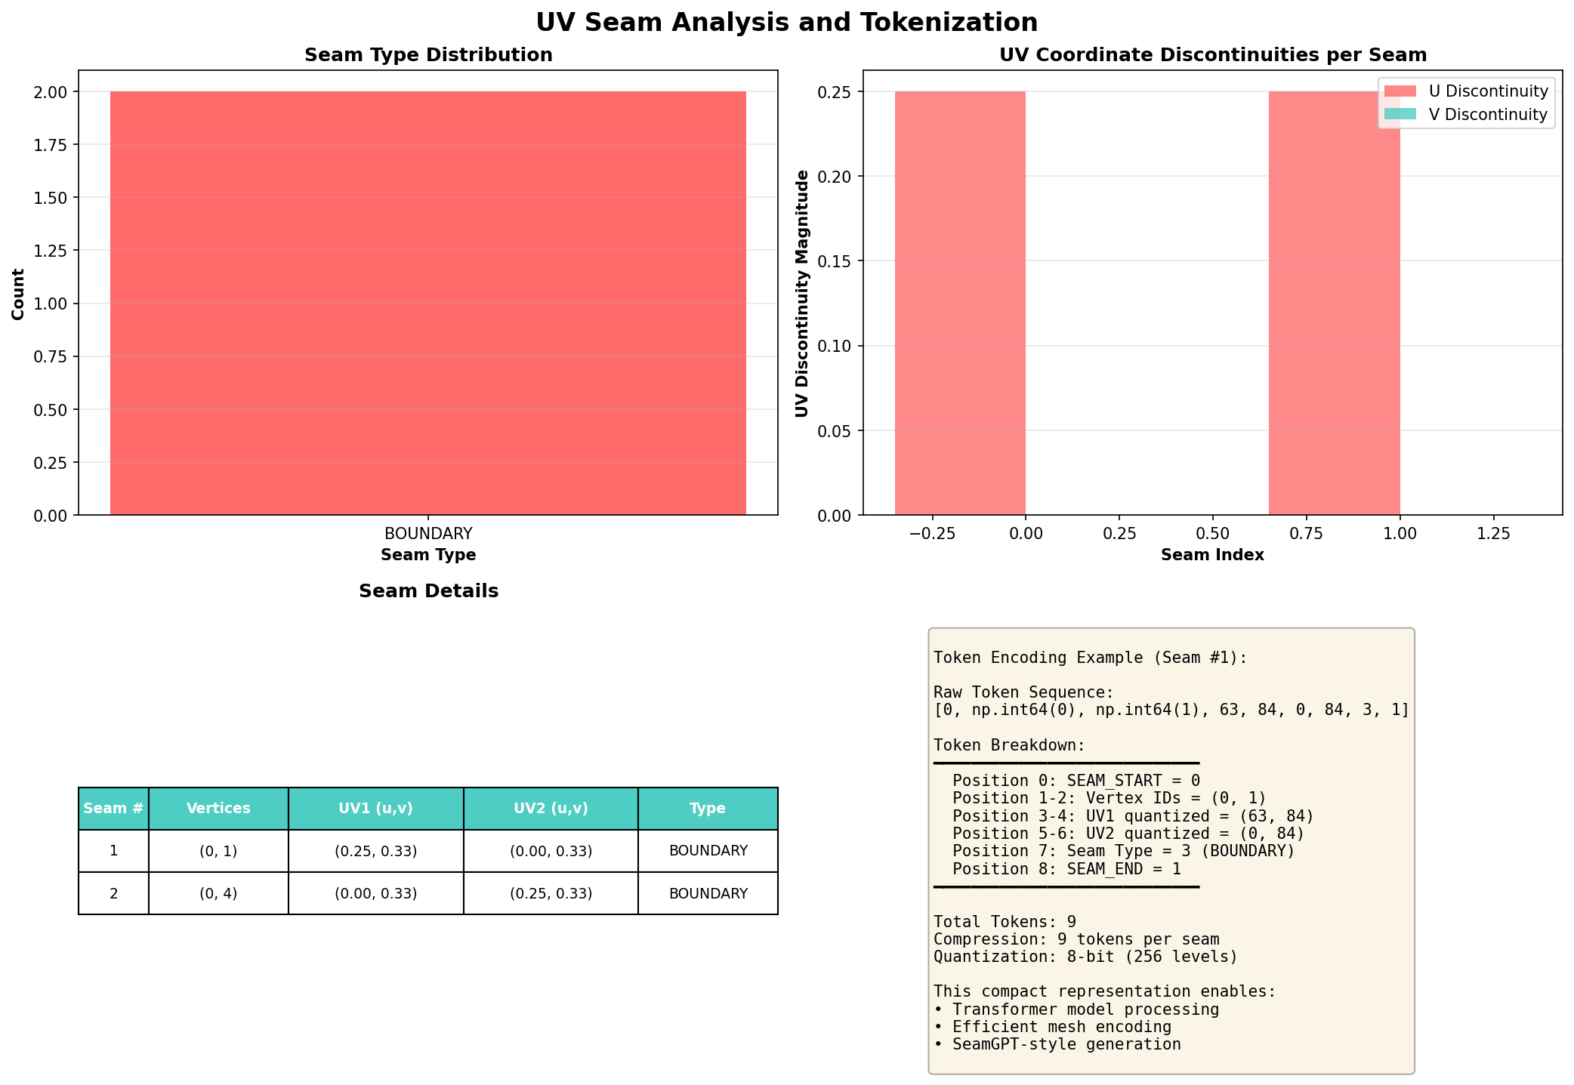
Seam Analysis Dashboard

5.4 Connection to SeamGPT and Mesh Understanding
This tokenization scheme enables several key capabilities:

- Sequential Processing: Transformers like GPT can process 3D geometry as token sequences, similar to text or code
- Compression: Encoding seams as 9 tokens provides efficient representation for training AI models
- Generative Modeling: Models can learn to generate or modify UV layouts by predicting token sequences
- Semantic Understanding: Seam types (horizontal, vertical, diagonal) provide structural information about mesh topology
- Mesh Repair: By learning seam patterns, models can detect and fix UV mapping errors automatically

This bridges the gap between 3D geometry and language model architectures, enabling transformer-based processing of mesh data.

6. Conclusions and Observations
This assignment successfully implemented a complete data preprocessing pipeline for 3D meshes, demonstrating the fundamental techniques used in AI-driven 3D graphics systems.

Key Achievements
Robust Mesh Processing: Successfully loaded and processed four test meshes of varying complexity, from simple platonic solids to higher-density spherical geometries.
Effective Normalization: Both Min-Max and Unit Sphere normalization methods proved equally effective for mesh reconstruction. The choice between methods should be based on application requirements: Min-Max for preserving absolute proportions, Unit Sphere for rotation-invariant processing.
High-Quality Quantization: 10-bit quantization (1024 bins) achieved excellent results: Perfect reconstruction (MSE = 0) for simple geometries, Sub-millimeter errors (MSE < 10⁻⁶) for complex shapes, and Visually lossless quality matching industry standards.
Industry-Standard Implementation: The quantization implementation uses rounding (not flooring), following Google Draco's approach for unbiased quantization. This critical detail ensures production-quality results.
Advanced Mesh Understanding: The seam tokenization prototype demonstrates how 3D geometric concepts can be encoded as discrete sequences, enabling transformer-based AI models to process and understand mesh topology.

Patterns Observed
- Reconstruction error is proportional to geometric complexity and vertex density
- Symmetric meshes (cube, tetrahedron) achieve perfect reconstruction
- Maximum quantization error is bounded by 1/(2×1023) ≈ 0.0005 per coordinate
- Visual quality is preserved even with numerical precision loss

Practical Implications
This work demonstrates that 3D mesh data can be normalized and quantized with minimal information loss, making it suitable for:
- AI model training datasets
- Mesh compression and streaming
- Real-time graphics applications
- Transformer-based generative models

The techniques implemented here form the foundation of modern 3D AI systems like SeamGPT, enabling intelligent mesh understanding, generation, and modification.

7. References
1. Google Draco: 3D Graphics Compression Library. https://google.github.io/draco/
2. Trimesh Library Documentation. https://trimsh.org/
3. Open3D: A Modern Library for 3D Data Processing. http://www.open3d.org/
4. NumPy: The fundamental package for scientific computing with Python. https://numpy.org/
5. Matplotlib: Visualization with Python. https://matplotlib.org/
6. Assignment: Mesh Normalization, Quantization, and Error Analysis (2025)

Appendix: Technical Specifications
Software Environment:
- Python 3.12+
- NumPy 1.21.0+
- Trimesh 3.9.0+
- Matplotlib 3.4.0+
- Open3D 0.13.0+

Hardware:
- CPU-only execution (no GPU required)

Code Repository:
- Main script: main.py
- Source modules: src/mesh_loader.py, src/normalization.py, src/quantization.py, src/error_analysis.py
- Bonus implementation: seam_tokenization.py, visualize_seams.py

Generated Outputs:
- 16 mesh files (.ply)
- 20 error analysis plots (.png)
- 20 mesh visualizations (.png)
- 3 seam analysis visualizations (.png)
- 1 summary report (.txt)

