FRONTEND ASSIGNMENT – 1
Introduction To Frontend Engineering – Theory
▁▁▁▁▁▁▁▁▁▁▁▁▁▁▁▁▁▁▁▁▁▁▁▁▁▁▁▁▁▁▁▁▁▁▁▁▁▁▁▁▁▁▁▁
Name: Aayushi
Course: B.Tech CSE
Roll No.: 22515000005
SECTION: NA
Subject: Introduction To Frontend Engineering
Assignment: Assignment 1

▁▁▁▁▁▁▁▁▁▁▁▁▁▁▁▁▁▁▁▁▁▁▁▁▁▁▁▁▁▁▁▁▁▁▁▁▁▁▁▁▁▁▁▁

Q1. HTTP Request–Response Cycle
The Hypertext Transfer Protocol (HTTP) Request–Response cycle describes the sequence of events that takes place when a client (typically a web browser) requests a resource — such as a web page, image, or file — from a web server, and the server sends back the requested resource. This cycle forms the foundation of communication on the World Wide Web.
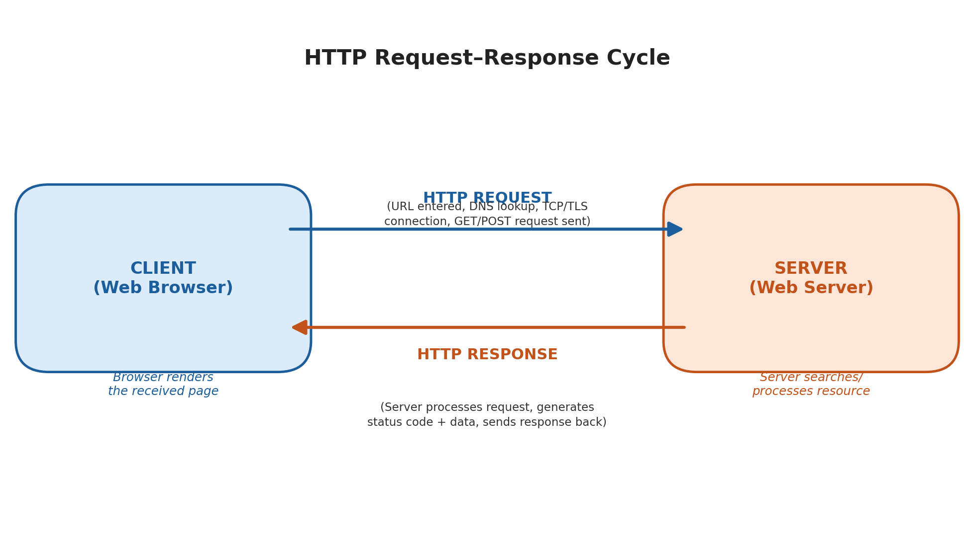
Fig 1.1: HTTP Request–Response Cycle
Major Steps Involved
- 1. URL Entry: The user types a URL (e.g., www.example.com) into the browser's address bar or clicks a hyperlink.
- 2. DNS Resolution: The browser contacts a Domain Name System (DNS) server to translate the human-readable domain name into the numeric IP address of the web server.
- 3. TCP/TLS Connection Establishment: The browser establishes a TCP (Transmission Control Protocol) connection with the server, and if the site uses HTTPS, a TLS/SSL handshake is performed to secure the connection.
- 4. Sending the HTTP Request: The browser sends an HTTP request to the server. This request includes a method (GET, POST, PUT, DELETE, etc.), headers (such as browser type and accepted content), and sometimes a body (e.g., form data).
- 5. Server Processing: The server receives the request, processes it (which may involve querying a database, running server-side scripts, or simply locating a static file), and prepares an appropriate response.
- 6. Sending the HTTP Response: The server sends back an HTTP response consisting of a status line (e.g., 200 OK, 404 Not Found), response headers, and the response body (HTML, JSON, image data, etc.).
- 7. Rendering the Response: The browser receives the response, parses the HTML/CSS/JavaScript, and renders the final web page on the user's screen.
- 8. Connection Closure: Once the data transfer is complete, the connection may be closed or kept alive (in the case of persistent HTTP connections) for further requests.
This entire cycle typically takes place within a fraction of a second and may be repeated multiple times as a single web page loads additional resources such as images, stylesheets, and scripts.

Q2. Introduction to Web Technologies
The following web technologies together form the foundation of modern web and frontend development:
1. HTML (HyperText Markup Language)
- Purpose: HTML is the standard markup language used to create the structure and content of web pages.
- Key Features: Uses elements/tags to define headings, paragraphs, links, images, tables, and forms; provides semantic structure; is platform-independent and forms the skeleton of every web page.
2. CSS (Cascading Style Sheets)
- Purpose: CSS is used to control the presentation, layout, and visual styling of HTML elements.
- Key Features: Separates content from design; supports colors, fonts, spacing, positioning, responsive design (media queries), animations, and Flexbox/Grid layouts.
3. JavaScript
- Purpose: JavaScript is a scripting language that adds interactivity and dynamic behavior to web pages.
- Key Features: Manipulates the DOM in real time, handles events (clicks, form submissions), supports asynchronous operations (AJAX, Fetch API), and runs on both client and server (Node.js).
4. Bootstrap
- Purpose: Bootstrap is a popular open-source CSS framework used to design responsive, mobile-first websites quickly.
- Key Features: Provides a 12-column responsive grid system, pre-built UI components (navbars, buttons, modals, cards), and consistent cross-browser styling.
5. jQuery
- Purpose: jQuery is a fast, lightweight JavaScript library that simplifies HTML DOM manipulation, event handling, and animation.
- Key Features: Offers simple syntax for complex tasks, cross-browser compatibility, and easy AJAX handling, using the well-known $() selector syntax.
6. React.js
- Purpose: React.js is a JavaScript library developed by Facebook (Meta) for building fast, interactive user interfaces, especially single-page applications (SPAs).
- Key Features: Uses a component-based architecture, a Virtual DOM for efficient rendering, one-way data binding, and JSX syntax for combining HTML with JavaScript.

Q3. Client-Side vs. Server-Side Technologies
Client-Side Technologies
Client-side technologies are those that run directly in the user's web browser. They are responsible for the presentation and interactivity of a website, and their code is downloaded and executed on the user's device. Examples include HTML, CSS, JavaScript, Bootstrap, jQuery, and React.js.
Server-Side Technologies
Server-side technologies run on the web server and are responsible for processing requests, interacting with databases, performing business logic, and generating dynamic content that is then sent to the client. Examples include PHP, Node.js, Python (Django/Flask), Java (Spring), ASP.NET, and databases such as MySQL or MongoDB.
Key Differences
Basis | Client-Side Technology | Server-Side Technology
Execution Location | Runs in the user's browser | Runs on the web server
Visibility | Source code is visible to the user (View Source) | Source code remains hidden from the user
Purpose | Handles UI, layout, and interactivity | Handles data processing, business logic, and storage
Dependency | Depends on browser and client device | Depends on server hardware/software
Examples | HTML, CSS, JavaScript, React.js | PHP, Node.js, Python, Java, databases
Performance Impact | Affects browser rendering speed | Affects server response time

Q4. Block-Level Elements in HTML
Block-level elements are HTML elements that start on a new line and take up the full width available, pushing subsequent content to the next line. They are used to structure the major sections of a web page's content.
Characteristics
- Starts on a new line: Each block-level element begins on a new line, separating it visually from surrounding content.
- Occupies full width: By default, a block-level element stretches to occupy the entire width of its parent container.
- Can contain other elements: Height, width, margin, and padding of block-level elements can be freely set using CSS.
- Nesting: Block-level elements can contain other block-level elements as well as inline elements (e.g., <span>, <a>).
Examples of Block-Level Elements
- <p> : Defines a paragraph of text.
- <div> : Defines a generic container/division used for grouping and styling content.
- <h1> to <h6> : Represent heading levels 1 through 6, from most to least important.
- <ol> and <ul> : Define ordered and unordered lists respectively.
- <form> : Used to group related form controls together.

Q5. Semantic HTML Elements
Semantic elements are HTML elements that clearly describe their meaning and purpose, both to the browser and to the developer, rather than simply defining how content should appear. Unlike generic elements such as <div> and <span>, semantic elements convey the role of the content they contain.
Importance in Web Development
- Improved Accessibility: Semantic tags help screen readers and assistive technologies understand page structure, making websites more accessible to users with disabilities.
- Better SEO: Search engines can better interpret the content and structure of a page, which helps improve search engine rankings.
- Readability & Maintainability: Semantic tags make the HTML code self-explanatory and easier to read, maintain, and debug for developers.
- Consistency Across Browsers: Semantic markup ensures pages display consistently and meaningfully across browsers and devices.
Examples of Semantic Elements
Element | Purpose
<header> | Represents introductory content or navigation links at the top of a page/section
<nav> | Defines a section containing navigation links
<main> | Represents the main, unique content of the document
<article> | Represents a self-contained piece of content (e.g., blog post, news article)
<section> | Defines a thematic grouping of content
<aside> | Represents content indirectly related to the main content (e.g., sidebar)
<footer> | Represents the footer of a page or section, usually containing copyright/contact info

Q6. Creating a Table Using HTML
The following HTML code creates the required table with appropriate headings, rows, and columns:
<!DOCTYPE html>
<html lang="en">
<head>
<meta charset="UTF-8">
<title>Employee Table</title>
<style>
table { border-collapse: collapse; width: 60%; }
th, td { border: 1px solid #333; padding: 8px; text-align: center; }
th { background-color: #1B5E9B; color: #ffffff; }
</style>
</head>
<body>
<table>
<thead>
<tr>
<th>Sr. No.</th>
<th>Name</th>
<th>Designation</th>
<th>Department</th>
</tr>
</thead>
<tbody>
<tr>
<td>1</td>
<td>John</td>
<td>Manager</td>
<td>Sales</td>
</tr>
<tr>
<td>2</td>
<td>Smith</td>
<td>Sr. Manager</td>
<td>Marketing</td>
</tr>
<tr>
<td>3</td>
<td>Jane</td>
<td>Manager</td>
<td>HR</td>
</tr>
</tbody>
</table>
</body>
</html>

Output Preview
Sr. No. | Name | Designation | Department
1 | John | Manager | Sales
2 | Smith | Sr. Manager | Marketing
3 | Jane | Manager | HR

Q7. Creating a Nested List Using HTML
Since "River" is the main category and its items are numbered sub-points, an unordered list (<ul>) is used for the outer item and a nested ordered list (<ol>) is used for the inner items:
<!DOCTYPE html>
<html lang="en">
<head>
<meta charset="UTF-8">
<title>Nested List</title>
</head>
<body>
<ul>
<li>River
<ol>
<li>Ganga</li>
<li>Yamuna</li>
<li>Brahmaputra</li>
<li>Narmada</li>
</ol>
</li>
</ul>
</body>
</html>

Q8. Types of CSS
CSS can be applied to an HTML document in three different ways, depending on the scope and reusability required:
1. Inline CSS
Applied directly to a single HTML element using the style attribute. It has the highest priority but is not reusable and mixes content with styling.
<p style="color: blue; font-size: 18px;">
This is an inline styled paragraph.
</p>
2. Internal (Embedded) CSS
Written within a <style> tag inside the <head> section of the HTML document. It applies to the entire page and is useful for single-page styling.
<head>
<style>
p {
color: green;
font-size: 18px;
}
</style>
</head>
3. External CSS
Written in a separate .css file and linked to the HTML document using the <link> tag. It is the most efficient method as it allows the same stylesheet to be reused across multiple pages, keeping content and design separate.
/* styles.css */
p {
color: red;
font-size: 18px;
}

<!-- In HTML file -->
<link rel="stylesheet" href="styles.css">

Q9. Practical Understanding
HTML, CSS, and JavaScript work together to build a complete, functional web page, with each technology playing a distinct role:
Technology | Role in Web Development
HTML | Provides the basic structure and content of the web page — text, images, links, forms, and layout elements.
CSS | Controls the visual presentation — colors, fonts, spacing, layout, and responsiveness — making the page attractive and user-friendly.
JavaScript | Adds interactivity and dynamic behavior — responding to user actions, validating forms, updating content without reloading the page.

In simple terms, HTML can be thought of as the skeleton of a web page, CSS as the skin and clothing that make it visually appealing, and JavaScript as the muscles and nervous system that bring it to life through interactivity.

Q10. Short Answer
a. Role of Bootstrap in Web Development
Bootstrap plays a major role in speeding up front-end development by providing a ready-to-use, responsive grid system and a library of pre-styled components such as buttons, navigation bars, forms, and modals. It ensures that websites look consistent across different browsers and automatically adapt to different screen sizes (mobile, tablet, desktop), reducing the amount of custom CSS a developer needs to write.
b. What is jQuery and why was it widely used?
jQuery is a lightweight, fast JavaScript library that simplifies HTML DOM manipulation, event handling, animation, and AJAX interactions. It became widely used because it drastically reduced the amount of code needed to perform common tasks, provided a simple and consistent syntax (using the $ selector), and offered built-in solutions for cross-browser compatibility issues that were common in early JavaScript development.
c. What is React.js and what problem does it solve?
React.js is an open-source JavaScript library used for building fast, interactive, and reusable user interface components, primarily for single-page applications. It solves the problem of inefficient and slow UI updates found in traditional DOM manipulation by using a Virtual DOM, which updates only the parts of the actual page that have changed. React also promotes a component-based architecture, making large applications easier to build, test, and maintain.

