AI Smart Helper

Simplifying smartphone usage with AI-powered assistance

Overview
AI Smart Helper is an AI-powered assistant interface designed to simplify communication and critical smartphone actions. It provides quick and intuitive access to features like emergency alerts, messaging, and AI-based command execution.

Problem Statement
Smartphone interfaces can be overwhelming, especially for elderly users. Performing basic tasks like calling or messaging can become confusing, particularly in urgent situations.

Solution
A clean and minimal interface that offers:
- One-tap emergency access
- Quick messaging
- AI-powered command execution

Key Features
- Emergency Button for instant alerts
- WhatsApp-style messaging UI
- AI Command Input
- ML Confidence Indicator
- Run AI Command Button
- Simple & accessible UI

AI Model
- Technique: TF-IDF + Logistic Regression
- Purpose: Predict user intent from commands
- Examples: "Call Mom", "Send message", "Emergency help"

Tech Stack
Layer | Technology
Frontend | HTML, CSS, JavaScript
Backend | Python (Flask)
ML Model | Scikit-learn

How to Run
- Clone the repository
- Install dependencies: pip install -r requirements.txt
- Run the application: python app.py
- Open in browser: http://127.0.0.1:5000/

UI Preview
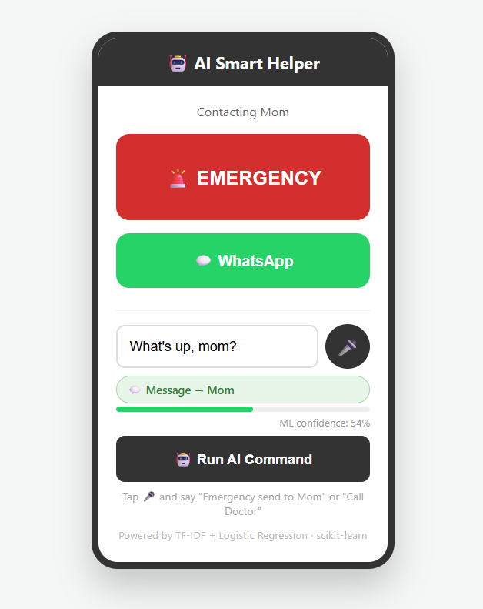

Future Improvements
- Voice command support
- Mobile app version
- Real API integrations
- Improved ML accuracy

Conclusion
AI Smart Helper makes essential smartphone actions faster, smarter, and more accessible using AI and a simplified interface.

Author
Aayushi Rao

