FEDERAL STATE AUTONOMOUS EDUCATIONAL INSTITUTION OF HIGHER EDUCATION

ITMO UNIVERSITY

Report on the practical task No. 2 “Laboratory work #2.   
Model Sensitivity and Uncertainly Analysis”

Performed by

*Alexander Yamoldin*

*J41321c*

Accepted by Sergei Ivanov

St. Petersburg 2022

Author/group

Yamoldin Alexander Alexeevich / J41321c

Description of the task

* Perform a sensitivity analysis for a demographic model with respect to a set of parameters: fertility rate, boys/girls ratio, «survival» rate for different age groups (not all can be taken). Model output: number of inhabitants for a given year. Test on the final forecast values ​​for 10, 20, 50, 100 years.
* Define ranges of model parameter values ​​from data for previous periods (2020-2050)
* Based on all ranges of parameter values, perform an uncertainty analysis in the form of a graph with confidence intervals of the results. The values ​​between the boundaries can be considered evenly distributed.

Solution methods

As in the previous task my chosen country was Russian Federation. I did the prediction for 2020-2050 years.

Sensitivity analysis is the study of how the uncertainty in the output of a mathematical model or system can be related to various sources of uncertainty in its input or parameters.

The sensitivity analysis technique is to change the selected parameters within certain limits, provided that the remaining parameters remain unchanged.

This technique is based on the principle of passing through certain steps. The general sensitivity estimation algorithm is:

1. Estimating the uncertainty of each input parameter (eg ranges, probability distributions).
2. Define the model and its output (result) to be analyzed.
3. Run the model several times using some experimental design dictated by the selection method and input uncertainty.
4. Using the obtained results of the model, calculate the sensitivity indicators of interest to you.

Consider the global sensitivity indices in the following form:

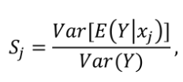

, where Sj is the global sensitivity index of xj; Y is the output of the model.

As an implementation of the ordered technique, a ready-made solution implemented in the SALib library is used. To interact with such a technique, it is first necessary to define a model. In our case, as the basis for the model, we will take a ready-made model made in the previous work (laboratory No. 1).

The next step is to describe the function for generating output data from a set of parameters. The essence of the function is to get the output parameters of the model through it with many different input parameters.

Then you need to set the possible parameters of the model in the form of a dictionary, which will list the conditional ranges of each input parameter.

After that, it is necessary to generate a sample of random model input parameters through the “sample” function in the saltelli library, which will allow you to get many variations of the model input parameters.

Finally, we can calculate the sensitivity indices themselves for the model. This can be done through the “analyze” function, where certain input and output parameters of the model are passed as input parameters.

After performing the required results, you can also do an uncertainty analysis.

Uncertainty analysis is a field of science that quantifies and reduces the uncertainties of systems. Such an analysis can be done on the basis of some possible deviations in the forecast.

Results

We analyze sensitivity coefficients and investigate that the model in most depends on Survival Rate, because of the sensitivity coefficient is the highest. The second important parameter is Fertility Rate. And we can see that Boys-Girls ratio almost not influence on our model.

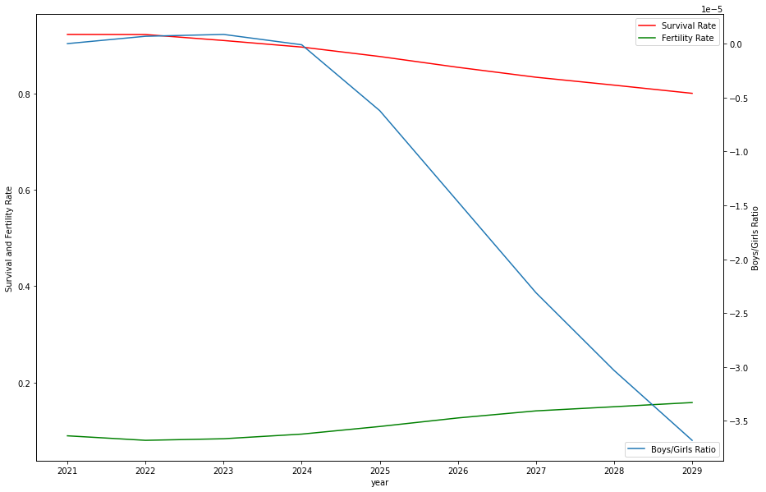

We simulate 88064 possible situations in demographic profile and obtained the next result. Also we can see that UNICEF predicted data is on our prediction interval

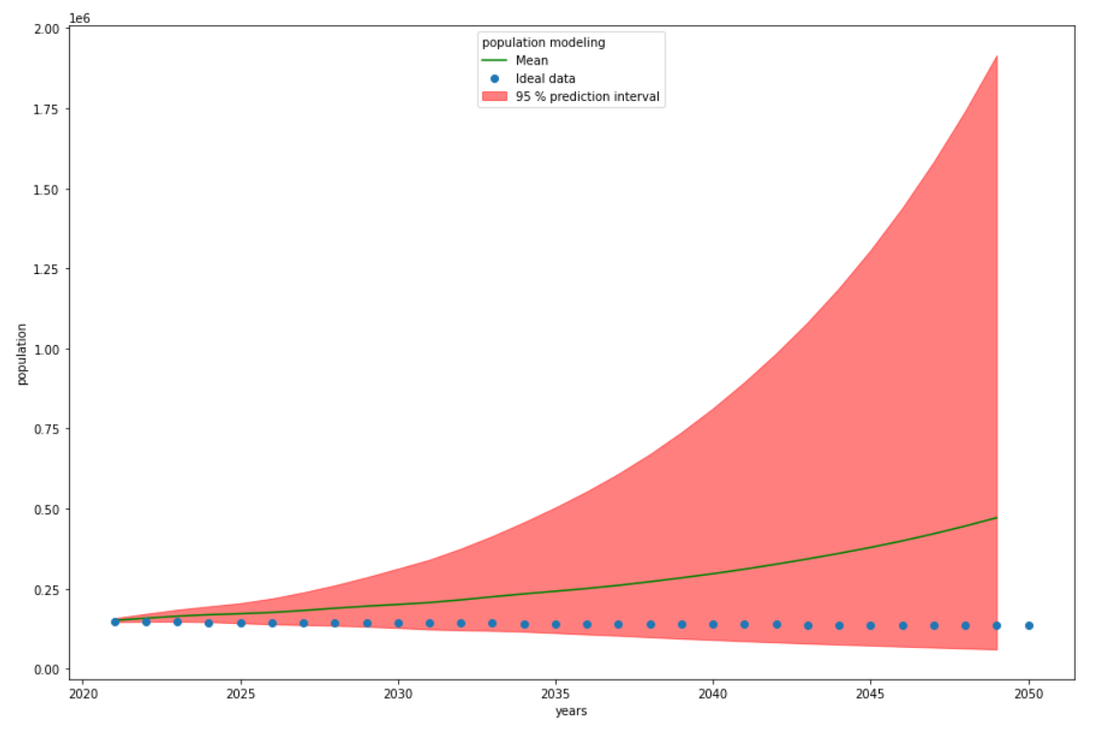

Conclusion

The model in most depends on Survival Rate, the second important parameter is Fertility Rate. Boys-Girls ratio almost not influence on our model. We simulate 88064 possible situations in demographic profile and we can see that UNICEF predicted data is on our prediction interval. So it means that one of the our simulation was as will our future.