Short Report by Lab3.

Yamoldin Alexander, J41321c

Table chemas

Transactions table

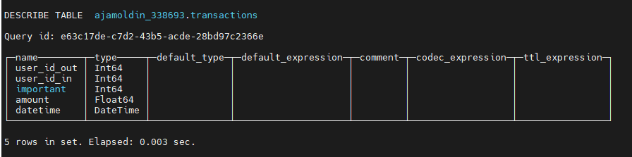

Average transactions per day

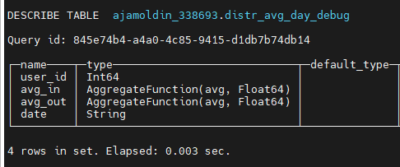

Average transactions per month

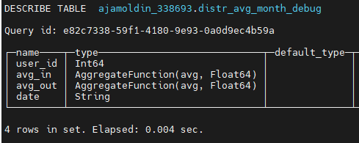

Sum transactions per month

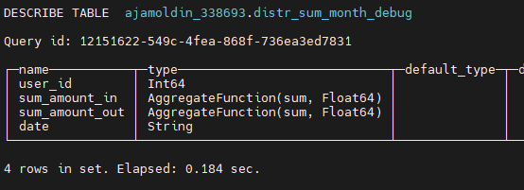

Create table transactions

/*создаём таблицу транзакций*/

CREATE TABLE ajamoldin_338693.transactions ON CLUSTER kube_clickhouse_cluster

(

    user_id_out Int64,

    user_id_in Int64,

    important Int64,

    amount Float64,

    datetime DateTime

)

ENGINE = MergeTree()

PARTITION BY toYYYYMM(datetime)

ORDER BY (user_id_out, user_id_in, amount)

I choose xxHash63 by datetime because in all my tasks I evaluate values per month/day so I need to keep the same data in same host.

CREATE TABLE ajamoldin_338693.distributed_transactions ON CLUSTER kube_clickhouse_cluster AS ajamoldin_338693.transactions

ENGINE = Distributed(

    kube_clickhouse_cluster,

    ajamoldin_338693,

    transactions,

    xxHash64(datetime)

)

Task 1. Average amount for incoming and outcoming transactions by months and days for each user.

Average transactions by day

CREATE MATERIALIZED VIEW ajamoldin_338693.avg_day_debug ON CLUSTER kube_clickhouse_cluster

ENGINE = AggregatingMergeTree

ORDER BY (user_id, date) POPULATE AS

SELECT

    user_id_in AS user_id,

    avg_amount_in AS avg_in,

    avg_amount_out AS avg_out,

    date_in AS date

FROM

(

    SELECT

        user_id_in,

        avgState(amount) AS avg_amount_in,

        formatDateTime(datetime, '%d-%m-%G') AS date_in

    FROM ajamoldin_338693.transactions

    GROUP BY

        user_id_in,

        date_in

) AS t1

INNER JOIN

(

    SELECT

        user_id_out,

        avgState(amount) AS avg_amount_out,

        formatDateTime(datetime, '%d-%m-%G') AS date_out

    FROM ajamoldin_338693.transactions

    GROUP BY

        user_id_out,

        date_out

) AS t2 ON (t1.user_id_in = t2.user_id_out) AND (t1.date_in = t2.date_out)

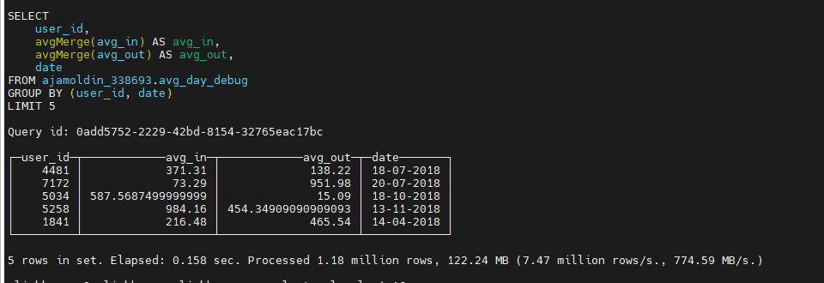

CREATE TABLE ajamoldin_338693.distr_avg_day_debug ON CLUSTER kube_clickhouse_cluster AS ajamoldin_338693.avg_day_debug

ENGINE = Distributed(kube_clickhouse_cluster, ajamoldin_338693, avg_day_debug, xxHash64(user_id))

Average transactions by month

/*Среднее ин/фут за месяц*/

CREATE MATERIALIZED VIEW ajamoldin_338693.avg_month_debug ON CLUSTER kube_clickhouse_cluster

ENGINE = AggregatingMergeTree

ORDER BY (user_id, date) POPULATE AS

SELECT

    user_id_in AS user_id,

    avg_amount_in AS avg_in,

    avg_amount_out AS avg_out,

    date_in AS date

FROM

(

    SELECT

        user_id_in,

        avgState(amount) AS avg_amount_in,

        formatDateTime(datetime, '%m-%G') AS date_in

    FROM ajamoldin_338693.transactions

    GROUP BY

        user_id_in,

        date_in

) AS t1

INNER JOIN

(

    SELECT

        user_id_out,

        avgState(amount) AS avg_amount_out,

        formatDateTime(datetime, '%m-%G') AS date_out

    FROM ajamoldin_338693.transactions

    GROUP BY

        user_id_out,

        date_out

) AS t2 ON (t1.user_id_in = t2.user_id_out) AND (t1.date_in = t2.date_out)

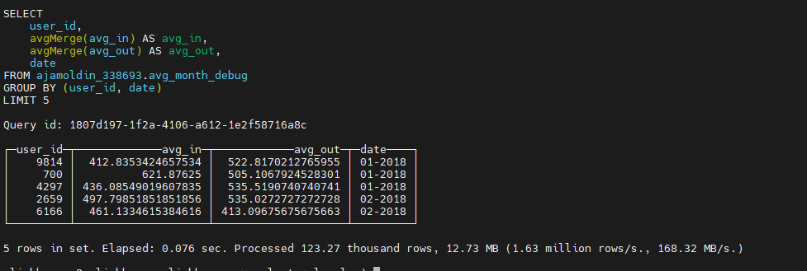

CREATE TABLE ajamoldin_338693.distr_avg_month_debug ON CLUSTER kube_clickhouse_cluster AS ajamoldin_338693.avg_month_debug

ENGINE = Distributed(kube_clickhouse_cluster, ajamoldin_338693, avg_month_debug)

Task 3. The sums for incoming and outcoming transactions by months for each user.

/*сумма за месяц*/

CREATE MATERIALIZED VIEW ajamoldin_338693.sum_month_debug ON CLUSTER kube_clickhouse_cluster

ENGINE = AggregatingMergeTree()

ORDER BY (user_id, date)

POPULATE

AS SELECT

    user_id_in AS user_id,

    sum_amount_in,

    sum_amount_out,

    date_in AS date

FROM

(

    SELECT

        user_id_in,

        sumState(amount) AS sum_amount_in,

        formatDateTime(datetime, '%m-%G') AS date_in

    FROM ajamoldin_338693.transactions

    GROUP BY

        user_id_in,

        date_in

) AS t1

INNER JOIN

(

    SELECT

        user_id_out,

        sumState(amount) AS sum_amount_out,

        formatDateTime(datetime, '%m-%G') AS date_out

    FROM ajamoldin_338693.transactions

    GROUP BY

        user_id_out,

        date_out

) AS t2 ON (t1.user_id_in = t2.user_id_out) AND (t1.date_in = t2.date_out)

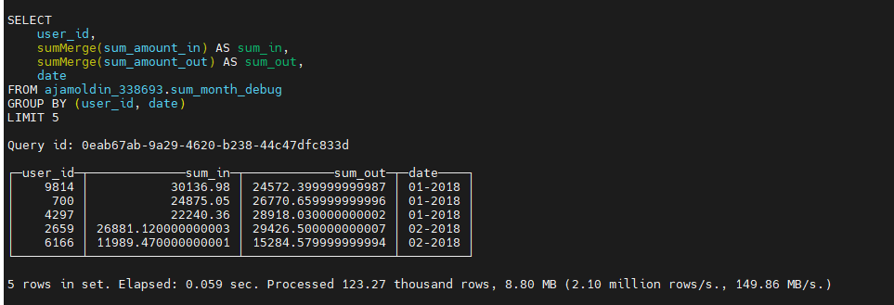

CREATE TABLE ajamoldin_338693.distr_sum_month_debug ON CLUSTER kube_clickhouse_cluster AS ajamoldin_338693.sum_month_debug

ENGINE = Distributed(kube_clickhouse_cluster, ajamoldin_338693, sum_month_debug)

Source code you can find in

<https://github.com/AAYamoldin/TrainingPrograms/blob/master/Python/ITMO_Technologies_and_Infrastructure_for_Big_Data/Lab3/чистовое.sql>