FEDERAL STATE AUTONOMOUS EDUCATIONAL INSTITUTION OF HIGHER EDUCATION

ITMO UNIVERSITY

Report

on the practical task No. 1 “Experimental time complexity analysis”

Performed by

*Alexander Yamoldin*

*J4134c*

Accepted by Dr Petr Chunaev

St. Petersburg 2021

# Goal

Experimental study of the time complexity of different algorithms

# Formulation of the problem

Experimentally study the complexity of the following algorithms on different data and compare it with the expected complexity:

* *Constant function;*
* *Sum of elements;*
* *Product of elements;*
* *Direct calculation of polynomial;*
* *Horner’s method for calculation polynomial;*
* *Bubble Sort;*
* *Quick Sort;*
* *Timsort;*
* *Matrix product.*

# Brief theoretical part

Constant function - Theoretical time complexity is O(1) Sum of elements - Theoretical time complexity is O(n)

Direct calculation of polynomial - Theoretical time complexity is O(nlog(n))

Horner’s method for calculation polynomial - Theoretical time complexity is O(n) Bubble Sort - Theoretical time complexity is O(n^2)

Quick Sort - Theoretical time complexity is O(nlog(n)) Timsort - Theoretical time complexity is O(nlog(n)) Matrix product - Theoretical time complexity is O(n^3)

# Results

Charts showing the experimental and theoretical time complexity of algorithms:

Constant function - Theoretical time complexity is O(1)

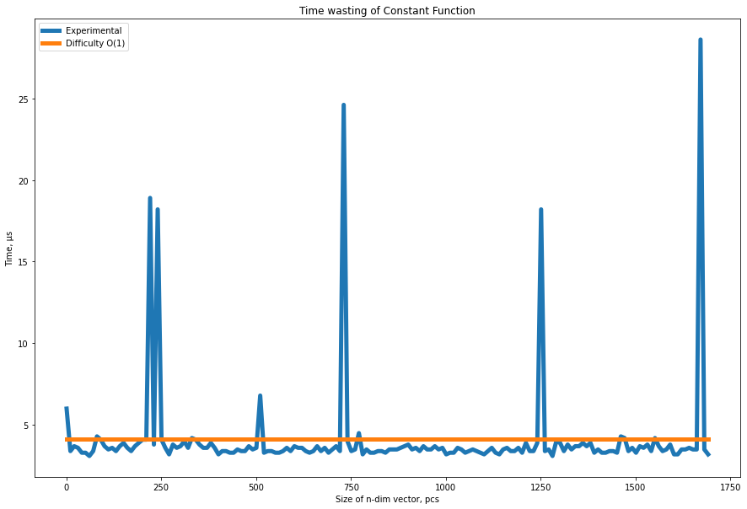

Sum of elements - Theoretical time complexity is O(n)

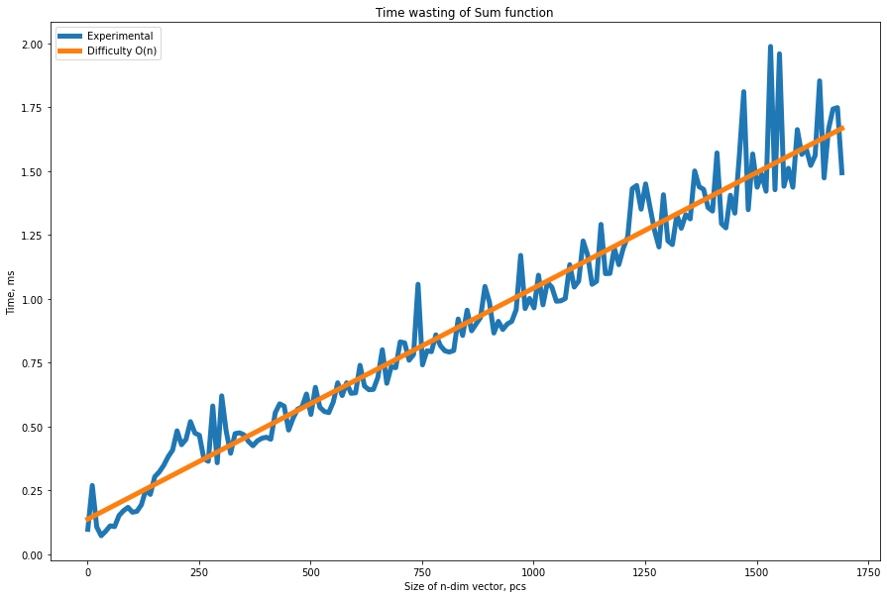

Product of elements - Theoretical time complexity is O(n)

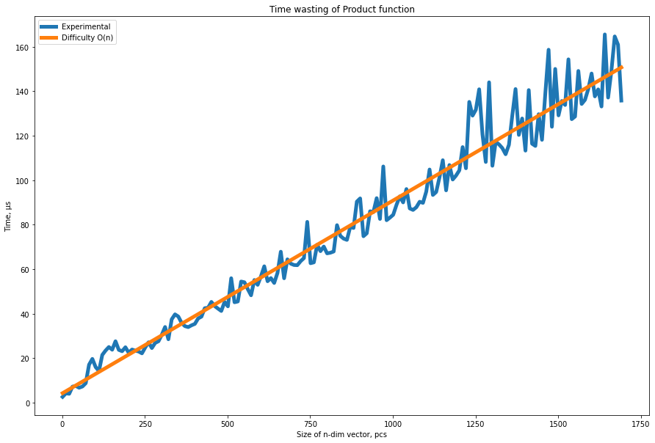

Direct calculation of polynomial - Theoretical time complexity is O(nlog(n))

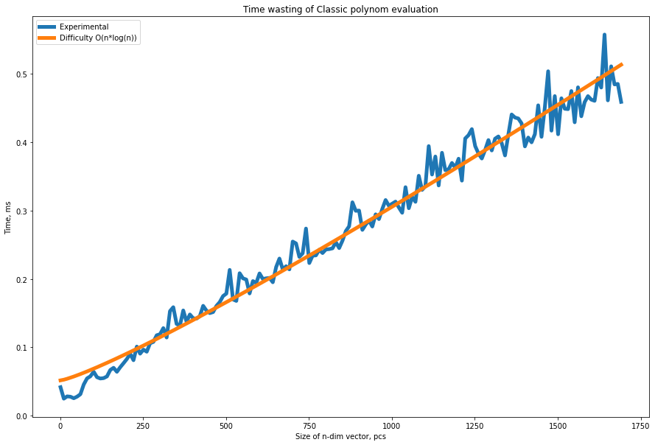

Horner’s method for calculation polynomial - Theoretical time complexity is O(n)

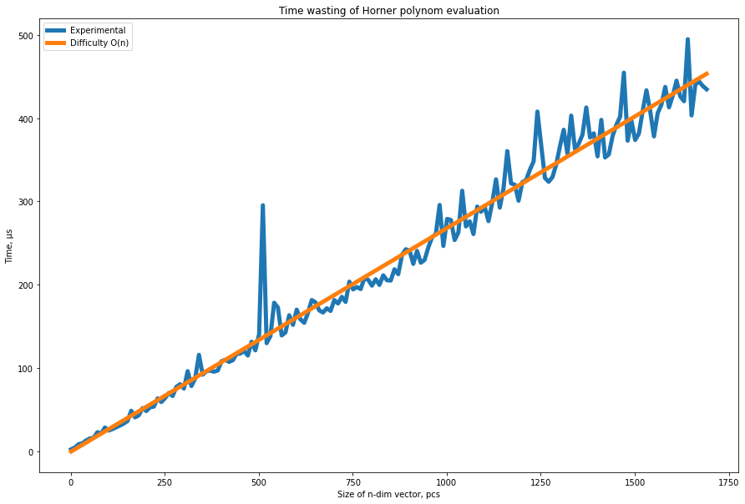

Bubble Sort - Theoretical time complexity is O(n^2)

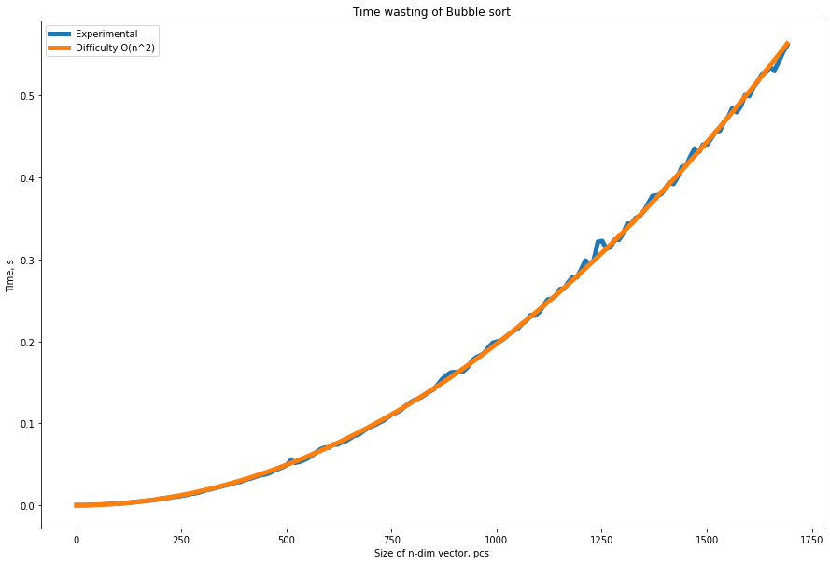

Quick Sort - Theoretical time complexity is O(nlog(n))

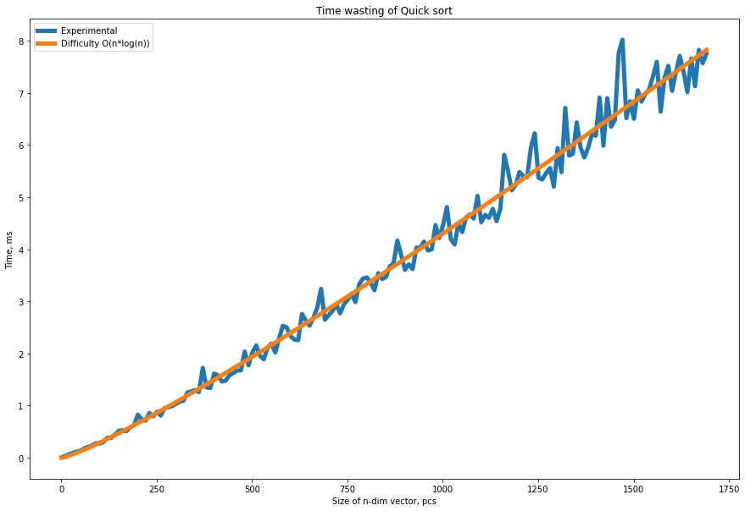

Timsort - Theoretical time complexity is O(nlog(n))

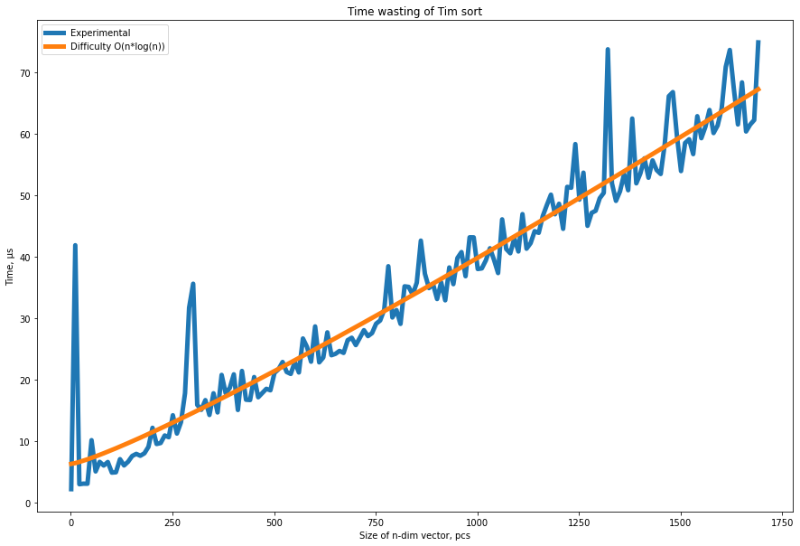

Matrix product - Theoretical time complexity is O(n^3)

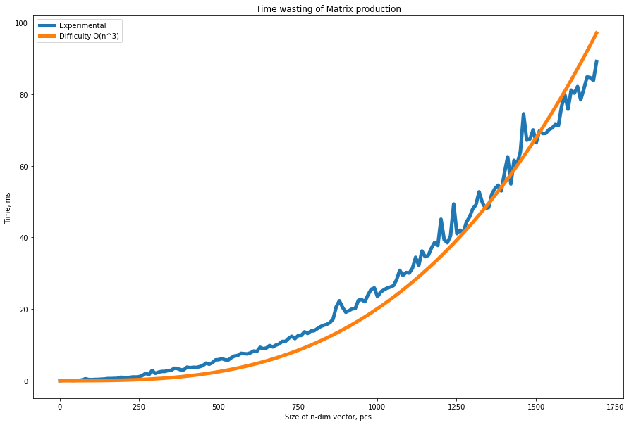

**Comparing**

|  |  |  |  |
| --- | --- | --- | --- |
| Algorithm | Time complexity Experimental | Time complexity Theoretical | Is the same? |
| Constant function | O(1) | O(1) | ✅ |
| Sum of elements | O(n) | O(n) | ✅ |
| Product of elements | O(n) | O(n) | ✅ |
| Direct calculation of polynomial | O(n*log(n)) | O(n*log(n)) | ✅ |
| Horner’s method for calculation polynomial | O(n) | O(n) | ✅ |
| Bubble Sort | O(n2) | O(n2) | ✅ |
| Quick Sort | O(n*log(n)) | O(n*log(n)) | ✅ |
| Timsort | O(n*log(n)) | O(n*log(n)) | ✅ |
| Matrix product | O(n3) | O(n3) | ✅ |

# Conclusions

From the obtained charts we can see that the experimental time complexity matches the theoretical one. Although there are periodic deviations from the theoretical complexity curve, they can be explained by the background processes of the system. The set goal has been achieved.

# Appendix

https://github.com/AAYamoldin/TrainingPrograms/blob/master/Python/ITMO_algorithms_lab/task1_Experimental_time_complexity_analysis.ipynb