FEDERAL STATE AUTONOMOUS EDUCATIONAL INSTITUTION OF HIGHER EDUCATION

ITMO UNIVERSITY

Report on the practical task No. 2

“Algorithms for unconstrained nonlinear optimization. Direct methods”

Performed by

*Alexander Yamoldin*

*J4134c*

Accepted by Dr Petr Chunaev

St. Petersburg 2021

# Goal

The use of direct methods (one-dimensional methods of exhaustive search, dichotomy, golden section search; multidimensional methods of exhaustive search, Gauss (coordinate descent), Nelder-Mead) in the tasks of unconstrained nonlinear optimization

# Formulation of the problem

1. *Use the one-dimensional methods of exhaustive search, dichotomy and golden section search to find an approximate (with precision* 𝜀 *= 0.001) solution* 𝑥: 𝑓(𝑥) → 𝑚𝑖𝑛 *for the following functions and domains:*

1. 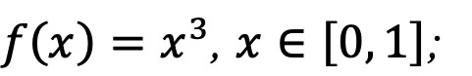

2. 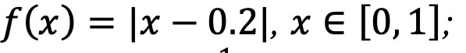

3. 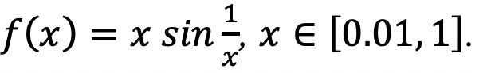

Calculate the number of 𝑓-calculations and the number of iterations performed in each method and analyze the results. Explain differences (if any) in the results obtained.

1. *Generate random numbers* 𝛼 ∈ (0,1) *and* 𝛽 ∈ (0,1) *. Furthermore, generate the noisy data 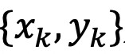* *, where* 𝑘 = 0, ... ,100*, according to the following rule:*

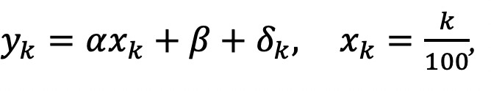

where 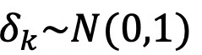 are values of a random variable with standard normal distribution. Approximate the data by the following linear and rational functions:

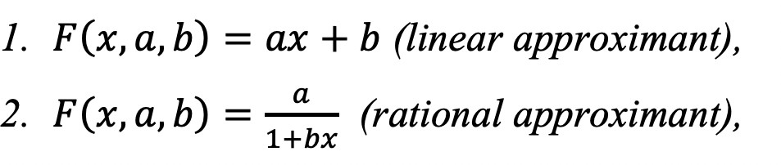

by means of least squares through the numerical minimization (with precision 𝜀 =0.001) of the following function:

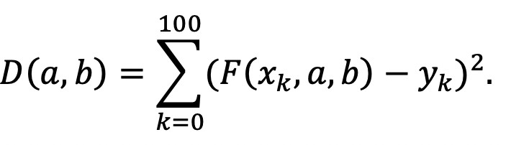

To solve the minimization problem, use the methods of exhaustive search, Gauss and Nelder-Mead. If necessary, set the initial approximations and other parameters of the

methods. Visualize the data and the approximants obtained in a plot separately for each type of **approximant** so that one can compare the results for the numerical methods used. Analyze

the results obtained (in terms of number of iterations, precision, number of function evaluations, etc.).

# Results Subtask 1 Cube function

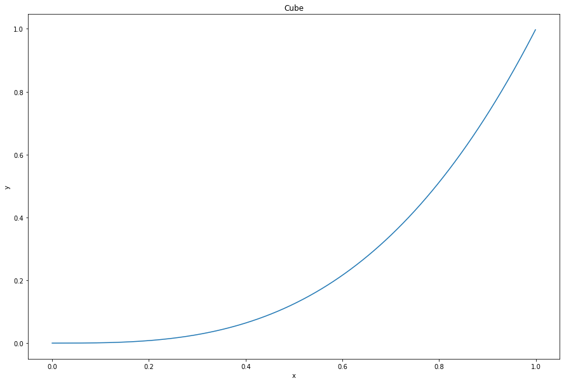

Results table:

|  |  |  |  |  |
| --- | --- | --- | --- | --- |
| *Method* | *f(x)* | *x* | *Number of function calls* | *Number of iterations* |
| *Brute force* | *0.0* | *0.0* | *1000* | *1000* |
| *Dichotomy method* | *0.0* | *0.0* | *21* | *10* |
| *Golden ratio method* | *4.9e-11* | *0.00037* | *31* | *15* |

# Absolut function



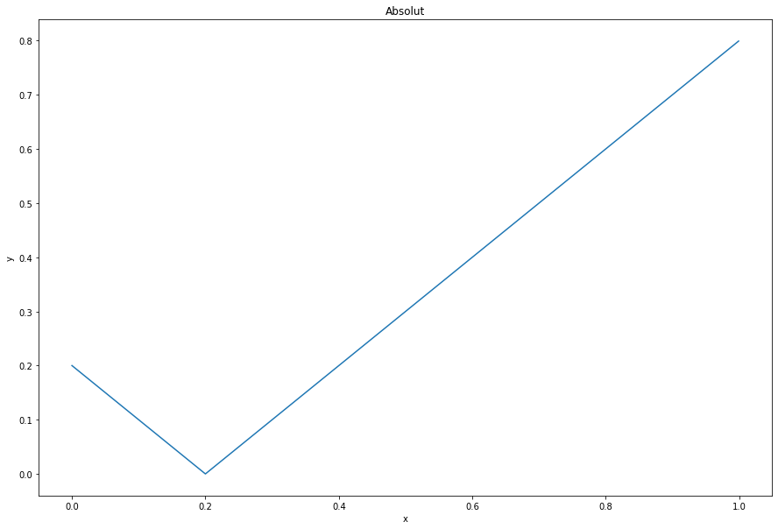

Results table:

|  |  |  |  |  |
| --- | --- | --- | --- | --- |
| *Method* | *f(x)* | *x* | *Number of function calls* | *Number of iterations* |
| *Brute force* | *0.0* | *0.2* | *1000* | *1000* |
| *Dichotomy method* | *0.001* | *0.1989* | *21* | *10* |
| *Golden ratio method* | *0.0001* | *0.1999* | *31* | *15* |

# Trigonometry function

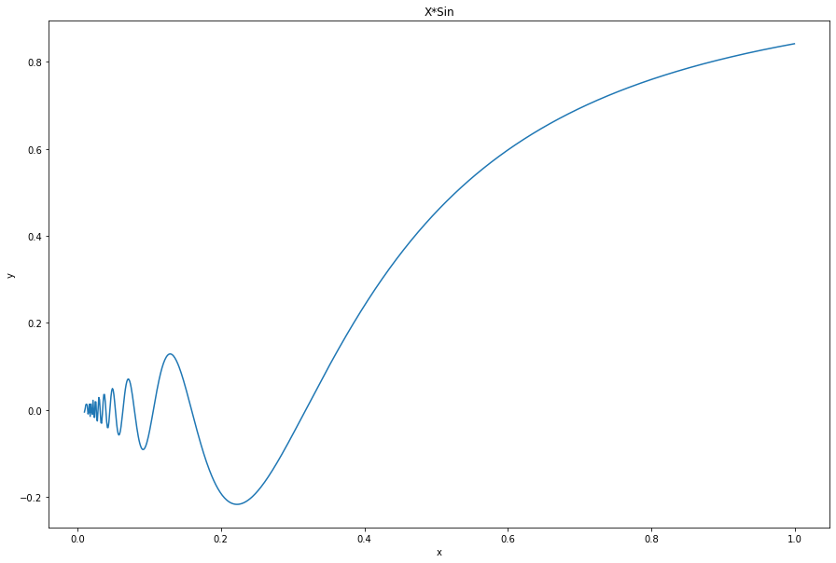

Results table:

|  |  |  |  |  |
| --- | --- | --- | --- | --- |
| *Method* | *f(x)* | *x* | *Number of functions call* | *Number of iterations* |
| *Brute force* | *-0.21722* | *0.223* | *990* | *990* |
| *Dichotomy method* | *-0.21717* | *0.2214* | *21* | *10* |
| *Golden ratio method* | *-0.21723* | *0.2225* | *31* | *15* |

# Subtask 2

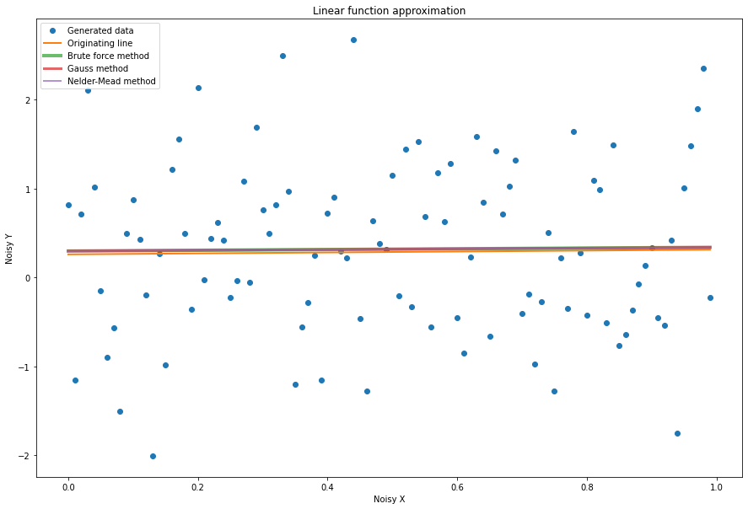

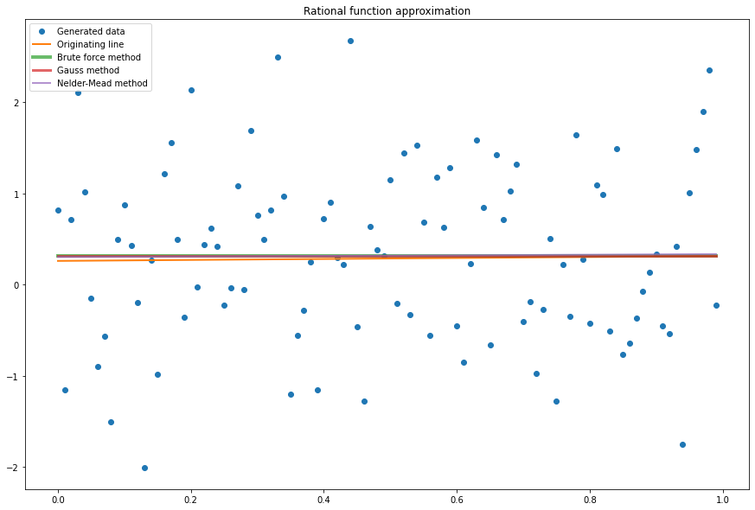

**Comparing MAPE for each type of approximation**

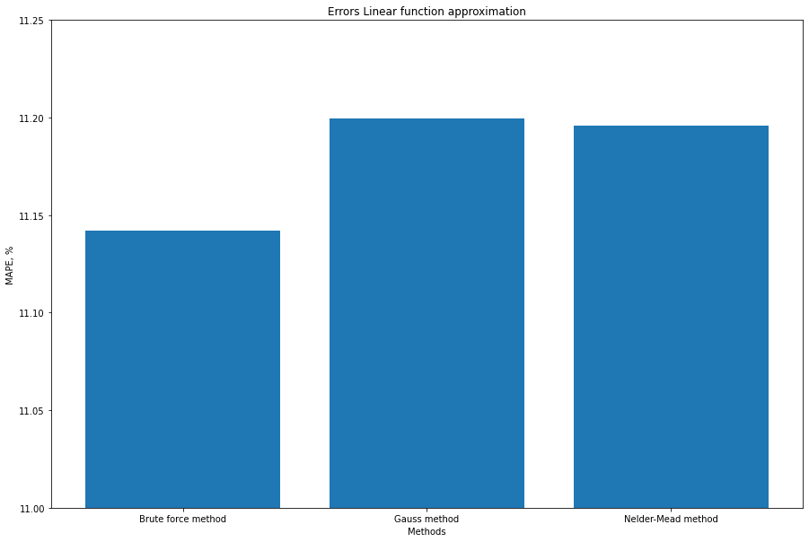

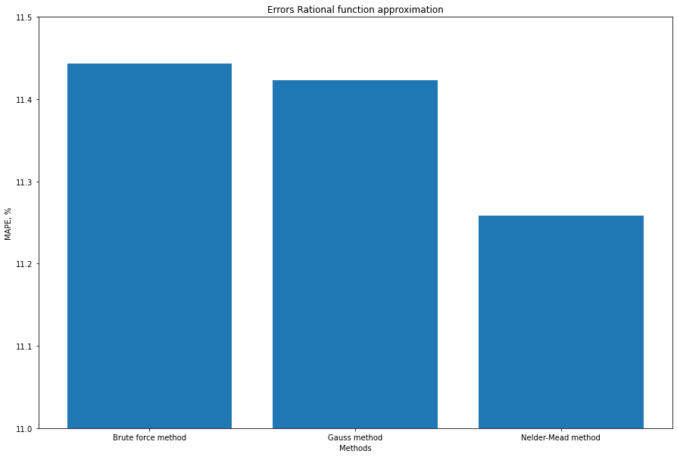

|  |  |  |  |
| --- | --- | --- | --- |
| **Method** | **MAPE for linear app, %** | **MAPE for rational app, %** | **What’s the better?** |
| Brute Force | **11.14** | **11.44** | **Linear** |
| Gauss | **11.20** | **11.42** | **Linear** |
| Nelder-Mead | **11.20** | **11.25** | **Linear** |

**Conclusions**

Subtask 1

From the results we see that all 3 methods find the minimum of the function within the margin of error. As expected, the brute-force method has the most iterations and calculations of the function. The number of iterations and calculations of the function for the dichotomy method and the brute force method are approximately equal.

Subtask 2

The results show that all three approximation methods give approximately the same result. But in comparing between the methods of approximation we can define that Linear approximation a little bit better than rational approximation. It is completely the same of our theoretical expectations because we generate our random data using mostly linear part of function ( y = ax+b+Noize(N(0,1)) ).

# Appendix

https://github.com/AAYamoldin/TrainingPrograms/blob/master/Python/ITMO_algorithms_lab/task2_Algorithms_for_unconstrained_nonlinear_optimization_direct_methods.ipynb