FEDERAL STATE AUTONOMOUS EDUCATIONAL INSTITUTION OF HIGHER EDUCATION

ITMO UNIVERSITY

Report on the practical task No. 4 “Task 4. Algorithms for unconstrained nonlinear optimization. Stochastic and metaheuristic algorithms”

Performed by

*Alexander Yamoldin*

*J4134c*

Accepted by Dr Petr Chunaev

St. Petersburg 2021

# Goal

The use of stochastic and metaheuristic algorithms (Simulated Annealing, Differential Evolution, Particle Swarm Optimization) in the tasks of unconstrained nonlinear optimization and the experimental comparison of them with Nelder-Mead and Levenberg-Marquardt algorithms.

# Formulation of the problem

1. 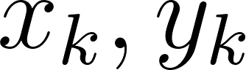*Generate the noisy data ( ), where* 𝑘 *= 0, ... ,1000, according to the rule:*

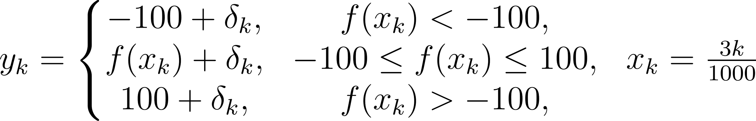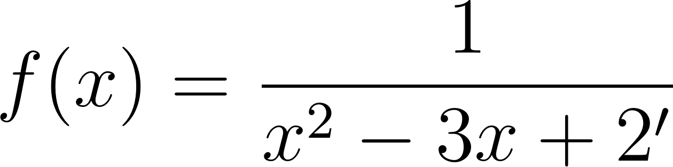

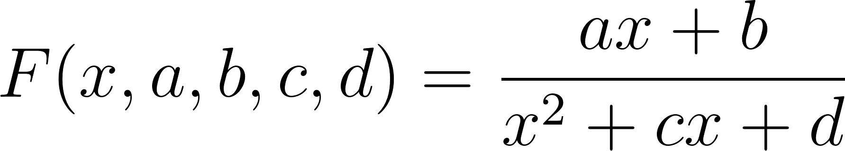where 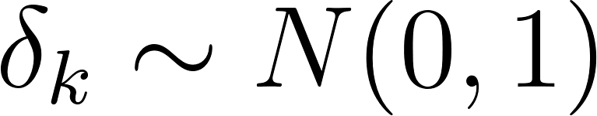 are values of a random variable with standard normal distribution. Approximate the data by the rational function

by means of least squares through the numerical minimization of the following function:

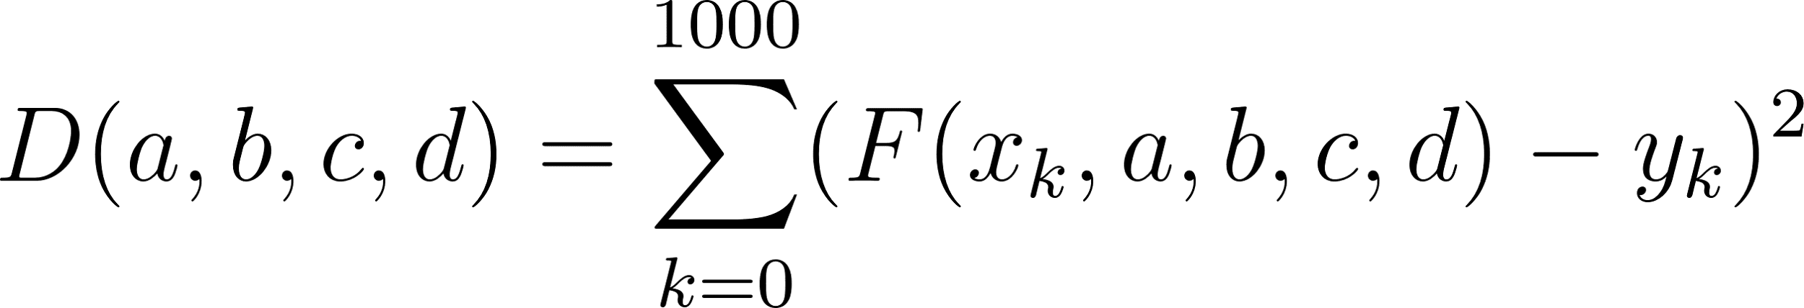

To solve the minimization problem, use Nelder-Mead algorithm, Levenberg- Marquardt algorithm and at least two of the methods among Simulated Annealing, Differential Evolution and Particle Swarm Optimization. If necessary, set the initial approximations and other parameters of the methods. Use 𝜀 = 0.001 as the precision; at most 1000 iterations are allowed. Visualize the data and the approximants obtained in a single plot. Analyze and

compare the results obtained (in terms of number of iterations, precision, number of function evaluations, etc.).

1. *Choose at least 15 cities in the world having land transport connections between them. Calculate the distance matrix for them and then apply the Simulated Annealing method to solve the corresponding Travelling Salesman Problem. Visualize the results at the first and the last iteration. If necessary, use the city dataset from* [*https://people.sc.fsu.edu/~jburkardt/datasets/cities/cities.html*](https://people.sc.fsu.edu/~jburkardt/datasets/cities/cities.html)

# Brief theoretical part

**Nelder-Mead** algorithm is a commonly applied numerical method used to find the minimum or maximum of an objective function in a multidimensional space. It is a direct search method (based on function comparison) and is often applied to nonlinear optimization problems for which derivatives may not be known.

**Levenberg- Marquardt** algorithm is used to solve non-linear least squares problems. In mathematics and computing, the Levenberg–Marquardt algorithm (LMA or just LM), also known as the damped least-squares (DLS) method, is used to solve non-linear least squares problems. These minimization problems arise especially in least squares curve fitting.

**Simulated annealing (SA)** is a probabilistic technique for approximating the global optimum of a given function. Specifically, it is a metaheuristic to approximate global optimization in a large search space for an optimization problem.

**Differential Evolution** is a method that optimizes a problem by iteratively trying to improve a candidate solution with regard to a given measure of quality.

**Results**

**TASK 1**

# 

Results table:

|  |  |  |  |  |  |  |
| --- | --- | --- | --- | --- | --- | --- |
| *Method* | *a* | *b* | *c* | *d* | *Number of iterations* | *Number of function calls* |
| *Nelder-Mead method* | *0.024* | *-0.02* | *-1.980* | *0.980* | *392* | *673* |
| *Levenberg-Mar quardt algorithm* | *-3.634* | *3.639* | *-2.006* | *1.010* | *1000* | *1000* |
| *Simulated Annealing* | *-1.007* | *1.007* | *-2.001* | *1.001* | *1000* | *9156* |
| *Differential Evolution* | *-1.007* | *1.007* | *-2.001* | *1.001* | *5* | *1175* |

**Statistical visualization**

We investigate that Simulated Annealing such as Levenberg-Marquardt reach the maximum numbers of iterations. The least iterations are in Differential Evolution algorithm.

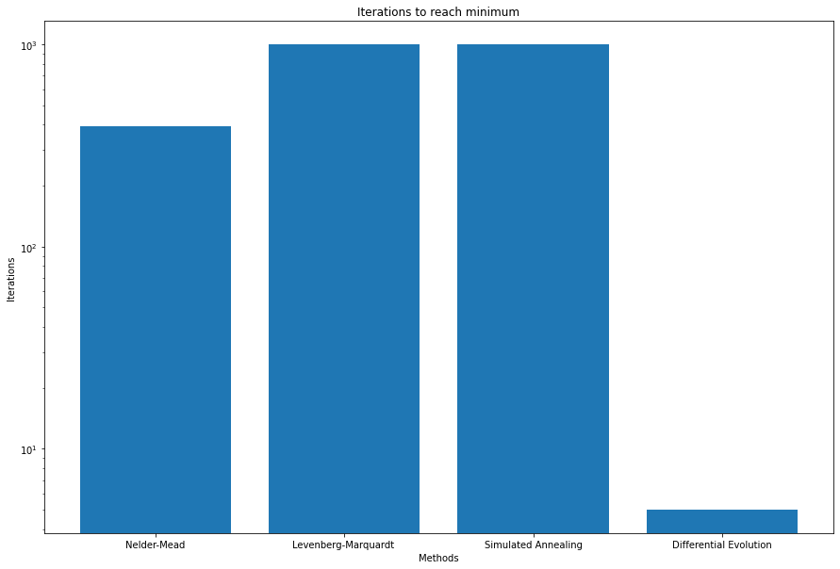

We investigate that the greatest number of functions calls is in Simulated Annealing algorithm

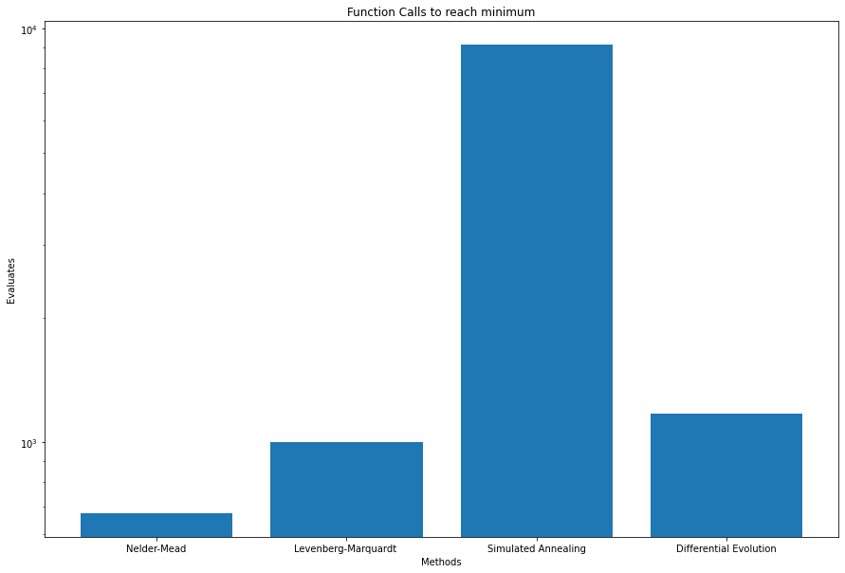

**TASK 2**

I have took a dataset which describes 22 cities in West Germany.

The original data is here <https://people.sc.fsu.edu/~jburkardt/datasets/cities/wg22_xy.txt>

I used Simulating Annealing Algorithm with exponential probability function

initial_temperature = 1000

temperature_step = 0.00005

The result of the fist iteration of Simulating Annealing Algorithm.

The distance = **2271.96 km.**

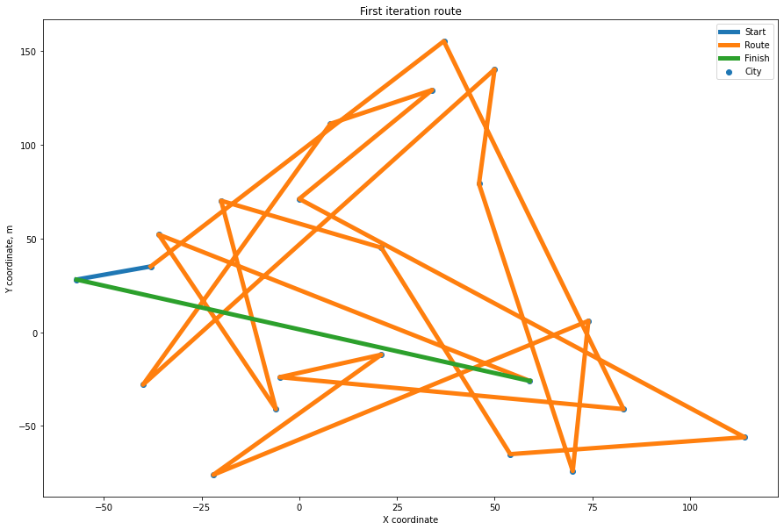

The result of 200_000_000 iterations of Simulating Annealing Algorithm.

Distance = **810.26 km**

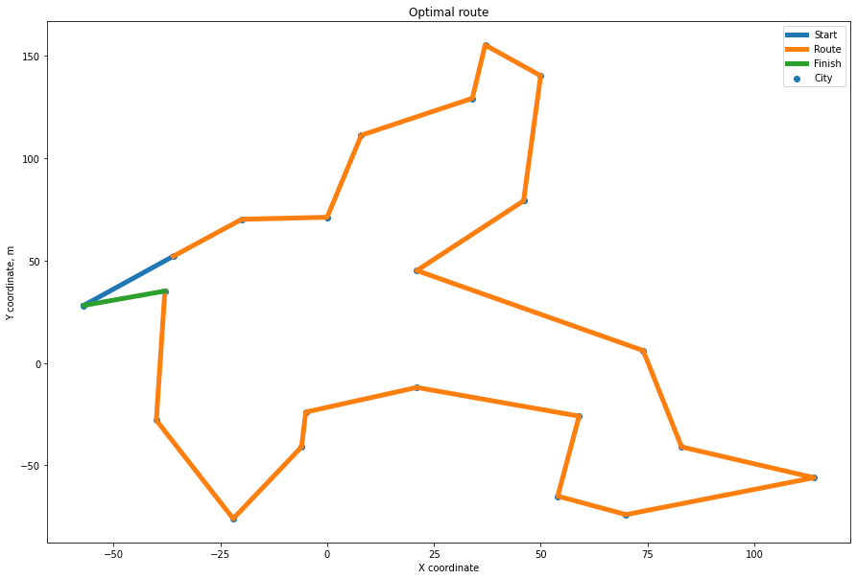

**Conclusions**

**Task 1.**

We investigate that the algorithms work not the same. The best result reached such methods as Dual Annealing and Differential Evolution. It’s because metaheuristic methods solving better nonlinear hard tasks. The metaheuristic methods expectantly require much more calculations than Nelder-Mead algorithm and Levenberg- Marquardt algorithm.

**Task 2.**

Due the experiment we investigate that the simulation annealing method is quite good at the traveling salesman problem. We reduced distances by **2.8 times** (from 2271.96 to 810.26 km).

# Appendix