FEDERAL STATE AUTONOMOUS EDUCATIONAL INSTITUTION OF HIGHER EDUCATION

ITMO UNIVERSITY

Report

on the practical task No. 12, 13, 14

Performed by

*Alexander Yamoldin*

*J4134c*

St. Petersburg 2021

# Goal

Understand basic MPI C++ syntax, use MPI library to realize delayed interactions, scheme of an iterative method with exchange over a ring topology using pending requests. Also understand collective process interactions, barrier, custom global function.

# Formulation of the problem

In the Assignment 12 need to find and fix errors in Assignment12.c, add the for loop.

In the Assignment 13 need to Find out which process will perform the multiplication of two 500x500 square matrices faster.

In the Assignment 14 need to Understand the new functions in Assignment14.c. Create your own global function for finding the maximum element, compare the correctness of execution with the MPI_MAX operation in the MPI_Reduce() function.

# Results

The code of the Assignment 12 can be found in

https://github.com/AAYamoldin/TrainingPrograms/blob/master/institute_c_programs/ITMO_Parallel_Algorithm/Task_12/Assignment12.c

The result of the program below:

The program Assignment12.c exchanges messages between processes in a circle. Prev and next variables store values for previous and next processes in a circle. The exchange is organized using delayed interaction. There are two errors in the program, the first one is that the first argument of MPI_Recv_init and MPI_Send_init should be a reference to thebuffer and the second one the last argument of MPI_Recv_init and MPI_Send_init should be a reference to the MPI_Request object. Loop can use to initialize a buffer array or to call MPI_Request_free in a loop. It is supposed to call MPI_Startall and MPI_Waitall only once, if we want to make an exchange over ring topology once. Otherwise, it is possible to call these methods in a loop.

The code of the Assignment 13 can be found in

https://github.com/AAYamoldin/TrainingPrograms/blob/master/institute_c_programs/ITMO_Parallel_Algorithm/Task_13/Assignment13.c

The result of the program is the picture below:

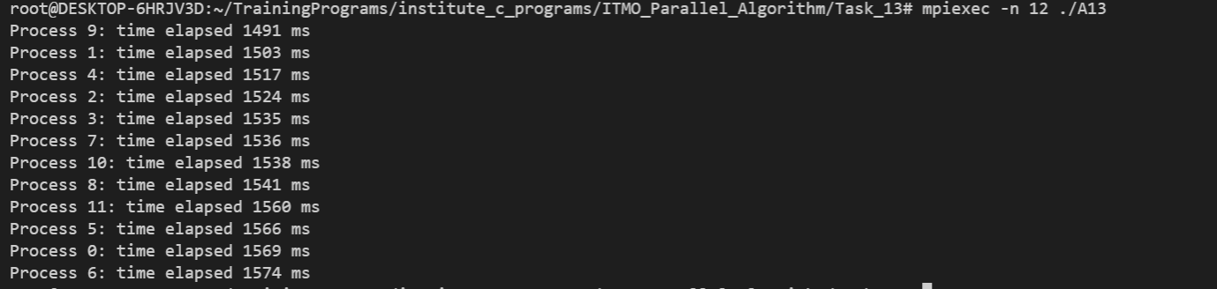

The code of the Assignment 14 can be found in

https://github.com/AAYamoldin/TrainingPrograms/blob/master/institute_c_programs/ITMO_Parallel_Algorithm/Task_14/Assignment14.c

The result in the picture and table below:

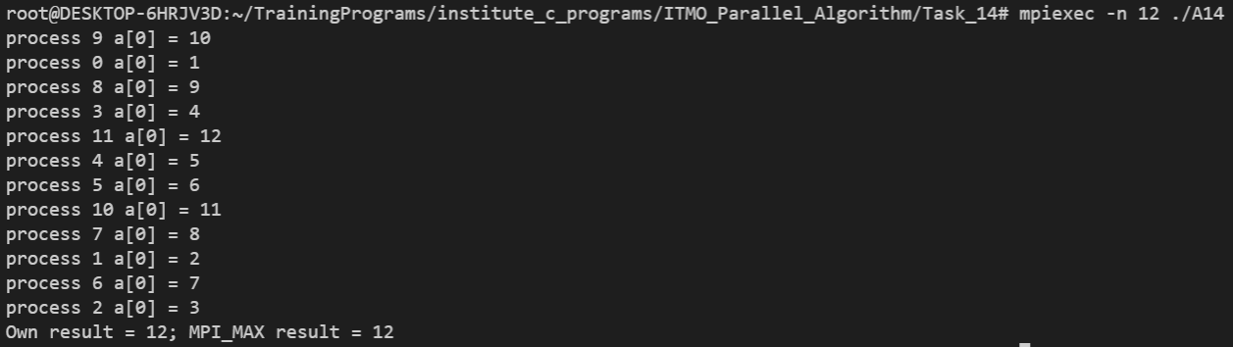

**Conclusion:**

In the first task two mistakes were found and correct. In the second task the fastest was process number 9. In the third task we obtained some results for selfcreated algorithm and for the MPI_MAX.