FEDERAL STATE AUTONOMOUS EDUCATIONAL INSTITUTION OF HIGHER EDUCATION

ITMO UNIVERSITY

Report

on the practical task No. 15, 16, 17

Performed by

*Alexander Yamoldin*

*J4134c*

St. Petersburg 2021

# Goal

Understand basic MPI C++ syntax, use MPI library to work with Operations with communicators, Partitioning the communicator and Data packing, Sending packed data.

# Formulation of the problem

In the Assignment 15 need to Understand the new functions in Assignment15.c. Append part of code.

In the Assignment 16 need to In the **MPI_Comm_split** function (Assignment16.c), replace the color parameter with (rank% 2), (rank% 3), look at how many groups the processes are split into, depending on the specified attribute of division into groups.

In the Assignment 17 need to Understand the new functions in Assignment17.c. and explain program execution.Display the values of the process number and arrays a[i], b[i], before packing and distribution, and after. See how broadcasting works.

# Results

The code of the Assignment 15 can be found in

https://github.com/AAYamoldin/TrainingPrograms/blob/master/institute_c_programs/ITMO_Parallel_Algorithm/Task_15/Assignment15.c

The result of the program in the picture below:

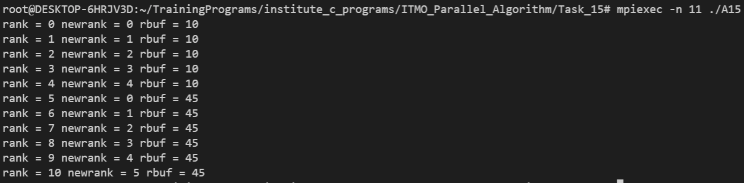

The code of the Assignment 16 can be found in

https://github.com/AAYamoldin/TrainingPrograms/blob/master/institute_c_programs/ITMO_Parallel_Algorithm/Task_16/Assignment16.c

The result of the program is the picture below:

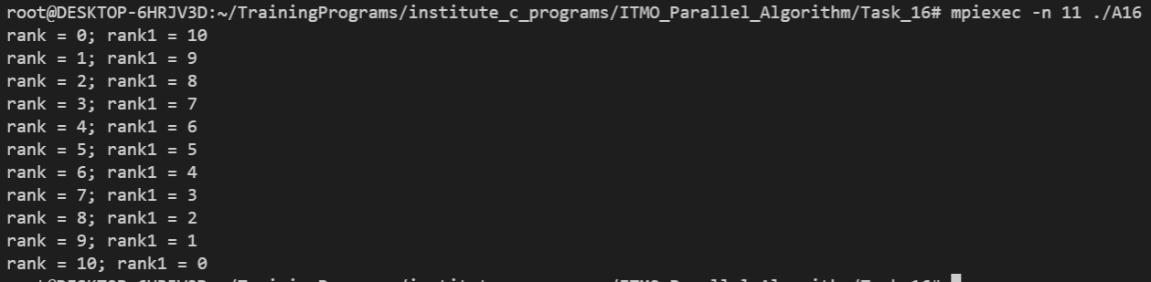

The code of the Assignment 17 can be found in

https://github.com/AAYamoldin/TrainingPrograms/blob/master/institute_c_programs/ITMO_Parallel_Algorithm/Task_17/Assignment17.c

The result in the picture and table below:

