FEDERAL STATE AUTONOMOUS EDUCATIONAL INSTITUTION OF HIGHER EDUCATION

ITMO UNIVERSITY

Report

on the practical task No. 18, 19, 20, 21

and

fixed 8, 9, 12

Performed by

*Alexander Yamoldin*

*J4134c*

St. Petersburg 2021

# Goal

Understand basic MPI C++ syntax, use MPI library to work with Spawning processes, Client-server communication, Buffered reading from a file and Collective reading from a file.

# Formulation of the problem

In the Assignment 18 needs to complete the task, you need to create and compile two programs: Master (master.o) and Slave (slave.o). The Master should start the worker, so be careful with the names of the executable files.

In the Assignment 19 needs to complete the task, you need to create and compile two programs: server and client. In one window of the SSH client, a server is launched for one process, which gives out the port name.

In the Assignment 20 needs to Understand the new functions in Assignment20.c, complete the program according to the assignment, explain the execution of the program.

Write a function that will create a file "file.txt" with random content (or with specific text). The function must be executed before the program reads the contents of the file. Run the program on one process. Check if the contents of the file are displayed correctly. Add an option that will delete the file on close.

In the Assignment 21 needs to Understand the new functions in Assignment20.c, complete the program according to the assignment, explain the execution of the program.

Write a function that will create a file "file.txt" with random content (or with specific text). The function must be executed before the program reads the contents of the file. Run the program on one process. Check if the contents of the file are displayed correctly. Add an option that will delete the file on close.

# Results

The code of the Assignment 18 can be found in

https://github.com/AAYamoldin/TrainingPrograms/blob/master/institute_c_programs/ITMO_Parallel_Algorithm/Task_18/Assignment18_master.c

https://github.com/AAYamoldin/TrainingPrograms/blob/master/institute_c_programs/ITMO_Parallel_Algorithm/Task_18/Assignment18_slave.c

The result of the program in the picture below:

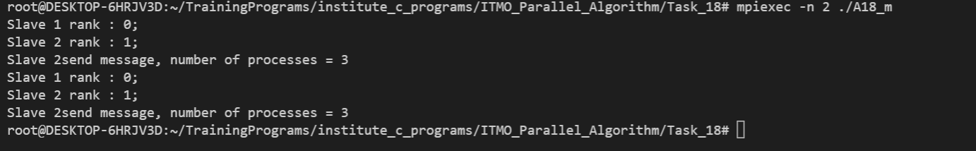

The code of the Assignment 19 can be found in

https://github.com/AAYamoldin/TrainingPrograms/blob/master/institute_c_programs/ITMO_Parallel_Algorithm/Task_19/Assignment19_client.c

https://github.com/AAYamoldin/TrainingPrograms/blob/master/institute_c_programs/ITMO_Parallel_Algorithm/Task_19/Assignment19_serv.c

The result of the program is the picture below:

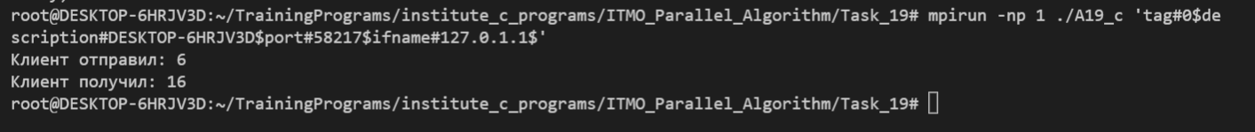

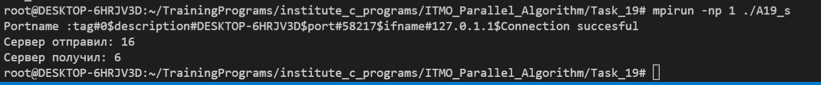

The code of the Assignment 20 can be found in

https://github.com/AAYamoldin/TrainingPrograms/blob/master/institute_c_programs/ITMO_Parallel_Algorithm/Task_20/Assignment20.cpp

The result in the picture below:





The code of the Assignment 21 can be found in

https://github.com/AAYamoldin/TrainingPrograms/blob/master/institute_c_programs/ITMO_Parallel_Algorithm/Task_21/Assignment21.c

The result in the picture below:

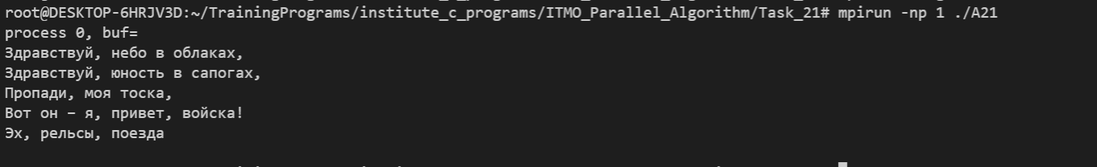

FIXED

Assignment 8:

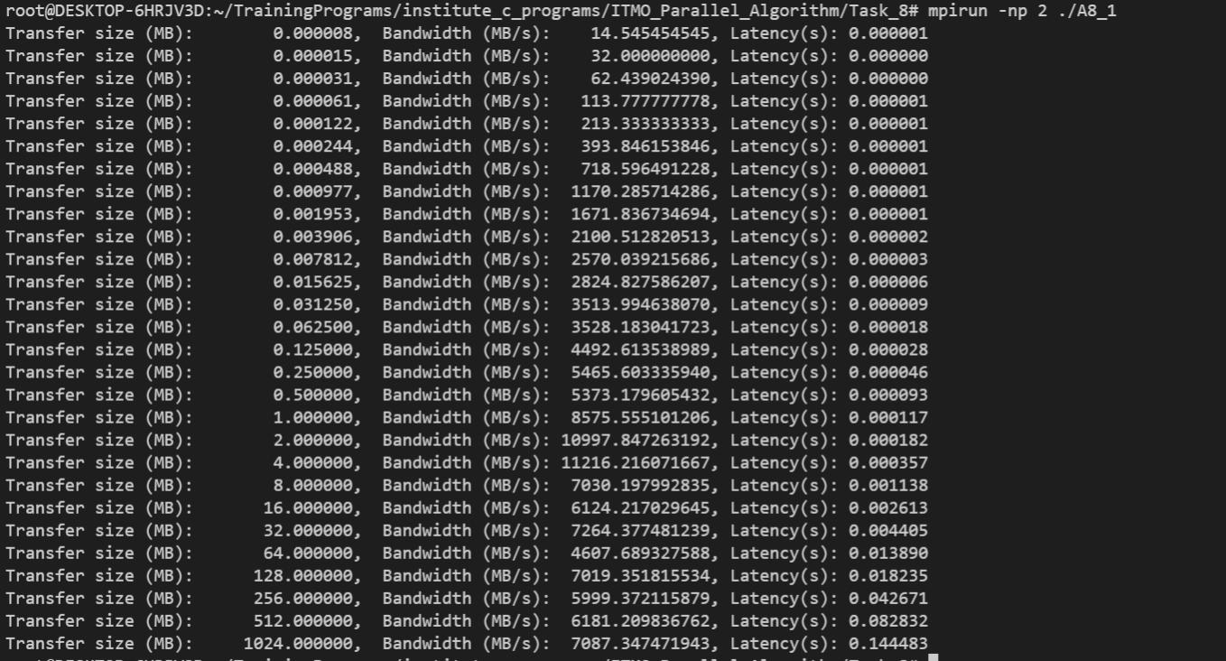

Assignment 9:

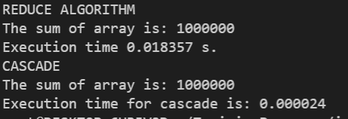

Assignment 12:

https://github.com/AAYamoldin/TrainingPrograms/blob/master/institute_c_programs/ITMO_Parallel_Algorithm/Task_12/Assignment12.c