FEDERAL STATE AUTONOMOUS EDUCATIONAL INSTITUTION OF HIGHER EDUCATION

ITMO UNIVERSITY

Report

on the practical task No. 6, 7, 8

Performed by

*Alexander Yamoldin*

*J4134c*

St. Petersburg 2021

# Goal

Understand basic MPI C++ syntax, use MPI library to work with tags, realize the program of dot vectors multiplication and bandwidth measurement.

# Formulation of the problem

In the Assignment 6 need to compile the example Assignment6.c in detail, run it and explain it.

Transform the program using the MPI_TAG field of the status structure in the condition.

In the Assignment 7 need to write an MPI program that implements the dot product of two vectors distributed between processes. Two vectors with a size of at least 1,000,000 elements are initialized at process zero and filled with “1”, then they are sent in equal parts to all processes. Parts of vectors are scalar multiplied on each process, the result is sent to the root process and summed up. The total is displayed.

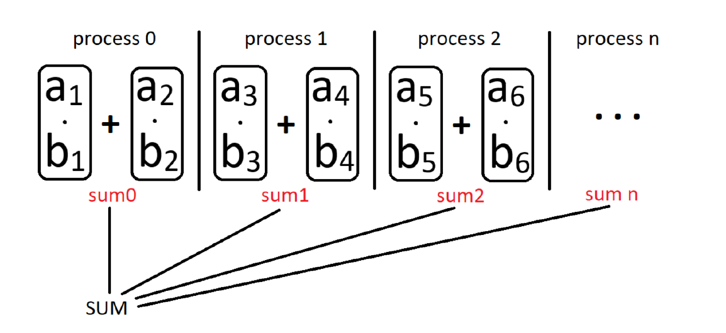

Scalar product for two vectors a = [a1, a2, ..., an] and b = [b1, b2, ..., bn] in n-dimensional space defined as: 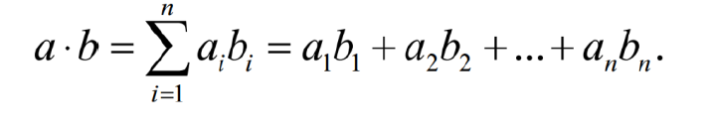

In the Assignment 5 need to write an MPI program in which two processes exchange messages, measure the time per exchange iteration, and determine the dependence of the exchange time on the message length. Determine the latency and maximum achievable bandwidth of the communication network. Print the message length in bytes and the throughput in MB/s to the console. Change the length of the message in a loop starting from 1 element and increase to 1,000,000 elements, increasing by 10 times at each iteration.

# Results

The code of the Assignment 6 can be found in

<https://github.com/AAYamoldin/TrainingPrograms/blob/master/institute_c_programs/ITMO_Parallel_Algorithm/Task_6/Assignment6.c>

The result of the program in the picture below:



The code of the Assignment 7 can be found in

<https://github.com/AAYamoldin/TrainingPrograms/blob/master/institute_c_programs/ITMO_Parallel_Algorithm/Task_7/Assignment7.cpp>

The result of the program is the picture below:



The code of the Assignment 8 can be found in

<https://github.com/AAYamoldin/TrainingPrograms/blob/master/institute_c_programs/ITMO_Parallel_Algorithm/Task_8/Assignment8.cpp>

The result in the picture and table below:

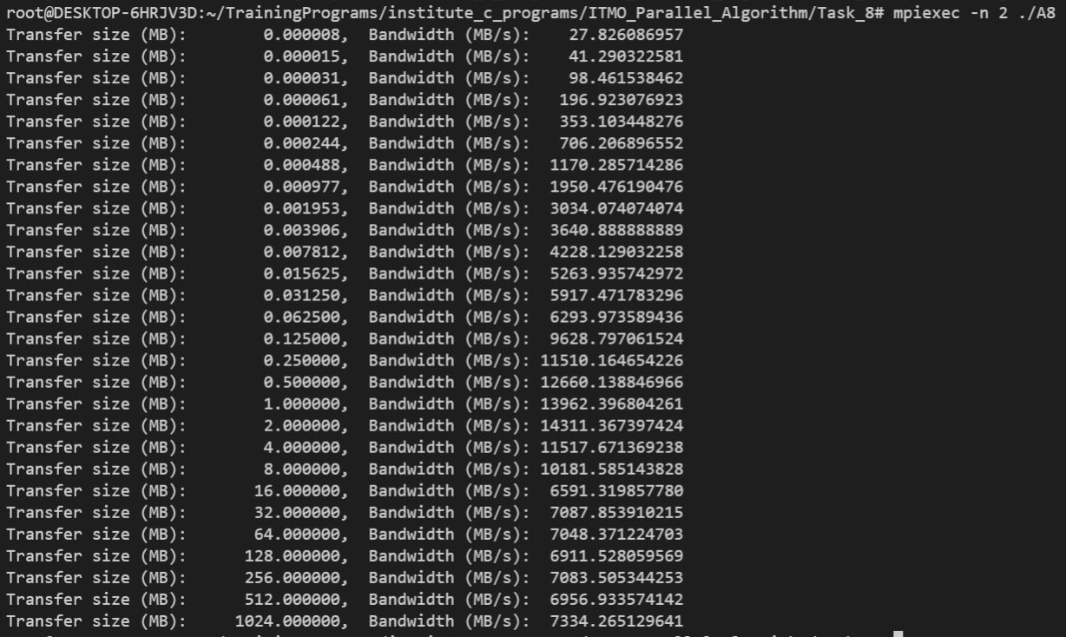

Transfer size (MB): 0.000008, Bandwidth (MB/s): 27.826086957

Transfer size (MB): 0.000015, Bandwidth (MB/s): 41.290322581

Transfer size (MB): 0.000031, Bandwidth (MB/s): 98.461538462

Transfer size (MB): 0.000061, Bandwidth (MB/s): 196.923076923

Transfer size (MB): 0.000122, Bandwidth (MB/s): 353.103448276

Transfer size (MB): 0.000244, Bandwidth (MB/s): 706.206896552

Transfer size (MB): 0.000488, Bandwidth (MB/s): 1170.285714286

Transfer size (MB): 0.000977, Bandwidth (MB/s): 1950.476190476

Transfer size (MB): 0.001953, Bandwidth (MB/s): 3034.074074074

Transfer size (MB): 0.003906, Bandwidth (MB/s): 3640.888888889

Transfer size (MB): 0.007812, Bandwidth (MB/s): 4228.129032258

Transfer size (MB): 0.015625, Bandwidth (MB/s): 5263.935742972

Transfer size (MB): 0.031250, Bandwidth (MB/s): 5917.471783296

Transfer size (MB): 0.062500, Bandwidth (MB/s): 6293.973589436

Transfer size (MB): 0.125000, Bandwidth (MB/s): 9628.797061524

Transfer size (MB): 0.250000, Bandwidth (MB/s): 11510.164654226

Transfer size (MB): 0.500000, Bandwidth (MB/s): 12660.138846966

Transfer size (MB): 1.000000, Bandwidth (MB/s): 13962.396804261

Transfer size (MB): 2.000000, Bandwidth (MB/s): 14311.367397424

Transfer size (MB): 4.000000, Bandwidth (MB/s): 11517.671369238

Transfer size (MB): 8.000000, Bandwidth (MB/s): 10181.585143828

Transfer size (MB): 16.000000, Bandwidth (MB/s): 6591.319857780

Transfer size (MB): 32.000000, Bandwidth (MB/s): 7087.853910215

Transfer size (MB): 64.000000, Bandwidth (MB/s): 7048.371224703

Transfer size (MB): 128.000000, Bandwidth (MB/s): 6911.528059569

Transfer size (MB): 256.000000, Bandwidth (MB/s): 7083.505344253

Transfer size (MB): 512.000000, Bandwidth (MB/s): 6956.933574142

Transfer size (MB): 1024.000000, Bandwidth (MB/s): 7334.265129641

# Conclusions

In the Assignment 6 we understand MPI_Probe procedure and how to pass MPI_TAG in condition structure.

In the Assignment 7 we learn how to divide data on portions and send this portions in different process. After that we combine a peace of solution into one in MASTER (0) process.

In the Assignment 8 we measure the time per each exchange messages iteration and bandwidth. The measurement range was from 8 byte to 1 GB. In the obtained result the best Bandwidth (14311.4 MB/s) is in transfer size 2 MB.