**Ministry of Science and Higher Education**

**of the Russian Federation**

**ITMO University**

Faculty of Digital Transformations

Educational program 01.04.02 Applied mathematics and informatics____

Subject area (major) Big Data and Machine Learning____

REPORT

on practical training Research Internship

Task topic: control of indoor air quality with on-demand controlled ventilation and dynamic natural ventilation

Student: Yamoldin Alexander, J4134c

Head of Practice from the trainee’s host organization: Basov Oleg, National Center for Cognitive Development, Senior Researcherhead of the laboratory «Center Information Optical Technologies»

Head of Practice from ITMO University: Alexandra Klimova, Faculty of Digital Transformation, assistant professor

|  |  |
| --- | --- |
|  | Practice completed with grade ____  Commission member signatures:  ______________ *full name*  (signature)  ______________ *full name*  (signature)  ______________ *full name*  (signature)  Date ________ |

St. Petersburg  
2022

**Annotation**

26 pages, 5 figures, 53 references

MACHINE LEARNING, CO2 PREDICTION, HVAC ENERGY CONSUMPTION, INDOOR AIR QUALITY, ENERGY EFFICIENTY, WELL-BEING

**Object of research**: Indoor air quality.

**Target of research:** The aim of the work is to create a model that provides a comfortable temperature and carbon dioxide level of indoor environment by using a combined method of ventilation.

**Methodology:** Application of Machine Learning and Artificial Intelligence for Dynamic Carbon Dioxide Level and Indoor Temperature Prediction.

**Results:** In this work, the approaches used to solve the problem of dynamic control of the indoor environment have been considered. In many articles there were found weaknesses, which should be considered in the future master's dissertation.

**Title**

List of Abbreviations and Designations 4

Introduction 5

The economic benefits 7

A comfortable office environment and the well-being of employees 9

Background and related work 10

Conclusion 25

References 27

# List of Abbreviations and Designations

IAQ - Indoor Air Quality

HVAC - Heating and Ventilating Air Conditioning systems

CCM - Classical Control Methods

ICA - Intelligent Control Approaches

MPC - Model Predictive Control

CO2 – Carbon Dioxide

CART - the Classification and Regression Tree

HMM - Hidden Markov Model

LSTM – Long Short-Term Memory

BES - Building Energy Simulation

# Introduction

The problem of air pollution in enclosed spaces such as office buildings, classrooms, and concert halls has long existed. As early as 2001, Dimitroulopoulou developed a dynamic model to describe the physical processes that determine the concentrations of pollutants in indoor air, depending on the concentration of pollutants in the open air [1]. People's need for good indoor air quality has increased many times over the past few years as the COVID-19 pandemic has encouraged many people to move to remote work in urban centers, where outdoor air pollution is one of the world's biggest health and environmental problems [2, 3]. In addition, there are improperly designed buildings that use only a small proportion of outdoor air, and the main air masses are simply recirculated, cleaned by filters and fed back to occupants [4, 5]. Many parameters are used to assess indoor air quality (IAQ), such as humidity and temperature [6], suspensions of solid particles [7] and organic compounds [8-11]. This paper considers one of the components of air pollution, the organic mixture of carbon dioxide.

The rapid growth of industry and human activity have a significant impact on the increase in the concentration of carbon dioxide in the air [12, 13]. Based on the IPCC study [12], the concentration of carbon dioxide in the atmosphere has increased from 300 to 390 ppm. An increase in the concentration of carbon dioxide in the atmosphere causes an increase in the concentration of carbon dioxide inside buildings, and therefore an increase in the energy cost of maintaining the premises [14]. There are three types of ventilation systems designed to control IAQ in office buildings and commercial spaces. The first type is natural convection ventilation that moves air masses through doors and windows. The second type is mechanical ventilation systems called HVAC (heating and ventilating air conditioning systems). The third type is a mixture of the first two types, i.e., it includes both mechanical ventilation through HVAC and natural convection ventilation produced through windows and doors [15]. The problem of dynamic regulation of indoor temperature and carbon dioxide concentrations is aimed at solving two problems at once: optimizing economic costs and maintaining the comfort of employees.

# The economic benefits

In this paper, the plan is to use the third type of ventilation system because HVAC systems are the best for ensuring the well-being of employees. However, there are economic costs associated with using HVAC.

According to the U.S. Energy Information Administration, up to 35% of energy consumption is in the industrial, commercial and residential building sector [16]. Despite the vast amount of office and peripheral equipment in modern office buildings, however, the largest consumers of electricity are heating, ventilation, and air conditioning (HVAC) systems [17]. It is obvious that HVAC is a source of excessive energy waste, which can be prevented by optimizing operating modes and controlling performance without causing damage to indoor occupants. Based on the results [18] efficient operation of the HVAC system is largely determined by the optimization of its control parameters and control modes. The researchers [19] concluded that the best, most reliable and cost-effective solution is to improve the HVAC control algorithm rather than replacing it with more energy-efficient and more expensive analogues. The authors [20] showed that smart HVAC system control can save up to 30% of energy while maintaining employee comfort levels. Improving the algorithms of HVAC systems is a priority in solving the optimization problems of improving the energy efficiency of ventilation systems [21, 22]. There are many methods of controlling the operation of HVAC systems. The totality of existing methods is usually classified into three large groups [23] CCM (classical control methods), ICA(intelligent control approaches), MPC (model predictive control). The CCM group includes such methods as: on-off, proportional, PI (proportional-integral), PID (proportional-integral derivative controllers. Classic control methods are used for indoor temperature control [24], dynamic control of supply air pressure [25], cooling coil unit control [26],  management of supply air temperature [27],  evaporator supply heat control [28],  and control of variable air volume unit temperature [29]. A significant disadvantage of the classical method of control is the impossibility to work with time delays, as a consequence of which such systems begin to work uncoordinatedly. Methods based on artificial intelligence are used to solve this problem [30, 31]. The neural network approach was applied by the authors in their work [32] for predicting temperature multizone comfort and occupants behavior. For the purpose of energy saving, companies often violate indoor air quality standards and, as a result, increased carbon dioxide concentrations are often observed in offices, classrooms, and concert halls. Therefore, in addition to solving the problem of optimizing the economic costs of electricity through the dynamic control of ventilation systems, the task of maintaining a comfortable office environment and the well-being of employees is no less relevant.

# A comfortable office environment and the well-being of employees

Most people spend more than 90% of their time indoors, which can include working in office buildings as well as working from home [33, 1]. Nowadays, most buildings are airtight shells to preserve and conserve heat and energy inside, so it is extremely important to have an adequate ventilation system in these buildings [34-36]. In addition, old restored buildings should not be forgotten. The result of the study [37] showed that in old renovated buildings the level of CO2, PM10, bacteria concentration is significantly higher than in new buildings, respectively, the need for an adequate ventilation system for these types of buildings is enormous. An inefficient ventilation system can lead to an accumulation of carbon dioxide in rooms and, once the CO2 concentration reaches more than 1000ppm, can significantly increase psycho-emotional symptoms such as headaches, difficulty concentrating, weakness, and irritability [38, 39]. Moreover, recent scientific research [40] has shown that classical ventilation control strategies cannot provide the level of indoor air quality required by ASHRAE Standard 62.1 2019. Another problem is the excessive concentration of carbon dioxide in overcrowded classrooms in schools in California, USA, whose ventilation system is not built for the current influx of students [41]. Erdmann’s work [42] studied a dataset of 100 buildings in the United States, obtaining statistically significant results about the relationship between indoor carbon dioxide concentrations and SBS symptoms. Based on all of the above, the problem of automatic dynamic control of carbon dioxide levels in the indoor environment, as one of the sources of air pollution, is extremely relevant. An effective solution to this problem can not only reduce the economic costs of energy costs, but also maintain a comfortable environment in the premises and thereby maintain the well-being and psycho-emotional state of the employees. These measures can significantly improve the company or educational institution in the opinion of potential employees.

# Background and related work

The problem of predicting carbon dioxide levels has been solved by several collectives of scientists. One approach to solving this problem is described in [42]. The authors used a supervised learning technique. The supervised learning occurs using class labeled instructional data. Each example of instructional data is a pair consisting of an input object and a target output. This study used a machine learning algorithm called The Classification and Regression Tree (CART) to predict the number of occupants and the Hidden Markov Model (HMM) to determine the amount of carbon dioxide in the air. The CART algorithm constructs a binary decision tree where each node has only two descendants. Consider the CART algorithm in more detail.

For the CART algorithm, the behavior of objects in the selected group means the proportion of modal value of the output attribute. Selected groups - the share of modal value of the output feature is high enough. At each step of tree building a node forms a rule that divides a given set of examples into two parts: the first part of the rule is satisfied, it is called the right child, the part where the rule is not satisfied is called the left child. The evaluation of model quality is based on an evaluation function based on the idea of entropy reduction in a node. One example of an evaluation function is the Gini index. If dataset T contains data of n classes, then Gini index can be defined

|  |  |
| --- | --- |
| $$Gini\left(T\right)=1-\sum_{i=1}^{n}{p_{i}^{2}}$$ | (1) |

where $p_{i}-$ is the probability of class i in T. If the set T is divided into two parts $T_{1}$ and $T_{2}$ with the number of parameters in each $N_{1}$ and $N_{2}$, respectively, then the quality score of the partitioning will be

|  |  |
| --- | --- |
| $${Gini}_{split}\left(T\right)=\frac{N_{1}}{N}*Gini\left(T_{1}\right)+\frac{N_{2}}{N}*Gini\left(T_{2}\right)$$ | (2) |

The best partition is the one for which ${Gini}_{split}\left(T\right)$ is minimal. Let us define N as the number of instances in a progenitor node, L, R as the number of objects respectively in the left and right descendant, $l_{i}$ and $r_{i}$ as the number of instances of i-th class in the left and right descendant. Then the quality of partitioning can be estimated by the following formula:

|  |  |
| --- | --- |
| $${Gini}_{split}=\frac{L}{N}*\left(1-\sum_{i=1}^{n}{{\left(\frac{l_{i}}{L}\right)}^{2}}\right)+\frac{R}{N}*\left(1-\sum_{i=1}^{n}{{\left(\frac{r_{i}}{R}\right)}^{2}}\right) → min$$ | (3) |

To reduce the amount of calculations this formula is converted to the form:

|  |  |
| --- | --- |
| $${Gini}_{split}=\frac{1}{N}*\left[L*\left(1-\frac{1}{L^{2}}*\sum_{i=1}^{n}{l_{i}^{2}}\right)+R*\left(1-\frac{1}{R^{2}}*\sum_{i=1}^{n}{r_{i}^{2}}\right)\right] → min$$ | (4) |

Since multiplication by a constant does not affect the minimization:

|  |  |
| --- | --- |
| $${Gini}_{split}=L-\frac{1}{L}\sum_{i=1}^{n}{l_{i}^{2}+R-\frac{1}{R}\sum_{i=1}^{n}{r_{i}^{2}→ min}}$$ | (5) |
|  |  |
| $${Gini}_{split}=N-\left(\frac{1}{L}\sum_{i=1}^{n}{l_{i}^{2}+\frac{1}{R}\sum_{i=1}^{n}{r_{i}^{2}}}\right)→ min$$ | (6) |
|  |  |
| $$G_{split}=\frac{1}{L}\sum_{i=1}^{n}{l_{i}^{2}+\frac{1}{R}\sum_{i=1}^{n}{r_{i}^{2}}}→ max$$ | (7) |
|  |  |

As a result, the best partition is the one for which the value of $G_{split}$ is maximal. This means that when building CART, we look for such a branching option, at which the value of ${Gini}_{split}$ decreases as much as possible.

In addition to CART, the Hidden Markov Model was used in this study. Consider the HMM in more detail. HMM is a statistical Markov model that simulates the behavior of a system, which is a Markov process with unknown parameters.

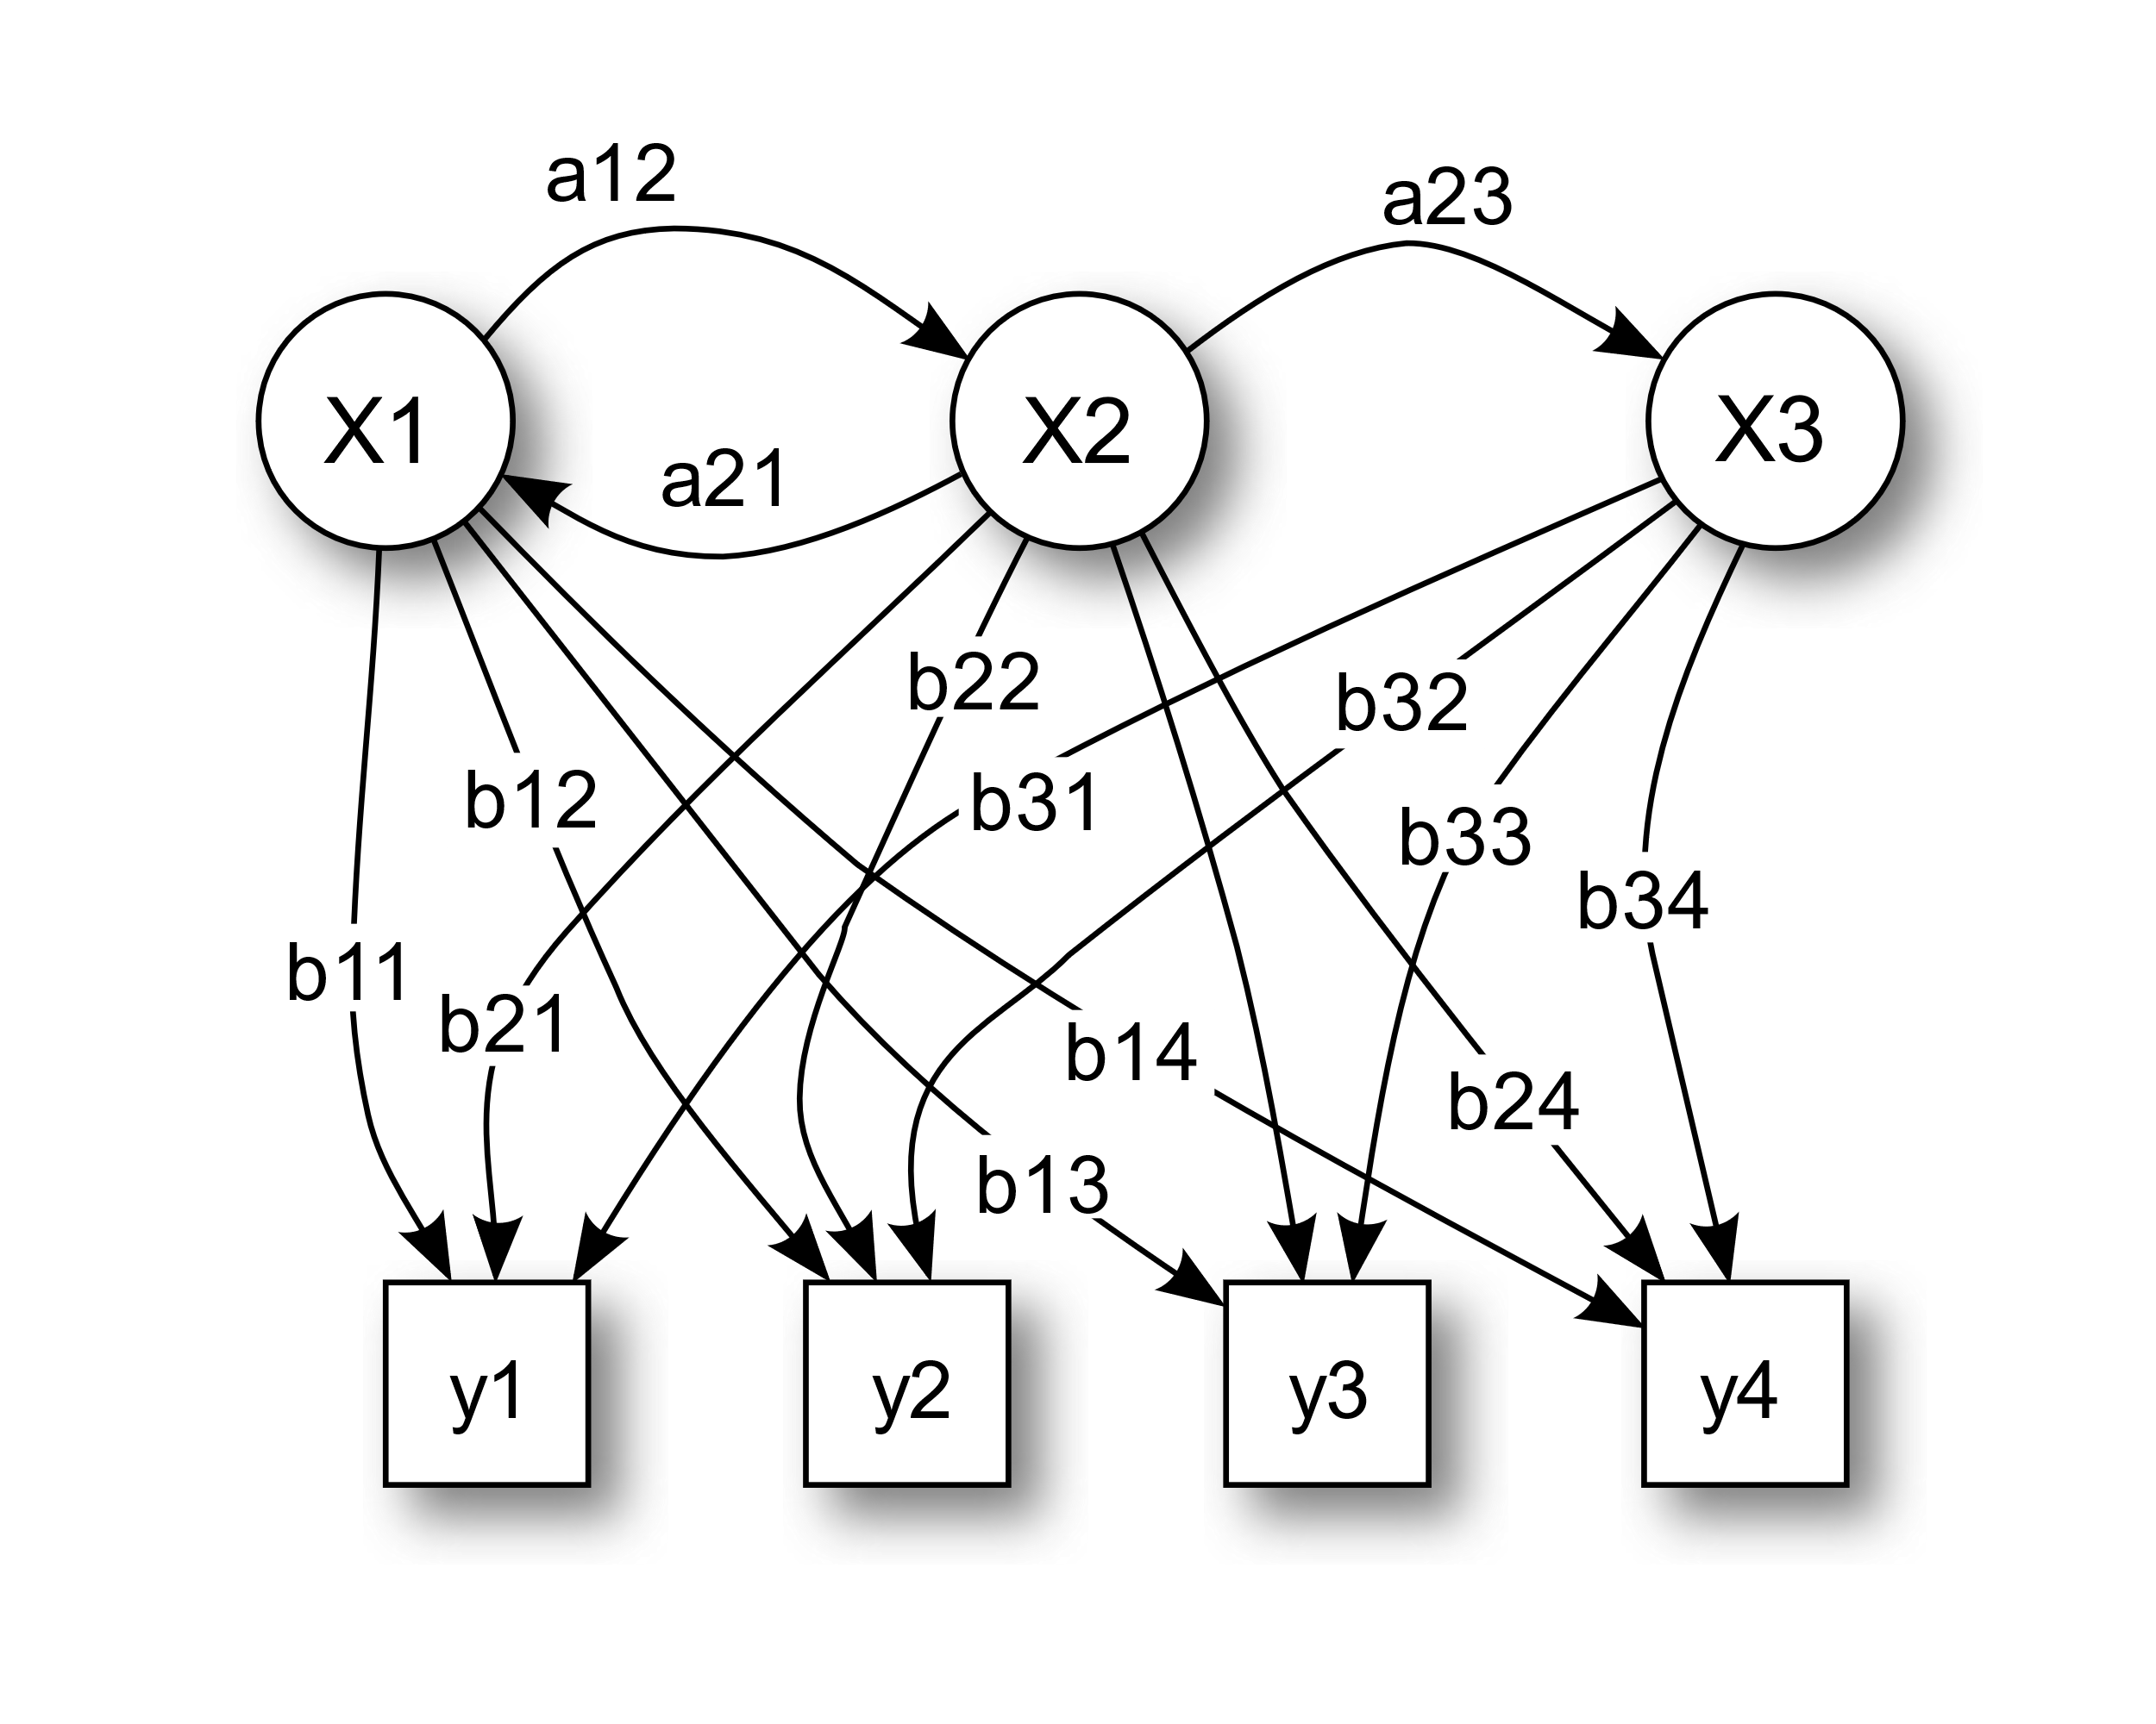

Figure 1 - Probabilistic parameters of a hidden Markov model (example).

X — states, y — possible observations, a — state transition probabilities, b — output probabilities [43]

The diagram below shows the general architecture of an instantiated HMM. Each oval shape represents a random variable that can adopt any of a number of values. The random variable $x(t)$  is the hidden state at time $t$  (with the model from the above diagram, $x\left(t\right)∈ \left\{x_{1}, x_{2},x_{3}\right\}$ ). The random variable $y(t)$  is the observation at time $t$  (with $y(t)$  ∈ $\left\{y_{1}, y_{2},y_{3},y_{4}\right\}$ ). The arrows in the diagram (often called a trellis diagram) denote conditional dependencies.

From the diagram, it is clear that the conditional probability distribution of the hidden variable $x(t)$ at time $t$, given the values of the hidden variable $x$ at all times, depends only on the value of the hidden variable $x(t-1)$; the values at time $t-2$ and before have no influence. This is called the Markov property. Similarly, the value of the observed variable $y(t)$ only depends on the value of the hidden variable $x\left(t\right)$ (both at time $t$).

Consider the standard HMM, the latent states are discrete, the observed parameters can also be discrete if they represent categorical distributions or continuous if they represent continuous distributions such as the Gaussian distribution. There are two types of parameters in the HMM, the first type is transition probabilities. This type of parameters is associated with the transition probabilities from the state with time $t-1$ to the state $t$. The second type of parameters is called emission probabilities (also known as output probabilities) this type defines the probability of obtaining a given observable depending on the state of the system.

The hidden space consists of $N$ possible values with a categorical distribution. This means that for each of $N$ possible values from the hidden space at time $t$ there are $N$ transition probabilities to each hidden state at time $t+1$, so in total there are $N^{2}$ transition probabilities. Thus, we have a Markov matrix of size $NxN$ transition probabilities. Since any transition probability can be determined when the others are known, there are $N(N-1)$ transition parameters in total. For each of the $N$ possible values, there is a set of emission probabilities defining the probability of the observed variable depending on what latent state the given system is in at that moment in time. To estimate the complexity, consider the example of $M$ possible observable parameters distributed discretely. Then the system will have $M-1$ distinct parameters, and the total number of parameters will be $N(M-1)$, if the $M$-dimensional vector of observable parameters is distributed as a multidimensional Gaussian distribution, then we will have $M$ parameters to control the mean values and $\frac{M(M+1)}{2}$ parameters to control the covariance matrix, so the total of parameters to control $N\left(M+\frac{M\left(M+1\right)}{2}\right)=\frac{NM(M+3)}{2}$, which leads to a complexity of the order of $O(NM^{2})$ when controlling emission parameters. Because complexity depends on $M$ quadratically, for large values of $M$ we impose artificial restrictions on the covariance matrix, implying, for example, that the elements are independent of each other.

In the article examined, the latent states of the Markov model were the predicted values of the number of occupancy through CART. The main advantage of HMM is the presence of temporal correlation in the time series. For this reason, the HMM model was chosen for predicting carbon dioxide consumption in this study. The authors obtained an accuracy of 89.5% in predicting the indoor CO2 concentration. However, this study has a number of weaknesses. One of them is the exceptional experimental conditions at the Building Integrated Control Test-bed (BICT) at Dankook University, Korea (Fig. 1).

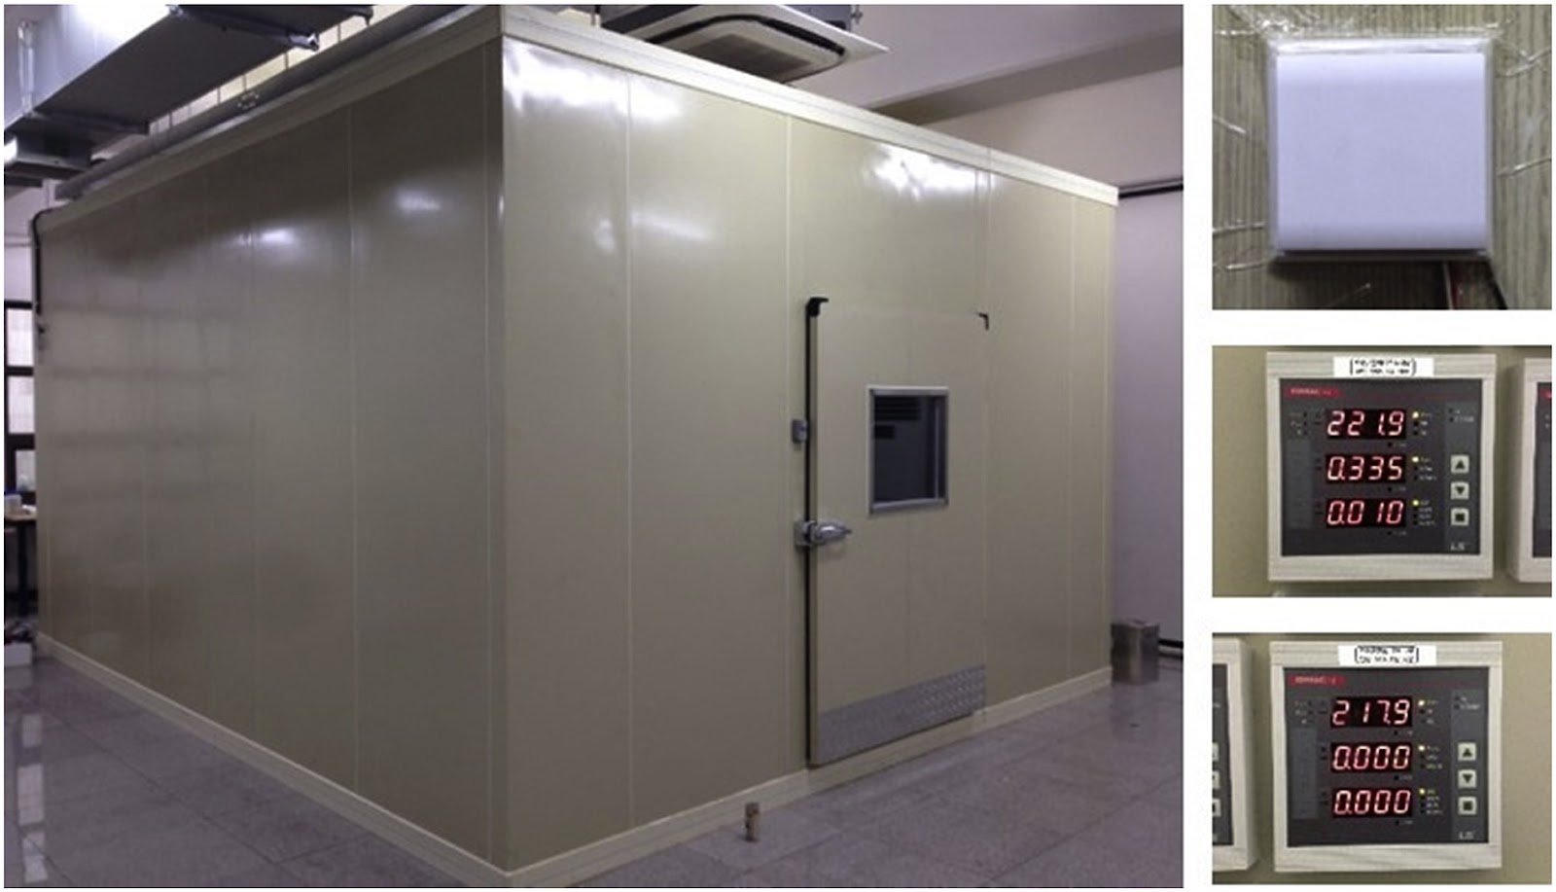

Figure 2 - Building Integrated Control Test-bed (BICT) used in the development of the occupancy prediction model [42]

Hence, it is not known whether this model can be applied in real conditions: in office buildings, classrooms or concert halls.

Another approach to solving the problem of predicting carbon dioxide concentrations is an approach based on a long-short term memory (LSTM) neural network architecture. LSTM is a special type of recurrent neural network architecture, capable of learning long-term dependencies. LSTM networks have an advantage over traditional recurrent neural networks, since the latter have the problem of vanishing gradient [44]. Hochreiter and Schmidhuber in their study [45] showed that LSTM RNNs address the vanishing gradient problem commonly found in ordinary recurrent neural networks by incorporating gating functions into their state dynamics. At each iteration, LSTM contains a hidden vector h and a memory vector m, which is responsible for the state of the output updates. More specifically Kawakami et al. [46] defined the computational iterations of the LSTM at time step $t$ as shown below:

|  |  |
| --- | --- |
| $$g^{u}=σ\left(W^{u} h_{t-1}+I^{u} x_{t}\right)$$ |  |
| $$g^{f}=σ\left(W^{f} h_{t-1}+I^{f} x_{t}\right)$$ |  |
| $$g^{o}=σ\left(W^{o} h_{t-1}+I^{o} x_{t}\right)$$ |  |
| $$g^{c}=tanh\left(W^{c} h_{t-1}+I^{c} x_{t}\right)$$ | (8) |
| $$m_{t}=g^{f}⊙m_{t-1}+g^{u}⊙g^{c}$$ |  |
| $$h_{t}=tanh⁡(g^{o}⊙m_{t})$$ |  |

where σ is the logistic sigmoid function, ⊙ represents elementwise multiplication, $W^{u}$, $W^{f}$, $W^{o}$, $W^{c}$ are recurrent weight matrices and $I^{u}$, $I^{f}$, $I^{o}$, $I^{c}$ are projection matrices.

In article [47] the authors used LSTM to predict the level of carbon dioxide concentration as a function of the number of people in the room, training on historical data. Predictions were made for a short prediction horizon. However, the obtained prediction accuracy does not exceed 70%, which is relatively low. Improving the architecture and methodology of the experiment can be considered as one of the possible objectives of our study.

In the paper [48] authors developed and applied algorithms based on sensory modeling, which can predict user behavior in buildings. After that, the resulting patterns were implemented in comfort management systems in buildings and simulations of energy consumption of these systems were carried out. Through their simulations, the authors have shown that there is the potential to reduce energy consumption by up to 30% without loss of workplace comfort. The study framework included the use of HMM for predicting energy consumption and comfort. Sensor data representing measurements of CO2 levels, temperature, and relative humidity in office spaces were used as observable parameters. This paper has shown that using machine learning to predict CO2 emissions has been useful, but it should understand that this paper is quite old (the year the paper was published was 2009), so we cannot be sure how much better or worse this approach is in today's realities. Therefore, one possible task for this paper could be to perform a comprehensive study comparing the suitability of modern machine learning algorithms for this problem.

Another strategy for estimating indoor carbon dioxide concentrations is presented in Paige WenbinTien et al. [49]. The researchers decided to reject a statistical approach to estimating office worker occupancy, fixed work schedules, and historical information about work hours. Instead, the paper proposed an approach to estimating employee employment and activity. The main idea of this work is to determine in real time the activity of employees during the working day using cameras. The researchers used a deep learning model based on a convolutional neural network. The general architecture of the neural network used in the study is shown in the picture below (Fig.3)

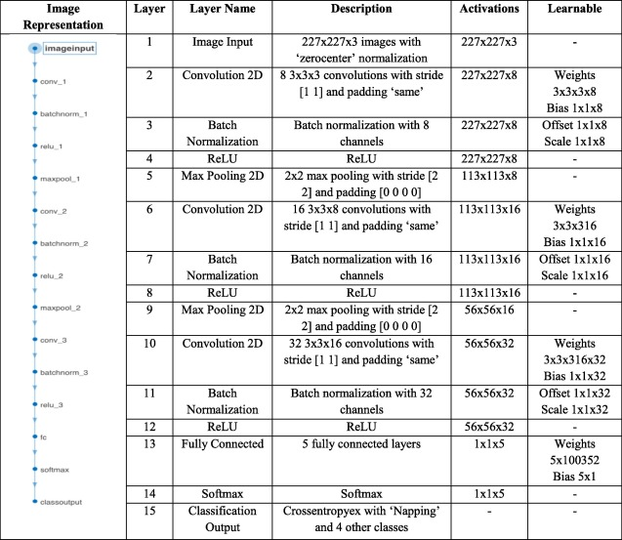

Figure 3 - The architecture of a 15-layer convolutional neural network used to detect office worker activity [49]

Researchers successful have developed a deep learning method to identify the main activities of office workers in a typical office building with an average detection accuracy of 80.62%. Having obtained a good accuracy in determining the number of occupants and their office activity, the authors suggested using this information to more accurately predict and estimate the concentration of carbon dioxide in the building. Since indoor carbon dioxide levels are one of the factors determining indoor air quality [50] authors suggested using the model they had developed to estimate this parameter when solving the problem of optimizing the quality of indoor air.

To test the methods, the authors modeled an office building in Nottingham, UK and performed a building energy simulation (BES) using simulated office processes in the building. Using the BES (Fig 4.) modeling, the author was showed that the level of carbon dioxide concentration in the air directly depends on the number of people in the room, as well as on what activities the office workers perform inside. This conclusion indicates a high potential of using this method for the prediction and regulation of carbon dioxide levels in office premises.

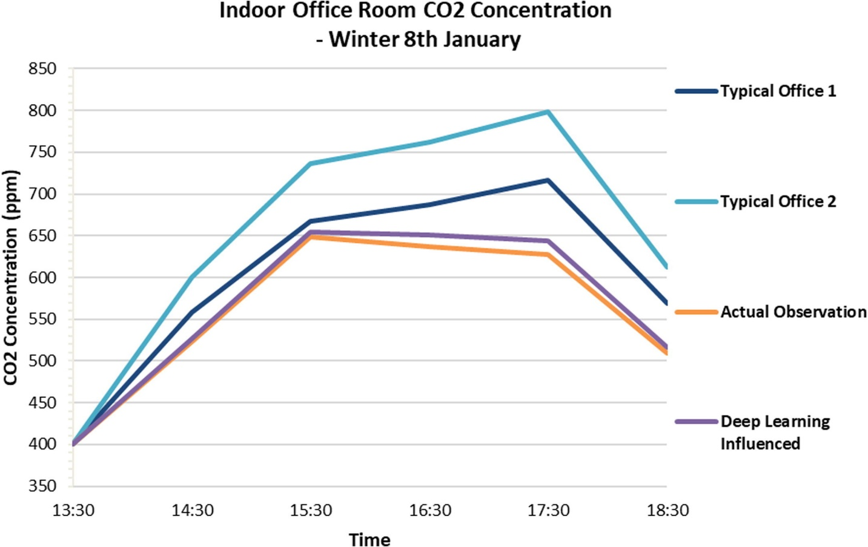

Figure 4 - CO2 Concentration for a winter day (8th January) at the open-plan office space with four occupants; based on the two Typical Office Profiles, DLIP and Actual Observation Profile [49]

Fig.4 shows a graph of the carbon dioxide concentration level in an office room, calculated based on the fact that there are 4 people inside the room. From the graph we can see that the difference in the CO2 concentration level between the real office and the neural network prediction can be as high as 248.8 ppm. This fact indicates that it is not enough to use only the number of people and their activity to estimate the level of carbon dioxide concentration in the room.

Other researchers in their work [51] describe a combined machine learning model and an algorithm for controlling the ventilation system to improve indoor air quality. In their work, the authors used an artificial neural network to predict the level of carbon dioxide concentration indoor. Control algorithms for ventilation systems are algorithms based on the contribution ratio of indoor climate. In their work, the authors found that by using strong strategies in managing HVAC systems, it is possible to save up to 35% of energy consumption. In our case, this work may be interesting because one of the regulated parameters is carbon dioxide, the regulation of which we want to implement in our study. However, the main drawback of this work is that the pollution and temperature parameters were simulated, so we do not have a clear understanding of the applicability of these technologies in real environments.

One of our most interesting papers is a recent study by Kallio et al. [52] on predicting carbon dioxide levels in office buildings using machine learning methods on a one-year dataset. In their paper, the authors used 4 machine learning methods to predict indoor CO2 concentrations. These methods were Ridge regression, Decision Tree, Random Forest, and Multilayer Perceptron. In the course of this literature review, we have already reviewed the CART decisional tree method. Let us describe in more detail the other machine learning methods.

The first method we will describe is called Ridge regression. If go a little bit deeper into history, may see that the method was originally called the Tikhonov regularization method, a method named after the Soviet and Russian mathematician Andrei Nikolaevich Tikhonov. Ridge regression is a method of dimensionality reduction. It is used to overcome data redundancy, when independent variables correlate with each other, resulting in unstable estimates of multivariate linear regression coefficients. Introduce the concept of multicollinearity. multicollinearity is the presence of linear dependence between independent variables of the regression model. A distinction is made between full collinearity and partial or simply multicollinearity - the presence of strong correlation between independent variables.

Consider an example of a linear model:

|  |  |
| --- | --- |
| $$y=b_{1}x_{1}+b_{2}x_{2}+b_{3}x_{3}+ε$$ | (9) |
|  |  |

In this case there is a dependence between the variables:

|  |  |
| --- | --- |
| $$x_{1}=x_{2}+x_{3}$$ | (10) |
|  |  |

Then add a random number a to the first coefficient, and subtract the same number from the other two coefficients.

Excluding random error, we obtain:

|  |  |
| --- | --- |
| $$y={(b}_{1}+a)x_{1}+\left(b_{2}-a\right)x_{2}+\left(b_{3}-a\right)x_{3}==b_{1}x_{1}+b_{2}x_{2}+b_{3}x_{3}+a\left(x_{1}-x_{2}-x_{3}\right)==b_{1}x_{1}+b_{2}x_{2}+b_{3}x_{3}$$ | (11) |
|  |  |

Despite the relatively arbitrary change in the coefficients of the model we obtained the original model, that is, such a model is undifferentiated. In practice, the problem of strong correlation between independent variables is more common. In this case it is possible to obtain estimates of model parameters, but they will be unstable.

Consider the problem of multivariate linear regression:

A linear dependence of the form is given:

|  |  |
| --- | --- |
| $$f\left(x, β\right)= <β, x>$$ | (12) |
|  |  |

Then needs to find the vector $\hat{β}$ at which the mean square error is minimized:

|  |  |
| --- | --- |
|  | (13) |

|  |  |
| --- | --- |
|  | (14) |

Finding the solution by the method of least squares:

|  |  |
| --- | --- |
| $$\hat{β}={(F^{T}F)}^{-1}F^{T}y$$ | (15) |
|  |  |

In conditions of multicollinearity, the matrix $F^{T}F$ becomes unconditioned.

|  |  |
| --- | --- |
| To solve this problem, we impose a restriction on the value of the coefficients: | (16) |

The functional Q, including the constraint, takes the form:

|  |  |
| --- | --- |
|  | (17) |

, where λ is a non-negative parameter.

The solution in this case is:

|  |  |
| --- | --- |
| $$\hat{β}={(F^{T}F+λI_{n})}^{-1}F^{T}y$$ | (18) |

This change increases the eigenvalues of the matrix $F^{T}F$, but does not change its eigenvectors. As a result, we obtain a well-conditioned matrix.  
The next method we will consider is called Multilayer perceptron (MLP), shown in Figure 5.  
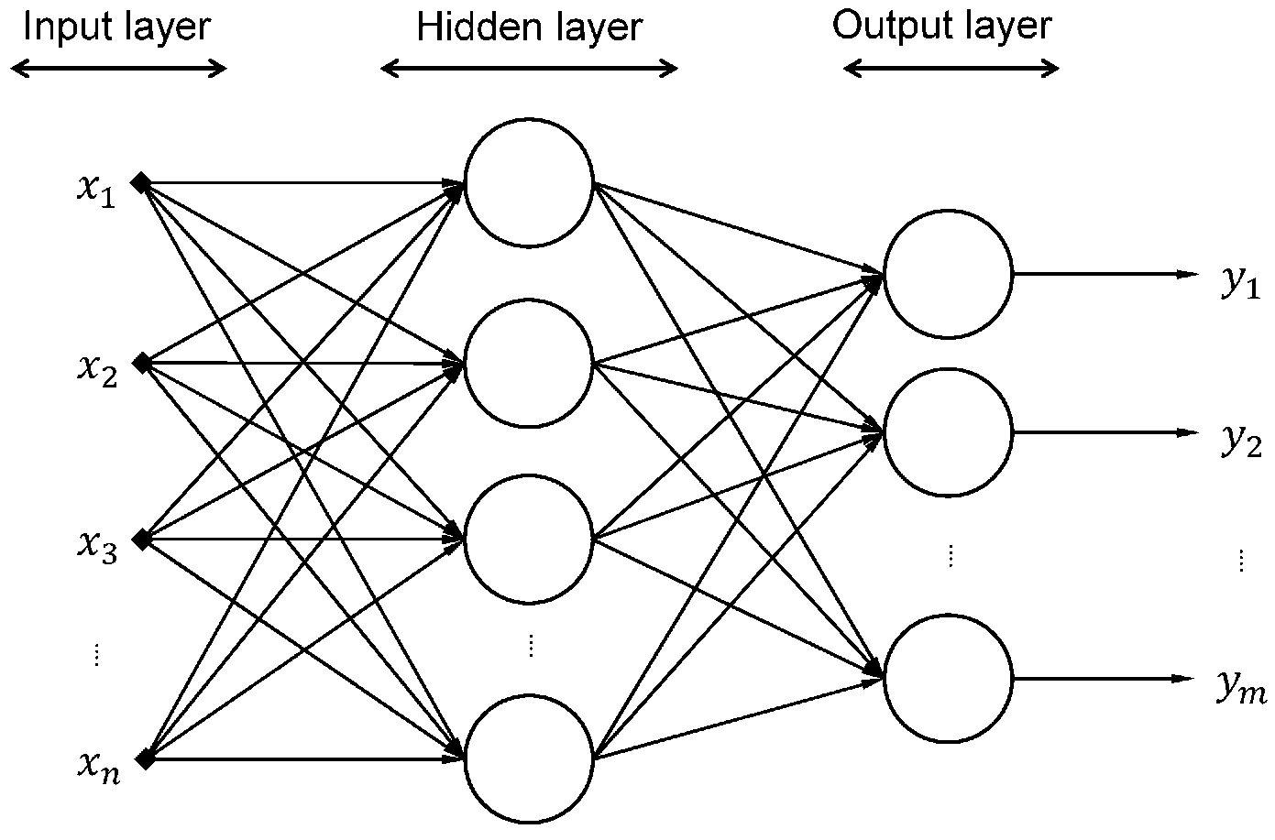

Figure 5 – Multilayer perceptron [53]

Multilayer perceptron consists of at least three layers, there are an input layer, a hidden layer and an output layer. Except for the input nodes, each node is a neuron that uses a nonlinear activation function. MLP utilizes a supervised learning technique called backpropagation for training. Training of the multilayer perceptron is based on changing the weights of the neuron's connections after processing each batch of data. Changing the weights is done by minimizing the error function, which signals how much the correct result is different from the output of the neural network. This method of learning is called supervised learning, the method has a mechanism of back propagation of the error and in general is a generalization of the least squares method in linear models. We can represent the degree of error in an output node j in the n-th training example by:

|  |  |
| --- | --- |
| $e_{j}(n)=d_{j}(n)-y_{j}(n)$ | (19) |

, where d is the target value and y is the value produced by the perceptron. The node weights can then be adjusted based on corrections that minimize the error in the entire output, given by:

|  |  |
| --- | --- |
| $$ε\left(n\right)=\frac{1}{2}\sum_{j}{e_{j}^{2}(n)}$$ | (20) |

Using gradient descent, the change in each weight is

|  |  |
| --- | --- |
| $$∆w_{ij}\left(n\right)=-η\frac{∂ε\left(n\right)}{∂v_{j}\left(n\right)}y_{i}(n)$$ | (21) |

, where $y_{i}$ is the output of the previous neuron and η is the learning rate, which is selected to ensure that the weights quickly converge to a response, without oscillations.

The derivative to be calculated depends on the induced local field $v_{j}$, which itself varies. It is easy to prove that for an output node this derivative can be simplified to

|  |  |
| --- | --- |
| $$-\frac{∂ε\left(n\right)}{∂v_{j}\left(n\right)}=e_{j}(n)φ'(v_{j}(n))$$ | (21) |

, where φ' is the derivative of the activation function, which itself does not vary. In artificial neural networks, the activation function of a node defines the output of that node given an input or set of inputs. The analysis is more difficult for the change in weights to a hidden node, but it can be shown that the relevant derivative is

|  |  |
| --- | --- |
| $$-\frac{∂ε\left(n\right)}{∂v_{j}\left(n\right)}=φ'(v_{j}(n))\sum_{k}{-\frac{∂ε\left(n\right)}{∂v_{j}\left(n\right)}}w_{ij}\left(n\right)$$ | (22) |

This depends on the change in weights of the k nodes, which represent the output layer. So, to change the hidden layer weights, the output layer weights change according to the derivative of the activation function, and so this algorithm represents a backpropagation of the activation function.

This work also has a number of shortcomings. For example, the authors use MAE (mean absolute error) as a quality metric in their study

|  |  |
| --- | --- |
|  | (23) |

, where $y_{i}$ is the prediction and $x_{i}$ the true value.

Obviously, such estimation is unstable to scale. Therefore, one of the options for the development of this problem in my work may be to clarify the results using different, scale-resistant metrics. For example, MAPE

|  |  |
| --- | --- |
|  | (24) |

And there is also an opinion [23] that for practical applications it is more appropriate to use longer forecasting horizons with higher indicators of quality metrics.

# Conclusion

In this review, several different approaches to the problem of air pollutant accumulation and removal in office buildings, auditoriums, and concert halls are examined. The main tasks to be solved are the task of predicting carbon dioxide levels depending on the number of employees, their activities, work schedules and the task of dynamic control of HVAC systems to control the climate in the building. In addition, some researches shows a reduction in energy consumption of up to 35% with dynamic HVAC control. However, in all of the reviewed papers, the authors consider maintaining a comfortable indoor climate through mechanical HVAC ventilation **only**.

But the regulation of the internal environment can also be carried out through natural ventilation. Obviously, the combination of HVAC and natural ventilation to solve the problems of thermal regulation and maintain a comfortable level of indoor carbon dioxide concentration is more energy efficient, because the natural movement of air flows from the room to the outside and back does not require energy costs. This approach requires the use of multi-parameter models, because in this case to predict the operation of HVAC systems should include the condition of the air outside, such as its temperature, humidity, the level of carbon dioxide concentration. Considering the level of outdoor carbon dioxide concentration is especially important because it can be a big problem in large city centers or its spikes caused by environmental causes. Outdoor air parameters can change dynamically, so an engineering approach only is not suitable. Machine learning and artificial intelligence methods should be used to analyze dynamically changing systems. Besides of the obvious economic benefits, punctual thermoregulation and maintaining a comfortable level of indoor carbon dioxide concentration can probably increase employee productivity, and thus reduce the economic costs of companies, educational institutions or concert halls.

The present master's work involves the creation of a special device for controlling the width of opening outdoor windows, machine learning models and algorithms that control the opening/closing of windows and HVAC system to maintain comfortable temperature and air quality for people working in enclosed spaces such as offices, classrooms or concert halls.

# References

    1.Dimitroulopoulou C. et al. Modelling of indoor exposure to nitrogen dioxide in the UK // Atmospheric Environment. 2001. Vol. 35, № 2. P. 269–279.

    2.Salmatonidis A. et al. Workplace Exposure to Nanoparticles during Thermal Spraying of Ceramic Coatings // Annals of Work Exposures and Health. 2018. Vol. 63, № 1. P. 91–106.

    3.Lasithiotakis M. et al. Heavy metals inhalation exposure analysis from particulate matter emitted from dry and wet recycling processes of waste electrical and electronic equipment // Environmental Progress & Sustainable Energy. 2019. Vol. 38, № 6.

    4.Quang T.N. et al. Influence of ventilation and filtration on indoor particle concentrations in urban office buildings // Atmospheric Environment. 2013. Vol. 79. P. 41–52.

    5.Jurado S., Bankoff A., Sanchez A. Indoor Air Quality in Brazilian Universities // International Journal of Environmental Research and Public Health. 2014. Vol. 11, № 7. P. 7081–7093.

    6.Wolkoff P., Kjærgaard S.K. The dichotomy of relative humidity on indoor air quality // Environment International. 2007. Vol. 33, № 6. P. 850–857.

    7.Horemans B., Van Grieken R. Speciation and diurnal variation of thoracic, fine thoracic and sub-micrometer airborne particulate matter at naturally ventilated office environments // Atmospheric Environment. 2010. Vol. 44, № 12. P. 1497–1505.

    8.Fraser A.J. et al. Polyfluorinated compounds in dust from homes, offices, and vehicles as predictors of concentrations in office workers’ serum // Environment International. 2013. Vol. 60. P. 128–136.

    9.Watkins D.J. et al. Associations between PBDEs in office air, dust, and surface wipes // Environment International. 2013. Vol. 59. P. 124–132.

    10.Lappalainen S. et al. Indoor air particles in office buildings with suspected indoor air problems in the Helsinki area // International Journal of Occupational Medicine and Environmental Health. 2013. Vol. 26, № 1.

    11.Salonen H.J. et al. Airborne Concentrations of Volatile Organic Compounds, Formaldehyde and Ammonia in Finnish Office Buildings with Suspected Indoor Air Problems // Journal of Occupational and Environmental Hygiene. 2009. Vol. 6, № 3. P. 200–209.

    12.Intergovernmental Panel on Climate Change. Climate Change 2014 Mitigation of Climate Change. Cambridge: Cambridge University Press, 2014.

    13.Sinyak Y. Global climate and energy systems // Science of The Total Environment. 1994. Vol. 143, № 1. P. 31–51.

    14.Leivo V. et al. Indoor thermal environment, air exchange rates, and carbon dioxide concentrations before and after energy retro fits in Finnish and Lithuanian multi-family buildings // Science of The Total Environment. 2018. Vol. 621. P. 398–406.

    15.Irga P.J., Torpy F.R. Indoor air pollutants in occupational buildings in a sub-tropical climate: Comparison among ventilation types // Building and Environment. 2016. Vol. 98. P. 190–199.

    16.Pang Z. et al. How much HVAC energy could be saved from the occupant-centric smart home thermostat: A nationwide simulation study // Applied Energy. 2021. Vol. 283. P. 116251.

    17.Papadopoulos S. et al. Rethinking HVAC temperature setpoints in commercial buildings: The potential for zero-cost energy savings and comfort improvement in different climates // Building and Environment. 2019. Vol. 155. P. 350–359.

    18.Zhu M. et al. An occupant-centric air-conditioning system for occupant thermal preference recognition control in personal micro-environment // Building and Environment. 2021. Vol. 196. P. 107749.

    19.Jazizadeh F., Joshi V., Battaglia F. Adaptive and distributed operation of HVAC systems: Energy and comfort implications of active diffusers as new adaptation capacities // Building and Environment. 2020. Vol. 186. P. 107089.

    20.Schito E. et al. Multi-objective optimization of HVAC control in museum environment for artwork preservation, visitors’ thermal comfort and energy efficiency // Building and Environment. 2020. Vol. 180. P. 107018.

    21.Mary Reena K.E., Mathew A.T., Jacob L. A flexible control strategy for energy and comfort aware HVAC in large buildings // Building and Environment. 2018. Vol. 145. P. 330–342.

    22.Taheri S. et al. Stochastic framework for planning studies of energy systems: a case of EHs // IET Renewable Power Generation. 2020. Vol. 14, № 3. P. 435–444.

    23.Taheri S., Razban A. Learning-based CO2 concentration prediction: Application to indoor air quality control using demand-controlled ventilation // Building and Environment. 2021. Vol. 205. P. 108164.

    24.Yang S. et al. Model predictive control with adaptive machine-learning-based model for building energy efficiency and comfort optimization // Applied Energy. 2020. Vol. 271. P. 115147.

    25.Zhao T. et al. Online differential pressure reset method with adaptive adjustment algorithm for variable chilled water flow control in central air-conditioning systems // Building Simulation. 2021. Vol. 14, № 5. P. 1407–1422.

    26.Wang H. et al. Eco-Cooling Control Strategy for Automotive Air-Conditioning System: Design and Experimental Validation // IEEE Transactions on Control Systems Technology. 2021. Vol. 29, № 6. P. 2339–2350.

    27.Ahamed M.S. et al. Gray-box virtual sensor of the supply air temperature of air handling units // Science and Technology for the Built Environment. 2020. Vol. 26, № 8. P. 1151–1162.

    28.Wu C., Xingxi Z., Shiming D. Development of control method and dynamic model for multi-evaporator air conditioners (MEAC) // Energy Conversion and Management. 2005. Vol. 46, № 3. P. 451–465.

    29.Li X. et al. Predication control for indoor temperature time-delay using Elman neural network in variable air volume system // Energy and Buildings. 2017. Vol. 154. P. 545–552.

    30.Fakhari I. et al. Design and tri-objective optimization of a hybrid efficient energy system for tri-generation, based on PEM fuel cell and MED using syngas as a fuel // Journal of Cleaner Production. 2021. Vol. 290. P. 125205.

    31.Fakhari I. et al. Comparative double and integer optimization of low-grade heat recovery from PEM fuel cells employing an organic Rankine cycle with zeotropic mixtures // Energy Conversion and Management. 2021. Vol. 228. P. 113695.

    32.Deng Z., Chen Q. Reinforcement learning of occupant behavior model for cross-building transfer learning to various HVAC control systems // Energy and Buildings. 2021. Vol. 238. P. 110860.

    33.McCreddin A. et al. Personal Exposure to Air Pollution in Office Workers in Ireland: Measurement, Analysis and Implications // Toxics. 2013. Vol. 1, № 1. P. 60–76.

    34.Berge M., Georges L., Mathisen H.M. On the oversupply of heat to bedrooms during winter in highly insulated dwellings with heat recovery ventilation // Building and Environment. 2016. Vol. 106. P. 389–401.

    35.Wang Z. et al. Indoor environment quality in a low-energy residential building in winter in Harbin // Building and Environment. 2018. Vol. 135. P. 194–201.

    36.Wu W., Skye H.M., Domanski P.A. Selecting HVAC systems to achieve comfortable and cost-effective residential net-zero energy buildings // Applied Energy. 2018. Vol. 212. P. 577–591.

    37.Fauzan N., Jalaludin J., Choo Chua P. Indoor Air Quality and Sick Building Syndrome (SBS) among staff in two different private higher learning institution settings in Kuala Lumpur and Selangor. 2016.

    38.Muscatiello N. et al. Classroom conditions and CO2concentrations and teacher health symptom reporting in 10 New York State Schools // Indoor Air. 2014. Vol. 25, № 2. P. 157–167.

    39.Persily A. Challenges in developing ventilation and indoor air quality standards: The story of ASHRAE Standard 62 // Building and Environment. 2015. Vol. 91. P. 61–69.

    40.Lu X. et al. Energy and ventilation performance analysis for CO2-based demand-controlled ventilation in multiple-zone VAV systems with fan-powered terminal units (ASHRAE RP-1819) // Science and Technology for the Built Environment. 2020. Vol. 27, № 2. P. 139–157.

    41.Chan W.R. et al. Ventilation rates in California classrooms: Why many recent HVAC retrofits are not delivering sufficient ventilation // Building and Environment. 2020. Vol. 167. P. 106426.

    42.Ryu S.H., Moon H.J. Development of an occupancy prediction model using indoor environmental data based on machine learning techniques // Building and Environment. 2016. Vol. 107. P. 1–9.

    43.Contributors to Wikimedia projects. Hidden Markov model [Electronic resource] // Wikipedia. 2022. URL: https://en.wikipedia.org/wiki/Hidden_Markov_model (accessed: 13.01.2022).

    44.Karim F. et al. LSTM Fully Convolutional Networks for Time Series Classification // IEEE Access. 2018. Vol. 6. P. 1662–1669.

    45.Hochreiter S., Schmidhuber J. Long Short-Term Memory // Neural Computation. 1997. Vol. 9, № 8. P. 1735–1780.

    46.Graves A. Supervised Sequence Labelling // Studies in Computational Intelligence. Berlin, Heidelberg: Springer Berlin Heidelberg, 2012. P. 5–13.

    47.2019 7th International Renewable and Sustainable Energy Conference (IRSEC) // 2019 7th International Renewable and Sustainable Energy Conference (IRSEC). IEEE, 2019.

    48.Dong B., Andrews B. Sensor-based occupancy behavioral pattern recognition for energy and comfort management in intelligent buildings // IBPSA 2009 - International Building Performance Simulation Association 2009. 2009.

    49.Tien P.W. et al. A vision-based deep learning approach for the detection and prediction of occupancy heat emissions for demand-driven control solutions // Energy and Buildings. 2020. Vol. 226. P. 110386.

    50.Pathirana S.M., Sheranie M.D.M., Halwatura R.U. Indoor thermal comfort and Carbon Dioxide concentration // 2017 Moratuwa Engineering Research Conference (MERCon). IEEE, 2017.

    51.Zhu H.-C., Ren C., Cao S.-J. Fast prediction for multi-parameters (concentration, temperature and humidity) of indoor environment towards the online control of HVAC system // Building Simulation. 2020. Vol. 14, № 3. P. 649–665.

    52.Kallio J. et al. Forecasting office indoor CO2 concentration using machine learning with a one-year dataset // Building and Environment. 2021. Vol. 187. P. 107409.

    53.Ryu S., Noh J., Kim H. Deep Neural Network Based Demand Side Short Term Load Forecasting // Energies. 2016. Vol. 10, № 1. P. 3.