**Alexander Yamoldin, j4134c**

**Review Paper**

**Control of indoor air quality with on-demand controlled ventilation and dynamic natural ventilation**

The problem of predicting carbon dioxide levels has been solved by several collectives of scientists. One approach to solving this problem is described in [1]. The authors used a supervised learning technique. The supervised learning occurs using class labeled instructional data. Each example of instructional data is a pair consisting of an input object and a target output. This study used a machine learning algorithm called The Classification and Regression Tree (CART) to predict the number of occupants and the Hidden Markov Model (HMM) to determine the amount of carbon dioxide in the air.

In the article examined, the latent states of the Markov model were the predicted values of the number of occupancy through CART. The main advantage of HMM is the presence of temporal correlation in the time series. For this reason, the HMM model was chosen for predicting carbon dioxide consumption in this study. The authors obtained an accuracy of 89.5% in predicting the indoor CO2 concentration. However, this study has a number of weaknesses. One of them is the exceptional experimental conditions at the Building Integrated Control Test-bed (BICT) at Dankook University, Korea (Fig. 1).

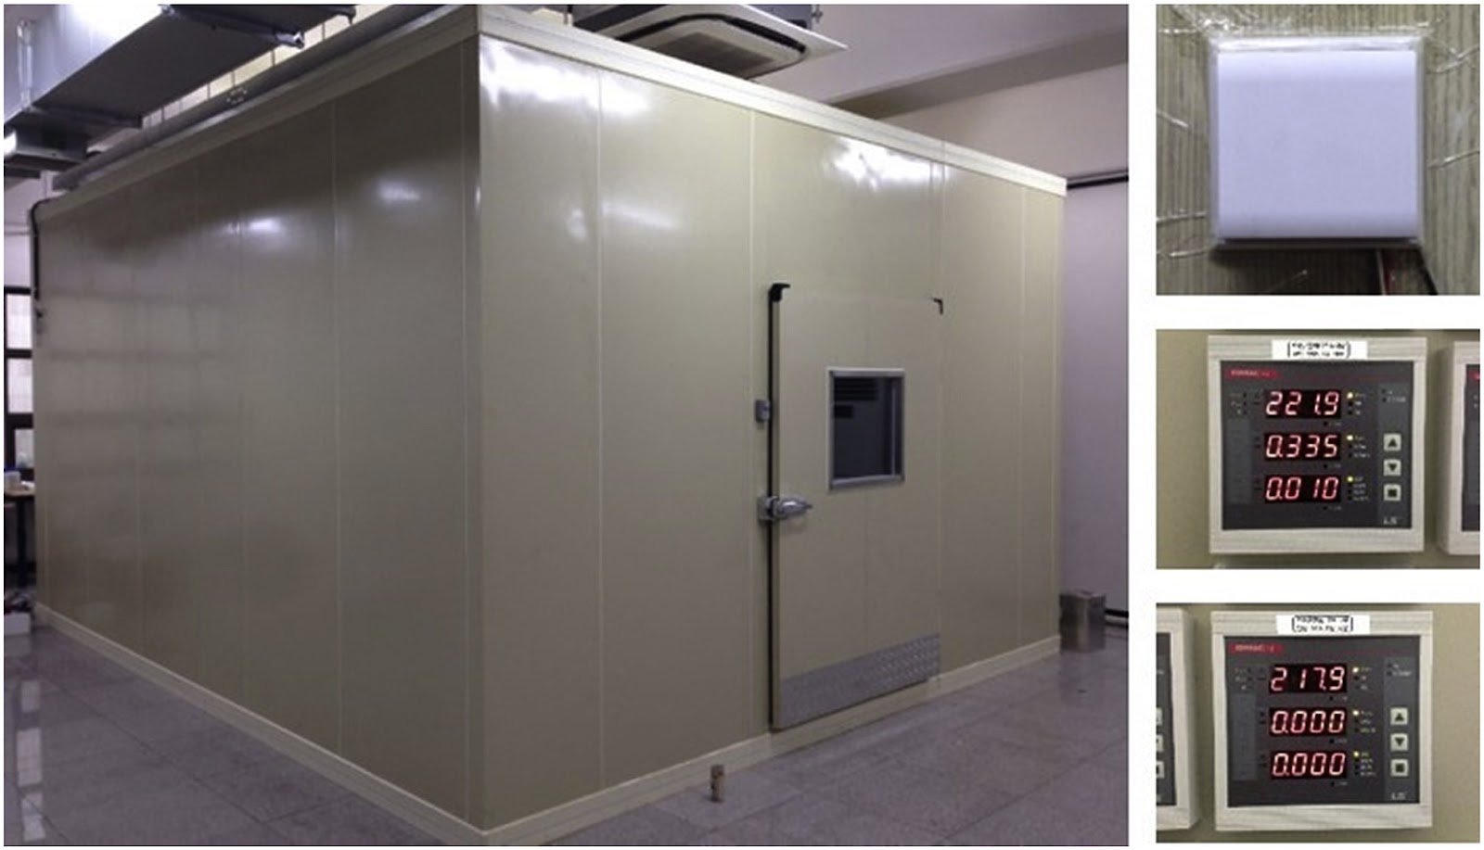

Figure 2 - Building Integrated Control Test-bed (BICT) used in the development of the occupancy prediction model [1]

Hence, it is not known whether this model can be applied in real conditions: in office buildings, classrooms or concert halls.

Another approach to solving the problem of predicting carbon dioxide concentrations is an approach based on a long-short term memory (LSTM) neural network architecture. LSTM is a special type of recurrent neural network architecture, capable of learning long-term dependencies. LSTM networks have an advantage over traditional recurrent neural networks, since the latter have the problem of vanishing gradient [2]. In article [3] the authors used LSTM to predict the level of carbon dioxide concentration as a function of the number of people in the room, training on historical data. Predictions were made for a short prediction horizon. However, the obtained prediction accuracy does not exceed 70%, which is relatively low. Improving the architecture and methodology of the experiment can be considered as one of the possible objectives of our study.

In the paper [4] authors developed and applied algorithms based on sensory modeling, which can predict user behavior in buildings. After that, the resulting patterns were implemented in comfort management systems in buildings and simulations of energy consumption of these systems were carried out. Through their simulations, the authors have shown that there is the potential to reduce energy consumption by up to 30% without loss of workplace comfort. The study framework included the use of HMM for predicting energy consumption and comfort. Sensor data representing measurements of CO2 levels, temperature, and relative humidity in office spaces were used as observable parameters. This paper has shown that using machine learning to predict CO2 emissions has been useful, but it should understand that this paper is quite old (the year the paper was published was 2009), so we cannot be sure how much better or worse this approach is in today's realities. Therefore, one possible task for this paper could be to perform a comprehensive study comparing the suitability of modern machine learning algorithms for this problem.

Another strategy for estimating indoor carbon dioxide concentrations is presented in Paige WenbinTien et al. [5]. The researchers decided to reject a statistical approach to estimating office worker occupancy, fixed work schedules, and historical information about work hours. Instead, the paper proposed an approach to estimating employee employment and activity. The main idea of this work is to determine in real time the activity of employees during the working day using cameras. The researchers used a deep learning model based on a convolutional neural network. The general architecture of the neural network used in the study is shown in the picture below (Fig.3)

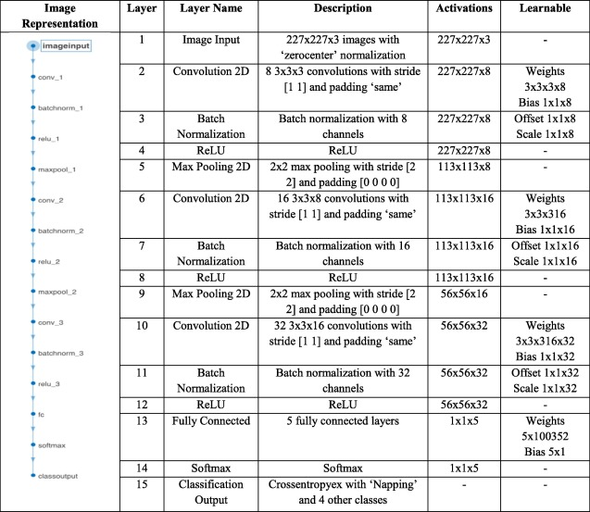

Figure 3 - The architecture of a 15-layer convolutional neural network used to detect office worker activity [5]

Researchers successful have developed a deep learning method to identify the main activities of office workers in a typical office building with an average detection accuracy of 80.62%. Having obtained a good accuracy in determining the number of occupants and their office activity, the authors suggested using this information to more accurately predict and estimate the concentration of carbon dioxide in the building. Since indoor carbon dioxide levels are one of the factors determining indoor air quality [50] authors suggested using the model they had developed to estimate this parameter when solving the problem of optimizing the quality of indoor air.

To test the methods, the authors modeled an office building in Nottingham, UK and performed a building energy simulation (BES) using simulated office processes in the building. Using the BES (Fig 4.) modeling, the author was showed that the level of carbon dioxide concentration in the air directly depends on the number of people in the room, as well as on what activities the office workers perform inside. This conclusion indicates a high potential of using this method for the prediction and regulation of carbon dioxide levels in office premises.

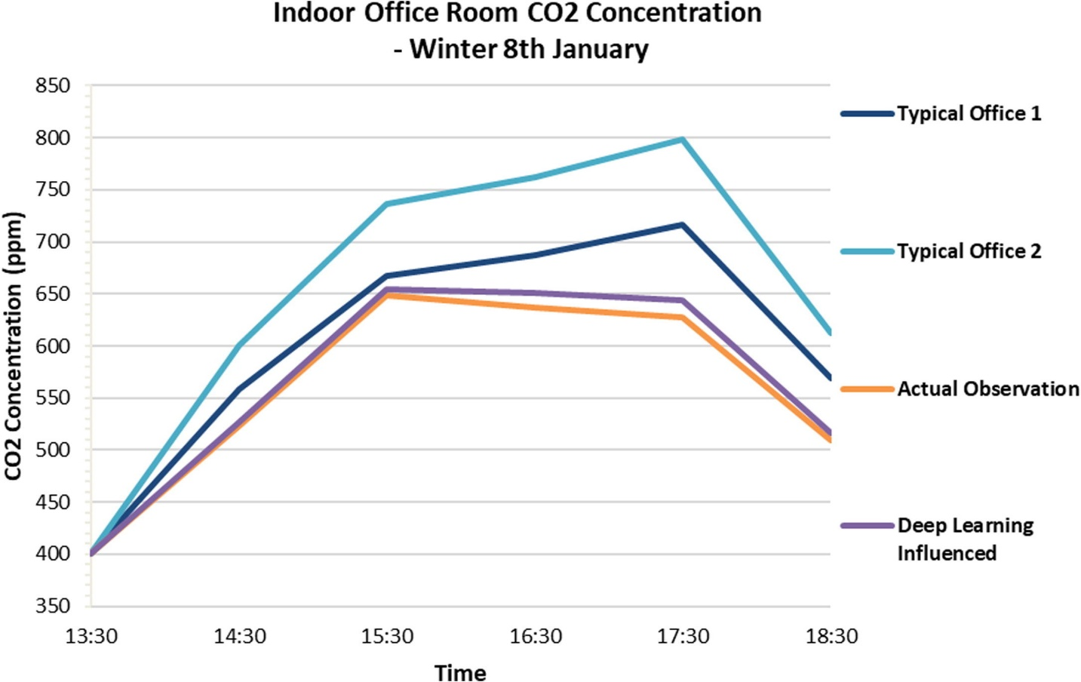

Figure 4 - CO2 Concentration for a winter day (8th January) at the open-plan office space with four occupants; based on the two Typical Office Profiles, DLIP and Actual Observation Profile [5]

Fig.4 shows a graph of the carbon dioxide concentration level in an office room, calculated based on the fact that there are 4 people inside the room. From the graph we can see that the difference in the CO2 concentration level between the real office and the neural network prediction can be as high as 248.8 ppm. This fact indicates that it is not enough to use only the number of people and their activity to estimate the level of carbon dioxide concentration in the room.

Other researchers in their work [6] describe a combined machine learning model and an algorithm for controlling the ventilation system to improve indoor air quality. In their work, the authors used an artificial neural network to predict the level of carbon dioxide concentration indoor. Control algorithms for ventilation systems are algorithms based on the contribution ratio of indoor climate. In their work, the authors found that by using strong strategies in managing HVAC systems, it is possible to save up to 35% of energy consumption. In our case, this work may be interesting because one of the regulated parameters is carbon dioxide, the regulation of which we want to implement in our study. However, the main drawback of this work is that the pollution and temperature parameters were simulated, so we do not have a clear understanding of the applicability of these technologies in real environments.

One of our most interesting papers is a recent study by Kallio et al. [7] on predicting carbon dioxide levels in office buildings using machine learning methods on a one-year dataset. In their paper, the authors used 4 machine learning methods to predict indoor CO2 concentrations. These methods were Ridge regression, Decision Tree, Random Forest, and Multilayer Perceptron

This work also has a number of shortcomings. For example, the authors use MAE (mean absolute error) as a quality metric in their study

|  |  |
| --- | --- |
|  | (23) |

, where $y_{i}$ is the prediction and $x_{i}$ the true value.

Obviously, such estimation is unstable to scale. Therefore, one of the options for the development of this problem in my work may be to clarify the results using different, scale-resistant metrics. For example, MAPE

|  |  |
| --- | --- |
|  | (24) |

And there is also an opinion [8] that for practical applications it is more appropriate to use longer forecasting horizons with higher indicators of quality metrics.

**References**

1. Ryu S.H., Moon H.J. Development of an occupancy prediction model using indoor environmental data based on machine learning techniques // Building and Environment. 2016. Vol. 107. P. 1–9.

2. Karim F. et al. LSTM Fully Convolutional Networks for Time Series Classification // IEEE Access. 2018. Vol. 6. P. 1662–1669.

3. 2019 7th International Renewable and Sustainable Energy Conference (IRSEC) // 2019 7th International Renewable and Sustainable Energy Conference (IRSEC). IEEE, 2019.

4. Dong B., Andrews B. Sensor-based occupancy behavioral pattern recognition for energy and comfort management in intelligent buildings // IBPSA 2009 - International Building Performance Simulation Association 2009. 2009.

5. Tien P.W. et al. A vision-based deep learning approach for the detection and prediction of occupancy heat emissions for demand-driven control solutions // Energy and Buildings. 2020. Vol. 226. P. 110386.

6. Zhu H.-C., Ren C., Cao S.-J. Fast prediction for multi-parameters (concentration, temperature and humidity) of indoor environment towards the online control of HVAC system // Building Simulation. 2020. Vol. 14, № 3. P. 649–665.

7. Kallio J. et al. Forecasting office indoor CO2 concentration using machine learning with a one-year dataset // Building and Environment. 2021. Vol. 187. P.

8. Taheri S., Razban A. Learning-based CO2 concentration prediction: Application to indoor air quality control using demand-controlled ventilation // Building and Environment. 2021. Vol. 205. P. 108164.