ABDULRAZAQ ABDULRAZAQ ZUBAIR  Lecturer · MRI Specialist Radiographer · Medical Imaging Researcher  Federal University of Health Sciences, Azare (FUHSA), Nigeria  African Institute for Research Advancement & Innovation (AIRA Africa)  aazubair01@gmail.com · abdulrazaq.zubair@fuhsa.edu.ng · aazubair@airaafrica.com  +234 818 981 7182 (WhatsApp) · +234 806 050 2348  Homepage: aazubair01.github.io/Resume · AIRA Africa: airaafrica.com | 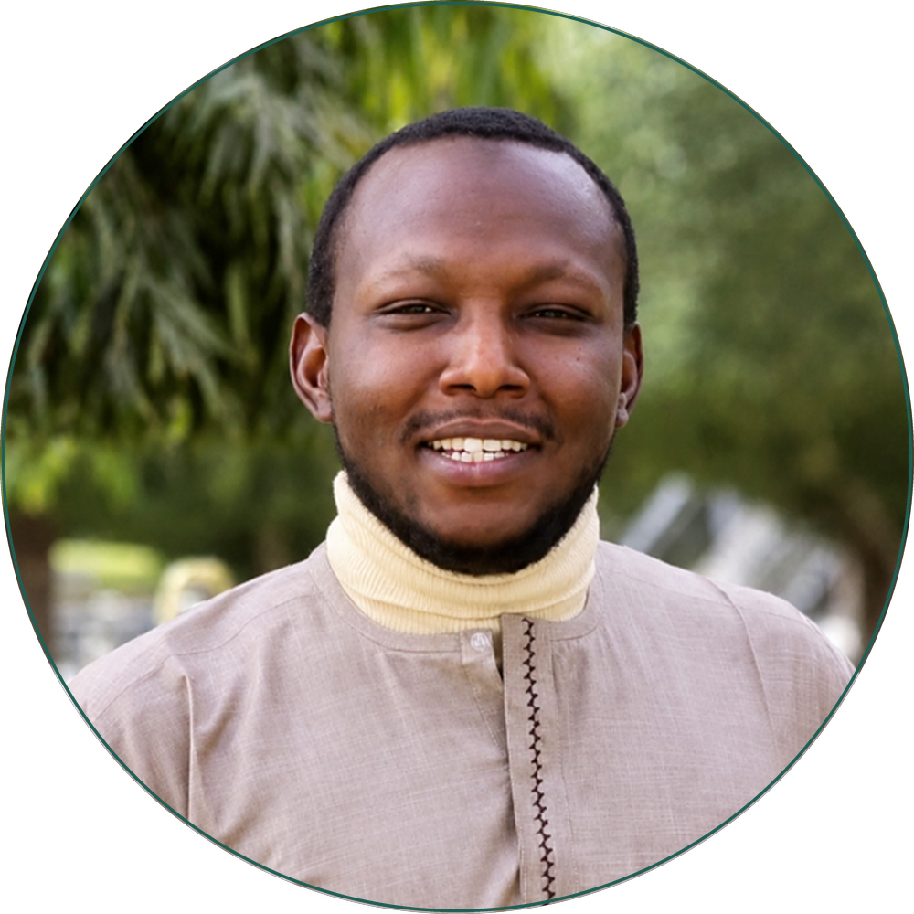
PROFILE SUMMARY
Lecturer, MRI specialist radiographer, and medical imaging researcher with over nine years of experience in clinical radiography, MRI, ultrasound, and CT. My work sits at the intersection of clinical imaging, neuroimaging, and artificial intelligence, with a strong focus on patient safety, workflow optimization, and equitable access to high-quality imaging, particularly in resource-limited settings. I have held academic and clinical leadership roles, including departmental headship of a diagnostic imaging service, training medical radiography students and coordinating advanced imaging and neuroimaging services in Nigeria. I am currently pursuing a PhD in Medical Radiography at Bayero University Kano, exploring AI-assisted workflow enhancement in MRI with emphasis on safety and image quality optimization.
EDUCATION
PhD, Medical Radiography (in progress) — Bayero University Kano, Nigeria 2023 – present
Postgraduate Diploma, Magnetic Resonance Imaging — Institute of Radiography, Abuja 2023 – 2024
Postgraduate Diploma, Medical Ultrasound — Institute of Radiography, Kano 2022 – 2023
MSc, Nuclear Physics — Bayero University Kano, Nigeria 2017 – 2022
BSc, Radiography — Bayero University Kano, Nigeria 2010 – 2016
PROFESSIONAL CERTIFICATIONS
Radiation Safety Officer — Nigerian Nuclear Regulatory Authority 2025
Computed Tomography (CT) Certification 2016
Recent Advanced Training
- SPARK Academy — Sprint AI Training for African Medical Imaging (2025)
- Neuroscience Workshop, African Brain Data Science Academy — ABDSA (2025)
- SWIM Program — Consortium for Advancement of MRI Research and Education in Africa (2024, 2025)
PROFESSIONAL EXPERIENCE
Executive Director — African Institute for Research Advancement & Innovation 2026 – present
- Oversee all institutional activities, including ongoing studies and mentorship programs.
- Deliver online lectures and lead community outreach activities.
Lecturer II — Federal University of Health Sciences, Azare 2025 – present
- Design and deliver lectures and clinical tutorials in general radiography and MRI.
- Supervise students, update curricula, and promote interdisciplinary learning.
- Lead departmental outreach and research capacity-building initiatives.
Team Lead Radiographer — Medserve Kano Diagnostic Center / AKTH, Kano 2019 – present
Part-time appointment at Aminu Kano Teaching Hospital, held alongside current academic role
- Oversee MRI, CT, X-ray, and ultrasound operations.
- Implement QA/QC protocols and safety compliance audits.
- Train and mentor interns and student radiographers; maintain digital imaging systems (RIS/PACS).
Chief Radiographer — Mercury Medical Diagnostic Center Dec 2018 – Jan 2024
Leadership & Departmental Management
- Supervised and coordinated the activities of radiography staff to ensure efficient service delivery.
- Oversaw workflow, scheduling, and resource allocation within the radiology department.
- Developed and implemented standard operating procedures (SOPs) for radiographic services.
SELECTED PUBLICATIONS
1. BRAIN-CATS: Brain Tumor Reliability-Aware Imaging with Neural Networks using Calibration-Aware Training and Segmentation. (link)
2. Correlation of Brain MRI Findings with Anthropometric Variables in Paediatric Patients with Seizure Disorder at Aminu Kano Teaching Hospital, Kano, Nigeria. (link)
3. Investigation of the Sonographic Association between Amniotic Fluid Volume and Fetal Movements. J. Neonatal Surgery, 2025. (link)
4. Sonographic Assessment of Urinary Bladder Wall Thickness in Children, Kaduna Metropolis. NJPAS, 2024. (link)
5. Dosimetric Audit of Diagnostic and Therapeutic Angiographic Procedures at Aminu Kano Teaching Hospital. WPRIM, 2017. (link)
6. Assessment of Access to Research Funds by Radiography Lecturers in Nigeria. JRRS, 2024. (link)
7. From Manuals to Maintenance: Fine-Tuning MedGemma for Multi-Modal Imaging System Support in Low-Resource Settings. arXiv preprint. (link)
8. Prepared or Unprepared? Evaluating Healthcare Workforce Readiness for Clinical Adoption of Artificial Intelligence in Nigeria. (link)
SKILLS & COMPETENCIES
- MRI and CT protocol optimization  - Ultrasound and general radiography  - AI and data science (Python, data processing, visualization) | - Quality assurance and radiation safety  - Clinical workflow management (LIS/RIS/PACS)  - Research design and scientific writing
AWARDS & PROFESSIONAL ACTIVITIES
- MICCAI Health Equity Grant — 2026
- MICCAI Open Data Micro-Grant Award — 2026
- MICCAI Travel Award — Daejeon, South Korea — 2025
- Founder/Director, African Institute for Research Advancement & Innovation (AIRA Africa) (link)
- Member, International Society for MR Radiographers and Technologists (ISMRT)
- Community outreach advocate for safe medical imaging practices
LANGUAGES
English (Fluent) · Hausa (Native) · Arabic (Intermediate)

