**Rules**

**Things you’ll need to play:**

1. 2 base decks of cards (80 each)
2. 2 piles of 3 goal cards
3. RP counters (The green and red cubes)
4. At least 6 20-sided die (3 per person)
5. 2-3 feet of open table space
6. A good attitude

**Set-Up**

**Note:** Goal cards do not go into your deck!

1. To begin, position yourself opposite and across to your opponent.
2. Choose a base deck (shown at the bottom of rules) set up to your right-hand side and your discard pile face up somewhere when you get rid of cards.
3. Shuffle your goal pile, and have your opponent choose one randomly. Look at the card, then place it facedown to the right of your deck. This is your goal card for the rest of the game.
4. Each player deals 7 cards from their deck to their hand
5. Each player starts with 5 Breath (designated on the 2 d10s)
6. Each player starts with 40 Health (designated on the 2 d20s)
7. Both player roll a d20. Whoever rolls a higher number goes first.

**Play Counters (suggested)**

1. Breath – 2 D10
2. Player Health – 2 D20
3. RP difference – (green block=+1 RP), (red block = -1 RP)

**Game Overview**

How to win (there are 3 different ways):

1. Satisfy your goal card.
2. Deal an accumulated 40 RP to your opponent.
3. Your opponent runs out of cards in their deck.

Turn mechanics:

**Note:** There is no limit to how many unit cards can be on the field

**Note:** There is no limit to how many cards you can have in your hand.

At the start of each turn, (except for the first player’s first turn) draw 1 card, and (except for both players’ first turn) increase your breath by +2.

1. In any order, you may:
   1. Call unit cards to the field by spending breath equal to that unit’s RP.
   2. Play action cards.
   3. Place reactive cards faced down on the field.
2. Deal Damage Using Your Unit cards. (except for each player’s first turn) This ends your turn.

**Card Types**

1. Unit Cards - unit cards say what rarity and type they are under the name. Typically, unit cards deal damage to your opponent. For unit cards, their RP serves as their cost, health, and attack power.
2. Action Cards - action cards have nothing under the name. Typically, action cards are one-time use. For action cards, their RP serves as their cost.
3. Reactive Cards – a type of action card which say, “Activate when ______” in their description. These cards are placed face down with no initial cost. Instead, if the specified condition is satisfied, the player may choose to use the card by revealing it and paying breath equal to its RP.

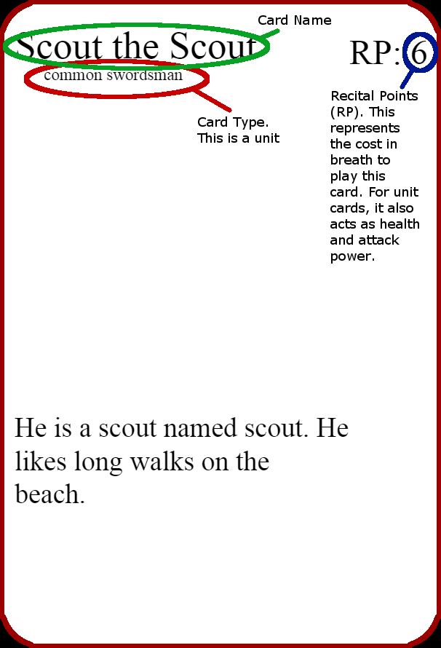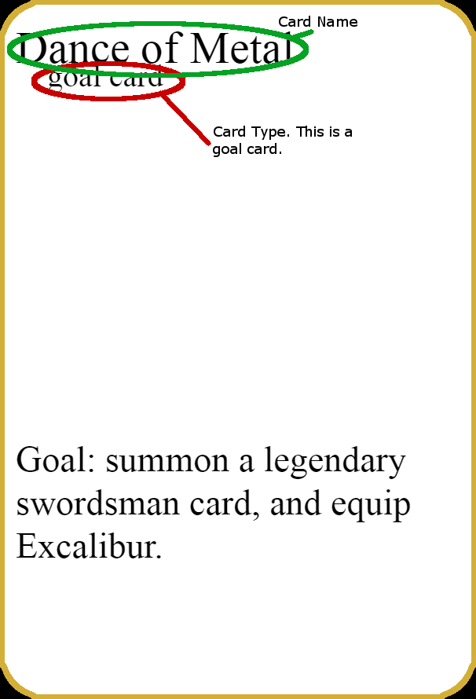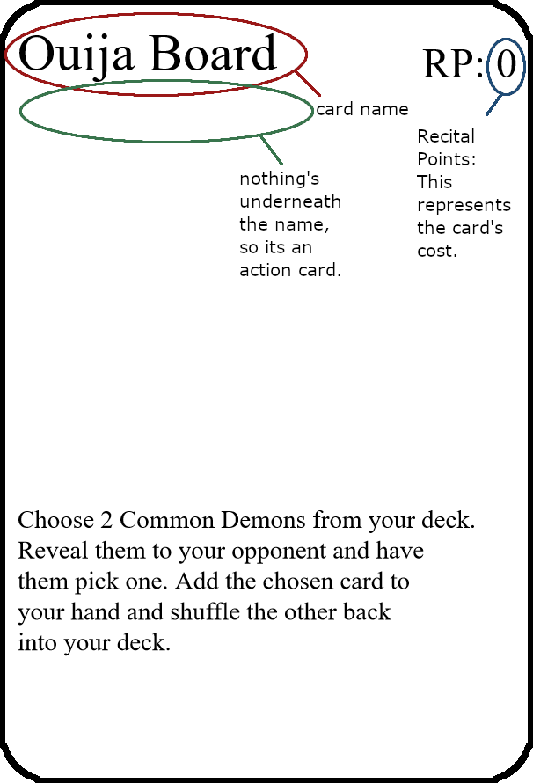

**Types of Unit Cards/Ways to Call a Unit**

Unit Cards can be called in 3 ways:

1. **Normal playing** - Play a card from your hand by paying breath equal to the card’s RP.
2. **Special calling** - Some cards can special call units to the field, playing them without paying their normal RP. Unlike the normal method, special called units may not attack or be activated the turn they are played.
3. **Sacrificing -** At any time during your turn before you attack, you may sacrifice any number of unit cards to call from your hand a unit card with RP less than or equal to the combined total of the sacrificed cards’ RP.

There are 3 ranks of Unit Cards.

1. **Common Unit**: These Unit Cards are typically weaker and range from 1-4 Cost unless otherwise written.
2. **Rare Unit**: These Unit Cards are strong and range from 5-9 Cost unless otherwise written.
3. **Legendary Unit**: The strongest unit cards of the deck. 10+ Cost and super powerful cards.

**Unit Battling Mechanics**

1. Each Player starting on their 2nd turn, can perform attacks using their Unit Cards.
2. Unit cards can only attack once per turn unless otherwise specified, and they attack the opponent directly.
3. The player being attacked can choose to block using any of their unit cards.
4. When blocking the difference in attack power is dealt to the both units as damage the difference is dealt to the defender as damage (this only applies in scenarios where the attacker has more RP then the blocking unit)
   1. **Example:** If a 6 RP Scout the Scout attacked, and the defender chose to block with a 3 RP Chad Squire, the attacking Scout the Scout would lose 3 RP, and the defending Chad Squire is destroyed and the opponent would take the difference as damage which in this case is 3.
   2. **Example:** If a 3 RP Chad Squire attacked, and the defender chose to block with a 6 RP Scout the Scout, the attacking Chad Squire would be destroyed, and the defending Scout the Scout would lose 3 RP.
5. When being attacked, players don’t have to block. If they decide not to, they take the damage directly. Just take the direct damage.
6. Each Unit can only block once per turn and each card can only attack once per turn.

**Card Amounts (Base Decks)**

**Demon:**

**Card Name Card Amount**

|  |  |
| --- | --- |
| Você Não | 2 |
| Banji’s Scream | 2 |
| Demon’s Greed | 3 |
| Ouija Board | 2 |
| Surprise Attack | 1 |
| Demonic Possession | 3 |
| Jaycob’s Inner Demon | 2 |
| Skinny Jaycob | 3 |
| Kiss of Death | 3 |
| Dragon King Hades | 2 |
| Metamorphosis | 2 |
| Messenger of Hades | 2 |
| Flesh Blade | 2 |
| Lucifer the Demon King | 1 |
| Jack the Ripper | 2 |
| Malfunction | 2 |
| Friends Close Enemies Closer | 3 |
| Sweaty Homunculus | 2 |
| Lucifer’s Servant | 2 |
| Aegis | 2 |
| Dig a Grave | 3 |
| Roar of Cerberus | 2 |
| Baby Demon | 2 |
| Black Market | 3 |
| Breath User Jaycob | 3 |
| ROID RAGE | 3 |
| Golden Claws | 2 |
| Jacob’s Revenge | 3 |
| The Book of Jaycob | 3 |
| Soul Snatcher | 3 |
| Book of Demons | 3 |
| Call of Hades | 2 |
| The Flaming Sword of Lucifer | 1 |
| Rust Cleaner | 1 |
| Charlotte the Witch | 2 |
| Dead Shinubo | 1 |
| Soul Bond | 1 |

**Swordsman:**

|  |  |
| --- | --- |
| Dig a Grave | 3 |
| Você Não | 2 |
| Chad Squire | 2 |
| Jacob’s Revenge | 3 |
| Tyranny | 3 |
| Friends Close Enemies Closer | 2 |
| Sir Lancelot | 2 |
| Malfunction | 2 |
| Sharpen Swords | 2 |
| Black Market | 3 |
| Swordsmen Unity | 2 |
| Achilles the Mythical Swordsman | 2 |
| Miyamoto Musashi | 2 |
| Swords Man | 2 |
| Jason the Hero | 3 |
| Hero’s Chant | 2 |
| The Book of Jaycob | 3 |
| Julius Caesar | 2 |
| Surprise Attack | 1 |
| Excalibur | 1 |
| Aegis | 2 |
| Mr. Deffrey Javis | 2 |
| Power of the Church | 2 |
| Baseball Lad | 2 |
| Scout the Scout | 2 |
| Skinny Jaycob | 3 |
| ROID RAGE | 2 |
| Ajax the Spearman | 2 |
| Recruitment | 2 |
| Total Annihilation | 2 |
| King Arthur | 1 |
| Swordsmen’s Final Shot | 2 |
| Achilles’s Shield | 2 |
| Piercing Power | 2 |
| Breath User Jaycob | 3 |
| Greedy Breather | 2 |
| Soul Bond | 1 |
| Rust Cleaner | 1 |
| Dead Shinubo | 1 |

**Goal Cards (Each Deck has 1):**

|  |  |
| --- | --- |
| Overwhelming Attack | 2 |
| Dance of Metal | 2 |
| Overwhelming Numbers | 2 |
| Overwhelming Defense | 2 |

**Strategy Guide**

**Possible strategy for breath**

Investing in Jaycob Cards early in the game is a smart decision because they can stack up and you can overpower your opponent very quickly. Breath is how you can call cards to the field and is a very useful tool to use.

**OP Demon deck strategy**

A strategy for the demon deck is to read the card effects closely because you can come up with some crazy combos because a lot of the cards let you use cards from your discard pile, this can be exploited by using op cards that destroy creatures and then using the recover from discard pile cards to get those op card back into your hand and just completely over power your opponent.

**OP Swordsmen deck combo**

Just getting King Arthur out onto the field is a crazy combo on its own because it can call to the field 3 other rare or common swordsmen from your deck which is super op because then you have a total of 5 cards to attack with on top of any cards you already control on the field. In addition to this all his effects makes satisfying the goal cards significantly easier.