Final Project Report

<< Digital Library Management System >>



Project Supervisor
<< Mukaram Shah >>

Submitted By

<< S210201E00>>

<<Muhammad Ahsan>> << MC190200251>>

Software Projects & Research Section,
Department of Computer Sciences,
Virtual University of Pakistan


CERTIFICATE

This is to certify that <<Muhammad Ahsan>> (<<MC190200251>>) has worked on and completed their Software Project at Software & Research Projects Section, Department of Computer Sciences, Virtual University of Pakistan in partial fulfillment of the requirement for the degree of BS in Computer Sciences under my guidance and supervision.

In our opinion, it is satisfactory and up to the mark and therefore fulfills the requirements of BS in Computer Sciences.

Supervisor / Internal Examiner

<< Mukaram Shah>>
Supervisor,
Software Projects & Research Section,
Department of Computer Sciences
Virtual University of Pakistan

___________________
(Signature)

External Examiner/Subject Specialist
<<External Supervisor Name>>

___________________
(Signature)

Accepted By:

_____________
(For office use)

EXORDIUM

In the name of Allah, the Compassionate, the Merciful.

Praise be to Allah, Lord of Creation,
The Compassionate, the Merciful,
King of Judgment-day!

You alone we worship, and to You alone we pray for help,
Guide us to the straight path

The path of those who You have favored,

Not of those who have incurred Your wrath,
Nor of those who have gone astray.

DEDICATION

I’m dedicating this project to my parents for all the sacrifices they have made to brought me up at this level where I have the opportunity to complete this project. I’m thankful to them for their support and the believe they have in me that I can do it and also for their guidance, prayers and advices which really helped me to be at this level and finish this project.

I’m also thankful to my teachers as well for their supportive teaching method in this online learning environment and their positive feedback.

ACKNOWLEDGEMENT

In the name of Allah, the most Gracious and the most Merciful. I would like to pay my sincere gratitude to my supervisor Mukaram Shah for his continuous support in the form of positive feedback during this final year project phase as well as our Virtual University who gave me this opportunity to do this wonderful project on topic Digital Library Management System which helps me a lot in doing some research and learning a lot about new things. It allows me to use and implement concepts and knowledge what I have gained during my stay here as virtual student into a practical working web application.

I would also like to thank my family members and friends for their support and encouragement they have given me during this course of my work.

PREFACE

Today as we know that the technology has revolutionized every field of life. Computers are becoming the part of almost every activity of any organization. This project Digital Library Management System is a web application. The main objective of this system is to provide better user experience by making librarian job easier by maintaining books record, issuing a book, fine collection, keeping user/student record.

When I was making this project, it helps me to enhance my knowledge related to the work and its practical implementation in the form of a working web app. I have also learned many things like programing concepts, oop, algorithms, front-end and back-end programing, data base integration etc. I have also experienced how the use of technology can really help to make things easier.

TABLE OF CONTENTS

CHAPTER NO. 1
gathering & Analyzing info 10

1.1 Introduction ………………………………………… 11
1.2 purpose ………………………………………………… 11
1.3 scope ………………………………………………… 12
1.4 definitions, acronyms and abbreviations …….. 13

1.5 Project requirements ………………………… 13
1.5.1 Functional Requirements ………………………… 13

1.5.2 Non-Functional Requirements ………………… 14

1.6 use cases and usage scenarios ………………… 15-16
1.6.1 Use Case Diagrams …………………………… 15-16

1.6.2 Usage Scenarios ……………………………….. 17-20

1.7 Development Methodology ……………………. 21
1.7.1 Chosen Methodology …………………………… 21

1.7.2 Reasons for Chosen Methodology ……………... 21

1.7.2 Work Plan (Gantt Chart) ……………………….. 22

1.7.2 Project Schedule (Submission Calendar) ………... 22

CHAPTER NO. 2
designing the project 23

2.1 Introduction ……………………………………… 24
2.2 purpose ……………………………………………… 24
2.3 scope ………………………………………………………. 25

2.4 definitions, acronyms and abbreviations ………………. 25

2.5 Architectural Representation (Architecture Diagram) …… 26

2.6 Dynamic Model: Sequence Diagrams ………………… 27-32

2.7 Object Model/Logical Model: Class Diagram …………… 33

2.8 Database Model (Database Diagram) ………………….. 34

2.9 Graphical User Interfaces ……………………………… 35-37

Chapter no.3
DEvelopment 38
3.1 Development plan (Architecture Diagram)

<<Dear Students, you have to take special care of page numbers, which are written against each Chapter and sub headings. You have to mention your own page numbers and correct one against each document heading. Make proper table of contents. Remember that if there are any new headings or you have included more headings in your documents then you also have to write these in table of contents and modify table of contents according to your documents material>>

<<Dear Students, before starting each chapter the following would be the title page for each chapter on a separate page>>

CHAPTER 1
Gathering & Analyzing Info

1.1 Introduction:

This project Digital Library Management System is a web application. It is developed in html, css, JavaScript and php. There are three users in this system Admin, Librarian and Student/User. Admin can register a librarian. A registered librarian will be performing all the basic operations related to a library like add new book, delete book, issue book, fine collection, add new student, delete student, search, return book. This system will make the job of librarian easy and automated. All the information of this system will be stored in a database which is helpful to keep available books record, borrowed books and members. This software is easy to use and error free.

1.2 Purpose:

The purpose of this system is to provide a user friendly, automated digital librarian system that will make very bothersome and complex job of librarian easy by maintaining books and user record online. This system will also eliminate the risk of lost or damage record because now there will be no paper work involved.

1.3 Scope:

As we know that technology has revolutionized every field of life. Computers are becoming the part of almost every activity of any organization. Previously the job of librarian was very complex and time taking everything was on paper so it was difficult to keep and find the record of books and readers at the time of need. However now with the availability of digital library management system librarian job becomes very easy and now there is no manual record burden on librarian anymore. The main objective of this system is to make the manual and bothersome operations of the library into a computerized and automated system. Here below are the list of the services will be provided in this system.

- Member Login.
- Member registration.
- Registered members list.
- Deleting an existing member.
- Add and delete book
- Search
- Fine collection.
- Issue book
- Return book

1.4 Definitions, Acronyms and Abbreviations:

Digital library management is a web app designed to perform operations of a library digitally and systematically.

1.5 Project requirements:

1.5.1 Functional Requirements:

- Admin will be able to login into system using by default username and id.
- Admin will be able to register, view already registered and delete a librarian.
- Librarian will be registering a user/student using his/her name, college roll number, email and class.
- Librarian will be able to search a book or already registered user/student through search option.
- Librarian will be able to view, add, issue a book.
- Librarian will be able to update or delete an existing book.
- The system will be calculating fine in case of late return of book after due date by the user/student.

1.5.2 Non Functional Requirements

- The Digital/Computerized Library Management System will use appropriate color and text and background for pages.
- The Digital/Computerized Library Management System will give different options to the librarian to reduce the complexity of his/her job.
- The Digital/Computerized Library Management System will perform desired action for each button and menu.
- The Digital/Computerized Library Management System will use appropriate icons for buttons.

1.6 use cases and usage scenarios
1.6.1 Use Case Diagrams

Use case Diagram for Admin:

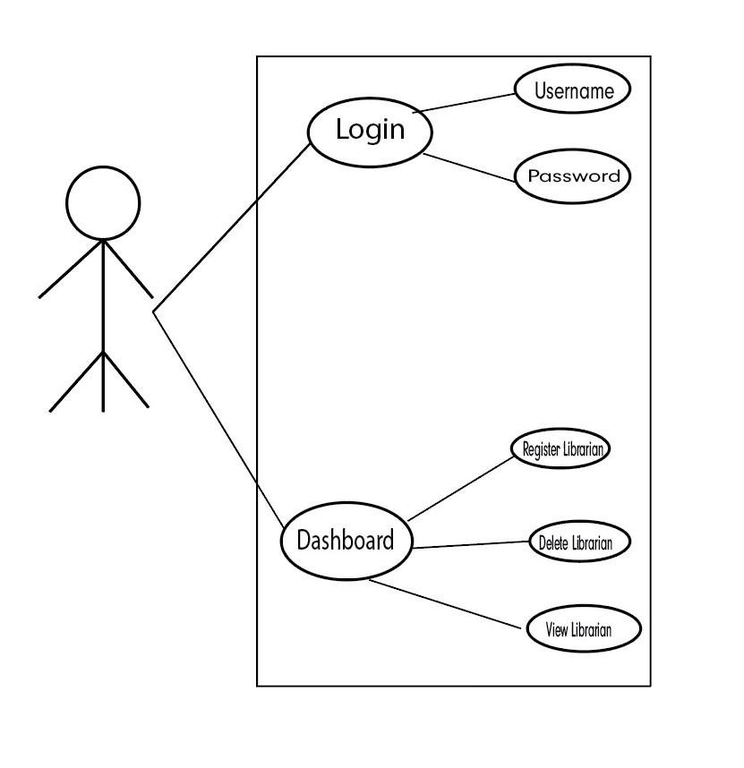

Use case Diagram for Librarian:

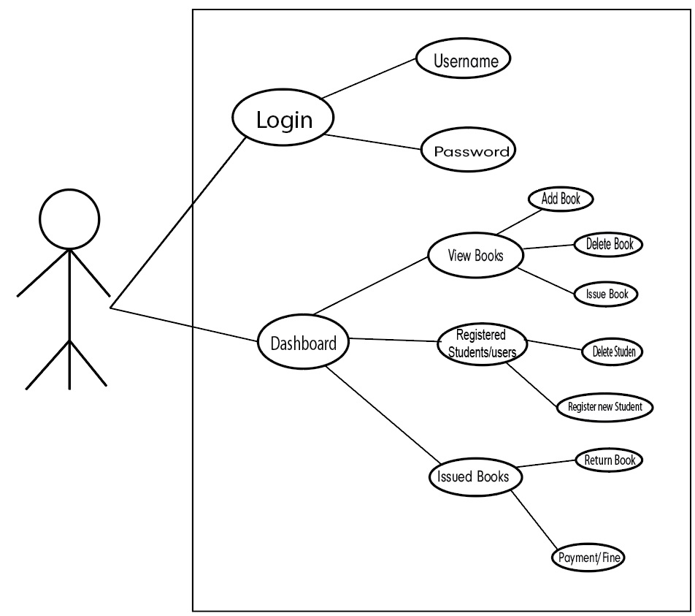

1.6.2 Usage Scenarios

Usage Scenarios for Admin:

Use Case Title: Login
Id | AD – 01
Actions | Admin will click on login button to sign in
Description | Admin can login into system by entering registered username and password
Alternative Paths | Admin’s username and password will be predefined
Pre-Condition | Registered username and password required
Post Condition | Login successfully
Author | Admin
Exceptions | Invalid username or password

Use Case Title: View Registered Librarian
Id | AD – 02
Actions | Admin can see its dashboard after login successfully
Description | After login successfully Admin can see the dashboard where all the registered librarian will be displayed.
Alternative Paths | Admin can add a new or delete already registered librarian
Pre-Condition | Successful login required
Post Condition | Registered librarian will be displayed on dashboard screen
Author | Admin
Exceptions | N/A

Use Case Title: Register New Librarian
Id | AD – 03
Actions | Admin can register a new librarian by clicking on Register new librarian button
Description | From dashboard screen Admin can register new librarian
Alternative Paths | Admin can view or delete already registered librarians
Pre-Condition | Click on Register New Librarian button
Post Condition | Admin can register a new librarian
Author | Admin
Exceptions | N/A

Use Case Title: Delete Already Registered Librarian
Id | AD – 04
Actions | Admin can delete an already registered librarian by clicking on delete librarian button
Description | From dashboard screen Admin can delete already registered librarian
Alternative Paths | Admin can view or add register new librarian
Pre-Condition | Click on delete Librarian button
Post Condition | Admin can register delete a librarian
Author | Admin
Exceptions | N/A

Usage Scenarios for Librarian:

Use Case Title: Sign In
Id | L – 01
Actions | Librarian will click on Sign in button to sign in
Description | Librarian can Sign in into system by entering registered username and password
Alternative Paths | If not registered already can request Admin for registration
Pre-Condition | Registered username and password required
Post Condition | Login successfully
Author | Librarian
Exceptions | Invalid username or password

Use Case Title: Librarian’s Dashboard
Id | L – 02
Actions | Librarian can see all available books on his/her dashboard
Description | After sign in successfully Librarian can see the dashboard where all the available books will be displayed.
Alternative Paths | Librarian can also add or delete a book he/she can also view registered user/student or issued books. He/she can also do search within book from his/her dashboard.
Pre-Condition | Successful login required
Post Condition | Available books list, search bar add or delete books options are available on dashboard
Author | Librarian
Exceptions | No Book Found

Use Case Title: Add New Book
Id | L – 03
Actions | Librarian can add new book from his/her dashboard
Description | After sign in successfully Librarian can see the dashboard where all the available books will be displayed from here he/she can add new book by clicking on add new book button.
Alternative Paths | Librarian can also view available books or delete a book. he/she can also view registered user/student or issued books. He/she can also do search within book from his/her dashboard.
Pre-Condition | Successful login required
Post Condition | Available books list, search bar add or delete books options are available on dashboard
Author | Librarian
Exceptions | No Book Found

Use Case Title: Delete Book
Id | L – 04
Actions | Librarian can delete book from his/her dashboard
Description | After sign in successfully Librarian can see the dashboard where all the available books will be displayed from here he/she can delete book by clicking on delete book button.
Alternative Paths | Librarian can also view available books or add a new book. he/she can also view registered user/student or issued books. He/she can also do search within book from his/her dashboard.
Pre-Condition | Successful login required
Post Condition | Available books list, search bar add or delete books options are available on dashboard
Author | Librarian
Exceptions | No Book Found

Use Case Title: Issue a Book
Id | L – 05
Actions | Librarian can Issue book from his/her dashboard
Description | After sign in successfully Librarian can see the dashboard where all the available books will be displayed from here he/she can issue a book by clicking on issue book button.
Alternative Paths | Librarian can also view available books, delete, issue or add a new book. he/she can also view registered user/student or issued books. He/she can also do search within book from his/her dashboard.
Pre-Condition | Successful login required
Post Condition | Available books list, search bar, issue, add or delete books options are available on dashboard
Author | Librarian
Exceptions | No Book Found

Use Case Title: Register a New Student/User
Id | L – 06
Actions | Librarian can register a new student from the already registered student screen.
Description | After clicking on Registered New Student/User button Librarian can register a new student/user.
Alternative Paths | Librarian can also view already registered or delete a student/user. He/she can also do search within students.
Pre-Condition | Click on registered student button required
Post Condition | Already registered student list, search bar, add or delete students options are available on dashboard
Author | Librarian
Exceptions | No Student Found

Use Case Title: Delete Student/User
Id | L – 07
Actions | Librarian can delete a student from the already registered student screen.
Description | After clicking on delete Student/User button Librarian can delete a student/user.
Alternative Paths | Librarian can also view already registered or add a new student/user. He/she can also do search within students.
Pre-Condition | Click on registered student button required
Post Condition | Already registered student list, search bar, delete or add students options are available on dashboard
Author | Librarian
Exceptions | No Student Found

Use Case Title: Return Book
Id | L – 08
Actions | Librarian can return a book by clicking on return book button
Description | After clicking on return book button Librarian can return a book from issued book screen.
Alternative Paths | Librarian can also view issued book list and find info too.
Pre-Condition | Click on issued student button required
Post Condition | Issued books list, return book option and fine information is available
Author | Librarian
Exceptions | No Book Found

1.7 Development Methodology

1.7.1 Chosen Methodology

Waterfall Methodology

1.7.2 Reasons for Chosen Methodology

The waterfall is the most traditional and sequential methodology. It was the first and most prominent methodology for several decades due to its plan driven approach. In this methodology next phase is started after the completion of the previous phase.

The Reason for choosing this methodology is because it is very simple and easy to use. It is good for small size projects where you have complete understanding of the project requirements like I have in my project. I know the complete flow of the app and before started actual development I already have complete documentation of the project.

1.7.3 Work Plan (Gantt Chart)

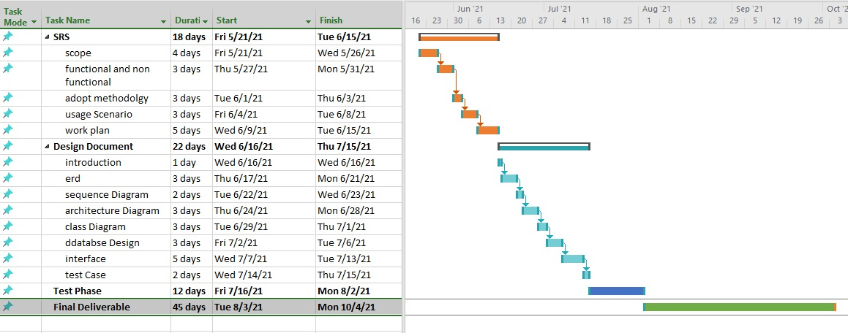

1.7.3 Project Schedule (Submission Calendar)

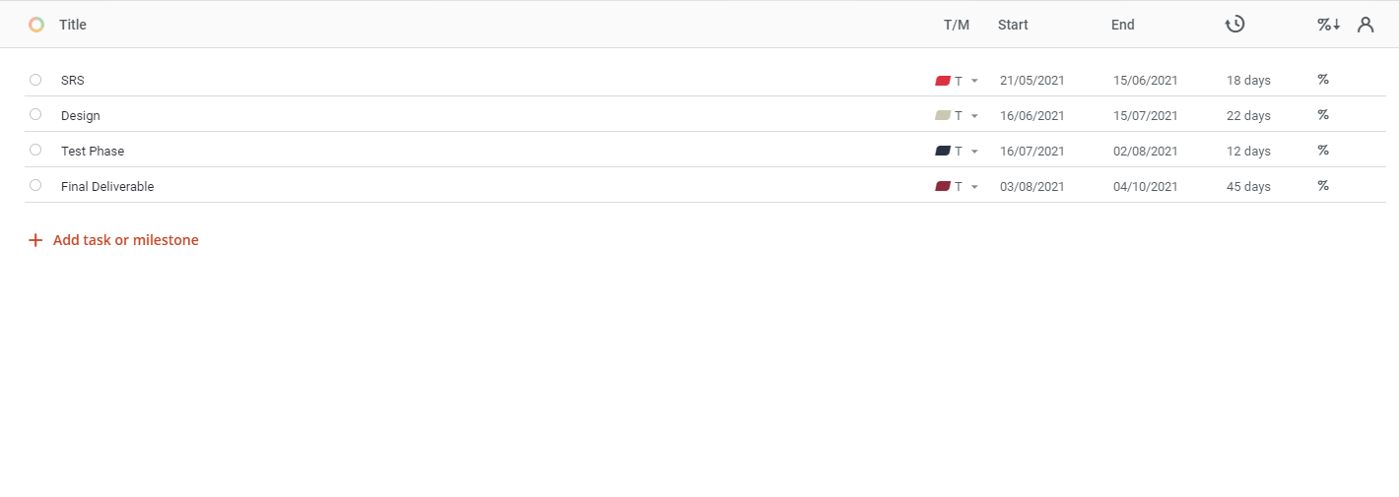

CHAPTER 2
Designing the Project

2.1 Introduction:

The digital library management system is designed to make the operations of a library systematic, automated and digitalize. While designing its user interface it is kept in mind that what the user wants to do and confirming that all the required features are available and easy to use. This system is a web based easy to use online system which is designed to help the user to organize library. This system will have the following features user can add or delete a book, Admin can register or delete a user, a search option to search books or members, issue or return book feature and automated fine calculation. There will be three users in this system. However, there are two user interfaces one for Admin and the other one is for Librarian. All the operations related to library will be performed by librarian. Admin can register a Librarian and he can also perform all the tasks of Librarian as well.

2.2 Purpose:

The purpose of this system is to provide a user friendly, automated digital librarian system that will make very bothersome and complex job of librarian easy by maintaining books and user record online. This system will also eliminate the risk of lost or damage record because now there will be no paper work involved.

2.3 Scope:

The system is user friendly. It is designed to make librarian’s difficult manual work into an online easy to use automated and systematic system, this system is highly flexible for future improvements and efficient to make easy interaction between librarian and students. The key focus of the system is to provide a time saving and hazel free facilitation system for both librarian and students.

2.4 Definitions, Acronyms and Abbreviations:

Digital library management is a web app designed to perform operations of a library digitally and systematically.

2.5 ARCHITECTURAL REPRESENTATION (ARCHITECTURE DIAGRAM)

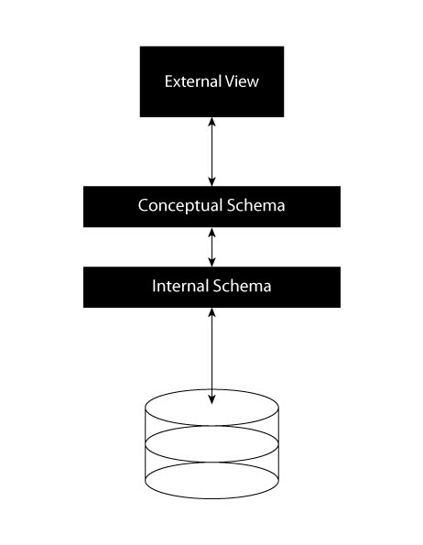

2.6 DYNAMIC MODEL: SEQUENCE DIAGRAMS

Sequence Diagrams For Admin
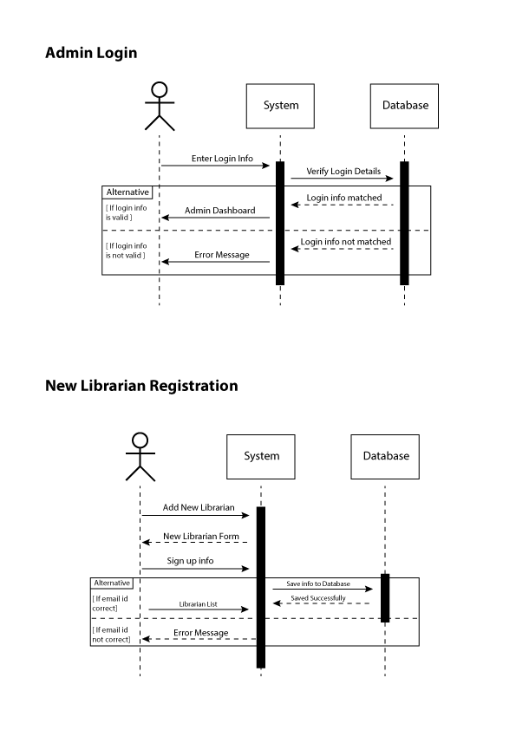
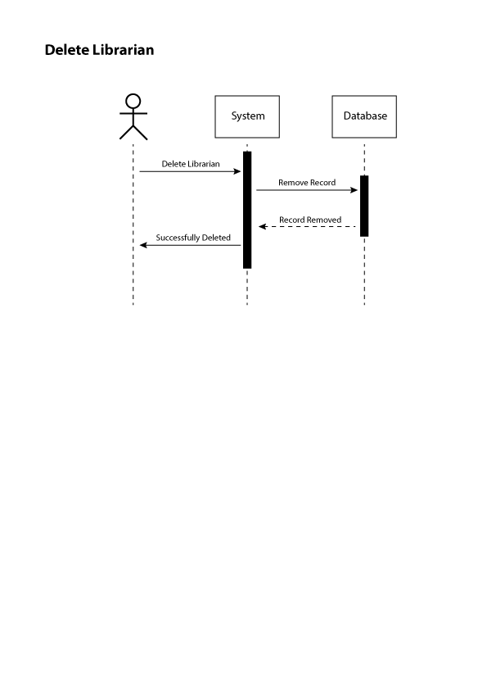

Sequence Diagrams For Librarian

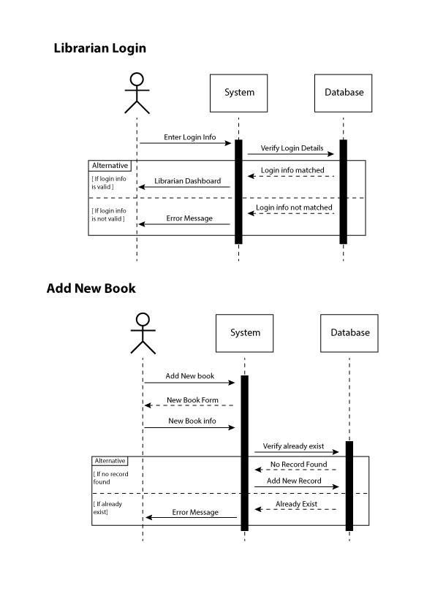
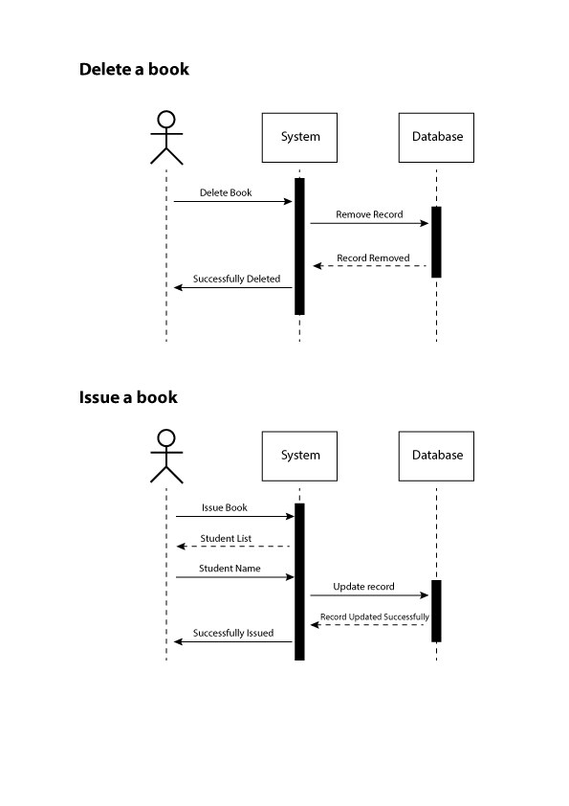
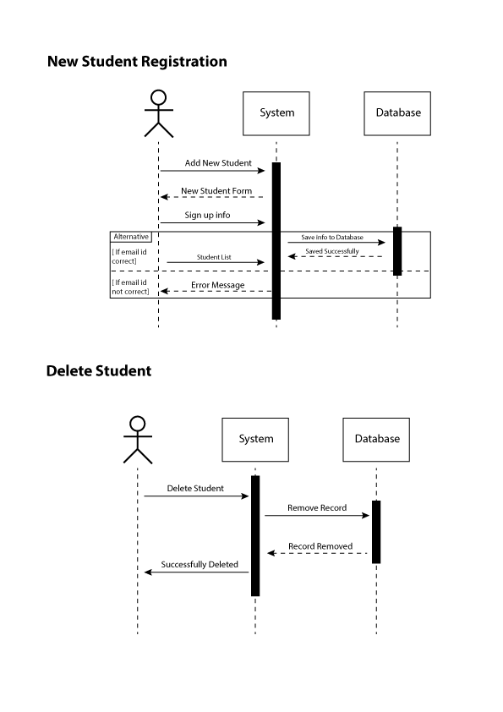
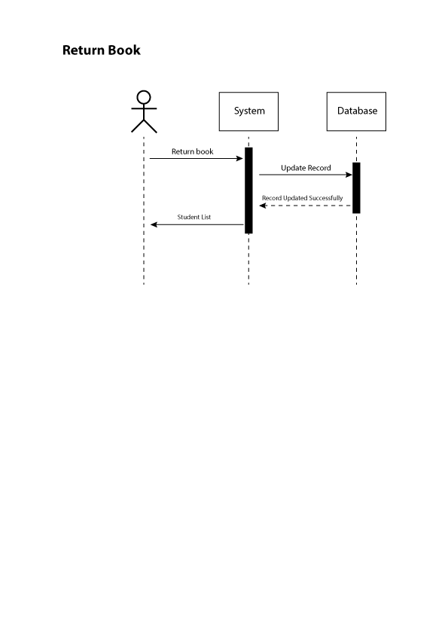

2.7 OBJECT MODEL/LOGICAL MODEL: CLASS DIAGRAM

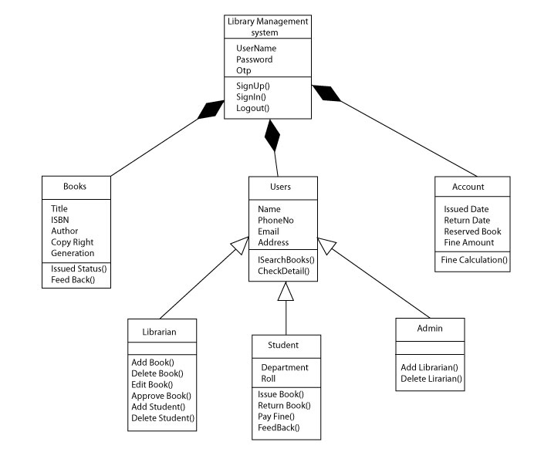

2.8 DATABASE MODEL (DATABASE DIAGRAM)

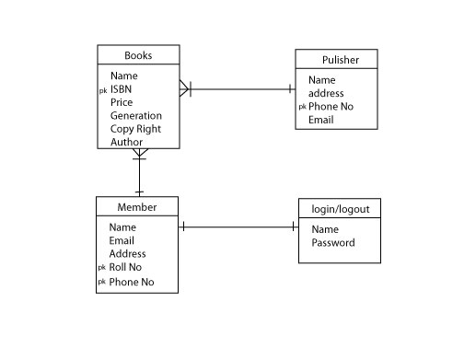

2.9 GRAPHICAL USER INTERFACES

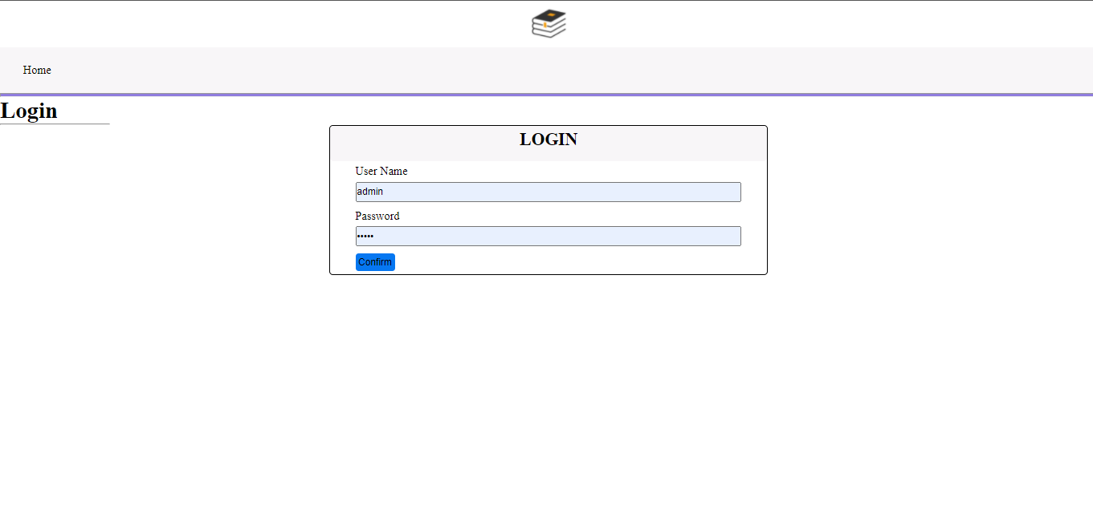
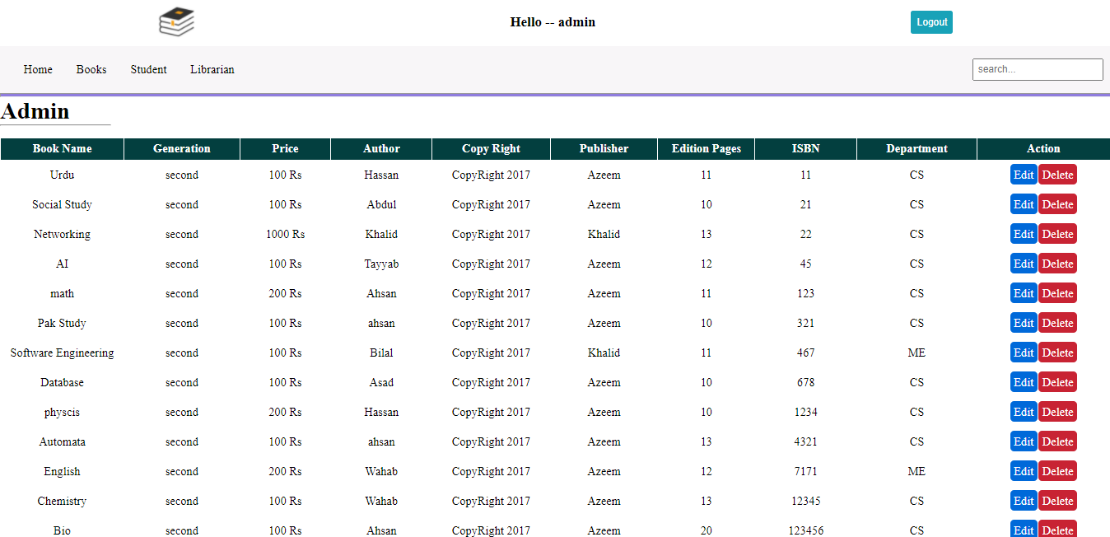

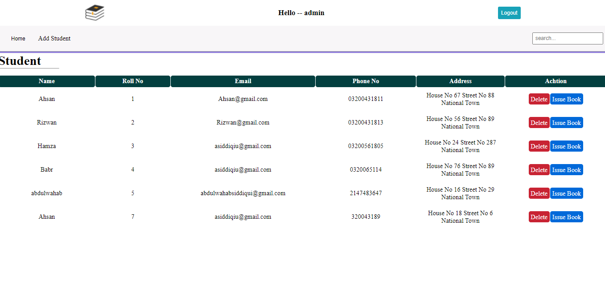
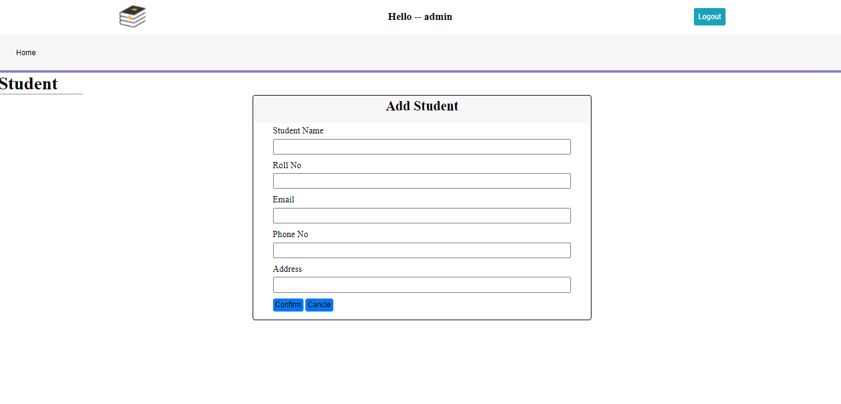

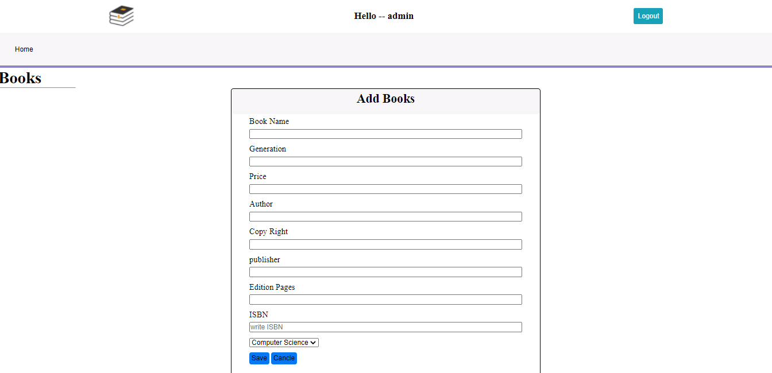

CHAPTER 3
Development

3.1 Development plan (Architecture Diagram)

REFERENCES

https://vulms.vu.edu.pk/Courses/CS403/Downloads/CS403%20Handouts.pdf

https://www.php.net/manual/en/language.types.php

https://www.w3schools.com/

https://vulms.vu.edu.pk/Courses/CS605/Downloads/SoftwareEngineeringII.pdf

APPENDIX

