Peer Evaluation for Lab 5 – Chapter 12
Your name: (Your lab is the one being evaluated) | Amanda Akins
Name(s) of peer evaluator(s) | Chris Henry
Date: | 5/25/16

Instructions
You should have already completed Lab 5. After you and a peer have evaluated your work, you will submit this evaluation along with screen shots and source code indicated in moodle. You may make corrections to your work as a result of the evaluation.
In Class Exercises – Customer Maintenance Application
Completed Application?  - Implemented Add Customer Form?  - Added a private instance variable that will refer to a customer?  - Added a public method GetNewCustomer? Method instantiates and shows the form as a dialog box and returns the customer object?  - Added a click event handler on the ok button? Event handler validates all of the data, creates a new customer object with those values, sets the dialog result property and closes the dialog?  - Added a click event handler on the cancel button? Event handler sets the dialog result property and closes the dialog?  - Implemented Customer Maintenance Form?  - Added a private instance variable that will refer to a list of customer objects?  - Added a load event handler for the form? Event handler uses the static method GetCustomers in the CustomerDB class to load the Customers from the file? Uses a loop to iterate through each customer in the list, calls the method GetDisplayText on each customer object and adds that string to the list box on the form? Created a method on the form to fill the list box from the list (because it’s used in 3 places on the form)?  - Added a click event handler for the Add button? Instantiates an Add Customer Form and calls an appropriate method to display the form and get the new customer information? If the user clicked the ok button, add the customer to the list, save the customer list and re-fill the list box? If the user clicked the cancel button, doesn’t do anything?  - Added a click event handler for the Delete button? Removes customer from the list? Calls the save method in the DB class to save the changes? Refreshes the list? | Yes

Concentration Problem
Create a solution that included 3 project? (Windows form, class library, console app for testing?) Concentration GUI is the startup project? Added a using using statement in the concentration form to access the class library? Added a reference in the gui project to access the class library? | Yes
Replaced instance variable that was an array of strings with an array of cards? | Yes
Methods that originally manipulated array of strings now manipulate array of cards? Which methods are those? | Yes
Does the application function appropriately? Can you interact with the application in a way that causes it to “degrade” and not gracefully? | Yes

Programming style for all programs
Is proper indentation used? Is each event handler indented properly? Is each method indented properly? | Yes
Are comments used appropriately? | Yes
Do variable names use camel case? (camelCase for example) | Yes
Do property/method names use Title Case (or Pascal Case?) | Yes

General comments and notes: Sorry if I gave you way too much code, wasn’t entirely sure what all to include.

Screen Shots and Source Code
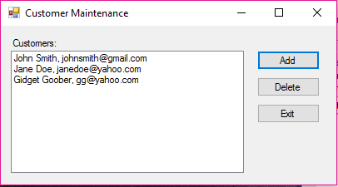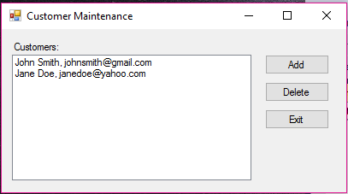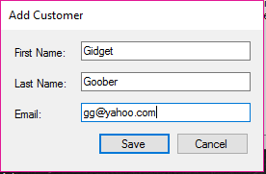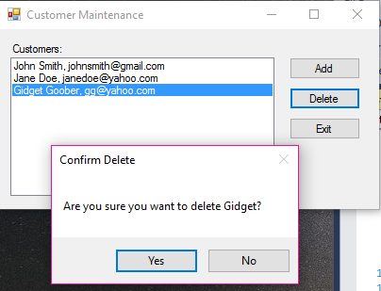
frmAddCustomer:
using System;
using System.Collections.Generic;
using System.ComponentModel;
using System.Data;
using System.Drawing;
using System.Linq;
using System.Text;
using System.Windows.Forms;
using CustomerMaintenanceClasses;

namespace CustomerMaintenance
{
// This is the starting point for exercise 12-1 from
// "Murach's C# 2010" by Joel Murach
// (c) 2010 by Mike Murach & Associates, Inc.
// www.murach.com

public partial class frmAddCustomer : Form
{
public frmAddCustomer()
{
InitializeComponent();
}

private Customer customer = null;

public Customer GetNewCustomer()
{
this.ShowDialog();
return customer;
}

private bool IsValidData()
{
return Validator.IsPresent(txtFirstName) &&
Validator.IsPresent(txtLastName) &&
Validator.IsPresent(txtEmail) &&
Validator.IsValidEmail(txtEmail);
}

private void btnSave_Click(object sender, EventArgs e)
{
if (IsValidData())
{
customer = new Customer(txtFirstName.Text, txtLastName.Text, txtEmail.Text);
this.Close();
}
}

private void btnCancel_Click(object sender, EventArgs e)
{
this.Close();
}

frmCustomers:

using System;
using System.Collections.Generic;
using System.ComponentModel;
using System.Data;
using System.Drawing;
using System.Linq;
using System.Text;
using System.Windows.Forms;
using CustomerMaintenanceClasses;

namespace CustomerMaintenance
{
// This is the starting point for exercise 12-1 from
// "Murach's C# 2010" by Joel Murach
// (c) 2010 by Mike Murach & Associates, Inc.
// www.murach.com

public partial class frmCustomers : Form
{
public frmCustomers()
{
InitializeComponent();
}

private List<Customer> customers = null;

private void frmCustomers_Load(object sender, EventArgs e)
{
customers = CustomerDB.GetCustomers();
FillCustomerListBox();
}

private void FillCustomerListBox()
{
lstCustomers.Items.Clear();
foreach (Customer c in customers)
{
lstCustomers.Items.Add(c.GetDisplayText());
}
}

private void btnAdd_Click(object sender, EventArgs e)
{
frmAddCustomer newCustomerForm = new frmAddCustomer();
Customer customer = newCustomerForm.GetNewCustomer();
if (customer != null)
{
customers.Add(customer);
CustomerDB.SaveCustomers(customers);
FillCustomerListBox();
}
}

private void btnDelete_Click(object sender, EventArgs e)
{
int i = lstCustomers.SelectedIndex;
if (i != -1)
{
Customer customer = customers[i];
string message = "Are you sure you want to delete "
+ customer.FirstName + "?";
DialogResult button =
MessageBox.Show(message, "Confirm Delete",
MessageBoxButtons.YesNo);
if (button == DialogResult.Yes)
{
customers.Remove(customer);
CustomerDB.SaveCustomers(customers);
FillCustomerListBox();
}
}
}

private void btnExit_Click(object sender, EventArgs e)
{
this.Close();
}
}
}

Customer:

using System;
using System.Collections.Generic;
using System.Linq;
using System.Text;
using System.Threading.Tasks;

namespace CustomerMaintenanceClasses
{
public class Customer
{
// Instance variables - "private" for data hiding
private string fName;
private string lName;
private string eMail;

public Customer()
{
fName = "???";
lName = "???";
eMail = "???";
}

public Customer(string firstName, string lastName, string eMailAddress)
{
fName = firstName;
lName = lastName;
eMail = eMailAddress;
}

//
public string FirstName
{
get
{
return fName;
}
set
{
fName = value;
}
}

public string LastName
{
get
{
return lName;
}
set
{
lName = value;
}
}

public string Email
{
get
{
return eMail;
}
set
{
eMail = value;
}
}

public string GetDisplayText()
{
return fName + " " + lName + ", " + eMail;
}

public override string ToString()
{
return GetDisplayText();
}
}
}

CustomerList:

using System;
using System.Collections.Generic;
using System.Linq;
using System.Text;

namespace CustomerMaintenanceClasses
{
public class CustomerList
{
private List<Customer> customers = new List<Customer>();

public CustomerList() { }

public int Count
{
get
{
return customers.Count;
}
}

public void Add(Customer bob)
{
customers.Add(bob);
}

public void Remove(Customer bob)
{
customers.Remove(bob);
}

public void Fill()
{
customers = CustomerDB.GetCustomers();
}

public void Save()
{
CustomerDB.SaveCustomers(customers);
}

public override string ToString()
{
string output = "";
foreach (Customer c in customers)
{
output += c.ToString() + "\n";
}
return output;
}
}
}

CONCENTRATION -

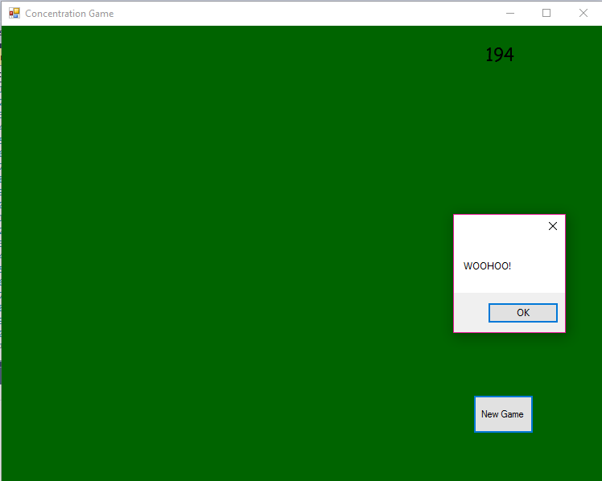
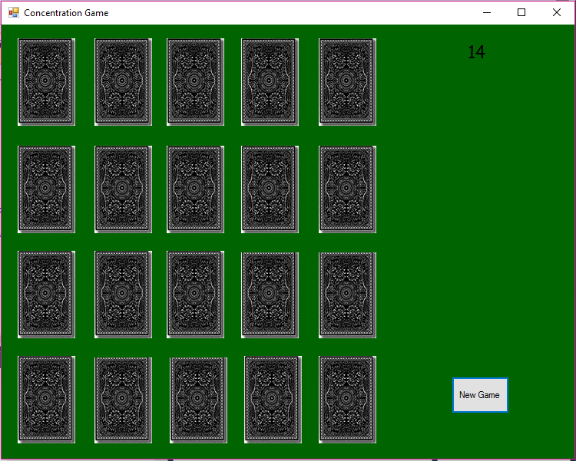
Card:
using System;
using System.Collections.Generic;
using System.Linq;
using System.Text;
using System.Threading.Tasks;

namespace CardClassLibrary
{
public class Card
{
private int suit;
private int value;

// static belongs to class as whole not individual object. Starts with "" because it starts with 1, ace is 1
private static string[] values = { "", "Ace", "2", "3", "4", "5", "6", "7", "8", "9", "Ten", "Jack", "Queen", "King" };
private static string[] suits = { "", "Clubs", "Diamonds", "Hearts", "Spades" };

public Card() // default constructor
{
value = 1; // 1 = Ace
suit = 3; // 3 =
}

public Card(int v, int s)
{
value = v;
suit = s;
}

public int Value
{
get
{
return value;
}
set
{
this.value = value; // left hand side = instance variable right hand side = context sensitive keyword "value"
}
}

public int Suit
{
get
{
return suit;
}
set
{
this.suit = value; // left hand side = instance variable right hand side = context sensitive keyword "value"
}
}

public bool IsFaceCard()
{
if (value > 10)
return true;
else
return false;
}

public bool IsAce()
{
if (value == 1)
return true;
else
return false;
}

public bool IsRed()
{
if (suit == 2 || suit == 3)
return true;
else
return false;
}

public bool IsBlack()
{
if (suit == 1 || suit == 4)
return true;
else
return false;
}

public bool IsClub()
{
if (suit == 1)
return true;
else
return false;
}

public bool IsDiamond()
{
if (suit == 2)
return true;
else
return false;
}

public bool IsHeart()
{
if (suit == 3)
return true;
else
return false;
}

public bool IsSpade()
{
if (suit == 4)
return true;
else
return false;
}

public string Filename
{
get
{
return "card" + values[value].Substring(0, 1) + suits[suit].Substring(0, 1) + ".jpg";
}
}

public bool HasMatchingValue(Card otherCard)
{
if (this.Value == otherCard.Value)
return true;
else
return false;
}

public override string ToString()
{
return values[value] + " of " + suits[suit]; // go to array and get value out of values, go to array and suit out of suits and concatenate
}
}
}
Hand:
using System;
using System.Collections.Generic;
using System.Linq;
using System.Text;
using System.Threading.Tasks;

namespace CardClassLibrary
{
public class Hand
{
private List<Card> cards = new List<Card>();

public Hand() { }

public int Count()
{
int i = 0;
foreach (Card count in cards)
{
i++;
}
return i;
}

public int NumCards
{
get
{
return cards.Count;
}
}

public Card GetCard(int index)
{
return cards[index];
}

public int IndexOf(Card newCard)
{
return cards.IndexOf(newCard);
}

public int IndexOf(int value)
{
for(int i = 0; i < NumCards; i ++)
{
if (cards[i].Value == value) // i is index of card in the cards list. Value is the property of the card.
return i;
}
return -1; // return if out of scope
}

public int IndexOf(int value, int suit)
{
for (int i = 0; i < NumCards; i++)
{
if (cards[i].Value == value && cards[i].Suit == suit) // i is index of a card in cards list. Value is the property of
{
return i;
}
}
return -1; // return if out of scope */
}

/*public int IndexOf(int value, int suit)
{
Card c = new Card(value, suit);
return IndexOf(c);
}*/

public bool HasCard(Card searchCard)
{
foreach (Card cardInHand in cards)
{
if (searchCard.Value == cardInHand.Value && searchCard.Suit == cardInHand.Suit)
return true;
}
return false;
}

public bool HasCard(int searchValue)
{
foreach (Card cardInHand in cards)
{
if (searchValue == cardInHand.Value)
return true;
}
return false;
}

public bool HasCard(int searchValue, int searchSuit)
{
foreach (Card c in cards)
{
if (searchValue == c.Value && searchSuit == c.Suit)
return true;
}
return false;
}

public void Add(Card card)
{
cards.Add(card);
}

public Card Discard(int index)
{
Card c1 = cards[index];
cards.RemoveAt(index);
return c1;
}

public override string ToString()
{
string output = "";
foreach (Card c in cards)
{
output += c.ToString() + "\n";
}
return output;
}

}
}

Deck:
using System;
using System.Collections.Generic;
using System.Linq;
using System.Text;
using System.Threading.Tasks;

namespace CardClassLibrary
{
public class Deck
{
private List<Card> cards = new List<Card>();

public Deck()
{
int index = 0;
for (int suit = 1; suit <= 4; suit++)
{
for (int value = 1; value <= 13; value++)
{
cards.Add(new Card(value, suit));
index++;
}
}
}

public int NumCards
{
get
{
return cards.Count;
}
}

public int Count()
{
int i = 0;
foreach (Card count in cards)
{
i++;
}
return i;
}

public void Shuffle()
{
Random randomNumberGenerator = new Random();

for (int index = 0; index < cards.Count ; index++)
{
int rndIndex = randomNumberGenerator.Next(0, cards.Count);
Card temp = cards[index];
cards[index] = cards[rndIndex];
cards[rndIndex] = temp;
}
}

public Card Deal()
{
Card c1 = cards[0];
cards.RemoveAt(0);
return c1;
}

public bool IsEmpty()
{
if (cards.Count() == 0)
return true;
else
return false;
}

public override string ToString()
{
string output = "";
foreach(Card c in cards)
{
output += c.ToString() + "\n";
}
return output;
}
}
}
boardForm:
using System;
using System.Collections.Generic;
using System.ComponentModel;
using System.Data;
using System.Drawing;
using System.Linq;
using System.Text;
using System.Windows.Forms;
using CardClassLibrary;

namespace Concentration
{
public partial class boardForm : Form
{
public boardForm()
{
InitializeComponent();
}

#region Instance Variables

//* You'll need an array of strings named cards, 2 indexes and the number of matches
//* My array is set up to hold 21 strings and I ignore the 0 element because I named the picture boxes
//* starting at 1 rather than 0
Card[] cards = new Card[21];
int matches = 0;
int firstPick = NOT_PICKED_YET, secondPick = NOT_PICKED_YET; // stores first and second indexes
const int NOT_PICKED_YET = -1;

// this is for the timer that displays the elapsed time. I included it for illustration purposed only.
private int seconds = 0;
#endregion

#region Methods
//* Write some methods
// you may need more methods but here's the list that I used
// this should fill the cards (array of strings) with card file names
private void FillCards()
{
int index = 1;
for (int suit = 1; suit <= 4; suit++)
{
for (int value = 1; value <= 5; value++)
{
// *Add a string for the filename of the card
// to the array. The first card, for example, should be
// cards[1] = "cardac.jpg";
cards[index] = new Card(value, suit);
index++;
}
}
}

//* determines if the 2 cards are a match. The "value" of the card is in the filename at the 5th char.
private bool IsMatch(int index1, int index2)
{
if (cards[index1].HasMatchingValue(cards[index2]))
return true;
else
return false;
}

//* Shuffles the strings in the cards array. I'll give you an algorithm in class for this.
private void ShuffleCards()
{
Random randomNumberGenerator = new Random();

for (int index = 1; index <= 20; index++)
{
int rndIndex = randomNumberGenerator.Next(1, 21);
Card temp = cards[index];
cards[index] = cards[rndIndex];
cards[rndIndex] = temp;
}
}

// loads the specified card picture box with the filename from the array
private void LoadCard(int i)
{
PictureBox card = (PictureBox)this.Controls["card" + i];
card.Image = Image.FromFile(System.Environment.CurrentDirectory + "\\Cards\\" + cards[i].Filename);
}

//* loads an image for the back of a card in the specified card
private void LoadCardBack(int i)
{
PictureBox card = (PictureBox)this.Controls["card" + i];
card.Image = Image.FromFile(System.Environment.CurrentDirectory + "\\Cards\\" + "black_back.jpg");
}

//* disables and hides the specified card - set visible property to false
private void HideCard(int i)
{
PictureBox card = (PictureBox)this.Controls["card" + i];
card.Visible = false;
}

//* disables and hides all cards. Call HideCard in a loop.
private void HideAllCards()
{
for (int i = 1; i <= 20; i++)
{
HideCard(i);
}
}

//* disables the specified card
private void DisableCard(int i)
{
PictureBox card = (PictureBox)this.Controls["card" + i];
card.Enabled = false;
}

//* disables all cards. Call DisableCard in a loop.
private void DisableAllCards()
{
for (int i = 1; i <= 20; i++)
{
DisableCard(i);
}
}

private void ShowCard(int i)
{
PictureBox card = (PictureBox)this.Controls["card" + i];
card.Visible = true;
}
//* enables and shows all of the cards, make picture box
private void ShowAllCards()
{
for (int i = 1; i <= 20; i++)
{
ShowCard(i);
}
}

//* enables the cards that are still visible on the board
private void EnableAllVisibleCards()
{
for (int i = 1; i <= 20; i++)
{
PictureBox card = (PictureBox)this.Controls["card" + i];
if (card.Visible == true)

{
card.Enabled = true;
}
else
{
card.Enabled = false;
}
}
}

#endregion
//* finish this
private void frmBoard_Load(object sender, EventArgs e)
{
gameTimer.Enabled = true;
lblElapsedTime.Text = seconds.ToString();
// fill the cards array - you have a method
FillCards();
// shuffle the cards.
ShuffleCards();
// show the back of all cards - you have a method
for (int i = 1; i <= 20; i++)
{
LoadCardBack(i);
}
}

// This is only for illustration purposes
private void gameTimer_Tick(object sender, EventArgs e)
{
seconds++;
lblElapsedTime.Text = seconds.ToString();
}

//* Finish this. See pseudocode below.
private void card_Click(object sender, EventArgs e)
{
PictureBox card = (PictureBox)sender;
int cardIndex = int.Parse(card.Name.Substring(4));

/* if the first card is not picked yet
* save the index
* load the card image
* disable the card so the user can't click the same card twice
* else (the first card has been picked so this is the second card)
* save the index of the second card
* load the card image
* disable all the cards
* start the flip timer - flipTimer.Enabled = true;
* end if
*/
if (firstPick == NOT_PICKED_YET)
{
firstPick = cardIndex;
LoadCard(firstPick);
DisableCard(firstPick);
}
else
{
secondPick = cardIndex;
LoadCard(secondPick);
DisableAllCards();
flipTimer.Enabled = true;
}
}

//* ToDo: Finish this. See pseudocode below.
private void flipTimer_Tick(object sender, EventArgs e)
{
/* stop the timer
* if there's a match
* hide the first card clicked
* hide the second card clicked
* reset both indexes
* increment the number of matches
* if the game is over
* if the user wants to play again
* shuffle the cards - ShuffleCards();
* show the card backs and enable all of the cards - LoadCardBack();
* else
* exit the application?
* end if
* else
* enable all of the cards left on the board - EnableAllCards();
* end if
* else
* show the back of the first card clicked
* show the back of the second card clicked
* reset both indexes
* enable all of the cards left on the board
* end if
*/
flipTimer.Enabled = false;
if (IsMatch(firstPick, secondPick))
{
HideCard(firstPick);
HideCard(secondPick);
firstPick = NOT_PICKED_YET;
secondPick = NOT_PICKED_YET;
matches++;
if (matches == 10)
{
MessageBox.Show("WOOHOO!");
}
}
else
{
LoadCardBack(firstPick);
LoadCardBack(secondPick);
firstPick = NOT_PICKED_YET;
secondPick = NOT_PICKED_YET;
}
EnableAllVisibleCards();
}

private void newGameButton_Click(object sender, EventArgs e)
{
EnableAllVisibleCards();
}
}
}

