**Portfolio Project – Angela Alfaro**

* **AAlfaro29.github.io**
* [AAlfaro29/AAlfaro29.github.io](https://github.com/AAlfaro29/AAlfaro29.github.io)

**Implementation of response design principles:**

1. **Desktop version**

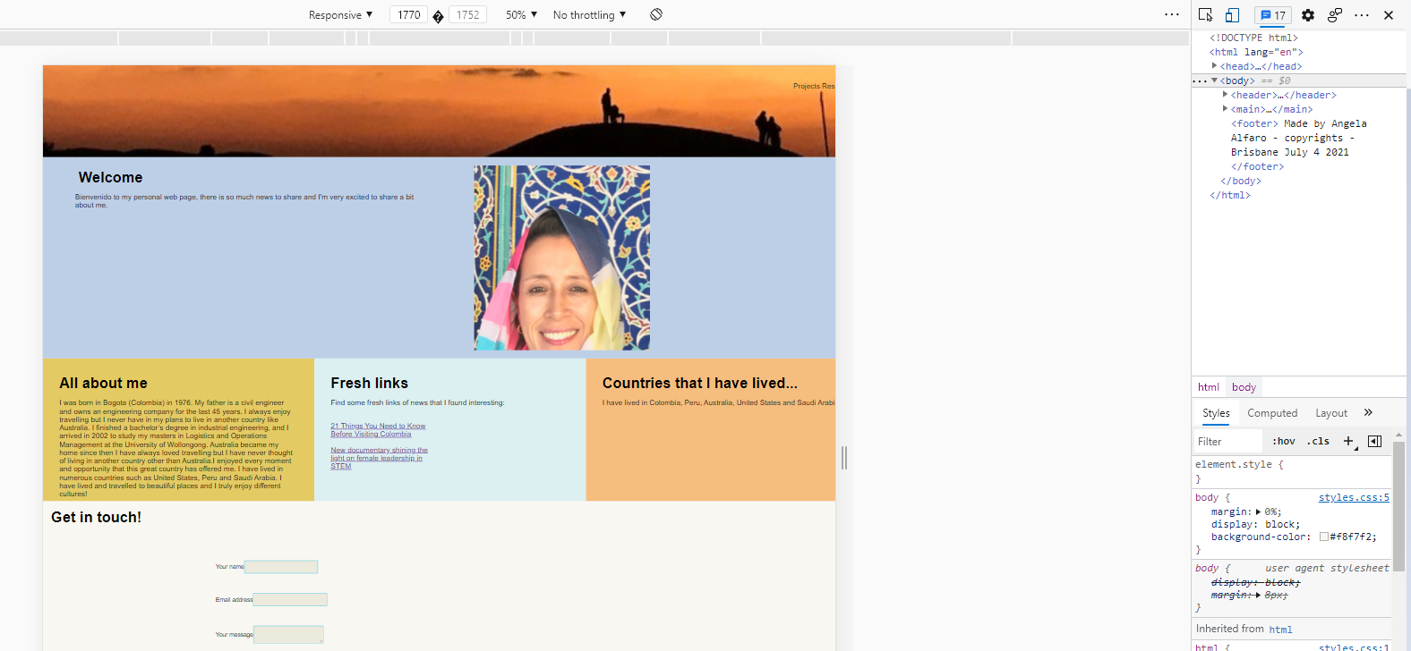

1. **Max-width: 900 px**

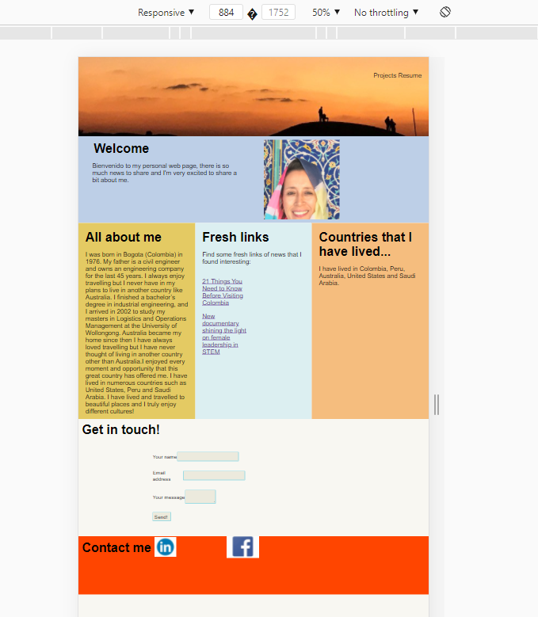

1. **Max-with: 600 pm**