**Learning NumPy with Pandas Library:**

1. **Prerequisites**

* Vectors and matrices https://www.mathsisfun.com/algebra/vectors.html
* Full course on linear algebra would help
* Gaussian distribution, in 1-D and 2-D
* Python experience.
* IDE – PyCharm Community Edition
* Install NumPy under Setting -> Project Interpreter -> + -> NumPy

1. **VECTORS**

* **Dot Product**

**Scaler:**

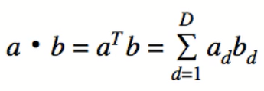

**Magnitude:**



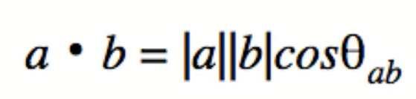

**Angle:**

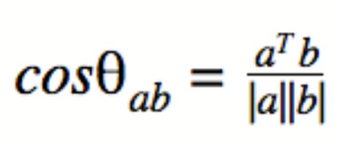

Vector is one-dimensional mathematical object

Matrix is two-dimensional mathematical object