1. **VALID REGISTRATION**

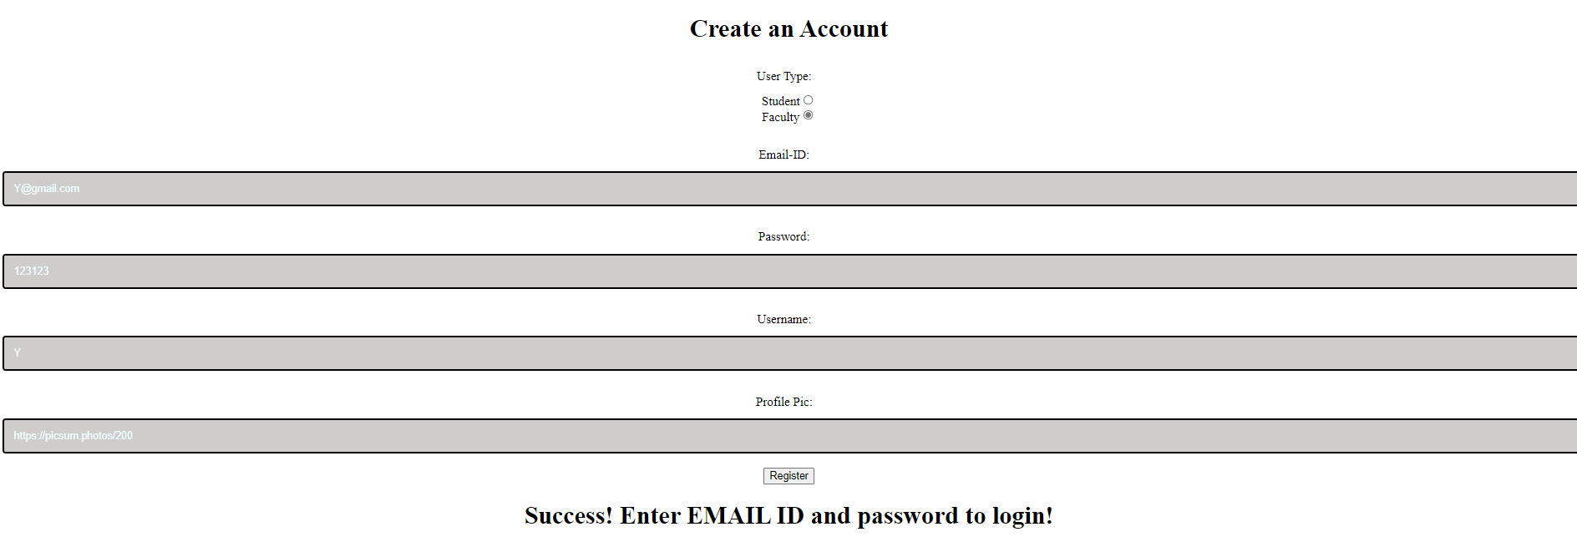

1. **INVALID REGISTRATION**

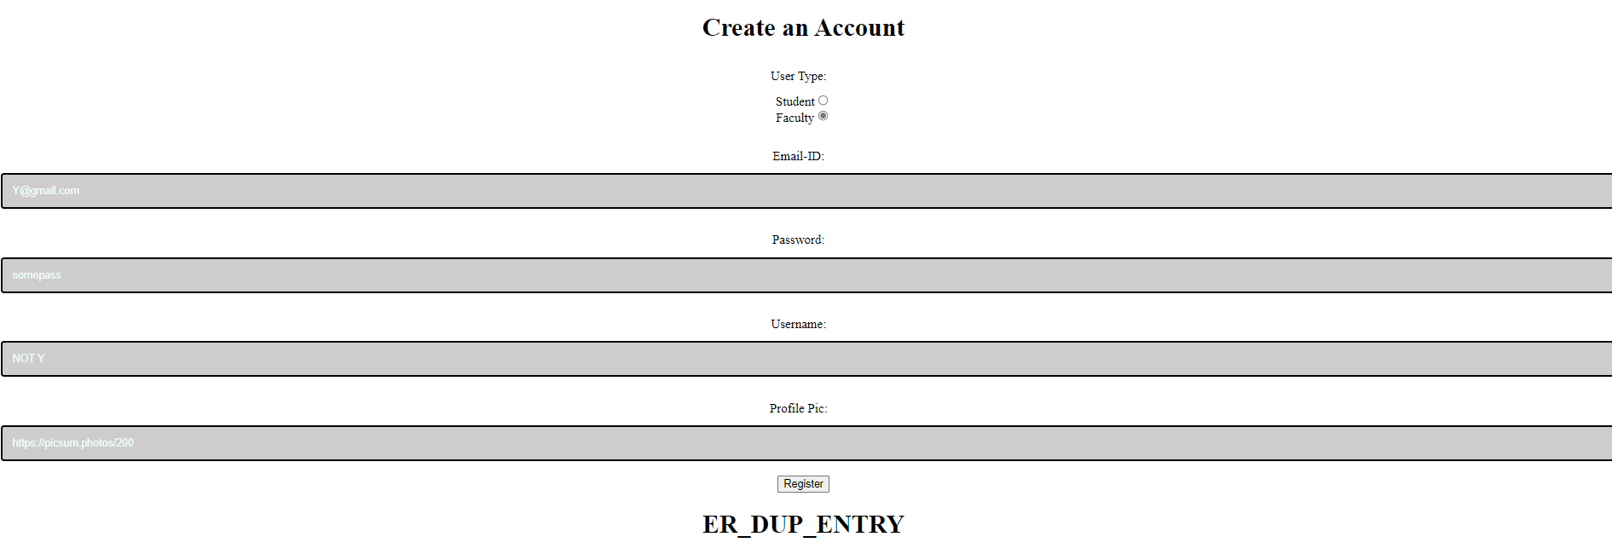

1. **INVALID LOGIN**

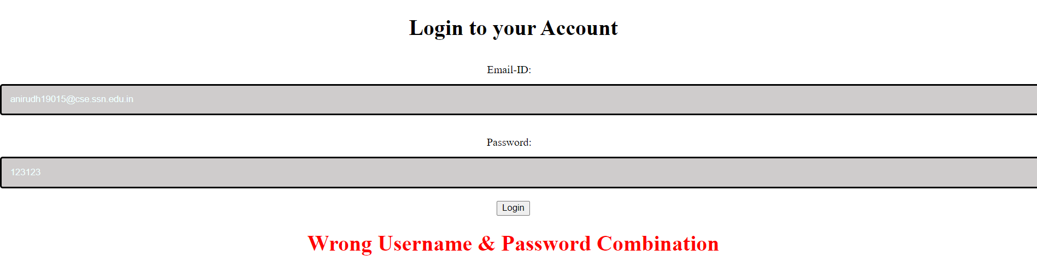

1. **VALID LOGIN: STUDENT**

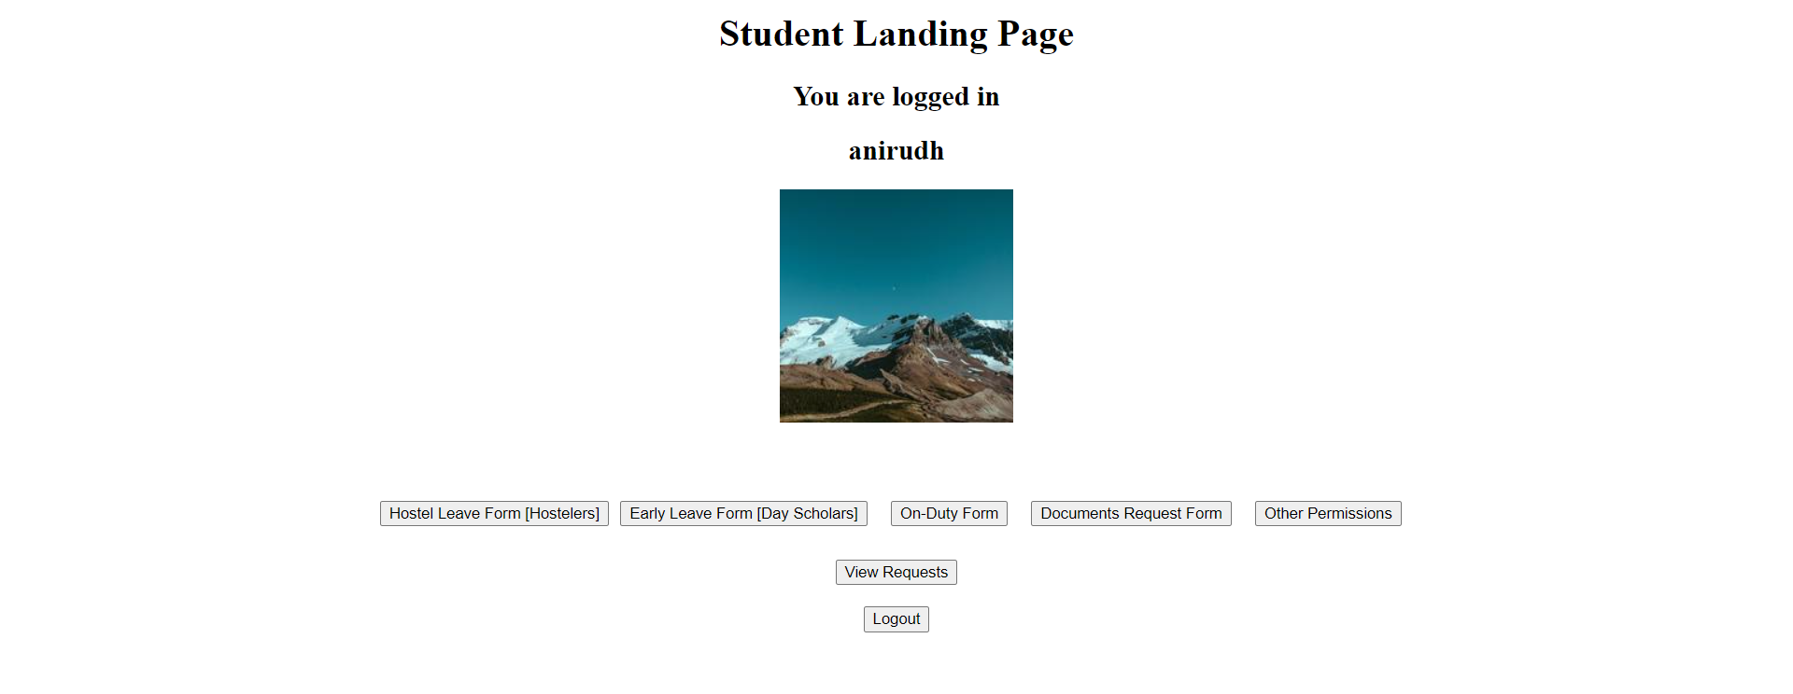

1. **VALID LOGIN: FACULTY**

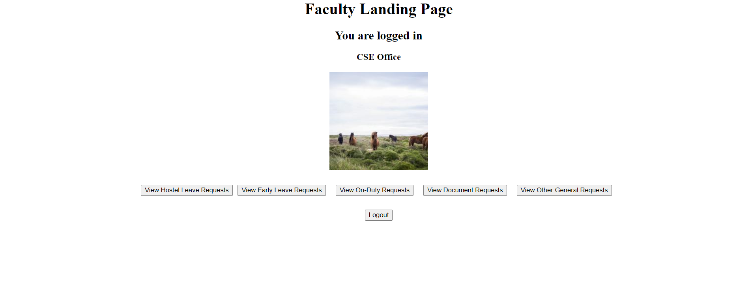

1. **STUDENT: HOSTEL LEAVE FORM**

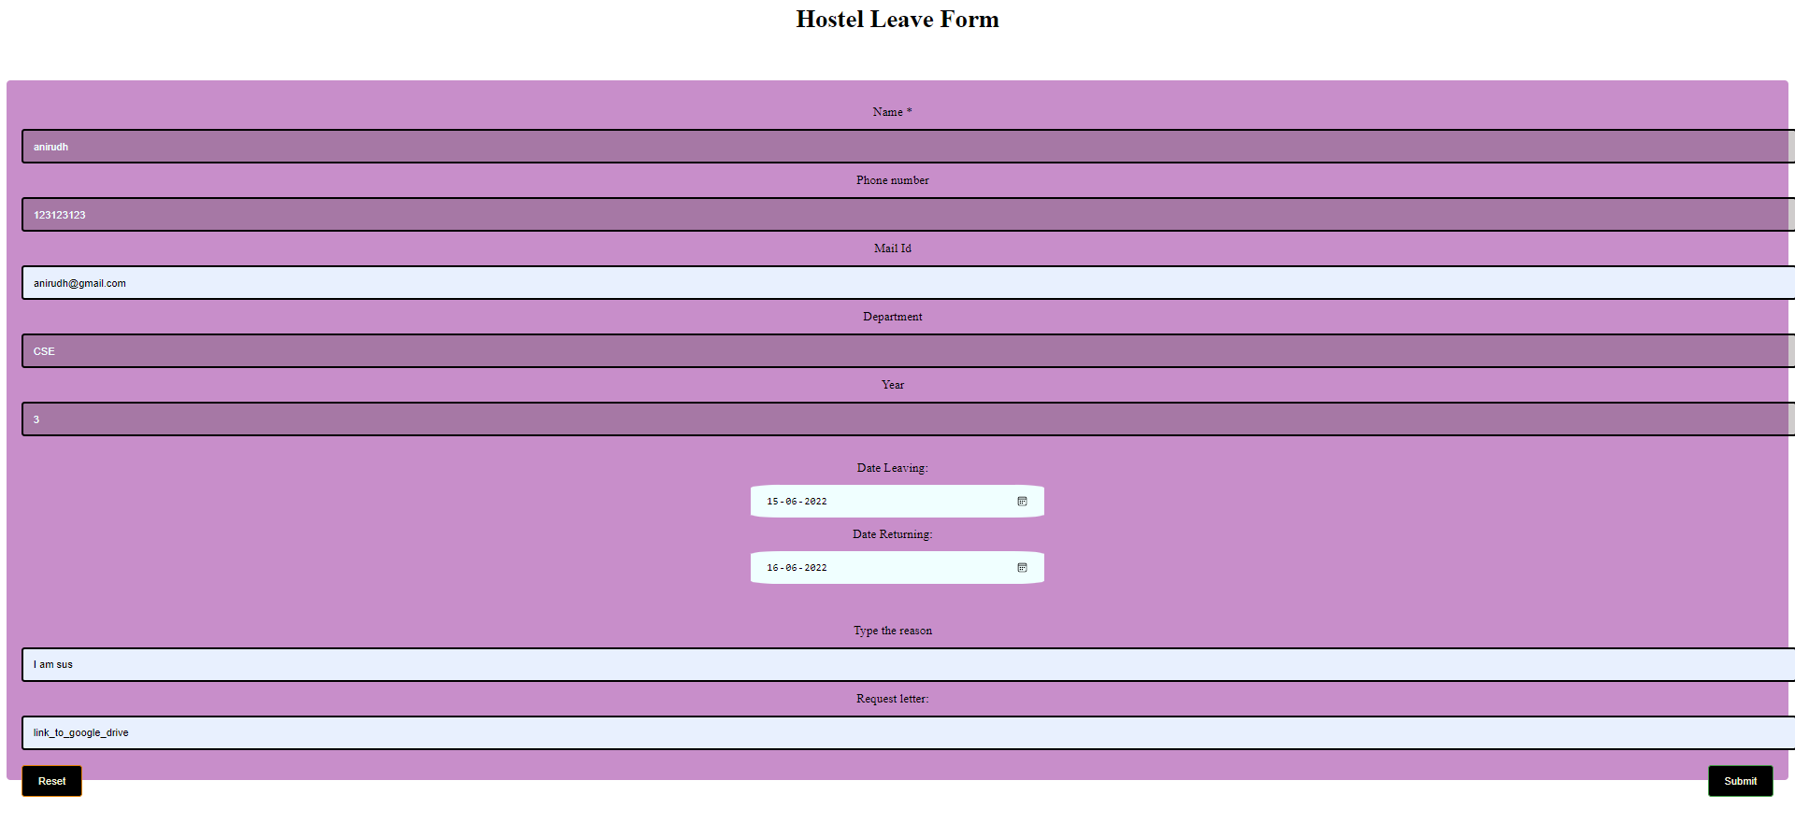

1. **STUDENT: SUCCESSFUL FORM SUBMISSION**

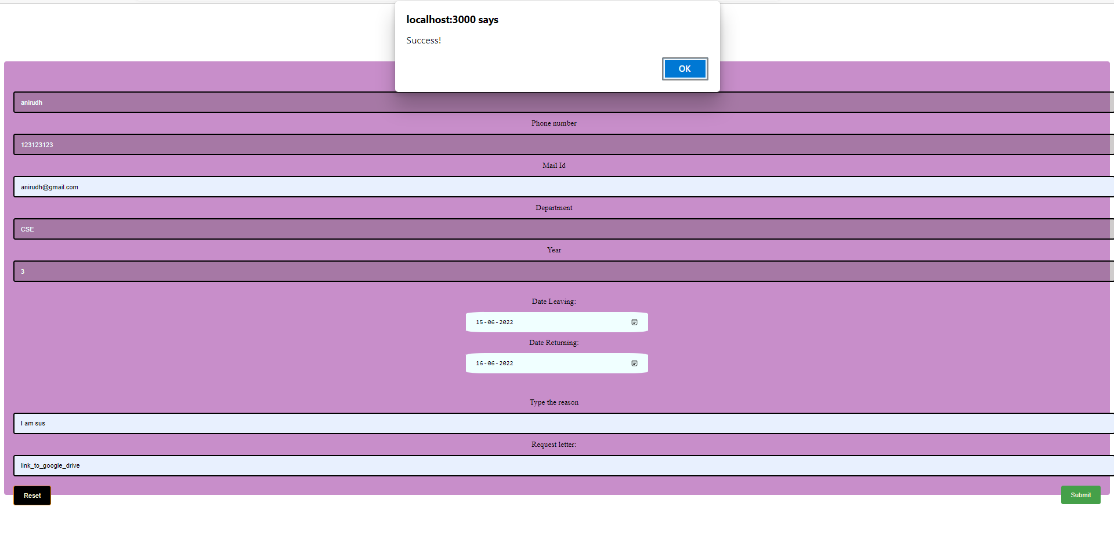

1. **STUDENT: UNSUCCESSFUL FORM SUBMISSION**

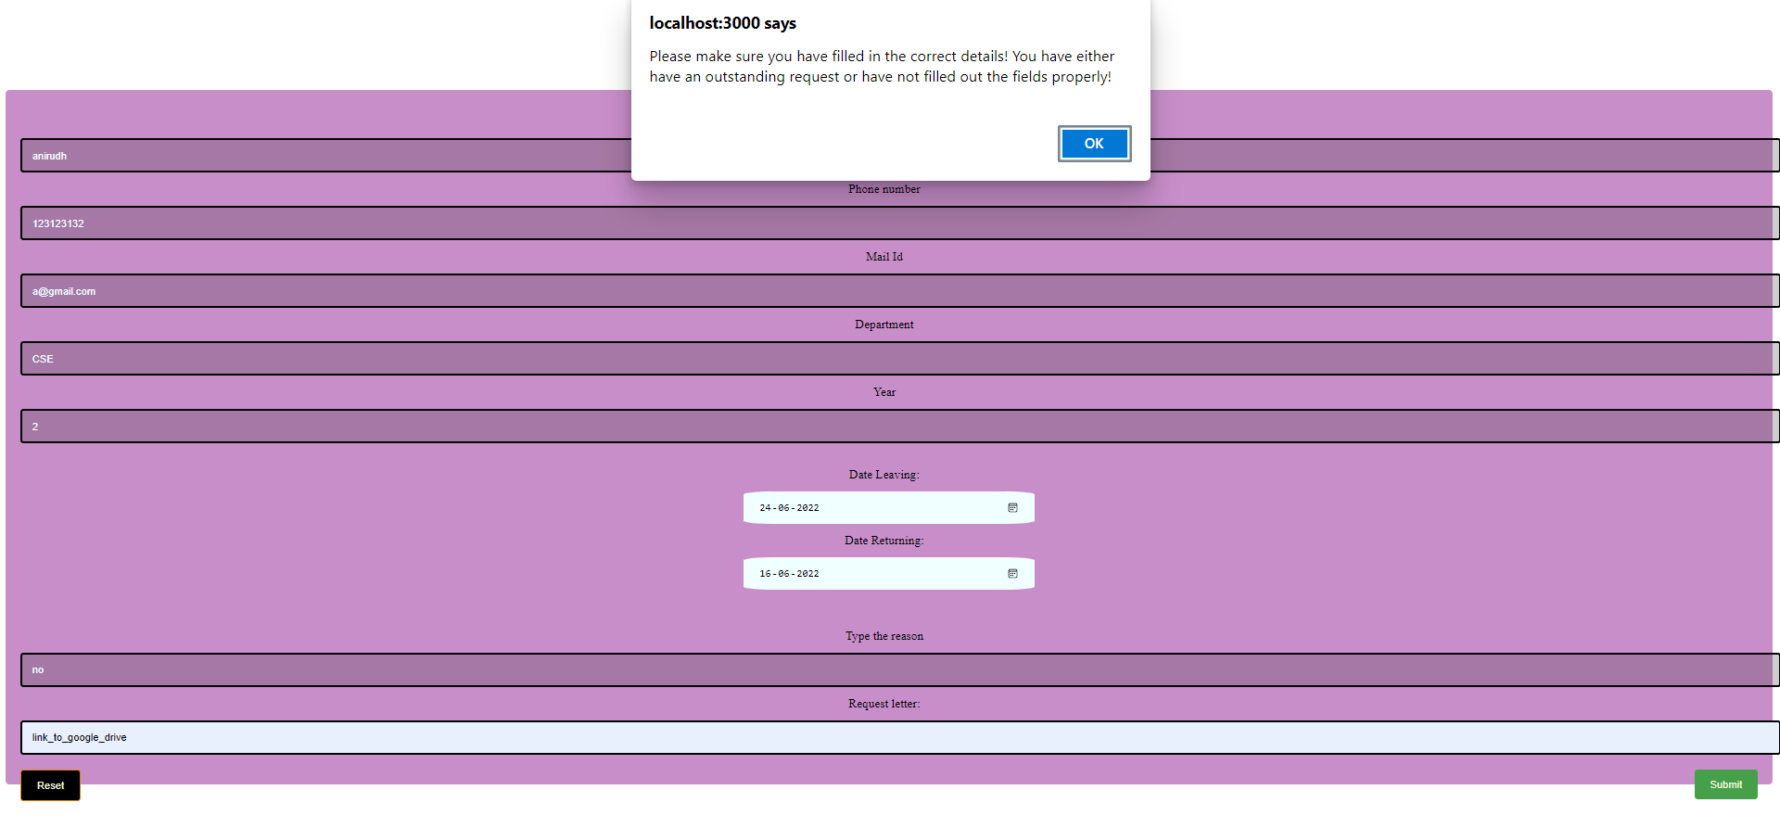

1. **STUDENT: VIEW REQUEST STATUS**

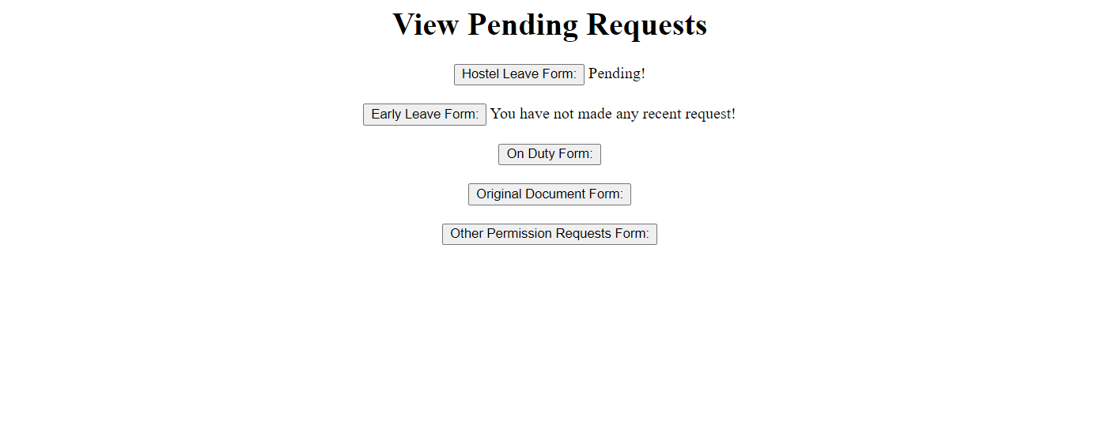

1. **LOGOUT**



1. **FACULTY: VIEW REQUESTS**
   1. **NO OUTSTANDING REQUESTS**



* 1. **ONE OR MORE OUTSTANDING REQUESTS**



1. **FACULTY: ACCEPT OR REJECT OUTSTANDING REQUESTS**



1. **FACULTY: SUBMIT DECISIONS**



1. **VIEW PENDING REQUESTS AFTER UPDATE**



1. **STUDENT: VIEW PENDING REQUESTS AFTER DECISION**

