Cross-Impact of Order Flow for Optimal Market-making

Aslanyan Artak

aaaslanyan_2@edu.hse.ru

# **Abstract**

Market making (MM) stands as a prominent high frequency trading (HFT) approach extensively employed in major stock exchanges like NYSE and NASDAQ. Unlike HFTs, which are not bound to constant trading, MM focuses solely on ensuring market liquidity through rapid execution of numerous orders within milliseconds. This liquidity provision is pivotal for market stability and investor engagement. The profit for MM entities is derived from the discrepancy between the quoted ask (selling) and bid (buying) prices of stocks. MM firms are obligated to consistently place buying and selling limit orders to augment market liquidity. Market liquidity is gauged by parameters like quoted spread and the number of successful trades, with lower spreads and higher trade volumes indicating higher liquidity.

With the rise of algorithmic trading, human involvement in MM roles has diminished, except in over-the-counter markets such as corporate bonds. MM now heavily relies on high-speed trading systems to capitalize on speed advantages. Nonetheless, mere speed isn't sufficient for MM agents to compete effectively. There's a necessity for automated MM incorporating human-like expertise into high-speed trading. Reinforcement learning (RL) emerges as a viable machine learning technique for automated MM. Recent research has developed RL-based MM agents aimed at maximizing profit and minimizing inventory, serving as the benchmark model for evaluating newer approaches.

# **1. Introduction**

Accurately assessing and predicting how the trading activities of market participants influence asset price movements is crucial for both practitioners and researchers. This includes areas like analyzing trading costs and optimizing trade execution. Numerous studies have delved into the concept of price impact, which is the effect of trades on asset prices. In more complex settings involving multiple assets, researchers have explored cross-impact, which aims to understand how trading one asset affects the prices of other assets.

Various studies have examined the contemporaneous cross-impact of order flow on returns by analyzing their cross-correlation structure. For instance, some have shown that the commonality in returns among certain stocks can largely be attributed to similarities in order flow. However, it's been argued that positive covariance between returns of a specific stock and order flow imbalances of other stocks might not necessarily indicate cross-impact. Additionally, it has been demonstrated that considering cross-impact terms in models may only slightly enhance performance, suggesting they could be disregarded.

Our study builds upon this research by considering both in-sample performance and the forecasting ability of cross-order flow using different metrics. Notably, there's a gap in literature regarding the influence of order flows on price movements across multiple assets while considering deeper levels in the limit order book (LOB).

While explaining contemporaneous returns has been extensively studied, examining the impact of trade orders on future prices has received less attention despite its economic significance. Some studies have explored the relationship between order imbalances and future daily returns, showing promising results in devising trading strategies based on these imbalances.

With the rise of high-frequency trading (HFT), accurately estimating cross-impact on future intraday returns has become increasingly important. Machine learning models, particularly deep neural networks, have shown promise in modeling stock returns and forecasting.

# **2 Description of strategy**

## **2.1 Literature Review**

Our strategy uses machine learning algorithms to predict the evolution of price of the stocks. We periodically sample the state of the market and use these models to output a signal indicating whether the price is expected to increase, decrease, or remain globally unchanged. Taking this evolution into account, we post ask and bid orders at a given price, adjusted for the evolution, in order to better capture the trend of the market.

## **2.2 Data**

We are going to use simulator of trading environment to generate synthetic data. There was defined several types of trading agents and their behaviors in an agent-based market simulation environment:

* **Trader:** Represents a trading agent that operates within a single market or exchange. It places orders to buy and sell assets based on various strategies.
* **Multi Trader:** Extends trader’s functionality to operate in multiple markets or exchanges simultaneously. It manages trading activities across different markets.
* **Random:** A trading agent that places orders randomly, mimicking noise or random trading behavior in the market.
* **Fundamentalist:** This trading agent makes trading decisions based on fundamental analysis, considering factors like dividends and risk-free rates to determine the value of assets.
* **Chartist:** Uses sentiment analysis of price movements on a single exchange to make trading decisions. It may buy or sell based on perceived trends in asset prices.
* **Multi Chartist:** Extends the behavior of Chartist to operate across multiple exchanges. It analyzes price movements across different markets to make trading decisions.
* **Universalist:** Combines the strategies of Fundamentalist and Chartist, switching between them randomly. It adapts its trading behavior based on market conditions and the performance of different strategies.
* **Market Maker:** Acts as a liquidity provider on a single exchange by placing limit orders on both sides of the order book. It aims to narrow the bid-ask spread and improve market liquidity.
* **Multi Market Maker:** Extends the behavior of MarketMaker1D to operate across multiple exchanges. It provides liquidity in multiple markets by placing orders on different exchanges.

We will use metrics defined in the article [1] for further analysis

**Order book Imbalance.**The literature extensively *confirms* that the structure of the orderbook significantly influences how future returns are distributed [16, 18–20]. This can be easily understood: when there is a considerable surplus of liquidity on the bid side compared to the ask side, it takes much less trading volume to push the price up than it does to push it down. Therefore, assuming that the likelihood of a sell order arriving is not significantly higher than that of a buy order, the chances of a future price increase are higher than those of a decrease. This logic also holds true for the reverse scenario where the orderbook structure is reversed.

Article [1] provides advanced Order Book Imbalance metric which shows better results compared to the classical notion that is given by

Where *a* and *b* represent the sum of the top ask and bid liquidity for the top *n*-prices at the time *t,* respectively. For example, we are going to use top 3 or 5 prices. In some articles was observed the deeper prices forecasting more long-term dependencies between metric and price changing.

**Trade Flow Imbalance.**

Article [1] also defines metric which is called trade imbalance and given by

Where represents volume of buy orders on market *i* in the time interval . Similarly, the quantity represents the total volume of sell orders on market *i* over the same time interval.

This feature was demonstrated in [2] to have significant explanatory power over contemporaneous returns.

**Figure 1:** Here are represented the features generated by simulator on 1000 ticks.

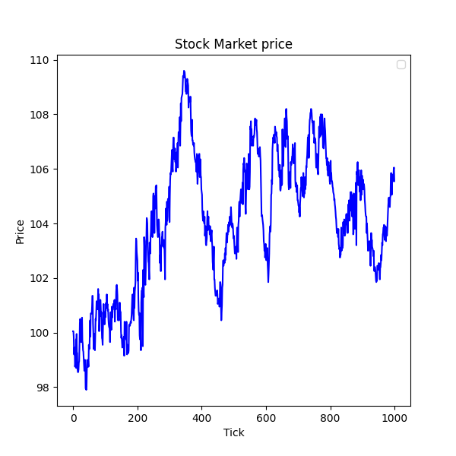

(b) TFI with 3 tick window (c) OBI with 1 tick window

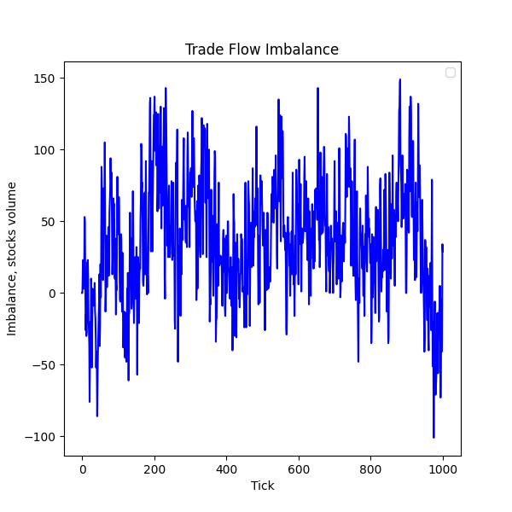

References

[1] Jakob Albers, Mihai Cucuringu, Sam Howison, Alexander Y. Shestopalof. Fragmentation, Price Formation, and Cross-Impact in Bitcoin Markets

[2] Rama Cont, Arseniy Kukanov, and Sasha Stoikov. The price impact of order book events. Journal of financial econometrics, 12(1):47–88, 2014.