Geoff Bohling
5 September 2005

Exploratory Data Analysis

Exploratory Analysis, Zone A Porosity

We will start with the analysis of porosity, since it is the most straightforward variable to analyze in this case. First of all we will look at a histogram of the values, particularly since we need to know the data limits for subsequent analysis. To launch the histogram dialog box, select Histogram (histplt) from the PostScript menu:

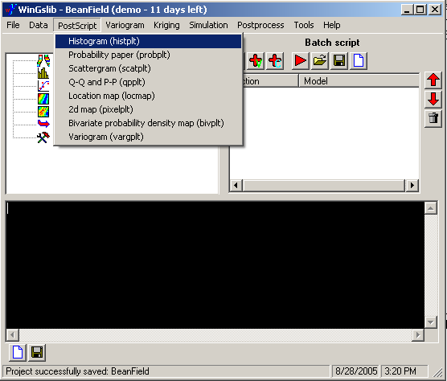

In the resulting dialog box (Parameters for histplt), change the data file name to ZoneA.dat, select Por % from the Variable drop-down list, change the output PostScript file name to HP_ZoneA_Por.ps (WinGslib will suggest HP_ZoneA.ps, with “HP” standing for histogram plot, but we will add “Por” to distinguish this histogram file from those for other variables), and the Title text box to read Zone A Porosity, leaving the other parameters at their default values:

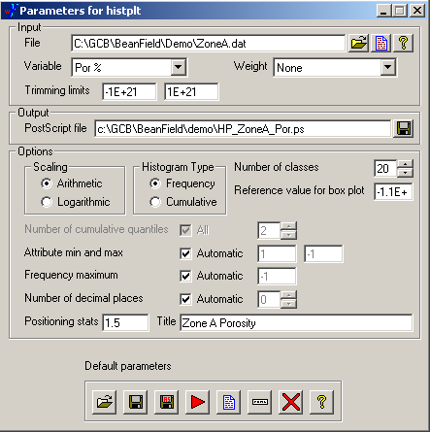

The controls at the bottom are common to all WinGslib dialog boxes. If you hover the cursor over a button for a moment, a tooltip will appear explaining that button’s function. Each dialog box is simply a front end to one of the underlying GSLIB programs (the histplt program in this case), and each of these programs runs from a parameter file. You can open an existing parameter file (replacing the values in this dialog box) by clicking on the button with the folder icon, save the displayed parameters to a file by clicking on the first diskette button, save a copy of the file (under a different name) by clicking on the next diskette button (the one with a barely visible “AS” written on it in red), run the GSLIB program by clicking on the red arrow, and view the results of a run by clicking on the document (piece of paper) icon. The icon in the form of a horizontal box permits insertion of comments in the output. The red X icon closes the dialog box and the question mark icon opens a help file.

If you click on the red arrow without having saved the current parameters, you will be prompted to save them in a parameter file, which by default will have the same base name as the output PostScript file. Using reasonable, unique parameter file names will help to document your work and ease the process of regenerating results at some later point should this be necessary:

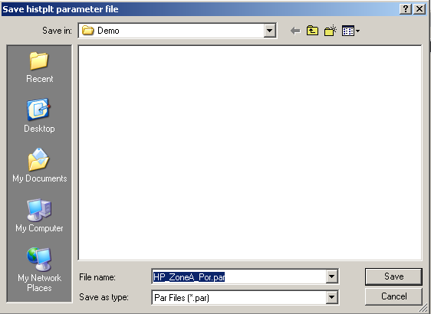

After you save the parameter file, the GSLIB program (histplt in this case) will run, with its summary text output being sent to the main WinGslib window:

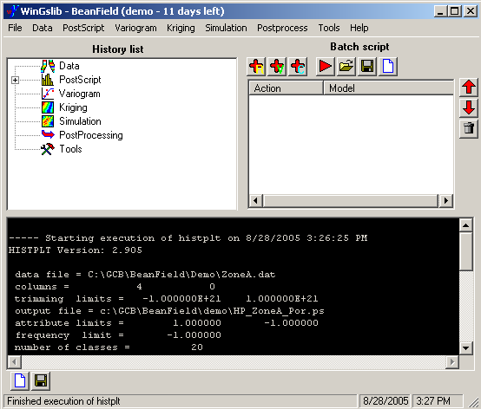

The program output for histplt will include summary statistics for the selected variable. What we are most interested in at this point are the minimum and maximum porosity values, which are 12.15% and 16.96%.

The histplt dialog box will remain open after the program has run. Clicking on the document button on the bottom should launch GhostView to display the PostScript file containing the actual histogram plot. The plot will also include the summary statistics:

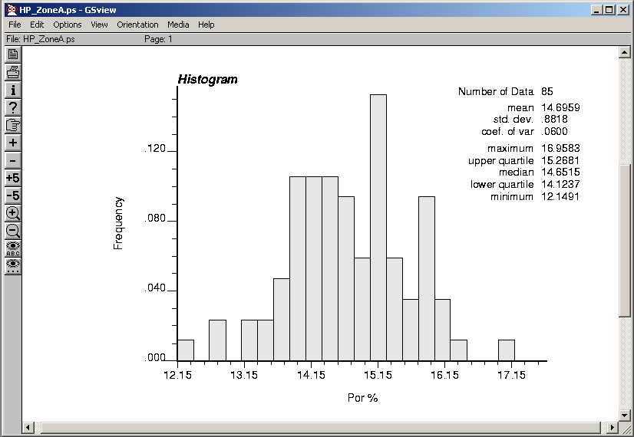

You can dismiss the histplt dialog box by clicking on the X button.

Another basic exploratory plot is a posting of the data values at the well locations, which you can produce by selecting Location map (locmap) from the PostScript menu. Then change the values in the Parameters for locmap dialog box to read as follows:

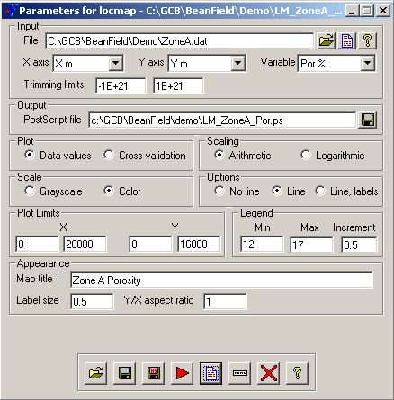

Be sure to specify the proper values for X axis, Y axis, and Variable and set the Plot Limits and Min and Max values for the legend (in this case, the porosity values) as shown. WinGslib does not try to figure out reasonable default values from the data, so you have to provide them. After filling in reasonable values, click the red arrow to run the locmap program (you will again be prompted to save a parameter file) and then click the document icon to view the resulting map in GhostView. The map will show the measured porosity values, represented by a range of colors, posted at the well locations:

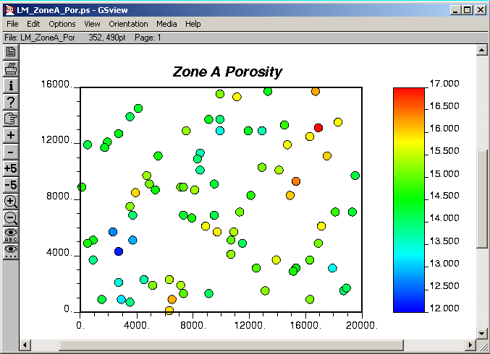

Unfortunately, there is no tool for computing statistics on the separation distances between wells, which would be helpful for determining reasonable lag distances to use in the variogram analysis. We will try lag increments of 500 m and 1000 m when we do the variogram analysis for this example.

Note that WinGslib has included the parameter files for our two program runs so far in its History list, as indicated by a small box containing a plus sign to the left of the PostScript icon. Clicking on this box will expand the history list to show the runs that have been made previously. Double-clicking on one of the entries will launch the dialog box for the associated program, filled in with the previously saved parameters:

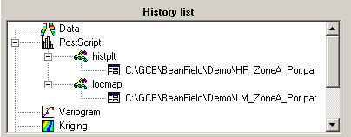

Exploratory Analysis, Zone A Thickness

To compute a histogram and summary statistics for the thickness, you can either select Histogram (histplt) again from the PostScript menu or re-open and modify the parameters that we used for the porosity histogram. To do the latter, expand the history list to show entry for HP_ZoneA_Por.par under histplt. Double-click on the parameter file name to launch the Parameters for histplt dialog box then change the Variable drop-down list to point to Thk m and change the output file name to HP_ZoneA_Thk.ps:

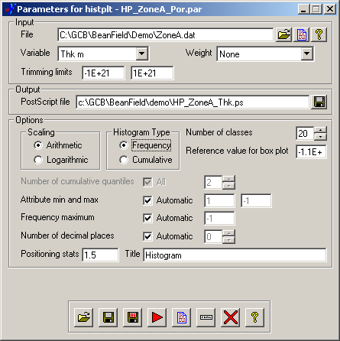

Click the Save As button (the second diskette icon) to save the modified parameters in a new parameter file (HP_ZoneA_Thk.par) and then click the red arrow to run the histplt program. Again, you can read the program’s text output, including summary statistics, in the console portion of the main WinGslib window and click on the document icon in the dialog box to display the histogram plot in GhostView:

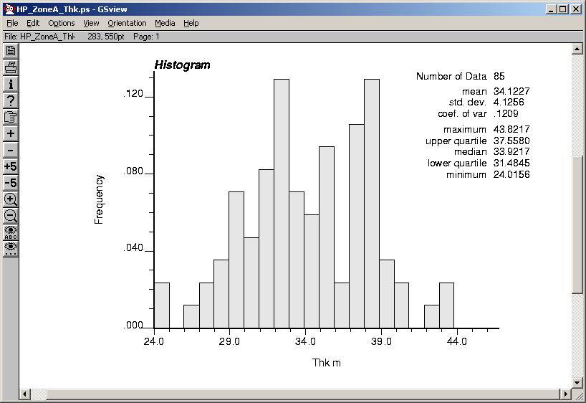

You may wish to experiment with the histogram parameters, particularly the Number of classes (a.k.a. bins) and Attribute min and max (the min value is the bin origin) to see what effects these have on the appearance of the histogram.

Similarly, you can generate a data posting for the thickness either by selecting Location map (locmap) again from the PostScript menu or by double-clicking on the parameter file entry for the porosity under locmap in the history list and modifying the information appropriately (changing the values for Variable, Postscript file, Map title, and the Legend parameters):

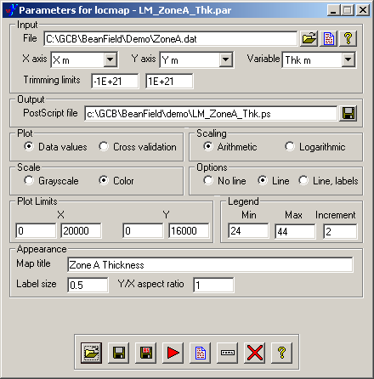

The resulting map seems to indicate a significant trend in the thickness values, roughly from the southwest to the northeast. We will need to take this trend into account when we perform variogram analysis and kriging.

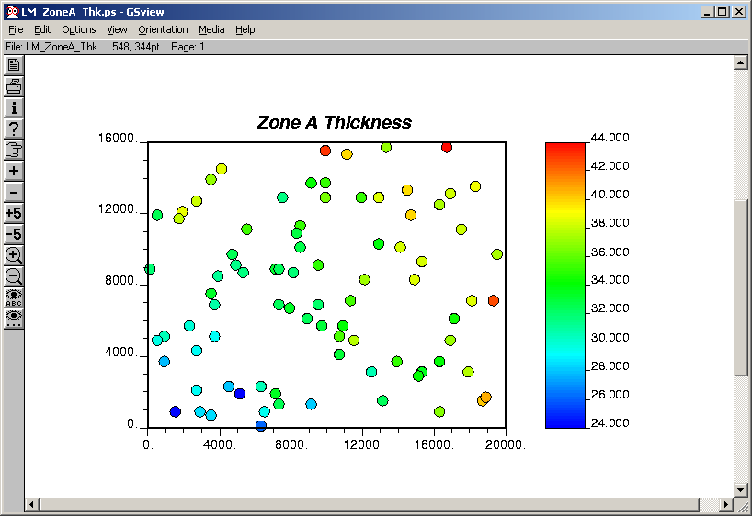

Exploratory Analysis, Zone A Permeability (actually, LogPerm)

To begin our analysis of the permeability for Zone A, generate a histogram using histplt. We will in fact be working with LogPerm (base 10 log of the permeability) in this example, since permeabilities tend to be lognormally distributed. Activate the Parameters for histplt dialog box and fill it out as shown below. Note the use of the lower trimming limit to exclude missing values (-999.9999) and the reduction of the number of histogram classes (bins) to 10, since we are computing the histogram from only 42 data values:

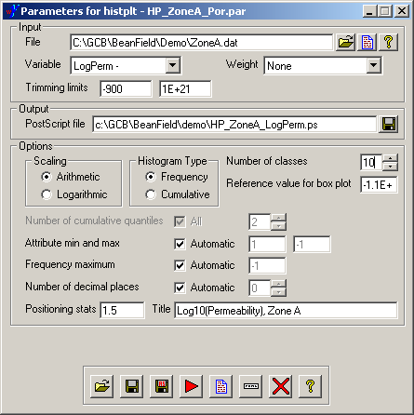

The resulting histogram looks roughly normal:

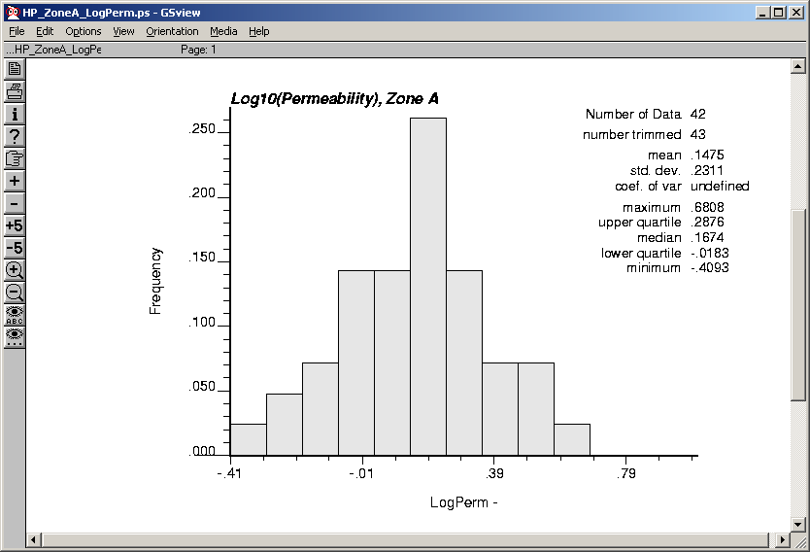

Note the minimum and maximum LogPerm values of -.41 and .68.

Use locmap to map look at the spatial distribution of the LogPerm values, remembering to trim out the missing values and set the legend scale to appropriate min and max values:

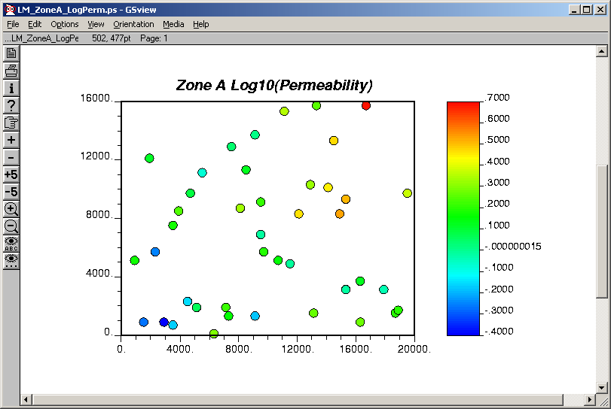

Use the program scatplt to look at the relationship between LogPerm and porosity values. Select Scattergram (scatplt) from the PostScript menu and fill out the dialog box more or less like this:

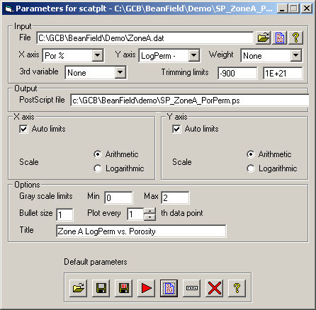

The Gray scale limits would only apply if we were using a third variable to color (or, actually, gray) the data points according to that third variable.

The crossplot shows a definite correlation between the log permeability and porosity values:

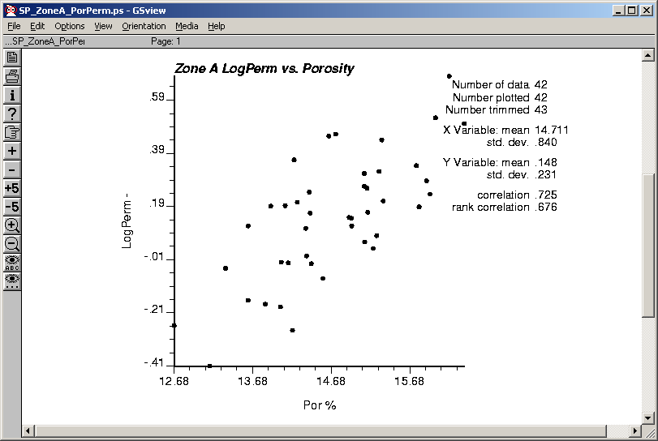

We would like to preserve some of this correlation between the gridded values of porosity and LogPerm. We also would like to use the more abundant information on porosity to help compensate for the sparsity of permeability values. This can be done by kriging LogPerm using "kriging with an external drift;" that is, using porosity as a collocated covariate. We can do this with kt3d, which will use the porosity and LogPerm values at the wells to determine the correlation between the two and then use the gridded porosity values to estimate local means of LogPerm based on the correlation. In this case, however, the variogram for LogPerm should be replaced by the variogram of the residuals from the LogPerm-Por correlation line, which is why I have provided the residual values in the data files.

