Geoff Bohling
5 September 2005

Kriging
Kriging, Zone A Porosity

To generate a grid of porosity values, we will use ordinary kriging as implemented in the GSLIB program kb2d. Ordinary kriging will compute a local estimate of the mean of the kriged variable at every grid point; simple kriging would require the specification of a global mean value for all locations. To start the process, select 2D kriging (kb2d) from the Kriging menu. Modify the Files tab of the Parameters for kb2d dialog box to appear as follows:

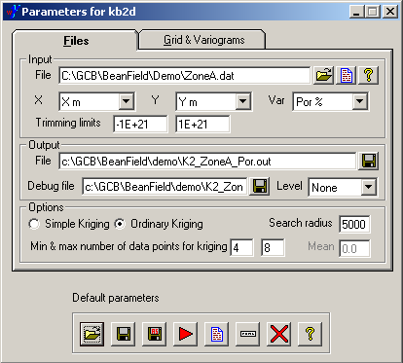

The output file, K2_ZoneA_Por.out, will contain the grid of estimated porosity values and the associated variances of the kriging estimates. The search radius of 5000 m was estimated from a look at the distribution of well locations in the location map we developed earlier; this radius should be large enough to encompass the minimum number of data points required for estimation (4) at any point in the grid. Using a smaller radius, like 3000 m, would result in “search failures” at some of the grid nodes (which might be reasonable if we wanted to avoid extrapolating too far from the well control).
Fill out the Grid & Variograms tab to appear as follows:

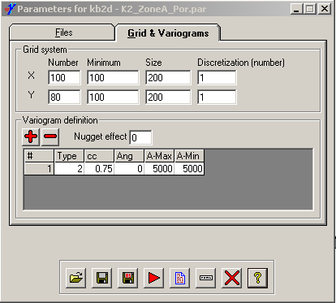

The parameters for the Grid system place the southwestern-most grid node at (X,Y) = (100 m, 100 m) with 100 grid nodes along the X axis and 80 along the Y axis with a grid spacing (or cell size) of 200 m. This puts the northeastern-most grid node at (X,Y) = (19900 m, 15900 m). However, since each grid node is at the center of a 200 m x 200 m cell, the area encompassed by the grid extends from (0 m, 0 m) to (20000 m, 16000 m). The discretization value of 1 means that we are performing point, rather than block, kriging.

The parameters listed under Variogram definition correspond to the exponential variogram model we developed earlier. Variogram type 2 means “exponential”. If you click on the Type entry for the model, the text box will turn into a dropdown list for selecting among the model types, listed by name, but the entry will turn back to a number once you have made your selection. The parameter cc is the model sill, A-Max and A-Min are the maximum and minimum ranges (called hMax and hMin in the dialog box for vmodel), and Ang is the azimuth for the direction of maximum range, which doesn’t matter if the maximum and minimum ranges are equal.

Run the program and then click the document icon to display the output grid file:

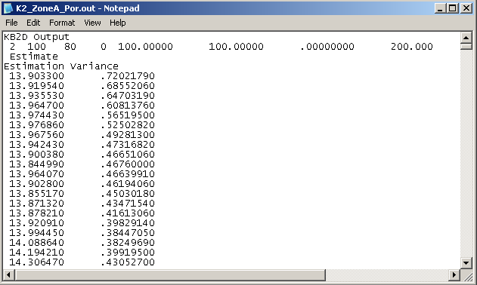

The second line of the file indicates that there are two variables listed in the file and then lists the parameters describing the grid layout (including the unused z dimension). The next two lines give the names of the two variables (the not-so-helpful labels Estimate and Estimation Variance), followed by a listing of the values of said variables at all grid nodes. To reduce the file size, X and Y coordinate values are not listed. Instead, the gridded values are listed in a conventional order, with the X index cycling fastest, then Y, and then Z (for a 3D grid). For this example, the first 100 values are those for the first row of the matrix, with Y = 100 m and X ranging from 100 m to 19900 m, the next 100 are for Y = 200 m, etc.

Finally, we can use the pixelplt program to create a raster map of the kriged porosity. Select 2d map (pixelplt) from the PostScript menu and fill in the Files tab of the dialog box as follows:

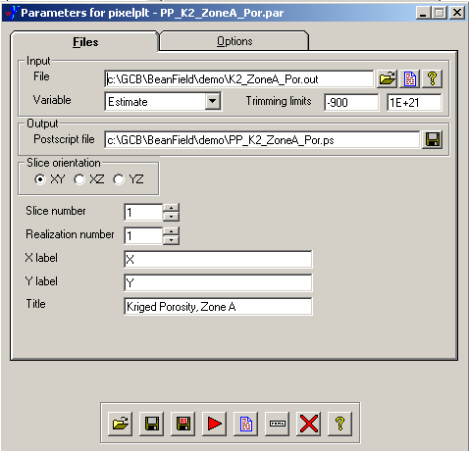

K2_ZoneA_Por.out is the grid file that we just created with kb2d and we are telling pixelplt to plot the variable Estimate (rather than Estimation Variance). If any search failures had happened during the kriging process, then the corresponding grid nodes would be assigned values of −999, so we use a lower trimming limit of −900 here to exclude missing values. (None occurred here, but this is good practice, anyway.)

Modify the Options tab as follows. Note that WinGslib does not actually read the grid definition info at the top of the grid file, so you will have to manually enter the Grid definition parameters here:

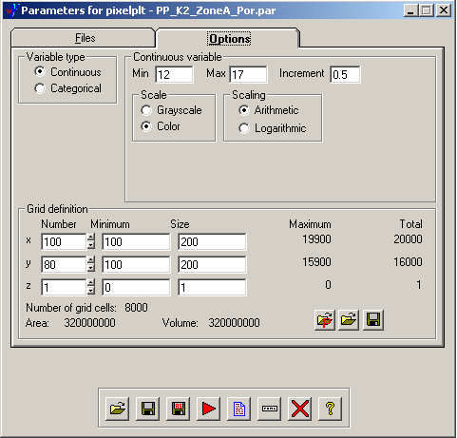

Note that I actually ran histplt on the gridded porosity values to determine that 12 and 17 were still reasonable limits to use for the color scale. They are, since ordinary kriging should not produce estimated values outside the range of the input data.

Run pixelplt and then display the result:

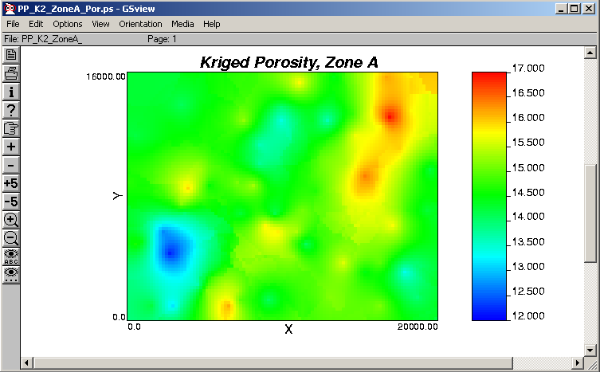

As expected, kriging has produced a rendition of the porosity field that is about as smooth and featureless as possible given the constraints of the well data. In fact, any reasonable interpolation algorithm should behave about the same way, since we would probably reject an algorithm that produced features unwarranted by the data. We would turn to simulation, rather than interpolation, if we wanted to see such speculative features.
Kriging, Zone A Thickness

Unfortunately, kb2d does not allow kriging with a trend, so we must turn to the more complicated 3D kriging program, kt3d. Select 3D kriging (kt3d) from the Kriging menu and modify the Files tab like so:

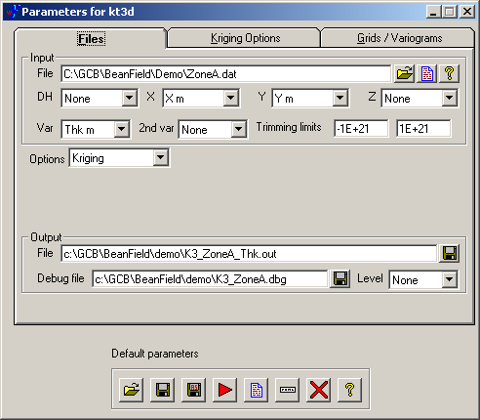

The only change I needed to make here was to change the output file name, adding the variable name (Thk) at the end. The remaining fields were already filled in properly. I have no idea what DH refers to and I cannot find an explanation of it in the documentation.

Fill out the Kriging Options tab as shown below. Note especially the selection of a linear drift (a.k.a. trend) in both X and Y and the increase in the search radius to 5000 m. We could specify an octant search, rather than a simple nearest neighbor search, by setting the Max per octant value to something greater than 0. This would represent the maximum number of data points to retain per octant.

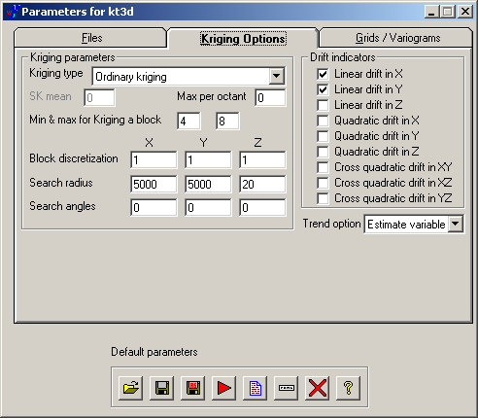

Finally, make sure the Grids/Variograms tab appears as follows. All of these values were automatically filled in when I ran the process:

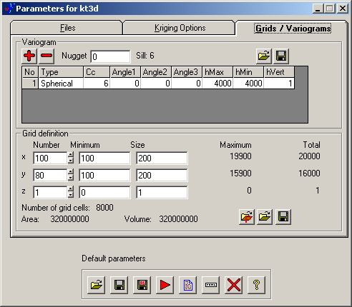

Use the red arrow to run the program and then take a look at the output grid file. It should again contain two columns, named Estimate and Estimation Variance, as did the porosity grid file. I am going to be so bold as to edit the opening lines of this file to contain a little more helpful information:

KT3D ESTIMATES for Thickness, Zone A, Big Bean Field
2 100 80 1 100.00000 100.00000 .00000000 200.000 200.000 1.00000 1
ThicknessEstimate
ThicknessEstimationVariance
22.398320 11.275070
22.489420 9.8298930
22.608850 8.4781400
23.335080 7.1763630
23.384630 6.1220490
23.489290 5.2360180

I have run histplt on the gridded values to established that the kriged thicknesses range from 19.68 to 44.28 meters, since we will need to specify reasonable min and max values for pixelplt.
To generate a map of the kriged thickness, activate the Parameters for pixelplt dialog box and modify the Files tab to read something like:

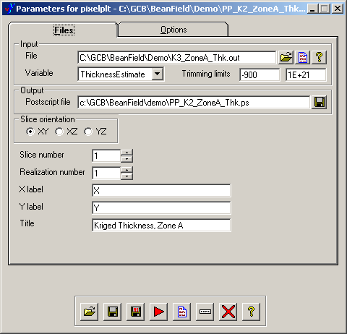

Note that with the above edits to the grid file, the Variable name now reads ThicknessEstimate rather than just Estimate.

On the options tab, change the Min and Max values and Increment for the mapped variable to 19, 45, and 4, or something similar. Also, make sure the Grid definition is right:

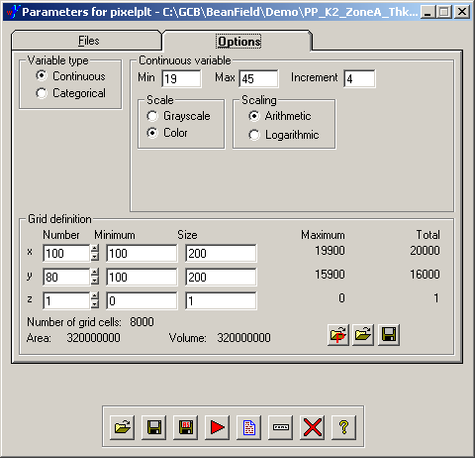

Save the parameters to a new file if you wish and run the program to produce the map:

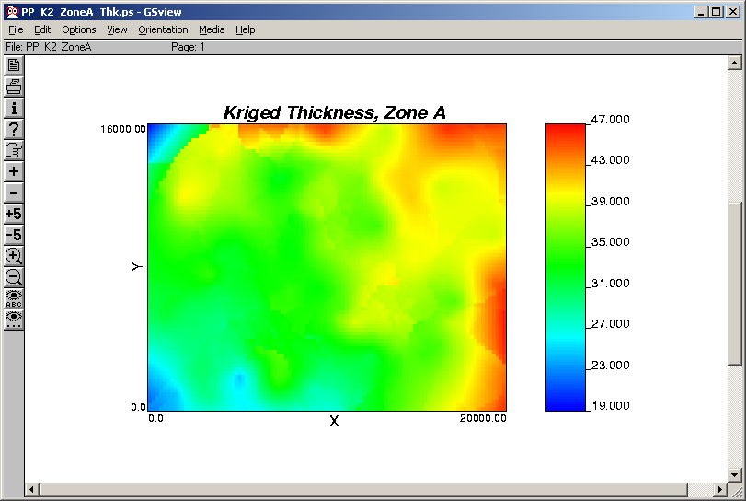

What structure might exist in the middle of the map is somewhat lost in a sea of green, at least to my color-deficient eyes, and there is clearly an artifact in the northwest corner resulting from extrapolation of the trend into a region with no well control. Such extrapolation can be avoided by reducing the search radius.

Kriging LogPerm with Porosity As External Drift, Zone A

Fire up the Parameters for kt3d dialog box once again and modify the Files tab as follows. Be sure to set LogPerm as Var and Por % as 2nd var and heed the lower trimming limit:

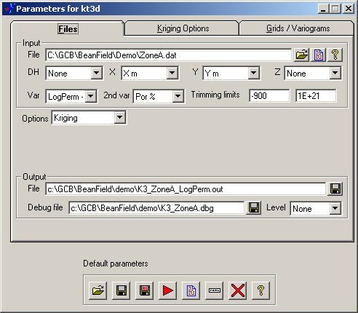

On the Kriging Options tab, set Kriging type to Kriging with an external drift and set the file name under Gridded file with drift/mean to point to the porosity grid file, K2_ZoneA_Por.out (or whatever you named it). I found that the open button (the folder) next to the file name field did not work, so I had to type in the file name. Also, make sure the Variable field for the external drift grid points to Estimate and not EstimationVariance, which is what WinGslib selected automatically in my case. Also, change the search radius to 5000 m:

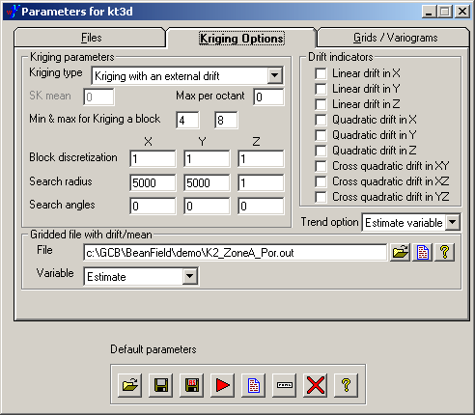

Make sure the Grids/Variograms tab correctly represents both your selected variogram model and grid layout. In my case all the values were remembered and filled in automagically:

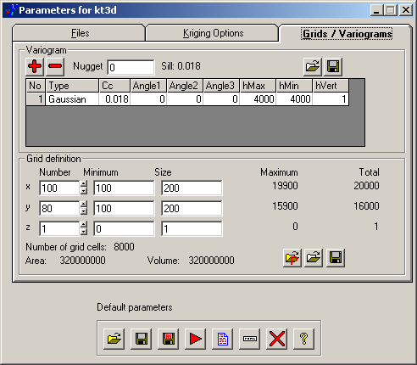

It would probably be a good idea to save these parameters in a new file. Then click the button to run kt3d and take a look at the output file if you care to. Again, I have edited the opening lines of this file to be a little more informative:

KT3D ESTIMATES of LogPerm, using gridded porosity as external drift
2 100 80 1 100.00000 100.00000 .00000000 200.000 200.000 1.00000 1
LogPermEstimate
LogPermEstimationVariance
-.30417570 .13681880E-01
-.30934730 .11669830E-01
-.21846280 .82404850E-02
-.22859720 .67881320E-02

A run of histplt will show that the gridded LogPerm values run from about -0.41 to 0.72 (rounding outward at both ends).
One last trip through pixelplt, updating the input and output file names and legend limits appropriately, shows:

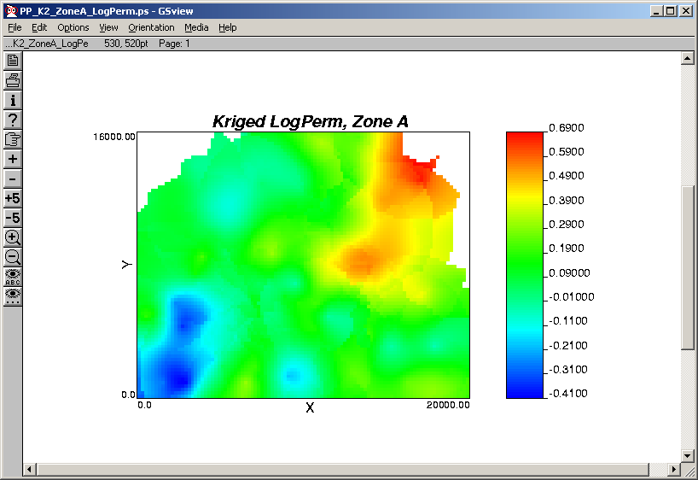

In this case, the 5000 m search radius has lead to search failures in the northwest and northeast corners of the area, due to the lack of well control for permeability in these regions. The white areas on the map represent the resulting missing values in the grid.

Not surprisingly, the kriged log permeability map looks a fair amount like the kriged porosity map.

