Geoff Bohling
5 September 2005

Variogram Analysis

Variogram Analysis, Zone A Porosity

First we will compute omnidirectional variograms for porosity, using lag increments of 500 m and 1000 m. Start the analysis by clicking on Irregularly spaced data variogram computation (gamv) on the Variogram menu. Then modify the Files tab of the dialog box to appear as follows:

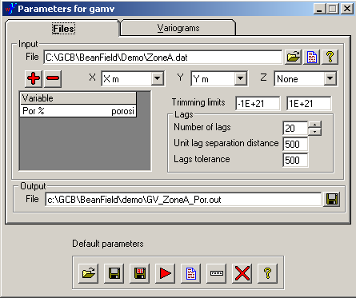

If you click on the single entry in the Variable list you will see that the text box turns into a dropdown list allowing you to select the appropriate variable, Por %. For now we will use 20 lags with a lag separation distance of 500 m and a lag tolerance of 500 m. Using a lag tolerance of more than half the separation distance will result in some pairs being counted in multiple lags, resulting in a smoother variogram.

Switch to the Variograms tab and uncheck Standardize sill, leaving the angular tolerances and bandwidths at their default values. The 90 degree azimuthal tolerance and wide bandwidth will result in an omnidirectional variogram. After making these changes, launch the gamv program by clicking the red arrow. Now when you click on the document icon, you will actually see the contents of the output variogram file, GV_ZoneA_Por.out, displayed in a text editor, rather than a plot of those numbers:

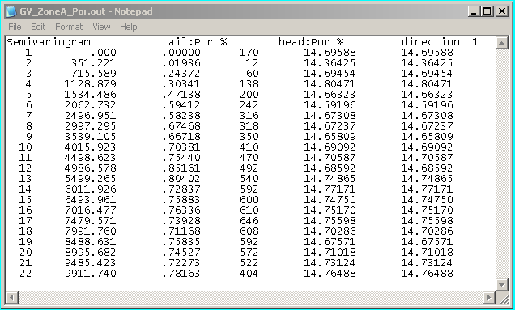
The columns are: lag number, lag distance, semivariogram value (gamma), number of data pairs for this lag, and the head and tail means (never mind these last two). The number of data pairs is important since we need a reasonable number of pairs to get a reliable estimate. Increasing lag increments and lag tolerances will increase the number of pairs but might also smooth out significant variations.

To see the variogram plot, you have to run the variogram output file through another of the PostScript programs, launched by clicking Variogram (vargplt) on the PostScript menu. Modify the resulting dialog box to appear as follows (rename the output file, uncheck Plot sill, and change the Plot title):

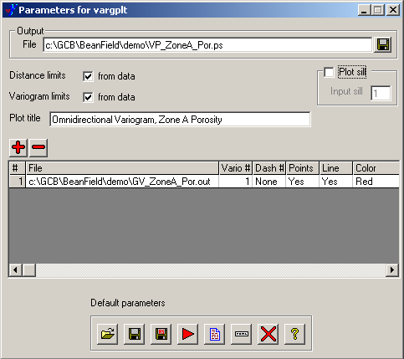

I have also expanded the File field in the list of input files (only one at the moment) to display the entire file name, letting me verify it was the right one. So . . . click on the red arrow and then the document icon to display the plot in GhostView:

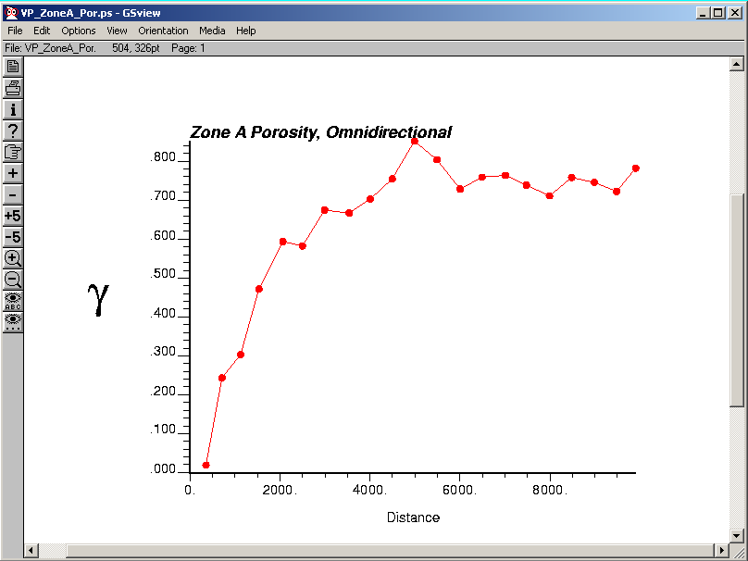

Next we will re-run the analysis with a 1000 m lag. Expand the Variogram and gamv entries to show the parameter file for the first analysis and double-click on that entry:

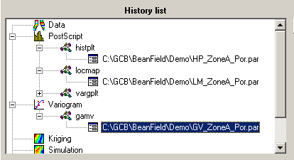

Change the number of lags to 10, change the lag and lag tolerance to 1000 m and change the output file name to reflect this fact (we should perhaps have included “500” in the original output file name):

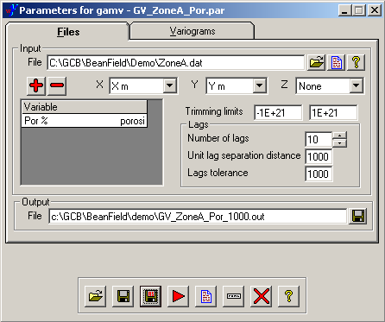

If you wish, click on the “Save As” button (the second diskette icon) to save this set of parameters in a different parameter file. Then click the red button to run the program.

Next, re-launch the variogram plotting dialog box (through the PostScript menu or by double-clicking the parameter file entry for the last plot), and add the 1000-m-lag variogram file to the list of input files by clicking on the Add Variogram button (the big +), clicking on the file name field to turn it into a Choose button, and then clicking on that button. In the resulting dialog box, select and open the 1000-m lag variogram file to add it to the list. You will have to manipulate some other piece of the dialog box to get the silly Choose button to go away. I have changed the new line color to dark blue:

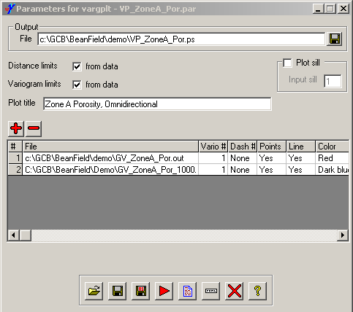

Then click the red arrow and document icons to reveal . . .

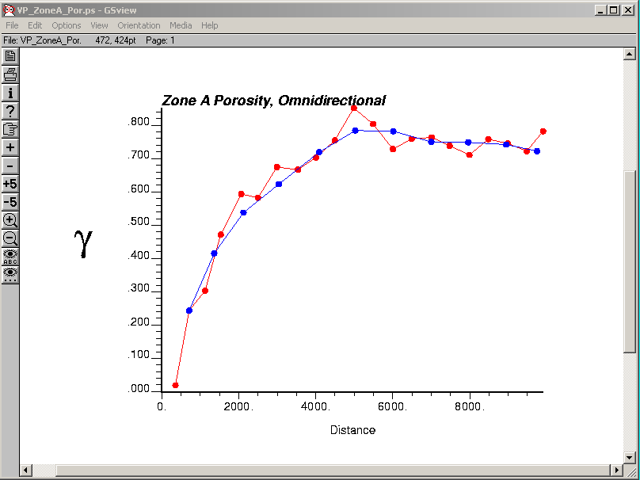

So the variogram with the 1000-meter lag looks like a smoothed version of the one with the 500-m lag, as expected. More to the point, the shorter-lag variogram does not seem to show inordinate variation, so we will use it in the following. For the sake of variogram modeling in the next step, it is helpful to notice that the variogram seems to reach a sill of around 0.75 (the units would be squared percent in this case) at a range of about 5000 m. You might also note that the shape of the variogram looks similar to that of an exponential model.

For the sake of kriging, we need to replace the empirical variogram (computed from the data) with a model variogram, hopefully one that matches the empirical variogram reasonably well. Variogram modeling in GSLIB and consequently in WinGslib is a tedious process, involving using the vmodel program to generate a model variogram file which can then be plotted together with the empircal variogram for comparison. Start the modeling process by selecting Variogram file from model (vmodel) from the Variogram menu. Modify the dialog box to appear as follows:

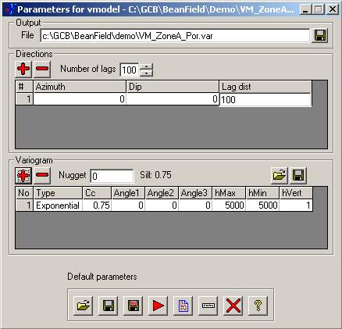

This will generate lag distance and variogram values for 100 lags out to a distance of 10000 m (100 lags times a lag distance of 100 m) using an exponential model with a sill of 0.75 and a range of 5000 m in the horizontal (specified by the equal values of the two lateral ranges, hMax and hMin; for this 2D application, hVert is irrelevant).

If you run the vmodel program and then look at the output file, you will see that the model data actually begins with two entries for lag 0, both with a variogram value of 0. (I believe that with a non-zero nugget, one of these entries would have a zero variogram value and the other would have the nugget value.):

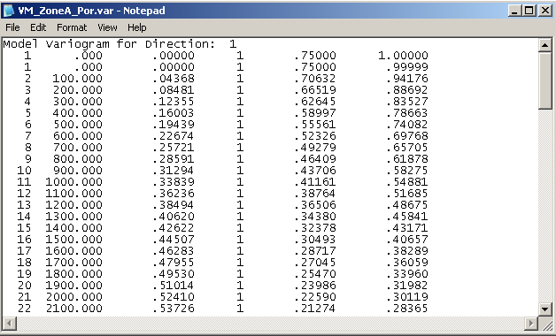

Probably the easiest way to plot the empirical and model variograms together is to modify the parameters that we used to plot the 500 m-lag and 1000 m-lag variograms together, replacing the 1000 m-lag variogram file with the model variogram file that we just produced. You can accomplish this by expanding the vargplt entry under PostScript in the history list and then double-clicking on the entry for the previously saved parameter file. On the Parameters for vargplt dialog box, click on the entry for the 1000 m-lag variogram file to once again activate the Choose button. Click on this button to trigger the Open dialog box and change the Files of type dropdown at the bottom to display Variogram model files (.var). Then select and open the variogram model file you just generated:

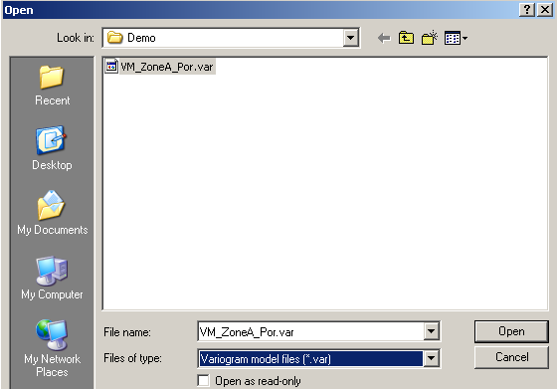
After you have replaced the 1000 m-lag variogram file with the model variogram file, you might also want to change the plot styles to display points only for the empirical variogram and a line only for the model variogram:

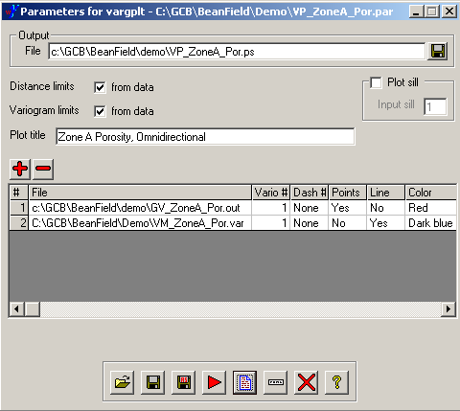

Then run the program and display the plot:

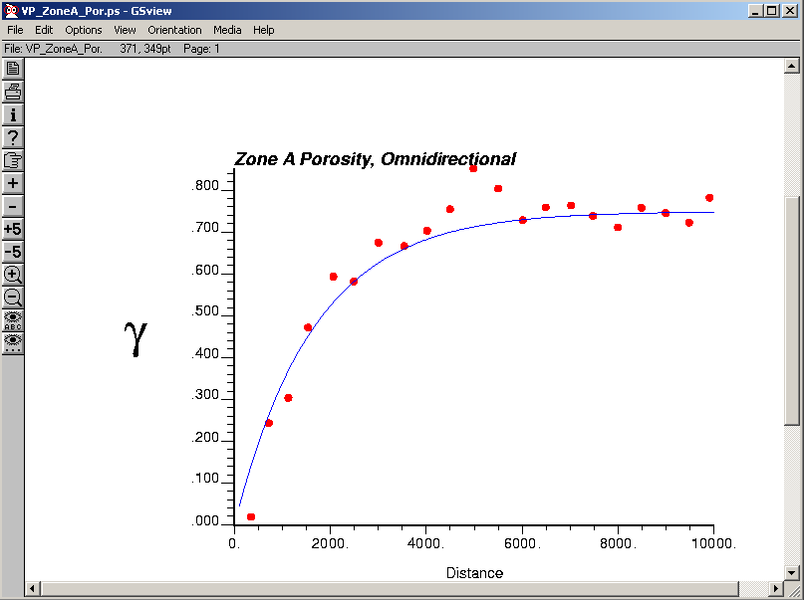

The model fits the empirical variogram quite well. In fact, it would be difficult to improve on this fit substantially. If this were a typical problem, you probably would have to modify the variogram model parameters and possibly the model type a few times before achieving a reasonable fit.
Probably the quickest way to perform iterative variogram model fitting in WinGslib is to keep both the Parameters for vmodel and Parameters for vargplt dialog boxes open simultaneously, with vargplt set up to plot the model variogram file generated by vmodel:

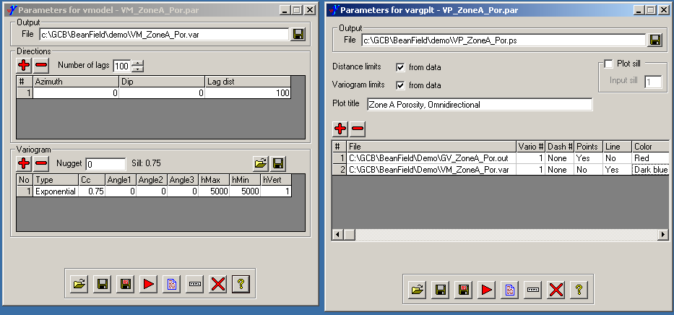

With this setup, it is reasonably quick to

1) modify the variogram model parameters in the vmodel dialog box,
2) regenerate the variogram model file by clicking the red arrow to run vmodel,
3) regenerate the plot file with the new model by clicking the red arrow on the vargplt dialog box, and
4) click the document icon on the vargplt dialog box to display the updated plot file.

You can repeat this process as necessary to achieve a reasonable fit. It is probably best to close the various plot (GhostView) windows as you go along to avoid confusion.

Note on Use of Variowin for Variogram Modeling

Variowin is much easier to use for modeling variograms because it is interactive and you can see the effects of changes in parameters. However, you must use caution when estimating variogram parameters in Variowin for use in WinGSlib. As far as I can tell, the variogram computations and definitions of the variogram models are consistent between Variowin and the current version of GSLIB (the routines which underlie WinGslib). In particular, for the asymptotic variogram models (exponential and Gaussian), both packages appear to use the “effective range” – the distance at which the variogram reaches 95% of the specified sill value – as the range parameter, rather than the “correlation length” which would be 1/3 of the effective range. However, if you use “Save As…” in the Variowin Model program to save variogram parameters appropriate for GSLIB, the parameters in the resulting file will not be correct. The parameters written out by the Variowin Model program (which are different from the parameters displayed on the screen) would be appropriate for use with the kriging programs in GSLIB Version 1.0, but not those in GSLIB90, which are the ones used by WinGslib.

In short, the variogram model definitions in Variowin are consistent with those in WinGslib if you use the parameters displayed in Variowin’s Model program rather than the ones written to the model file.
Variogram analysis, Zone A Thickness

Start the variogram analysis for zone thickness by re-opening the gamv parameter file that you used for porosity (under Variogram and gamv in the history list), switching the variable to analyze to Thk, and switching back to 20 lags at an increment of 500 m (if necessary). Change the output file name to indicate the change of variable:

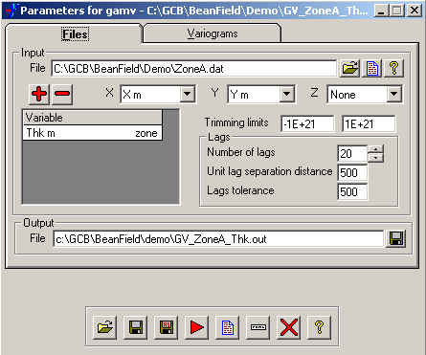

The settings in the Variograms tab should still be reasonable (for an omnidirectional variogram). Save the current parameters under a new parameter file name and run the program to produce:

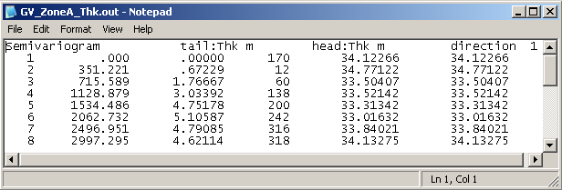
Similarly, you can modify the parameters for plotting the porosity semivariogram to plot the thickness semivariogram (under PostScript and vargplt in the history list). Change the input file for the empirical variogram (the first in the list) to the one for thickness that we just produced and then delete the model variogram file by clicking on the 2 (the row label for the second entry) and then clicking the red minus sign. Also, change the plot title and add the line for the empirical variogram back in, to yield:

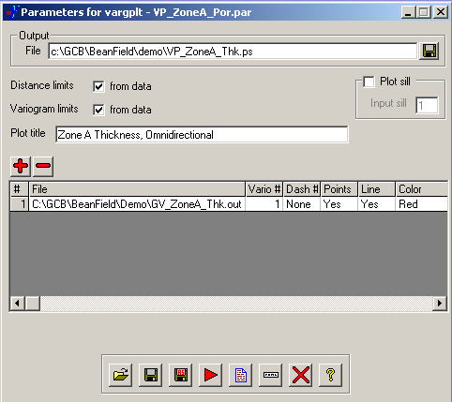

The resulting plot shows that the variogram fails to reach a sill, probably due to the trend in the thickness values that we observed in the posting map:

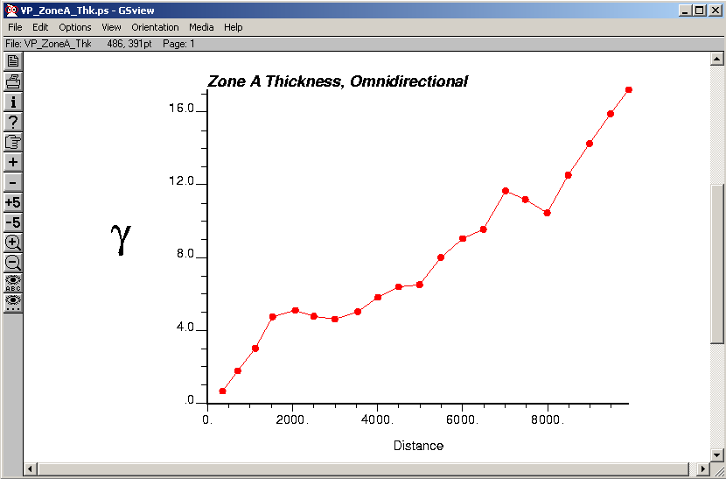

It is possible to account for trends in the kriging process, but the variogram model used should be that for the residuals from the trend, which requires an estimate of the trend in the first place. One possible means of escape from this circularity is to estimate the variogram in a presumed trend-free direction and take this as an approximation of the variogram of the residuals. The thickness map we produced earlier seems to indicate a roughly southwest-northeast trend, meaning that northwest-southeast transects might be fairly free of trend. We will investigate this possibility by computing directional variograms for the thickness. To accomplish this, re-open your parameter file for the thickness variogram computation and, if you wish, rename the output file to indicate that you are now computing a set of directional variograms (for example, change it to GV_ZoneA_Thk_Dir.out), then switch to the Variograms tab and change the azimuthal tolerance (Az tol) to 22.5 and the horizontal bandwidth (Bandwidth h) to 5000, leaving the azimuth at 0 (meaning north). The azimuthal tolerance and bandwidth are both “half window” values, so the search window looking out from any data point will sweep out at an angle of 45° until it reaches a width of 10000 m, beyond which it will remain at the specified width. Decreasing the angular tolerance and bandwidth will increase the directional resolution but also decrease the number of data pairs for each lag and thus increase the level of noise in the variogram. The dip, dip angle tolerance, and vertical bandwidth don’t matter in this 2D application.

After changing Az tol and Bandwidth h, click on the big red + above Azimuth to add another directional variogram, with the same settings, to the list. Change the azimuth for this variogram to 45 (that is, N 45° E). Repeat the procedure two more times, changing the azimuths to 90 and 135:

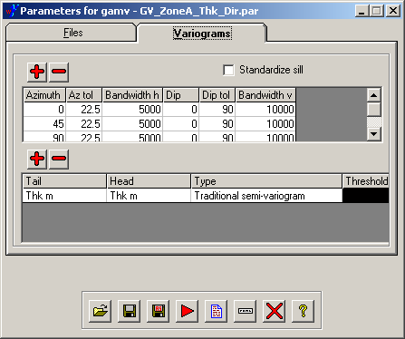
After making these changes, run the program and take a look at the output file, which should contain the empirical variogram values for four different directions. To plot the file, return to your variogram plotting (vargplt) parameter file for thickness and modify it to show all four variograms in the directional variogram output file. (Use the red plus button to add successive variograms from the file.) Note that you will have to remember the associations between line colors/styles and directions; this information will not be included on the plot. As before, you may choose to save the output in a new PostScript file (by changing the name of the output file) and save these parameters in a new parameter file (using the Save As button), or simply overwrite the previously existing files:

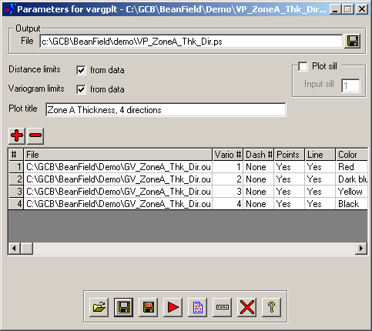

The resulting variogram plot should look something like:

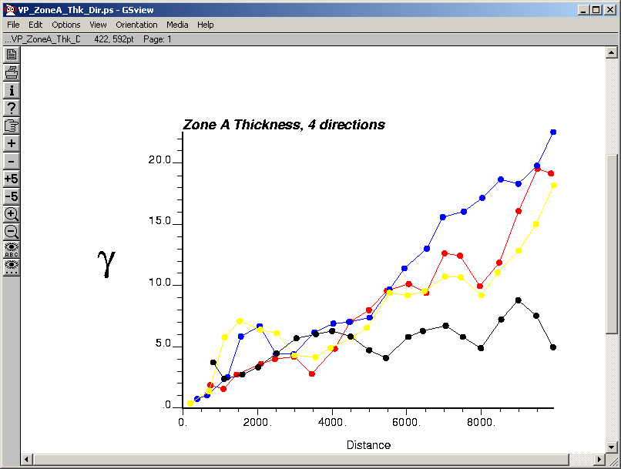

The black line on this plot represents the variogram in the direction N 135° E (that is, southeast) and it appears to be reasonably trend free, in accordance with our expectations from the thickness map. If you wish, you may attempt to refine your search, looking in more detail at directions near 135°, but here we will proceed with treating this as the trend-free variogram.

If you are curious about the rather high first point on the 135° variogram, you can right-click on the entry for the parameter file that you used to generate the directional variogram file (possibly GV_ZoneA_Thk_Dir.par under gamv in the history list) and then select View result from the pop-up menu. This will redisplay the variogram data file, which shows that the variogram value for the first non-zero lag for “direction 4” (a.k.a. 135°) has been computed from only 5 data pairs, and therefore is not very reliable. Ignoring this point, the variogram seems to increase gradually to a sill of about 6 m² at a distance of about 4000 m. Armed with this information, we return to vmodel . . .

Fire up the Parameters for vmodel dialog box again either by going through the Variogram menu or by double-clicking on the previously saved file for the porosity variogram model, and modify the entries to look something like:

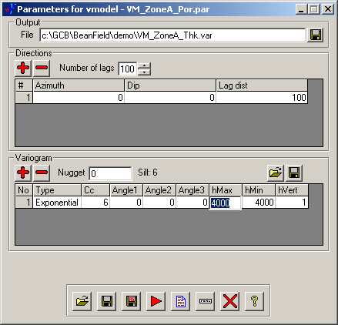

Note that I have changed the output file name to indicate that we are now working with the thickness and have changed the model sill (cc) and range (hMax and hMin), leaving the model type as Exponential. We are not concerned about the azimuth here because we will only be comparing the model to the 135° empirical variogram and will be using it as an omnidirectional representation of the variogram for the residuals.

Save these parameters to a new parameter file, if you wish, then run the program to produce the model variogram output file.

Activate the Parameters for vargplt dialog box by your method of choice and modify it to display the 135 empirical variogram (number 4) from the directional variogram file and the model variogram you just generated:

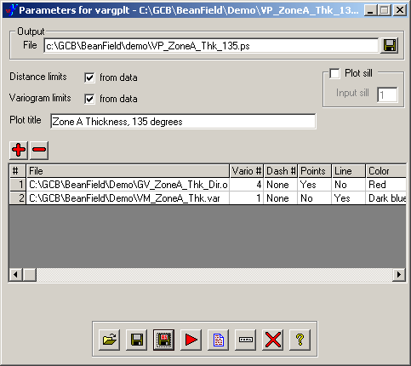

The resulting fit is not great:

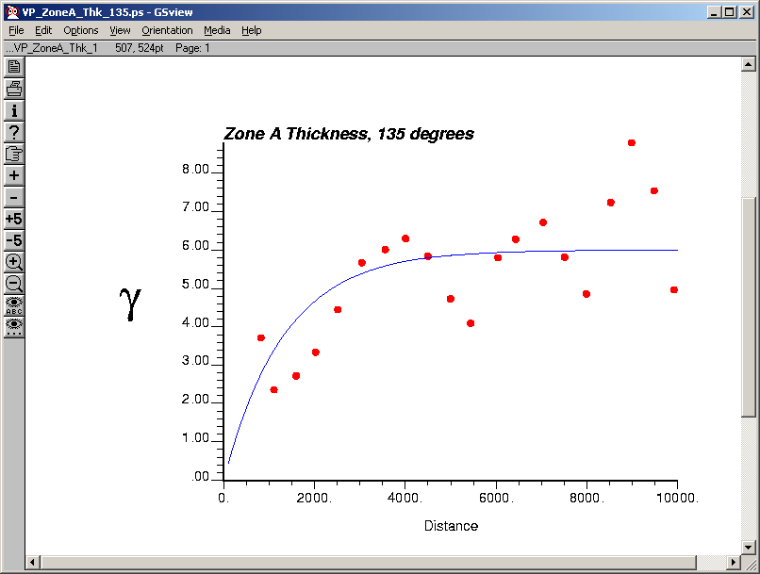

The behavior of the data in the early lags almost suggests a Gaussian variogram with a nugget, but it is a little inconsistent to combine a Gaussian model, which implies considerable smoothness, with a nugget, which implies significant lack of smoothness.

Let’s try again with a spherical variogram, which will approach the sill in a more linear fashion. This will require re-running vmodel with a different model type and then re-running vargplt. As described above, repeated iterations of this process can be simplified by leaving both dialog boxes open and switching back and forth between them, simply re-running both processes in sequence (model generation then plotting) after making the changes to the variogram model parameters:

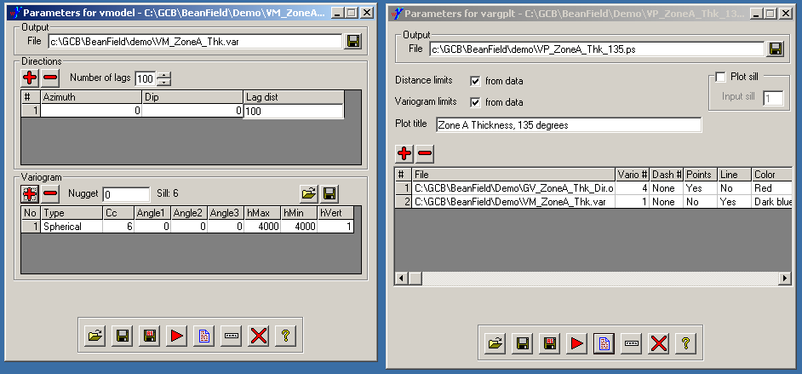

The spherical variogram provides a somewhat better fit:

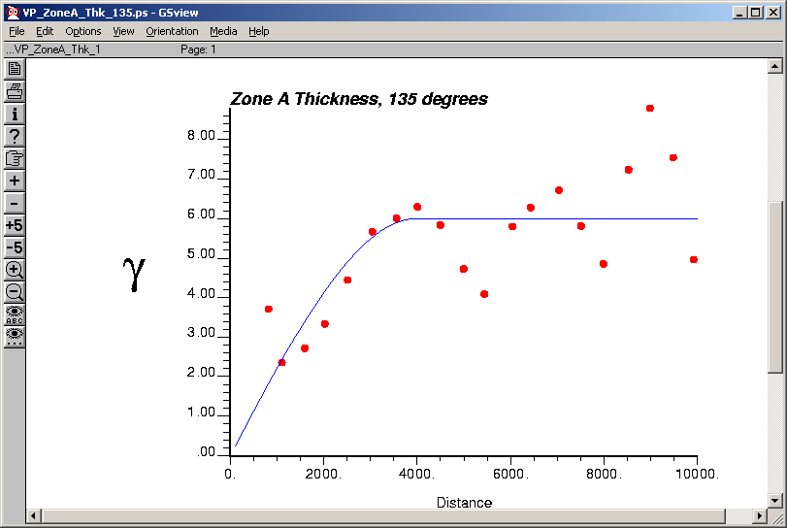

We will use this model (spherical with a sill of 6 m² and range of 4000 m) for kriging.
Variogram Analysis, LogPerm residuals, Zone A

Open one of your previously saved gamv parameter files and modify it for computing an omnidirectional variogram for the variable LogPermRsd, the difference between the observed LogPerm and that predicted by the regression against porosity (LogPermPrd). Make sure to set the lower trimming limit to exclude missing values (represented by −999.9999):

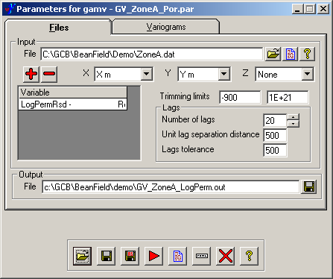

On the Variograms tab, make sure the settings are appropriate for an omnidirectional variogram (azimuthal tolerance of 90° and a large bandwidth).

A glance a the output variogram file shows that there are not very many data pairs associated with the early lags, since there are not that many data points altogether. Therefore, we might expect the variogram to be somewhat poorly estimated. Running the variogram file through vargplt shows:

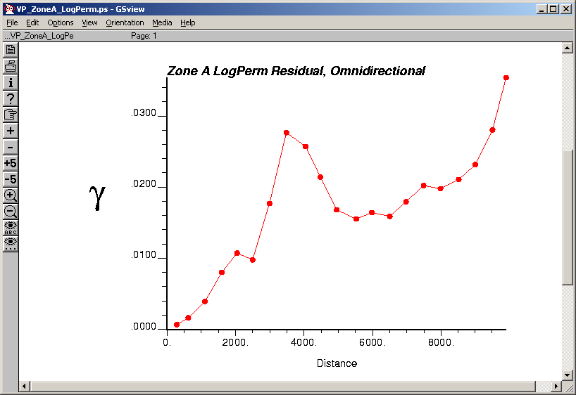

If you wish, you may try to find a directional variogram that lacks the apparent trend shown by this variogram. I, however, will brazenly ignore the ratty nature of this thing and just try to fit a model to the early lags, on the presumption that the larger scale structure will be accounted for by using porosity as a covariate. Again, I expedite the fitting process (as much as it can be) by keeping both the vmodel and vargplt dialog boxes open simultaneously, modifying the model parameters and running vmodel to generate the model output, and then running vargplt (with no further changes once I have it set up to include the model variogram) and displaying the result.

A Gaussian variogram with a sill of 0.018 and a range of 4000 seems to provide a tolerable fit:

