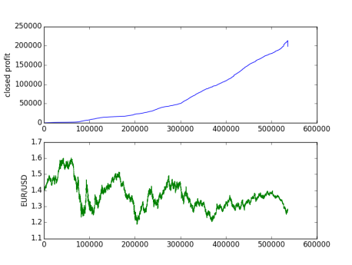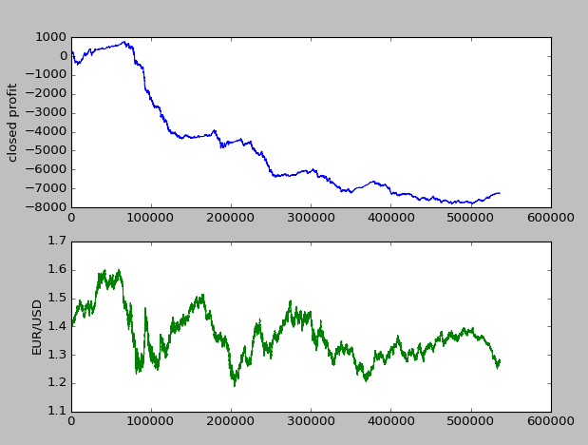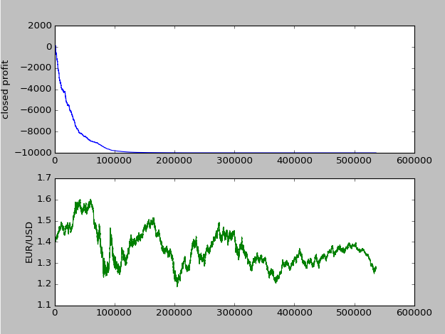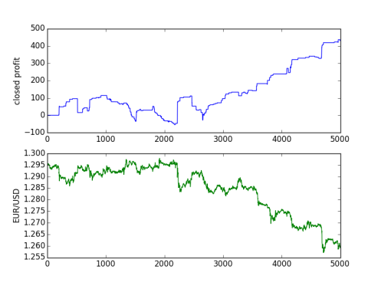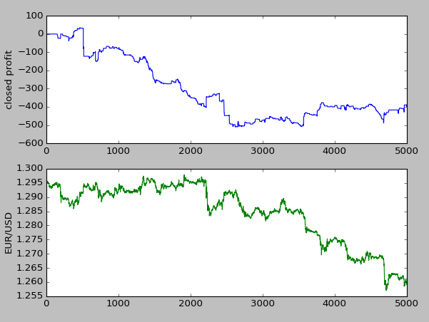

Conclusion for the project, and the limits of our back-testing platform. Why the real world, might be different despite being tested on real world data.

Explain about the new Buy/Sell strategy… basically we close an order, whenever the order is in profit.

Invested: 10.000 $,Leverage: 20

Duration: ~ 7 years, Classifier,

New Buy/Sell Strategy

Invested: 10.000 $,Leverage: 20

Duration: ~ 7 years, Classifier

Invested: 10.000 $,Leverage: 20

Duration: ~ 7 years, Random

Invested: 10.000 $,Leverage: 20

Duration: 23 days, Classifier

Invested: 10.000 $,Leverage: 20

Duration: 23 days, Random

Buy and sell strategy with takeProfit and stopLoss and only use 2% of current account Balance per order

*~66% - Long*

Long

Short

Make a Blog diagram on how the classifier works.

100:Volume

1.235:Bid

RSI: 45

1:SMA

Process diagram

Explain about the features we have chosen

Introduction to our strategy of using machine learning on our profitable trades, on our random trader

Introduction to the concepts of ask and buy prices… Show a graph only consisting of the y-axes with 4 different prices (lowAsk, highAsk, lowBid, highBid). The difference between the highAsk and the lowBid is the spread we pay per closed order.

Introduction to the project