Week 10 Assignments

Task Details & Resources

**Have your Scrum Master keep track of how long your assignment takes**

**Due Date:** 11/19/21

**Resources:**

[IEEE](https://teams.microsoft.com/_?culture=en-us&country=US&lm=deeplink&lmsrc=homePageWeb&cmpid=WebSignIn#/pdf/viewer/teams/https:~2F~2Fwebmailbyui.sharepoint.com~2Fsites~2F21FallCSE372SWRequirements~2FShared%20Documents~2FGeneral~2FWk02_ReqIEEE29148-2018.pdf?threadId=19:2VNFwzydLkybBZ7Q5ER7oDKBK0dEolGZausur5uLCdM1@thread.tacv2&baseUrl=https:~2F~2Fwebmailbyui.sharepoint.com~2Fsites~2F21FallCSE372SWRequirements&fileId=18799c6f-0caa-4a00-813d-5e7ec729117a&ctx=files&rootContext=items_view&viewerAction=view)

* The book

[Detailed Outline from the Sponsor](https://teams.microsoft.com/_?culture=en-us&country=US&lm=deeplink&lmsrc=homePageWeb&cmpid=WebSignIn#/docx/viewer/teams/https:~2F~2Fwebmailbyui.sharepoint.com~2Fsites~2F21FallCSE372SWRequirements~2FShared%20Documents~2FProject%20Sponsor~2FmyJym%20Specifications.docx?threadId=19:c3fe79d02e564aebbace977c0a1e1ec5@thread.tacv2&baseUrl=https:~2F~2Fwebmailbyui.sharepoint.com~2Fsites~2F21FallCSE372SWRequirements&fileId=7362c28c-e02c-4080-af1b-baf2d29fb833&ctx=files&rootContext=items_view&viewerAction=view)

* The document linked above covers the details of the project from the perspective of the sponsor

[Gym goer data](https://docs.google.com/forms/d/1w8c47X_x0IfFxD012EwbVwyP2bRBr60ZcdaviP-QwoE/edit#responses)

* The document linked above is the survey feedback that was collected from BYUI gym goers

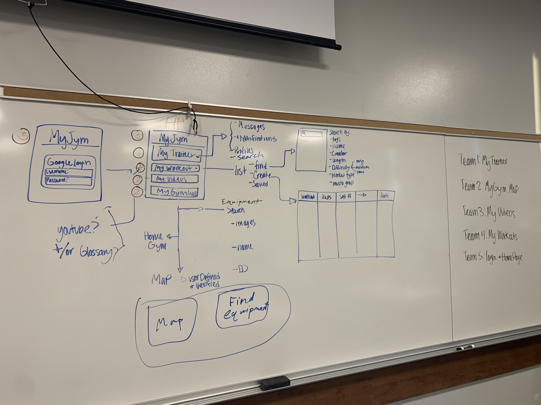

* Diagram from class on Tuesday

**Notes:**

* Assignment related items:
  + Look at Gym goer data and the project outlines linked above to produce the requirements
  + You create the requirements and the details of what your part of the app looks like
  + If you have any ideas for the app, write them down and your Chief editor can add them to intro of the SRS
* Role related items:
  + Consult your Chief Editor on how to format the document
  + Consult your Specialist for details about the contents of the document
  + Ask your scrum masters/leads if you have any additional questions (or the PM if they do not have the answers)

Assignments by Team

**For each of your assignments complete the following:**

9.6.14 Performance requirements - Page 72 SRS

9.6.15 Logical database requirements - Page 73 SRS

9.6.16 Design constraints - Page 73 SRS

**Team 1**

* My Trainer

**Team 2**

* My Gym Map

**Team 3**

* My Videos

**Team 4**

* My Workouts

**Team 5**

* Login & Homepage