Lab 1 - Getting Started with RISC-V (Assembly Language) in VS Code

Name: Aayan Rizvi | Student ID: 11089
main:
li x1, 5 # int a = 5;
li x2, 0 # 2 int b = 0 + 0;
addi x1,x2,32 #3 a = b + 32;

add x3, x1,x2 # (a + b)
addi x4, x3, -5 # 4 int d = (a + b)- 5;

sub x5, x1, x4 # (a- d)
sub x6, x2, x1 # (b- a)

add x7, x5, x6 # ((a- d) + (b- a))
add x8, x7, x4 # 5 int e = (((a- d) + (b- a)) + d);

add x9, x8, x4
add x10, x1, x2
add x11, x9, x10 # 6 e = a + b + d + e;
end:
j end

Task 3:

Code:

Results:
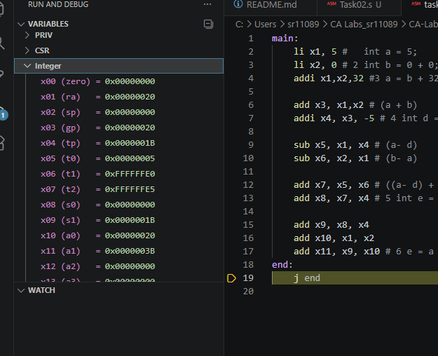

Task 4a:
- Store x10 as unsigned integer at address 0x100.
li x2, 0x100
sw x10, 0(x2)

- Store x11 as unsigned integer at address 0x1F0.
li x3, 0x1F0
sw x11, 0(x3)

- Load an unsigned short integer (two bytes) from address 0x100 in x12.
li x4, 0x100
lhu x12, 0(x4)

- Load a short integer from address 0x1F0 in register x13.
li x5, 0x1F0
lh x13, 0(x5)

- Load a singed character from address 0x1F0 in register x14.
li x6, 0x1F0
lb x14, 0(x6)

Task 4b:
main:
li x10, 0x100 # a
li x11, 0x200 # b
li x12, 0x300 # c

# populate array a
li x5, 1
sb x5, 0(x10)
li x5, 2
sb x5, 1(x10)
li x5, 3
sb x5, 2(x10)
li x5, 4
sb x5, 3(x10)

# populate array b
li x6, 10
sh x6, 0(x11)
li x6, 20
sh x6, 2(x11)
li x6, 30
sh x6, 4(x11)
li x6, 40
sh x6, 6(x11)

# first iteration, where i=0
lb x5 0(x10)
lh x6 0(x11)
add x7, x5, x6
sw x7, 0(x12)

# second iteration, where i =1, thus offset multipllied by 1
lb x5 1(x10)
lh x6 2(x11)
add x7, x5, x6
sw x7, 4(x12)

# third iteration, where i =2
lb x5 2(x10)
lh x6 4(x11)
add x7, x5, x6
sw x7, 8(x12)

# fourth iteration, where i = 3
lb x5 3(x10)
lh x6 6(x11)
add x7, x5, x6
sw x7, 12(x12)

end:
j end

Code:

Results:
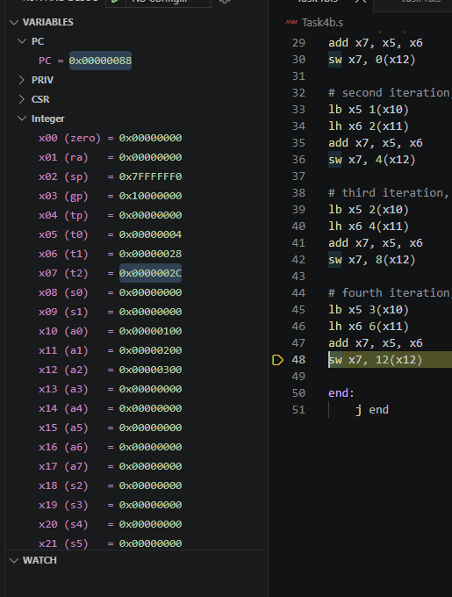

https://github.com/AAyannn-del/CA-Labs-Git-Aayan-Rizvi.git

Assessment Rubric
Lab 1: Getting Started with RISC-V (Assembly Language) n VS Code

Name: Aayan Rizvi | Student ID: 11089 | Section: T4

Points Distribution:

 | Task No. | LR 2 (Code) | LR 5 (Results)
In-Lab | Task 1 | - | /15
 | Task 2 | - | /15
 | Task 3 | /10 | /5
 | Task 4a | /10 | /5
 | Task 4b | /10 | /10
Total Points: 100 |  | /30 | /50
CLO Mapped |  | CLO 2

Affective Domain Rubric |  | Points | CLO Mapped
AR7 | Report Submission & Git Upload | /10 & /10 | CLO 2

CLO | Total Points | Points Obtained
2 | 100
Total | 100

